VCE Vocational Major

Unit 3 Respectful and Ethical Entreperneurs
Numeracy Curriculum
Support Material

Authorised and published by the Victorian Curriculum and Assessment Authority
Level 7, 2 Lonsdale Street
Melbourne VIC 3000
ISBN: 978-1-xxxxxx-xx-x [email vcaa.media.publications@edumail.vic.gov.au for ISBN requests]
© Victorian Curriculum and Assessment Authority [year]

No part of this publication may be reproduced except as specified under the Copyright Act 1968 or by permission from the VCAA. Excepting third-party elements, schools may use this resource in accordance with the VCAA educational allowance. For more information go to https://www.vcaa.vic.edu.au/Footer/Pages/Copyright.aspx.
The VCAA provides the only official, up-to-date versions of VCAA publications. Details of updates can be found on the VCAA website at www.vcaa.vic.edu.au.
This publication may contain copyright material belonging to a third party. Every effort has been made to contact all copyright owners. If you believe that material in this publication is an infringement of your copyright, please email the Copyright Officer vcaa.copyright@edumail.vic.gov.au
Copyright in materials appearing at any sites linked to this document rests with the copyright owner/s of those materials, subject to the Copyright Act. The VCAA recommends you refer to copyright statements at linked sites before using such materials.
The VCAA logo is a registered trademark of the Victorian Curriculum and Assessment Authority.

Contact us if you need this information in an accessible format - for example, large print or audio.
Telephone (03) 9032 1635 or email vcaa.media.publications@edumail.vic.gov.au

Contents
Contents
Numeracy activities 4
Numeracy Task 1-Big and small numbers 4
Task 1- Big and small numbers Activity 1.1 What is a big number? 5
Task 1- Big and small numbers Activity 1.2 What is a small? 5
Task 1- Big and small numbers Activity 1.3 Power and square roots 6
Task 1- Big and small numbers Activity 1.4 Partner challenge 7
Task 1- Big and small numbers Activity 1.5 Numbers confidence reflection 7
Task 1- Big and small numbers Activity 1.6 Numbers related to health 7
Task 1- Big and small numbers Activity 1.7 Large and small number problem 8
Task 1 Big and small numbers– Peer feedback and Assessment 8
Numeracy Task 2-Decimals, percentages and ratios 10
Task 2- Decimals, percentages and ratios Activity 2.1 Findings equivalent decimals, fractions and percentages. 11
Task 2- Decimals, percentages and ratios Activity 2.2 Heart rate 11
Task 2- Decimals, percentages and ratios Activity 2.3 Working out percentage amounts 13
Task 2- Decimals, percentages and ratios Activity 2.4 Ratios and simplifying 15
Task 2- Decimals, percentages and ratios Activity 2.5 Proportion 16
Task 2- Decimals, percentages and ratios Activity 2.6 Proportion and ratio 17
Task 2 - Feedback and Assessment 18
Numeracy Task 3 – Profit and loss 20
Task 3- Profit and loss 3.1 Stop watch challenge 21
Task 3- Profit and loss 3.2 Ordering numbers 22
Task 3- Profit and loss 3.3 Rounding decimal places 23
Task 3- Profit and loss 3.4 Fractions, decmals and percentages 24
Task 3 - Feedback and Assessment 26
Numeracy Task 4 – Shape properties 28
Task 4- Shape properties Activity 4.1 2D Shape matching 28
Task 4- Shape properties Activity 4.2 Rotational symmetry 30
Task 4- Shape properties Activity 4.3 Reflection symmetry 33
Task 4- Shape properties Activity 4.4 Design task 35
Task 4 - Feedback and Assessment 35
Numeracy Task 5- Shapes in recreational settings 37
Task 5- Shapes in recreational settings 5.1 Identifying shapes in recreational settings 38
Task 5- Shapes in recreational settings 5.2 Identifying shapes in architecture 40
Task 5 - Feedback and Assessment 41
Numeracy Task 6 Shapes and area planning 43
Task 6- Shapes and area planning Activity 6.1 Outdoor festival planning 43
Task 6- Shapes and area planning Activity 6.2 Sports and athletics hub 45
Task 6- Shapes and area planning Activity 6.3 Manipulating space 45
Task 6 - Feedback and Assessment 48
Numeracy Task 7 How far, how much and how big? 50
Task 7- How far, how much and how big? Activity 7.1 Collecting data 50
Task 7- How far, how much and how big? Activity 7.2 Building dimension estimates 51
Task 7- How far, how much and how big? Activity 7.3 Measuring using a Lasertec Tool (Laser measuring device) 52
Task 7- How far, how much and how big? 7.4 Measuring using a measuring tape 53
Task 7- How far, how much and how big? 7.5 Perimeter and area 54
Task 7- How far, how much and how big? 7.6 Volume and capacity 56
Task 7- How far, how much and how big? 7.7 Compound shapes 56
Task 7 - Feedback and Assessment 57
Numeracy Task 8 How much is that? 59
Task 8- How much is that? 8.1 Collecting data 59
Task 8- How much is that? Activity 8.2 Converting measurements (centrimetres and inches) 61
Task 8- How much is that? Activity 8.3 Converting measurements (kilograms and pounds) 64
Task 8- How much is that? Activity 8.4 Converting measurements (celsius to fahrenheit) 65
Task 8 - Feedback and Assessment 67
Numeracy Task 9 Life logbook 69
Task 9- Life logbook Activity 9.1 What activities do I do? 70
Task 9- Life logbook Activity 9.2 Monthly planner 72
Task 9 - Feedback and Assessment 73
Numeracy Task 10 What’s the time? 74
Task 10- What’s the time? 10.1 12 hour and 24 hour conversion 75
Task 10- What’s the time? 10.2 Time and timetables 76
Task 10- What’s the time? 10.3 Time zones 77
Task 10- What’s the time? 10.4 Gym session bookings 79
Task 10 - Feedback and Assessment 80
Numeracy Task 11 Human resources (HR) wages 82
Task 11- HR wages 11.1 Collecting data and performing calculations 83
Task 11- HR wages 11.2 Covering costs 86
Task 11 - Feedback and Assessment 87

Numeracy activities

Numeracy Task 1-Big and small numbers

Numeracy Context: Health (d)
Area of Study (AoS): 1 Number

Key knowledge and key skills
AoS 1 KS 1 Fluently read very large and very small numbers
AoS 1 KS 4 Solve problems involving powers and square roots

Task Checklist
Students will complete the following for Numeracy Context: Health (d)
☐ Task 1- Activity 1.1 What is a big number?
☐ Task 1- Activity 1.2 What is a small number?
☐ Task 1- Activity 1.3 Power and square roots
☐ Task 1- Activity 1.4 Partner challenge
☐ Task 1- Activity 1.5 Number confidence reflection
☐ Task 1- Activity 1.6 Numbers related to health
☐ Task 1- Activity 1.7 Challenge task

 In this task, you will need will fluently read and identify very large and very small numbers in a number of health scenarios. This task is based on numbers you will or may see in regards to your own health, Australia’s health and global health.

Task 1- Big and small numbers Activity 1.1 What is a big number?
  Part 1: Small business focus- Read and then write what the number are in the table below. You will need to find, caluculate or research the following. Then record your answers in the table.
Item | Number | In words
Weights total
Membership Fees
Exercise Industry Employees
Australian numbers
What is the current Australian population?

How many Australians in 2021 were living with diabetes?

How many road fatalities were there in 2023 in Australia?

What is Australia’s current ‘Total Confirmed Cases’ of Covid cases?

Task 1- Big and small numbers Activity 1.2 What is a small?
Part 1: Small business focus- Read and then write what the number are in the table below. You will need to find, caluculate or research the following. Then record your answers in the table.
Item | Number | Write your answer in words as a fraction.
Blood alcohol concentration | 0.1%
Average hair thickness | 0.05mm
Conversion calculator link
1 Micrometre to mm
1 Nanometer to mm

Task 1- Big and small numbers Activity 1.3 Power and square roots
Part 1: Identify the number and write the number in the tables below.

Item | Number | Written form
Example: 10² | 100 | One hundred
5²
9²
2³
4³
5³
10³

Item | Number | Written form
Example: √4 | 2 | Two
√25

√64

Item | Fraction | Decimal | Written form
Example: 10⁻¹ | $$\frac{1}{10}$$ | 0.1 | One tenth
10⁻² | $$\frac{1}{100}$$
10⁻³ | $$\frac{1}{1000}$$

Task 1- Big and small numbers Activity 1.4 Partner challenge
Part 1: Large and Small Number fluency - write and record 3 large/small numbers to test your partner on and get your partner to read the numbers out loud! Then switch roles (Up to 1 Billion).

My Testing Numbers
1 -
2 -
3 -

My Partner’s Numbers (for me)
1 -
2 -
3 -

Task 1- Big and small numbers Activity 1.5 Numbers confidence reflection
Part 1: In the number areas of money, workplace and measurement, how confident do you feel using the following? Give yourself a score out of 1-5 in the right hand column in the table below (1- Not confident at all to 5-Very confident)

One to 1000 | Add your rating out of 1-5 is this colum.
1000-100000
100000-1000000
Beyond 1 million
Tenths, hundredths and thousanths

Task 1- Big and small numbers Activity 1.6 Numbers related to health
Part 1: List some numbers, large and small that relate to your health.

Hint- you could think about the following, height, weight, hours of rest, total steps per day, heart rate, blood pressure, energy consumed/needed per day etc.

Number example | Context
Example- 371 kj | Energy in a banana.

Task 1- Big and small numbers Activity 1.7 Large and small number problem
Part 1: The distance between the earth and the moon is 384,400km, and the thickness of a piece of paper is approximately 0.001cm. How many times would this paper have to be folded to reach the moon?

My guess that the number of times the paper will need to be folded is…

1 fold | 0.002 cm
2 folds | 0.004 cm
3 folds | 0.008 cm
10 folds

Answer - Watch here for the problem solution

Task 1 Big and small numbers– Peer feedback and Assessment
Peer Feedback
Activity 1.1 | What’s a big number? | Choose an item.
Activity 1.2 | What’s a small number? | Choose an item.
Activity 1.3 | Power and square roots | Choose an item.
Activity 1.4 | Partner challenge | Choose an item.
Activity 1.5 | Number confidence reflection | Choose an item.
Activity 1.6 | Numbers related to health | Choose an item.
Activity 1.7 | Challenge task | Choose an item.
Peer Comment:
Name of Peer:

AoS 1 KS 1 Fluently read very large and very small numbers
Student Reflection - How well did you go with this step? (Please check the box below)
☐Not Submitted | ☐Beginning | ☐Consolidating | ☐Achieving | ☐Excelling
Student Comment (Optional):
Teacher Feedback
☐Not Submitted | ☐Beginning | ☐Consolidating | ☐Achieving | ☐Excelling
Not Submitted: No work has been submitted or attempted for this outcome. | Beginning: You have attempted to answer some of the questions. To bump it up, you need to complete all parts of the activity and show that you can fluently read large and small numbers. | Consolidating You have shown a basic ability to fluently read large and small numbers. You have shown some working out. To bump it up, check over your answers to see if they are correct and include more details of your working out. | Achieving: You have shown an ability to fluently read very large and very small numbers numbers. You have shown your workings. To bump it up, recheck your answers to make sure your answers are all correct. | Excelling: You have shown a high ability to fluently read large and small numbers within a range of different contexts. You have shown all your workings out and all your answers are correct. Great work!
Teacher Comment:

AoS 1 KS 4 Solve problems involving powers and square roots
Student Reflection - How well did you go with this step? (Please check the box below)
☐Not Submitted | ☐Beginning | ☐Consolidating | ☐Achieving | ☐Excelling
Student Comment (Optional):
Teacher Feedback
☐Not Submitted | ☐Beginning | ☐Consolidating | ☐Achieving | ☐Excelling
Not Submitted: No work has been submitted or attempted for this outcome. | Beginning: You have attempted to answer some of the questions. To bump it up, you need to complete all parts of the activity and show that you can solve problems involving powers and square roots. | Consolidating: You have shown a basic understanding of solving problems involving powers and square roots. You have shown some working out. To bump it up, check over your answers to see if they are correct and include more details of your working out. | Achieving: You have shown an understanding of solving problems involving powers and square roots. You have shown your workings. To bump it up, recheck your answers to make sure your answers are all correct. | Excelling: You have shown a high level of understanding of solving problems involving powers and square roots. You have shown all your workings out and all your answers are correct. Great work!
Teacher Comment:

Numeracy Task 2-Decimals, percentages and ratios

Numeracy Context: Health (d)
Area of Study (AoS): 1 Number
Key knowledge and key skills
AoS 1 KS 2 Solve a range of practical calculations including positive and negative numbers, including rounding whole numbers and decimals up to three places.
AoS 1 KS 3 Solve problems involving fractions, decimals, percentages, including calculating percentage increase and decrease.
AoS 1 KS 5 Solve simple problems with ratios and proportions.

Task Checklist
Students will complete the following for Numeracy Context: Vocational (e)
☐ Task 2- Activity 2.1 Finding equivalent decimals, fractions and percentages
☐ Task 2- Activity 2.2 Heart rate
☐ Task 2- Activity 2.3 Working out of percentages of amounts
☐ Task 2- Activity 2.4 Ratios and simplifying
☐ Task 2- Activity 2.5 Proportion
☐ Task 2- Activity 2.6 Proportion and ratio

In this task you will need to solve health-related problems using ratio and proportions calculations. At the end of this task students will be able to use ratios and proportions to solve health-related problems and make predictions.

Task 2- Decimals, percentages and ratios Activity 2.1 Findings equivalent decimals, fractions and percentages.
Part 1: Fill in the table below by providing the equivalent decimal, fraction, and percentage for each row.
Fraction | Decimal- Round to 2 decimal places.  Hint- numerator divided by denominator. | Percentage- Round to the nearest whole number.  Hint- Decimal multipled by 100.
Example:  70/100  Simplified 7/10 | 0.70 | 70%
2/3
 |  | 85%
 | 0.55
70/80
Simplified=7/8

Task 2- Decimals, percentages and ratios Activity 2.2 Heart rate
Part 1: Resting heart rate (HR)- You need to record your resting heart rate measured as beats per minute (BPM).
Hint- you can do this in a number of ways including - a smartwatch, taking your radial pulse or carotid pulse. use the following website that explains these techniques.
Add your response here.

Part 2: Active heart rate- Complete the following:
- Run, jump or skip for 1 minute.
- Directly after the minute, record your heart rate using the same method you used above. Record your heart rate below.

Add your response here.

Part 3: Find the percentage increase.

Worked example
Finding out percentage increase example:

Rod had a resting heart rate of 80 beats per minute. Rod completed 1 minute of high-intensity exercise. After 1 minute, Rod’s heart rate was 130 beats per minute (active heart rate). Calculate the percentage increase of Rod’s heart rate as a percentage.

  - Find the difference:
(Active heart rate) - (Resting heart rate)
130 - 80 = 50 bpm difference.

2. Divide the difference by the initial value:
(Difference between active and resting HR) / (resting HR)
50 / 80 = 0.625

3. Multiply by 100:
0.625 x 100
62.5% increase

In the space below, calculate the percentage increase in your heart rate from resting to active.

Add your response here.

Part 4: Find your maximum heart rate.To find out your approximate maximum heart rate, use the formula below.
Maximum heart rate = 220 - your age.
Worked example
Rod is 50 years old.
Maximum heart rate = 220 - 50
Maximum heart rate = 170 beats per minute

Add your response here.

Task 2- Decimals, percentages and ratios Activity 2.3 Working out percentage amounts

You are following a training program that requires you to monitor the intensity of your workouts. Use the table below to determine the heart rate needed to maintain different intensity levels.
Zone | Intensity | Percentage of maximum heart rate %
Zone 1 | Very light | 50-60%
Zone 2 | Light | 61-70%
Zone 3 | Moderate | 71-80%
Zone 4 | Hard | 81-90%
Zone 5 | Maximum | 91-100%

Worked example
Rod's coach has advised that one of his 60-minute training sessions per week should be at a 'moderate' intensity. Based on the table above, calculate the heart rate range Rod should maintain during this session.

Given:
- Rod’s maximum heart rate (HR) = 170 bpm
- Moderate intensity heart rate range = 71% - 80% of maximum heart rate

Calculating the Heart Rate Range

Lowest:
- Determine 71% of the maximum heart rate.
- Convert the percentage to a decimal: 71/100=0.71
- Multiply by the maximum heart rate: 0.71×170=121
Highest:
- Determine 80% of the maximum heart rate.
- Convert the percentage to a decimal: 80/100=0.80
- Multiply by the maximum heart rate: 0.80×170=136

Conclusion:
To train at a 'moderate' intensity, Rod should maintain his heart rate between 121 and 136 bpm.

Part 1: During your Tuesday afternoon fitness session, you aim to exercise at a moderate intensity. Based on the information from the previous questions and the table, what heart rate range should you maintain to achieve this level of intensity?
Your heart rate:

Moderate intensity heart rate range (refer to table):

Lowest:

Highest:

Conclusion:

Part 2: During your workout, you want to spend 10 minutes exercising at a 'hard intensity'. Using the information from the previous questions and the table, determine the heart rate range you should maintain to reach this intensity level.
Your max heart rate:

Moderate intensity heart range (refer to table):

Lowest:

Highest:

Conclusion:

Task 2- Decimals, percentages and ratios Activity 2.4 Ratios and simplifying

How to simplify a ratio
Worked example
To simplify ratios, divide all the numbers in the ratio by the same amount.

30:10
3:1
Divide both sides
by 10

You are planning a 40-minute workout session that includes 30 minutes at a 'moderate intensity' and 10 minutes at a 'hard intensity'. Write a ratio that represents the time spent at each intensity level.
Ratio:
30:10
Simplified Ratio:
3:1

Part 1: You are completing a 60-minute session, with 45 minutes at a 'light' intensity and 15 minutes at a 'moderate' intensity. Write the original ratio and then simplify it to reflect this distribution.
Initial ratio:

Simplified ratio:

Part 2: As part of your circuit training, you perform 45 seconds of work followed by 15 seconds of rest. Write this work-to-rest ratio and then simplify it.
Initial ratio:

Simplified ratio:

Task 2- Decimals, percentages and ratios Activity 2.5 Proportion
Worked example
Jo is a consistent runner and keeps his pace stable. He runs 6 km in 36 minutes. How far does he run in 96 minutes?
Speed = Distance ÷ time

First, convert the time into hours 36 ÷ 60 = 0.6 hours

Speed = 6 ÷ 0.6 = 10 km/h

Convert 96 minutes to hours 96 ÷ 60 = 1.6

Distance = speed x time

Distance = 10 x 1.6 = 16 km

Part 1: Review the worked example above and respond to the questions below.

- In a relay walk, Team A have 3 walkers who walk 120 km over the whole distance. If they each walk equal distances how far does each walker do?
Working:

- Team B has 5 walkers doing the same distance. If they each walk equal distances how far does each walker do?

- Team B has a walker injured and they can no longer do their part in the relay. How much do the other walkers have to do now?

Task 2- Decimals, percentages and ratios Activity 2.6 Proportion and ratio
Worked example
Lachie’s workout is in the moderate and hard zone at a ratio of 2 : 3. If he works out for 30 minutes, how much time is he working out in each of the zones?

Moderate : hard
2 : 3

Add the ratio 2 + 3 = 5

Then 30 minutes ÷ 5 = 6 minutes

Moderate : hard
2 : 3
2 x 6 : 3 x 6
12 : 18

12 minutes in the moderate zone and 18 minutes in the hard zone

Part 1: All of the following students did a 3:1 ratio of their workout in the hard and maximum range. They each worked out for different times. Calculate how much time they each spent in hard and maximum zone. Complete the table below.

Student | Overall workout time in minutes | Hard | Maximum
Roisin | 40
Sanjeev | 56
Rehana | 72
Workings:

Task 2 - Feedback and Assessment
Peer Feedback
Activity 2.1 | Finding equivalent decimals, fractions and percentages | Choose an item.
Activity 2.2 | Heart rate | Choose an item.
Activity 2.3 | Working out percentages of amounts | Choose an item.
Activity 2.4 | Ratios and simplifying | Choose an item.
Activity 2.5 | Proportion | Choose an item.
Activity 2.6 | Proportion and ratio | Choose an item.
Peer Comment:
Name of Peer:

AoS 1 KS 2 Solve a range of practical calculations including positive and negative numbers, including rounding whole numbers and decimals up to three places.
Student Reflection - How well did you go with this step? (Please check the box below)

☐Not Submitted | ☐Beginning | ☐Consolidating | ☐Achieving | ☐Excelling
Student Comment (Optional):
Teacher Feedback
☐Not Submitted | ☐Beginning | ☐Consolidating | ☐Achieving | ☐Excelling
Not Submitted: No work has been submitted or attempted for this outcome. | Beginning: You have attempted to answer some of the questions. To bump it up, you need to complete all parts of the activity and show that you can solve calculations and round whole numbers and decimal places | Consolidating: You have shown a basic understanding of solving problems including rounding numbers and decimals. You have shown some working out. To bump it up, check over your answers to see if they are correct and include more details of your working out. | Achieving: You have shown an understanding of solving problems including accurately rounding numbers and decimals. You have shown your workings. To bump it up, recheck your answers to make sure your answers are all correct. | Excelling: You have shown a high level of understanding of solving problems involving accurately rounding numbers and decimals. You have shown all your workings out and all your answers are correct. Great work!
Teacher Comment:

AoS 1 KS 3 Solve problems involving fractions, decimals, percentages, including calculating percentage increase and decrease.
Student Reflection - How well did you go with this step? (Please check the box below)
☐Not Submitted | ☐Beginning | ☐Consolidating | ☐Achieving | ☐Excelling
Student Comment (Optional):
Teacher Feedback
☐Not Submitted | ☐Beginning | ☐Consolidating | ☐Achieving | ☐Excelling
Not Submitted: No work has been submitted or attempted for this outcome. | Beginning: You have attempted to answer some of the questions. To bump it up, you need to complete all parts of the activity and show that you can solve problems involving fractions, decimals and percentages. | Consolidating: You have shown a basic understanding of solving problems involving fractions, decimals and percentages, including percentage increase and decrease. You have shown some working out. To bump it up, check over your answers to see if they are correct and include more details of your working out. | Achieving: You have shown an understanding of solving problems involving fractions, decimals and percentages, including percentage increase and decrease. You have shown your workings. To bump it up, recheck your answers to make sure your answers are all correct. | Excelling: You have shown a high level of understanding of solving problems involving fractions, decimals and percentages, including percentage increase and decrease. You have shown all your workings out and all your answers are correct. Great work!
Teacher Comment:

AoS 1 KS 5 Solve simple problems with ratios and proportions.
Student Reflection - How well did you go with this step? (Please check the box below)
☐Not Submitted | ☐Beginning | ☐Consolidating | ☐Achieving | ☐Excelling
Student Comment (Optional):
Teacher Feedback
☐Not Submitted | ☐Beginning | ☐Consolidating | ☐Achieving | ☐Excelling
Not Submitted: No work has been submitted or attempted for this outcome. | Beginning: You have attempted to answer some of the questions. To bump it up, you need to complete all parts of the activity and show that you can solve simple problems with ratios and proportions. | Consolidating: You have shown a basic understanding of solving problems with ratios and proportions. You have shown some working out. To bump it up, check over your answers to see if they are correct and include more details of your working out. | Achieving: You have shown a basic understanding of solving problems with ratios and proportions. You have shown some working out. To bump it up, check over your answers to see if they are correct and include more details of your working out. | Excelling: You have shown a high level of understanding of solving problems with ratios and proportions. You have shown all your workings out and all your answers are correct. Great work!
Teacher Comment:

Numeracy Task 3 – Profit and loss

Numeracy Context: Vocational (e)
Area of Study (AoS): 1 Number

Key knowledge and key skills
AoS 1 KS 2 Solve a range of practical calculations including positive and negative numbers, including rounding whole numbers and decimals up to three places.
AoS 1 KS 3 Solve problems involving fractions, decimals, percentages, including calculating percentage increase and decrease.

Task Checklist
Students will complete the following for Numeracy Context: Vocational (e)
☐ Task 3- Activity 3.1 Stop watch challenge
☐ Task 3- Activity 3.2 Ordering numbers
☐ Task 3- Activity 3.3 Rounding to decimal places
☐ Task 3- Activity 3.4 Fractions, decimals and percentages

In this task, you will solve a range of number problems, round whole numbers and decimals and calculate percentage increase and decrease. You will solve problems involving positive and negative numbers, round to 3 decimal places and increase/decrease percentages. You will need to use a stopwatch. You will be given a range of data and apply the key mathematical concepts to the provided data.

Task 3- Profit and loss 3.1 Stop watch challenge
Part 1: The aim is to stop the stopwatch at exactly 1 second = 1.00

Attempt | Result
1
2
3
4
5

Part 2: Ordering Numbers - Using the measurements you have just collected in part 1 order them from nearest to furthest to 1.00

1.00
1
2
3
4
5

Task 3- Profit and loss 3.2 Ordering numbers
Part 1: Ordering Numbers- These businesses worked at the 2023 student run Vfestival. Using the profit and loss statements, order from most profitable to least profitable business.
Business | Profit/Loss statements | Ordered from most to least profitable
Butters Burgers | + $17.20
Coffee Van | + $124.50
Vegan Ventures | -$56
Retro Fashion | + $60.20
Recycled Art | -$45
Busking | +$17.15
Tarot Readings | +$30
Bead Bus | -$18

Part 2: Show me the Money- The aim is to look at some of the biggest net revenues made in business in 2023.
Worked example
Name | Profit/loss | Placing
Butters Burgers | $17.20 | 2nd
Coffee Van | $124.50 | 3rd
Commonwealth Bank | $10.2 billion | 1st

Fill out the placings for the table below.
Name | Net income ($) | Placing
Shell | 29 billion
Apple | 94.76 billion
Alphabet (Google) | 60.95 billion
Microsoft | 72.36 billion

Task 3- Profit and loss 3.3 Rounding decimal places
Part 1: Rounding to 3 decimal places- Percentage profit returns for these successful businesses were incredibly tight. Complete the table below to round profit returns to the necessary 3 decimal places.
Business name | Initial return  (4 decimal places) | Offical dividend return  (3 decimal places)
Butters Burgers | 9.5765 %
Coffee Van | 9.6831 %
Retro Fashion | 9.7349 %
Tarot Readings | 9.7657 %
Busking | 9.7684 %

Part 2: Rounding to 3 decimal places- Some of the businesses at the festival made a loss. Complete the table below to round the loss to 3 decimal places.
Business name | Initial loss  (4 decimal places) | Offical dividend loss  (3 decimal places) | Placing
Vegan Ventures | -11.8734 %
Recycled Fashuon | -5.4987 %
Bead Bus | -8.2969 %

Part 3: Butters v Coffee Van - Looking at the above figures, what exactly was the difference between Butters Burgers and the Coffee Van in % return?
Add answer and workings out here.

Part 4: Compare the figures from the tables above. Calculate the difference for the following business names below.
Butters Burgers and Busking
Tarot Readings and Recycle Fashion
Coffee Van and Bead Bus
Vegan Ventures and Recycled Fashion

Task 3- Profit and loss 3.4 Fractions, decmals and percentages
Worked example
Attendance at a VCE-VM excursion - 20 Total
Year 11’s - 12 students
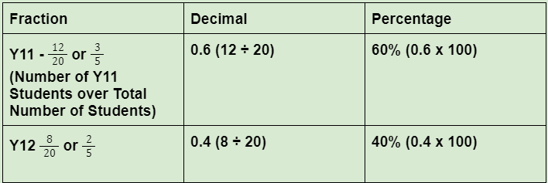
Year 12’s - 8 students

Part 1: The aim is to see what our VFest attendance breakdown was. Usining the attendance numbers complete the table below.

Festival 2024 Total Attendance- 80
Year 11’s - 25
Year 12’s - 50
Staff – 5

Fraction | Decimal | Percentage
Year 11-
Year 12-
Staff-

Part 2: Percentage increase and decrease- Review the worked example and then complete the table below.
Worked example
Excursion Participation - Percentage increase and decrease.

Total Y12 participants - 8

I want to increase this participation by 50% (work out what 50% of 8 is and then add this to the original amount)

Working out: 8 x 0.50 (50%) = 4
original amount + increase = new total 8 + 4 = 12

I want to decrease this participation by 25% (work out what 25% of 8 is and subtract this from the original amount)

Working out: 8 x 0.25 (25%) = 2
Original amount - decrease = new total 8 - 2 = 6

Festival 2025 Participation Percentage increase and decrease.

Total Y12 Participants =

- Increase your Y12 participation numbers by 30%

Working out-

- Decrease your Y12 participation numbers by 5%

Working out-

- Try these using ‘total attendance’ -
- Increase Participants by 75%

Working out-

- Decrease Participants by 25%

Working out-

Task 3 - Feedback and Assessment

Peer Feedback
Activity 3.1 | Stop watch challenge | Choose an item.
Activity 3.2 | Ordering numbers | Choose an item.
Activity 3.3 | Rounding decimal places | Choose an item.
Activity 3.4 | Fractions, decimals and percentages | Choose an item.
Peer Comment:
Name of Peer:

AoS 1 KS 2 Solve a range of practical calculations including positive and negative numbers, including rounding whole numbers and decimals up to three places.
Student Reflection - How well did you go with this step? (Please check the box below)
☐Not Submitted | ☐Beginning | ☐Consolidating | ☐Achieving | ☐Excelling
Student Comment (Optional):
Teacher Feedback
☐Not Submitted | ☐Beginning | ☐Consolidating | ☐Achieving | ☐Excelling
Not Submitted: No work has been submitted or attempted for this outcome. | Beginning: You have attempted to answer some of the questions. To bump it up, you need to complete all parts of the activity and show that you can solve calculations and round whole numbers and decimal places. | Consolidating: You have shown a basic understanding of solving problems including rounding numbers and decimals. You have shown some working out. To bump it up, check over your answers to see if they are correct and include more details of your working out. | Achieving: You have shown an understanding of solving problems including accurately rounding numbers and decimals. You have shown your workings. To bump it up, recheck your answers to make sure your answers are all correct. | Excelling: You have shown a high level of understanding of solving problems involving accurately rounding numbers and decimals. You have shown all your workings out and all your answers are correct. Great work!
Teacher Comment:

AoS 1 KS 3 Solve problems involving fractions, decimals, percentages, including calculating percentage increase and decrease.
Student Reflection - How well did you go with this step? (Please check the box below)
☐Not Submitted | ☐Beginning | ☐Consolidating | ☐Achieving | ☐Excelling
Student Comment (Optional):
Teacher Feedback
☐Not Submitted | ☐Beginning | ☐Consolidating | ☐Achieving | ☐Excelling
Not Submitted: No work has been submitted or attempted for this outcome. | Beginning: You have attempted to answer some of the questions. To bump it up, you need to complete all parts of the activity and show that you can solve problems involving fractions, decimals and percentages. | Consolidating: You have shown a basic understanding of solving problems involving fractions, decimals and percentages, including percentage increase and decrease. You have shown some working out. To bump it up, check over your answers to see if they are correct and include more details of your working out. | Achieving: You have shown an understanding of solving problems involving fractions, decimals and percentages, including percentage increase and decrease. You have shown your workings. To bump it up, recheck your answers to make sure your answers are all correct. | Excelling: You have shown a high level of understanding of solving problems involving fractions, decimals and percentages, including percentage increase and decrease. You have shown all your workings out and all your answers are correct. Great work!
Teacher Comment:

Numeracy Task 4 – Shape properties

Numeracy Context: Recreational (f)
Area of Study (AoS): 2 Shape

Key knowledge and key skills
AoS 2 KS 2 Determine reflectional and rotational symmetry and use these to manipulate shapes.
AoS 2 KS 3 Understand common angle properties in relation to two-dimensional shapes.

Task Checklist
Students will complete the following for Numeracy Context: Recreational (f)
☐ Task 4- Activity 4.1 2D shape matching
☐ Task 4- Activity 4.2 Rotational symmetry
☐ Task 4- Activity 4.3 Reflection symmetry
☐ Task 4- Activity 4.4 Design task

In this task, you will be able to identify that 2D shapes have their own patterns and properties depending on many factors, such as angle, sides, length, height, width, area, volume, etc. You will need to manipulate 2D shapes to identify their various properties and patterns.

Task 4- Shape properties Activity 4.1 2D Shape matching

Part 1: 2D shapes and 3D shapes are explained widely to make you understand the different types of objects you come across in real life. These shapes have their own pattern and properties. The shapes can vary depending on many factors, such as angle, sides, length, height, width, area, volume, etc. Match the correct properties below with the correct 2D shape.

4 equal sides.
4 equal angles (90˚).
The total angle of a circle is equal to 360˚ .
It can have no, 2 or 3 equal sides.
5 sides (can be equal or unequal).
6 sides
(can be equal or unequal).
8 sides
(can be equal or unequal).
2 sets of 2 equal angles.
All sides the same length.
2 sets of 2 equal angles.
6 sides (can be equal or unequal).
5 sides
(can be equal or unequal).
It can have no, 2 or 3 equal sides.
2 sets of 2 equal sides.
Four equal angles (90˚).
2 equal sides, 1 unequal.
No equal angles.

At least 2 parallel sides.

2D Shapes | Sides | Angles
Rectangle  Add a picture of the correct shape here. | 2 sets of 2 equal angles.
Equilateral triangle

Isosceles triangle |  | 2 sets of 2 equal angles.
Scalene Triangle | 3 unequal sides.
Circle | Circumference= π x diameter
Pentagon

Hexagon

Octagon |  | 8 angles (can be equal or unequal)
Parallelogram

Rhombus

Trapezium |  | Can have pairs of equal angles.

Task 4- Shape properties Activity 4.2 Rotational symmetry
Rotational symmetry of a shape means that when an object is rotated on its centre axis, the shape of the object can look exactly like how it looked before it was rotated. Many geometrical shapes appear to be symmetrical when they are rotated 180 degrees or with some angles, clockwise or anticlockwise.
Worked example
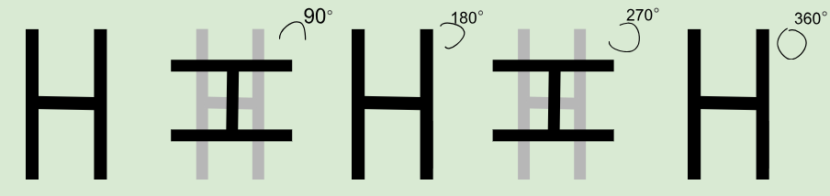
H has rotational symmetry. When you turn it 180° it looks exactly like it did originally. It has a rotational symmetry of 2 (180° and 360°).
No rotational symmetry: If a shape only has a rotational symmetry of 1(360°) we say it DOES NOT have rotational symmetry. (The hard thing to get your head around is that when a shape has more than just 360° rotational symmetry we count the 360° as being one of its rotational symmetries, but when a shape only has 360° symmetry we do not count that as being 1.)
A kite is an example of a shape with no rotational symmetry. A shape with no rotational symmetry only fits into its original outline once (360°). We can see that the only time that the kite matches its outline is when it has not been rotated.
Part 1: Complete the table below.
Shape | Does this shape have rotational symmetry? Yes/ No | Number of rotational symmetry




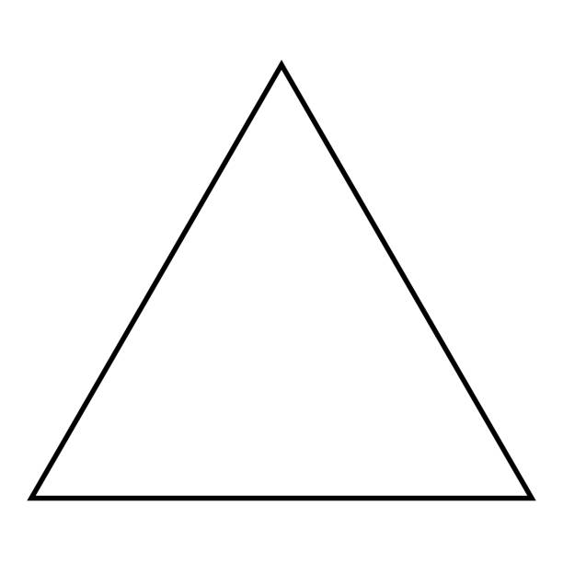
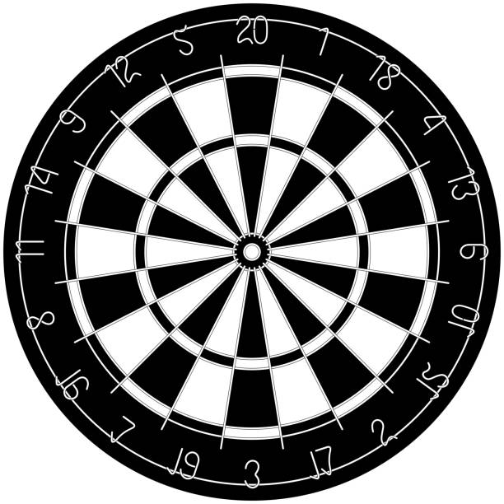


Task 4- Shape properties Activity 4.3 Reflection symmetry
Worked example
Any image is said to have reflectional symmetry if there is one or more than one line that could be drawn on the shape which would mean both sides of the line matched each other.
These letters have reflection symmetry.
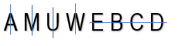
= 1 line of symmetry
A rectangle has reflection symmetry.
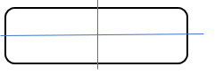
= 2 lines of symmetry
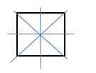
A square has reflection symmetry.
= 4 lines of symmetry
Part 1: Add the lines of symmetry to the following images and shapes.
 | 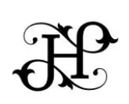 | 
Lines of reflectional symmetry | Lines of reflectional symmetry | Lines of reflectional symmetry
Add number of lines here.
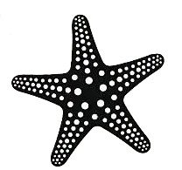 | 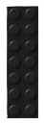 | 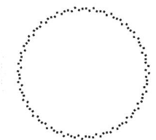
Lines of reflectional symmetry | Lines of reflectional symmetry | Lines of reflectional symmetry
Add number of lines here.
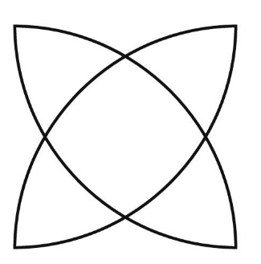 |  | 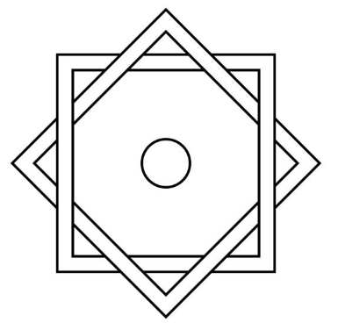
Lines of reflectional symmetry | Lines of reflectional symmetry | Lines of reflectional symmetry
Add number of lines here.

Task 4- Shape properties Activity 4.4 Design task
Part 1: A new gym is opening up across the road from the school. They want local students to come up with designs for their new logo. The design brief is to create 3 different designs with the following criteria:
1. Logo 1 needs to have horizontal or vertical symmetry
2. Logo 2 should only be made up of simple 2 dimensional shapes
3. Logo 3 needs to have rotational symmetry

Add your designs here.

Task 4 - Feedback and Assessment

Peer Feedback
Activity 4.1 | 2D Shape matching | Choose an item.
Activity 4.2 | Rotational symmetry | Choose an item.
Activity 4.3 | Reflection symmetry | Choose an item.
Activity 4.4 | Design task | Choose an item.
Peer Comment:

Name of Peer:

AoS 2 KS 2 Determine reflectional and rotational symmetry and use these to manipulate shapes.
Student Reflection - How well did you go with this step? (Please check the box below)
☐Not Submitted | ☐Beginning | ☐Consolidating | ☐Achieving | ☐Excelling
Student Comment (Optional):
Teacher Feedback
☐Not Submitted | ☐Beginning | ☐Consolidating | ☐Achieving | ☐Excelling
Not Submitted: No work has been submitted or attempted for this outcome. | Beginning: You have attempted to answer some of the questions. To bump it up, you need to complete all parts of the activity and show that you can determine reflectional and rotational symmetry and use these to manipulate shapes. | Consolidating: You have shown a basic ability to determine reflectional and rotational symmetry and use these to manipulate shapes. To bump it up, check over your answers to see if they are correct and make sure all parts of each question are answered. | Achieving: You have shown an ability to determine reflectional and rotational symmetry and use these to manipulate shapes. To bump it up, recheck your answers to make sure your answers are all correct. | Excelling: You have shown a high ability to determine reflectional and rotational symmetry and use these to manipulate shapes. You have included great detail in your answers and all answers are correct. Great work!
Teacher Comment:

AoS 2 KS 3 Understand common angle properties in relation to two-dimensional shapes.
Student Reflection - How well did you go with this step? (Please check the box below)
☐Not Submitted | ☐Beginning | ☐Consolidating | ☐Achieving | ☐Excelling
Student Comment (Optional):
Teacher Feedback
☐Not Submitted | ☐Beginning | ☐Consolidating | ☐Achieving | ☐Excelling
Not Submitted: No work has been submitted or attempted for this outcome. | Beginning: You have attempted to answer some of the questions. To bump it up, you need to complete all parts of the activity and show that you understand common angle properties in relation to 2D shapes. | Consolidating: You have shown a basic understanding of common angle properties in relation to 2D shapes. To bump it up, check over your answers to see if they are correct and make sure all parts of each question are answered. | Achieving: You have shown an ability to understand angle properties in relation to 2D shapes. To bump it up, recheck your answers to make sure your answers are all correct. | Excelling: You have shown a high level of understanding of angle properties in relation to 2D shapes. You have included great detail in your answers and all answers are correct. Great work!
Teacher Comment:

Numeracy Task 5- Shapes in recreational settings

Numeracy Context: Recreational (f)
Area of Study (AoS): 2 Shape

Key knowledge and key skills
AoS 2 KS 1 Describe and classify a range of different two-dimensional shapes and three-dimensional objects
AoS KS 4 Use ideas of congruence and self-similarity
AoS 2 KS 6 Determine, name and describe patterns according to different properties of shapes such as those found in engineering, architecture and design, for example, bridges, buildings, and sculptures.

Task Checklist
☐ Task 5- Activity 5.1 Identifying shapes in recreational settings
☐ Task 5- Activity 5.2 Identifying shapes in architecture

Task 5- Shapes in recreational settings 5.1 Identifying shapes in recreational settings

Shapes are in buildings and structures all around. You need to identify and name a range of 2D and 3D shapes that make up a space. Often the space will dictate the type of shapes you will see.

Congruent shapes are exactly the same shape and size, corresponding sides and angles are the same.
Similar shapes are the same shape but are a different size, corresponding sides are in the same ratio (not same length) and angles will be the same

Worked example

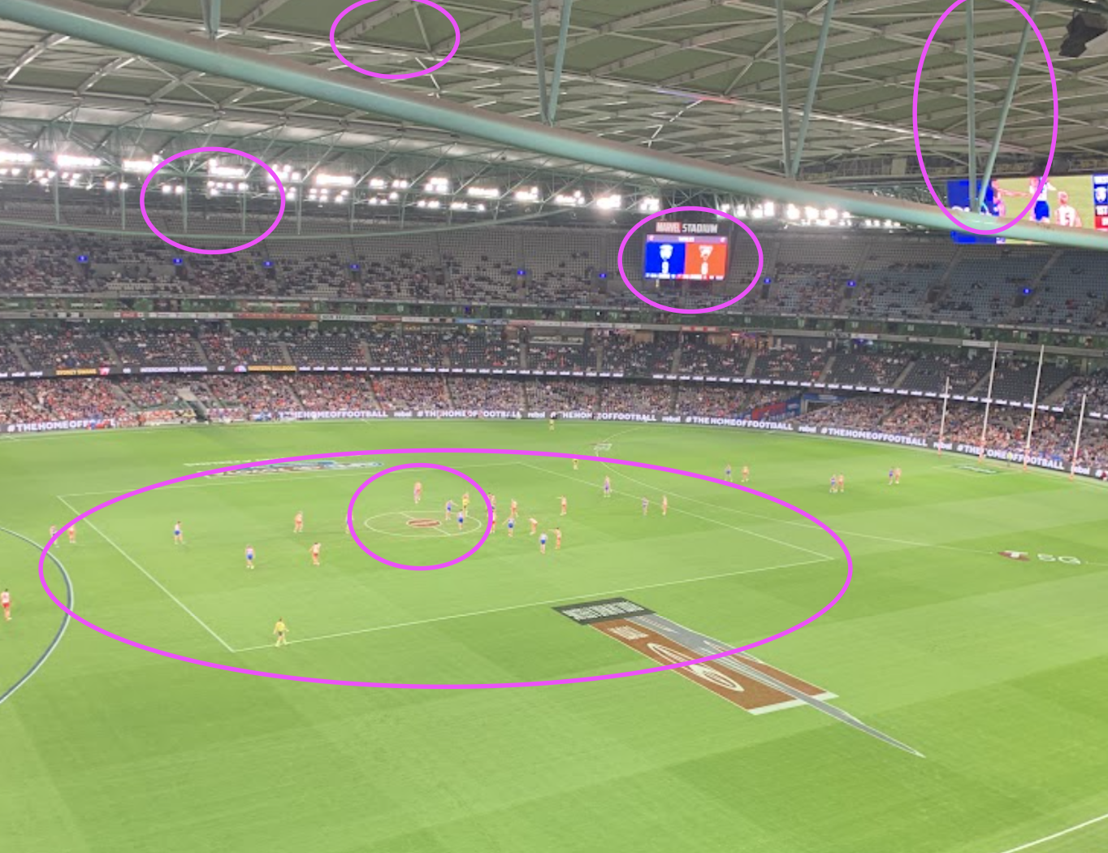
- Screen - Rectangle
- Roof Support- Triangle
- Centre Circle - Circle
- Centre square - Square

Congruent Shapes - Triangle roof support structures.
Similar Shapes - Rectangular scoreboard and rectangular field advertisement.

Teacher advice- you can add in specific recreational settings that you want your students to analyse here.

Part 1: Name and circle a minimum of 10 objects in each setting which are 2D and 3D shapes. Then identify and label examples of congruent and similar shapes.

Recreational (Board games eg chess, sports courts, community recreational areas, gyms.)

Add image of your recreational setting here.

List the shapes you can see in the photo that you have taken (2D and 3D shapes).

Identify and label examples of congruent and similar shapes:

Part 2: Scenario: ‘You are about to redesign your living room. Before starting, you gather inspiration by researching and exploring various living room designs. You are focussed particularly on the different shapes and how each element fits within the space.’

Add image of your living room image here.

List the shapes you can see in the photo that you have taken (2D and 3D shapes).

Identify and label examples of congruent and similar shapes:

Task 5- Shapes in recreational settings 5.2 Identifying shapes in architecture

 Part 1: Many shapes make up structural elements in buildings and architecture. Research some of the most common shapes that occur in structural elements. Select and find an example of one in your everyday life. Example- The Geelong Regional Library is a dome with an outer shell made of hexagons.

Structural element:

Add image here.

Is this shape congruent or similar? Explain.

Part 2: Self-similarity can be found in architecture and nature where small pieces of the shape replicate the whole shape. Research and give examples found in nature of self similarity.
Natural element:

Add image here.

Why do you consider this to be an example of self-similarity? Explain.

Task 5 - Feedback and Assessment
Peer Feedback
Activity 5.1 | Identifying shapes in recreational settings. | Choose an item.
Activity 5.2 | Identifying shapes in architectural settings | Choose an item.
Peer Comment:

Name of Peer:

AoS 2 KS 1 Describe and classify a range of different two-dimensional shapes and three-dimensional objects.
Student Reflection - How well did you go with this step? (Please check the box below)
☐Not Submitted | ☐Beginning | ☐Consolidating | ☐Achieving | ☐Excelling
Student Comment (Optional):
Teacher Feedback
☐Not Submitted | ☐Beginning | ☐Consolidating | ☐Achieving | ☐Excelling
Not Submitted: No work has been submitted or attempted for this outcome. | Beginning: You have attempted to answer some of the questions. To bump it up, you need to complete all parts of the activity and show that you can describe and classify a range of 2D and 3D shapes and objects. | Consolidating: You have shown a basic understanding of classifying and describing 2D and 3D shapes and objects. To bump it up, check over your answers to see if they are correct and include more details of your working out. | Achieving: You have shown an understanding of classifying and describing 2D and 3D shapes and objects. You have shown your workings. To bump it up, recheck your answers to make sure your answers are all correct. | Excelling: You have shown a high level of understanding of describing and classifying a range of 2D and 3D shapes and objects. You have shown all your workings out and all your answers are correct. Great work!
Teacher Comment:

AoS 2 KS 4 Use ideas of congruence and self-similarity.
Student Reflection - How well did you go with this step? (Please check the box below)
☐Not Submitted | ☐Beginning | ☐Consolidating | ☐Achieving | ☐Excelling
Student Comment (Optional):
Teacher Feedback
☐Not Submitted | ☐Beginning | ☐Consolidating | ☐Achieving | ☐Excelling
Not Submitted: No work has been submitted or attempted for this outcome. | Beginning: You have attempted to answer some of the questions. To bump it up, you need to complete all parts of the activity and show that you understand the ideas of congruence and self-similarity. | Consolidating: You have shown a basic understanding of congruence and self-similarity. To bump it up, check over your answers to see if they are correct. | Achieving: You have shown an understanding of congruence and self-similarity. You have shown your workings. To bump it up, recheck your answers to make sure your answers are all correct. | Excelling: You have shown a high level of understanding of congruence and self-similarity. All your answers are correct. Great work!
Teacher Comment:

AoS 2 KS 6 Determine, name and describe patterns according to different properties of shapes such as those found in engineering, architecture and design, for example, bridges, buildings, and sculptures.
Student Reflection - How well did you go with this step? (Please check the box below)
☐Not Submitted | ☐Beginning | ☐Consolidating | ☐Achieving | ☐Excelling
Student Comment (Optional):
Teacher Feedback
☐Not Submitted | ☐Beginning | ☐Consolidating | ☐Achieving | ☐Excelling
Not Submitted: No work has been submitted or attempted for this outcome. | Beginning: You have attempted to answer some of the questions. To bump it up, you need to complete all parts of the activity and show that you can determine, name and describe patterns according to different properties of shape. | Consolidating: You have shown a basic ability to determine, name and describe patterns according to different properties of shape. To bump it up, check over your answers to see if they are correct. | Achieving: You have shown an ability to determine, name and describe patterns according to different properties of shape. To bump it up, recheck your answers to make sure your answers are all correct. | Excelling: You have shown a high level of ability to determine, name and describe patterns according to different properties of shape. All your answers are correct. Great work!
Teacher Comment:

Numeracy Task 6 Shapes and area planning

Numeracy Context: Recreational (f)
Area of Study (AoS): 2 Shape and 3 Quantity and measures

Key knowledge and key skills
AoS 2 KS 2 undertake calculations and determine measurements of distance, perimeter, area, volume and capacity for routine, more complex two-dimensional shapes and three-dimensional objects including compound shapes, for example the use of pi in circular measurements.
AoS 2 KS 4 use ideas of congruence and self-similarity.
AoS 2 KS 5 Create compound two-dimensional shapes and three-dimensional objects and describe the relationship between these, including through the use of technology.
AoS 3 KS 2 Undertake calculations and determine measurements of distance, perimeter, area, volume and capacity for routine, more complex two-dimensional shapes and three-dimensional objects including compound shapes, for example the use of pi in circular measurements.

Task Checklist
Students will complete the following for Numeracy Context: Recreational (f)
☐ Task 6- Activity 6.1 Outdoor festival space
☐ Task 6- Activity 6.2 Sports and athletics hub
☐ Task 6- Activity 6.3 Manipulating space

In this task, you will need to navigate technology to create a floor plan containing 2D and 3D shapes. You will need to use an interactive website to create a two and three-dimensional space

Task 6- Shapes and area planning Activity 6.1 Outdoor festival planning
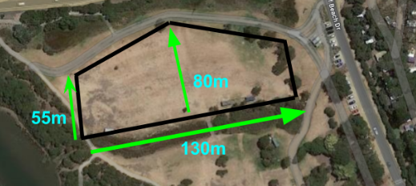
Part 1: You are the organiser of a popular outdoor summer festival and have been given this public space to use.

Worked example
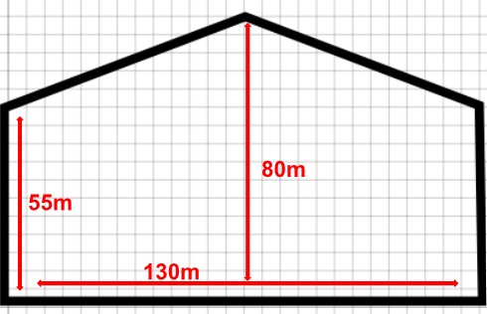
Outdoor Festival Space
(Smartdraw)

 Create the festival space using one of these free interior decorating websites:
https://floorplanner.com/
https://www.smartdraw.com/
https://www.sketchup.com/
Scenario/Space:

Add image here.
Calculate the total area of the festival space. (The space is a composite shape so we must calculate the area of each of the shapes inside the space and then add them together for the total).
Area of a Rectangle Formula = L x W
_______ X _______
=________m2

Area of a Triangle Formula = ½ B x H
_______X________
=________m2
Total area of festival space: ______________m2
10% of this space needs to be left empty so people can move around freely. Calculate your space's total area and then available area by subtracting 10 percent:

Total Area of shape in m²:________________

10% of the total area of shape which needs to be empty =________

Total area available for adding furnishings=___________m²

Task 6- Shapes and area planning Activity 6.2 Sports and athletics hub
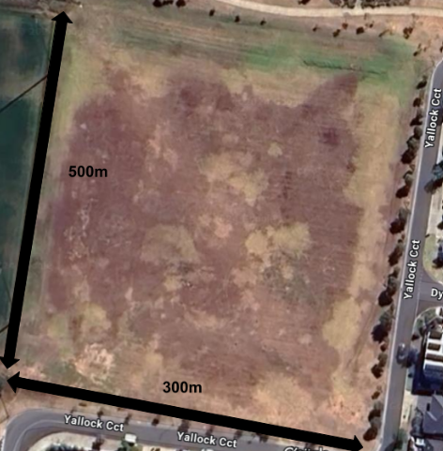
Part 1: You have been asked to design a sports and athletics hub in the space provided which anyone can use recreationally.

Calculate the total area of the provided space. 10% of this total area needs to be left empty so people can move freely and safely around the sports hub.

Total area of space:________________m2.
Working out-
10% (Total area x0.1) =__________m2.
Working out-
Total area available for sports and athletics fields=___________m²
Working out-

Task 6- Shapes and area planning Activity 6.3 Manipulating space

Part 1: Using the interior decorating software create a sports hub that maximized the available space. Use the shapes below to fill in your space. You must use at least one of each shape. You do not need to worry about additing sports field details in just add the relevant shapes from the table below.
Rectangular soccer fields  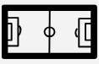  W =50m L = 100m  Triangular discuss field    B = 50m H = 50m  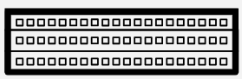  Rectangular Tiered Stadium Seating  W=15m L= 40m |   Circular cricket oval  Radius = 40m  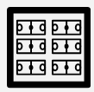  Square basketball and netball area  Side = 60m
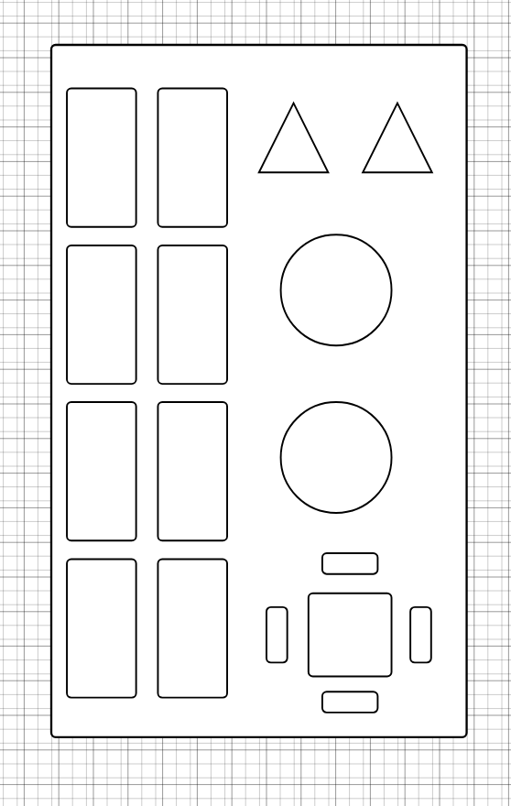
Worked example

Free interior decorating websites:
https://floorplanner.com/
https://www.smartdraw.com/
https://www.sketchup.com/
Add your sketch here.

Part 2: Complete the table below.

No. of Soccer fields used_______. Area of one rectangle ______________
Total area of all Rectangles_________m²
Working out:

No. of Discuss fields used_______. Area of one triangle______________
Total area of all Triangles_________m²
Working out:

No. of Basketball and Netball fields used_______. Total area of all Squares_________m²
Working out:

No. of Cricket pitches used_______. Area of one circle______________________
Total area of all Circles_________m²
Working out:

No. of Stadium seating used_______. Area of one circle______________________
Total area of all Circles_________m²
Working out:

Total amount of area used_____________m² of ________________m² Available Space.
Working out:

Task 6 - Feedback and Assessment
Peer Feedback
Activity 6.1 | Outdoor festival space | Choose an item.
Activity 6.2 | Sports and athletics hub | Choose an item.
Activity 6.3 | Manipulating space | Choose an item.
Peer Comment:

Name of Peer:

AoS 2 KS 2 undertake calculations and determine measurements of distance, perimeter, area, volume and capacity for routine, more complex two-dimensional shapes and three-dimensional objects including compound shapes, for example the use of pi in circular measurements.
Student Reflection - How well did you go with this step? (Please check the box below)
☐Not Submitted | ☐Beginning | ☐Consolidating | ☐Achieving | ☐Excelling
Student Comment (Optional):
Teacher Feedback
☐Not Submitted | ☐Beginning | ☐Consolidating | ☐Achieving | ☐Excelling
Not Submitted: No work has been submitted or attempted for this outcome. | Beginning: You have attempted to answer some of the questions. To bump it up, you need to complete all parts of the activity and show that you can calculate and determine measurements of distance, perimeter, area, volume and capacity. | Consolidating: You have shown a basic ability to calculate and determine measurements of distance, perimeter, area, volume and capacity. To bump it up, check over your answers to see if they are correct and include more details of your working out. | Achieving: You have shown an ability to calculate and determine measurements of distance, perimeter, area, volume and capacity. You have shown your workings. To bump it up, recheck your answers to make sure your answers are all correct. | Excelling: You have shown a high ability to calculate and determine measurements of distance, perimeter, area, volume and capacity. You have shown all your workings out and all your answers are correct. Great work!
Teacher Comment:

AoS 2 KS 4 Use ideas of congruence and self-similarity.
Student Reflection - How well did you go with this step? (Please check the box below)
☐Not Submitted | ☐Beginning | ☐Consolidating | ☐Achieving | ☐Excelling
Student Comment (Optional):
Teacher Feedback
☐Not Submitted | ☐Beginning | ☐Consolidating | ☐Achieving | ☐Excelling
Not Submitted: No work has been submitted or attempted for this outcome. | Beginning: You have attempted to answer some of the questions. To bump it up, you need to complete all parts of the activity and show that you understand the ideas of congruence and self-similarity. | Consolidating: You have shown a basic understanding of congruence and self-similarity. To bump it up, check over your answers to see if they are correct. | Achieving: You have shown an understanding of congruence and self-similarity. You have shown your workings. To bump it up, recheck your answers to make sure your answers are all correct. | Excelling: You have shown a high level of understanding of congruence and self-similarity. All your answers are correct. Great work!
Teacher Comment:

AoS 2 KS 5 Create compound two-dimensional shapes and three-dimensional objects and describe the relationship between these, including through the use of technology.
Student Reflection - How well did you go with this step? (Please check the box below)
☐Not Submitted | ☐Beginning | ☐Consolidating | ☐Achieving | ☐Excelling
Student Comment (Optional):
Teacher Feedback
☐Not Submitted | ☐Beginning | ☐Consolidating | ☐Achieving | ☐Excelling
Not Submitted: No work has been submitted or attempted for this outcome. | Beginning: You have attempted to create a floor plan of a space using an interior decorating website. To bump it up, you need to complete all parts of the activity and show that you can create compound 2D and 3D shapes and objects in your space. | Consolidating: You have shown a basic ability to create a floor plan using compound 2D and 3D shapes and objects. To bump it up, add more details and make sure that all elements are labelled on your floor plan. | Achieving: You were able to create an accurate 2D and 3D representation of a floor plan and show various ways of manipulating space. To bump it up, add more information and label all elements of the floor plan. | Excelling: You were able to create an accurate 2D and 3D representation of a floor plan, identify different shapes within a space and show the ability to manipulate space in a variety of ways. Well done!
Teacher Comment:

Numeracy Task 7 How far, how much and how big?

Numeracy Context: Vocational (e)
Area of Study (AoS): 3 Quantity and measure

Key knowledge and key skills
AoS 3 KS 1 Estimate and measure objects and distances by using measurement tools with appropriate accuracy and tolerance.
AoS 3 KS 2 Undertake calculations and determine measurements of distance, perimeter, area, volume and capacity for routine, more complex two-dimensional shapes and three-dimensional objects including compound shapes, for example, the use of pi in circular measurements.

Task Checklist
Students will complete the following for Numeracy Context: Vocational (e)
☐ Task 7 Activity 7.1 Collecting data
☐ Task 7 Activity 7.2 Building dimensions estimates
☐ Task 7 Activity 7.3 Measuring Lasertec tool
☐ Task 7 Activity 7.4 Measuring using a measuring tape
☐ Task 7 Activity 7.5 Perimeter and area
☐ Task 7 Activity 7.6 Volume and capacity
☐ Task 7 Activity 7.7 Compound shapes

At the end of this task, you will be able to estimate and measure distances using measurement tools and undertake a range of calculations to determine perimeter, area, volume and capacity. Your calculations will need to be applied to your Structured Work Placement business and/or other local businesses.

Task 7- How far, how much and how big? Activity 7.1 Collecting data

Part 1: Determine the distance and travel time from your home to your current SWL (Structured Workplace Learning) or workplace. Use a technology tool such as Google Maps, Strava, or a timer to find out the distance and the time it takes to get there (driving). Enter your data below.
Destination

Distance (Km)
Time taken (Minutes)

Part 2: What about these destinations if you are driving?

Destination: MCG

Distance (Km)

Time Taken (Minutes)

Destination: Cumberland River

Distance (Km)
Time Taken (Minutes)

Task 7- How far, how much and how big? Activity 7.2 Building dimension estimates

Part 1: Estimating only, record your estimates for the following below.
Worked example
School Canteen

Length: 10m or 1000cm

Width: 5m or 500cm

Height (ceiling): 3m or 300cm

1.The room you are currently working in.
Name of room:

Length:

Width:

Height (ceiling):

2.Local business/gym activity that you visit regularly.
Name of business:

Length:

Width:

Height (ceiling):

3.Your workplace or a place you would like to work.
Name of workplace:

Length:

Width:

Height (ceiling):

Task 7- How far, how much and how big? Activity 7.3 Measuring using a Lasertec Tool (Laser measuring device)
Part 1: Rotate the lasertec tool through each gym activity, business and workplace visit so dimensions of all buildings are recorded. Add your recorded measurements in the tables below.
1.The room you are currently working in.
Name of room:

Length:

Width:

Height (ceiling):

Add images of your space here.

2.Local business/gym activity that you visit regularly.
Name of business:

Length:

Width:

Height (ceiling):

Add images of your space here.

3.Your workplace or a place you would like to work.
Name of workplace:

Length:

Width:

Height (ceiling):

Add images of your space here.

Task 7- How far, how much and how big? 7.4 Measuring using a measuring tape
Part 1: Measure the following items with a measuring tape.
1.VCE VM fridge
Length:

Width:

Height:

Add images of your space here.

2.VCE VM door way
Width:

Height:

Add images of your space here.

Task 7- How far, how much and how big? 7.5 Perimeter and area
Part 1: Now you have some accurate measurements from Task 7 Activity 7.3 and 7.4 you will use those measurments to find the perimeter of following spaces below.
Worked example
Perimeter = distance around the outside of the shape/object
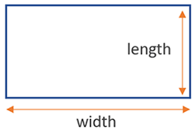
Table:
length 2m
width 1m

2m + 1m + 2m + 1m = 6m
The perimeter of the table is 6m

1.Perimetre of the VCE VM door way
Working out:

2.Perimetre of gym/local business you chose to measure.
Name of place:

Working out:

Part 2: Again using your accurate measurements use these to find the area of the following spaces below.

Worked example
Area = the size of the surface within the shape/object

Table:
length 2m
width 1m

Area of rectangle = Length x Width

2m x 1m = 2m²

*Remember the squared sign to show we are talking about the surface space of the table.

1.Area of the VCE VM door way
Working out:

2.Area of gym/local business you chose to measure.
Name of place:

Working out:

Task 7- How far, how much and how big? 7.6 Volume and capacity
Part 1: Again, using your accurate measurements, use these to find the volume and capacity for the following below.
Worked example
Volume = the amount of space contained in a 3-dimensional shape/object
Capacity = the amount of liquid, gas, solid that space could hold or contain

Milk carton in our fridge:
length 10cm
width 5cm
Height 20cm

Volume of cuboid = Length x Width x Height
10 x 5 x 20 = 1000cm³

*Remember the cubed sign to show we are talking about the 3D space within the carton!

1.Volume of the VCE VM fridge.
Working out:

2.Volume of the room you are currently working in (measurements from Task 7 Activity 7.2).

Task 7- How far, how much and how big? 7.7 Compound shapes
Part 1: Challenge Problem- Discuss with your teacher and choose a space that challenges you. Find the overall area measurement of the space. Then you will need to remove any compound shapes from the area.
Some examples could be:
- The surface area of the wall minus windows
- The surface area of available gym floor space minus gym equipment.
- The surface area of an open planned office- desk space only.

Hint compound shapes- Think rectangles, squares, circles, 2D and 3D.

Working out:

Add images of your space here.

Task 7 - Feedback and Assessment
Peer Feedback
Activity 7.1 | Collecting data | Choose an item.
Activity 7.2 | Building dimension estimates | Choose an item.
Activity 7.3 | Measuring using Lasertec Tool | Choose an item.
Activity 7.4 | Measuring using a measuring tape | Choose an item.
Activity 7.5 | Perimeter and area | Choose an item.
Activity 7.6 | Volume and capacity | Choose an item.
Activity 7.7 | Compound shapes | Choose an item.
Peer Comment:

Name of Peer:

AoS 2 KS 1 Estimate and measure objects and distances by using measurement tools with appropriate accuracy and tolerance.
Student Reflection - How well did you go with this step? (Please check the box below)
☐Not Submitted | ☐Beginning | ☐Consolidating | ☐Achieving | ☐Excelling
Student Comment (Optional):
Teacher Feedback
☐Not Submitted | ☐Beginning | ☐Consolidating | ☐Achieving | ☐Excelling
Not Submitted: No work has been submitted or attempted for this outcome. | Beginning: You have attempted to answer some of the questions. To bump it up, you need to complete all parts of the activity and show that you can estimate and measure objects and distances. | Consolidating: You have shown a basic ability to estimate and measure objects and distances by using measurement tools. You have shown some working out. To bump it up, check over your answers to see if they are correct and include more details of your working out. | Achieving: You have shown an ability to estimate and measure objects and distances by using measurement tools with appropriate accuracy and tolerance. You have shown your workings. To bump it up, recheck your answers to make sure your answers are all correct. | Excelling: You have shown a high ability to estimate and measure objects and distances by using measurement tools with appropriate accuracy and tolerance. You have shown all your workings out and all your answers are correct. Great work!
Teacher Comment:

AoS 2 KS 2 undertake calculations and determine measurements of distance, perimeter, area, volume and capacity for routine, more complex two-dimensional shapes and three-dimensional objects including compound shapes, for example, the use of pi in circular measurements.
Student Reflection - How well did you go with this step? (Please check the box below)
☐Not Submitted | ☐Beginning | ☐Consolidating | ☐Achieving | ☐Excelling
Student Comment (Optional):
Teacher Feedback
☐Not Submitted | ☐Beginning | ☐Consolidating | ☐Achieving | ☐Excelling
Not Submitted: No work has been submitted or attempted for this outcome. | Beginning: You have attempted to answer some of the questions. To bump it up, you need to complete all parts of the activity and show that you can calculate and determine measurements of distance, perimeter, area, volume and capacity. | Consolidating: You have shown a basic ability to calculate and determine measurements of distance, perimeter, area, volume and capacity. To bump it up, check over your answers to see if they are correct and include more details of your working out. | Achieving: You have shown an ability to calculate and determine measurements of distance, perimeter, area, volume and capacity. You have shown your workings. To bump it up, recheck your answers to make sure your answers are all correct. | Excelling: You have shown a high ability to calculate and determine measurements of distance, perimeter, area, volume and capacity. You have shown all your workings out and all your answers are correct. Great work!
Teacher Comment:

Numeracy Task 8 How much is that?

Numeracy Context: Health (d)
Area of Study (AoS): 3 Quantity and measures

Key knowledge and key skills
AoS 2 KS 3 Convert between both metric and non-metric units where relevant such as cm/inch, Celsius/Fahrenheit, and grams/pounds
AoS 2 KS 5 Read, interpret and calculate temperature measurements

Task Checklist
Students will complete the following for Numeracy Context: Health (d)
☐ Task 8- Activity 8.1 Collecting data
☐ Task 8- Activity 8.2 Converting measurements (centimetres and inches)
☐ Task 8- Activity 8.3 Converting measurements (kilograms and pounds)
☐ Task 8- Activity 8.4 Converting measurements (celsius to fahrenheit)

In this task, you will be able to convert different types of measurements. You will need to record a range of weights, distances and temperatures.

Task 8- How much is that? 8.1 Collecting data
Part 1: When walking to and of our VCE VM program activities or getting to your SWL (anywhere that you walk) use a piece of technology to find out the distance it is to your location and also how long it takes. Eg. Garmin Connect, Stravia, Google Maps, timer. Enter your data below.
Destination

Distance (Km)
Time Taken (Minutes)

Part 2: Using the measurements you have just collected in part 1, use the appropriate formula to convert the measurements from metric to non-metric below. Make sure you show your working out.

Worked example

Kilometres to miles

1 km = 0.62 miles

Formula: number of km x 0.62 = number of miles

Working out: 1 x 0.62 = 0.62 miles

1.School to SWL / work placement

___km = ___ Miles:

Formula: number of km x 0.62 = number of miles

Working out:

2.School to McDonald's

2.4 km = ___ Miles

Formula:

Working out:

3. School to Melbourne

___ km = ___ Miles

Formula:

Working out:

Worked example

Miles to kilometres
1 mile = 1.609 km
Formula: Number of miles x 1.609 = number of kilometres

Working out: 1 x 1.609= 1.609km

4.Adelaide to Portland
334 Miles = ____ km

Formula:

Working out:

Task 8- How much is that? Activity 8.2 Converting measurements (centrimetres and inches)
Part 1: Converting Measurements (centimetres to inches)- Use the appropriate formula to convert these measurements from metric to non-metric. Make sure you show your working out.
Worked example
Centimetres to inches

Centimeter: 1 = Inch: 0.39

1 cm = 0.39 inches
Formula: number of cm x 0.39 = number of inches

Working out: 1 x 0.39 = 0.39 inches

1.Your height- cm to inches

___ cm = ___ inches:

Formula:

Working out:

2.Spinal cord- usually approximately 45cm long.

45 cm = ___ Inches:

Formula:

Working out:

 Part 2: Converting Measurements (inches to centimetres)- Use the appropriate formula to convert these measurements from non-metric to metric. Make sure you show your working out on the tables below.
Worked example
Inches to centimetres
1 inch = 2.54cm
Formula: Number of inches x 2.54 = number of centimetres

Working out: 1 x 2.54= 2.54cm

1.Which TV?
A hospital needs to purchase televisions for waiting areas and patients rooms. Think about the size of screens required for different purposes in the hospital.
Discuss and share your answer answer with a peer.
Television screens are measured in inches. Find 3 different size TV screens from one retailer and fill out the table.
Brand | Size in inches | Size in centimetres | Retailer | Cost

2. Repeat the activity with a different retailer choosing the same brand and size of TV screens and fill out the table.
Brand | Size in inches | Size in centimetres | Retailer | Cost

3. Repeat the activity with a third retailer choosing the same brand and size of TV screens and fill out the table.
Brand | Size in inches | Size in centimetres | Retailer | Cost
4.Choose which TV screen size and which retailer it is from, for the hospital waiting area. Explain your answer.
5.Choose which TV screen size and which retailer it is from, for the patient's rooms. Explain your answer.

Task 8- How much is that? Activity 8.3 Converting measurements (kilograms and pounds)

Part 1: Converting Measurements (kilograms to pounds)- Use the appropriate formula to convert these measurements from metric to non-metric. Make sure you show your working out.
Worked example
Kilograms to pounds

1 kg = 2.2 pounds
Formula: number of kg x 2.2 = number of pounds

Working out: 1 x 2.2 = 2.2 pounds

1.10kg child to pounds

10kg = ___ pounds

Formula:

Working out:

2.50kg shipment of stock to pounds

50kg = ___ pounds

Formula:

Working out:

Task 8- How much is that? Activity 8.4 Converting measurements (celsius to fahrenheit)
Part 1: Converting Measurements (celsius to Fahrenheit)- Use the appropriate formula to convert these measurements from metric to non-metric. Make sure you show your working out.
Worked example
Celsius to Fahrenheit
Celsius: 1 = Fahrenheit: 33.8

1 degree celsius = 33.8 degrees fahrenheit

Formula: Celsius (c) x 33.8 (fahrenheit)

Number of degrees Celsius x 33.8 = number of degrees Fahrenheit

Working out: 1 x 33.8 = 33.8 fahrenheit)

1. Normal Body temp of 37 degrees Celsius to Fahrenheit.

Celsius: 37 = ___ fahrenheit:

Formula:

Working out:

2. Today’s weather Temperature: celsius to Fahrenheit.

Celsius: 37 = ___ fahrenheit:

Formula:

Working out:

Part 2: Research the 7 day weather forecast for your location. Add the image of your 7 day weather forecast in the space below.
Add 7 day weather forecast here.

Part 3: Read and interpret temperature measurements - Use your weekly weather forecast from part 2 to answer the following prompts in the space below.

Weeks maximum temperature is:
Weeks minimum temperature is:
What is the temperature difference between the max and min:
What is the day time temperature range for the week:
Using your own weather app, what is the max temp for today (included ate):
What is the boiling point temperature of water:
What is the freezing point temperature of water:

Task 8 - Feedback and Assessment
Peer Feedback
Activity 8.1 | Collect data | Choose an item.
Activity 8.2 | Converting measurements (centimetres and inches) | Choose an item.
Activity 8.3 | Converting measurements (kilograms and pounds) | Choose an item.
Activity 8.4 | Converting measurements (Celsius to fahrenheit) | Choose an item.
Peer Comment:

Name of Peer:

AoS 2 KS 3 Convert between both metric and non-metric units where relevant such as cm/inch, Celsius/Fahrenheit, and grams/pounds.
Student Reflection - How well did you go with this step? (Please check the box below)
☐Not Submitted | ☐Beginning | ☐Consolidating | ☐Achieving | ☐Excelling
Student Comment (Optional):
Teacher Feedback
☐Not Submitted | ☐Beginning | ☐Consolidating | ☐Achieving | ☐Excelling
Not Submitted: No work has been submitted or attempted for this outcome. | Beginning: You have attempted to answer some of the questions. To bump it up, you need to complete all parts of the activity and show that you can convert between both metric and non-metric units. | Consolidating: You have shown a basic ability to convert between both metric and non-metric units. You have shown some working out. To bump it up, check over your answers to see if they are correct and include more details of your working out. | Achieving: You have shown an ability to convert between both metric and non-metric units. You have shown your workings. To bump it up, recheck your answers to make sure your answers are all correct. | Excelling: You have shown a high ability to convert between both metric and non-metric units. You have shown all your workings out and all your answers are correct. Great work!
Teacher Comment:

AoS 2 KS 5 Read, interpret and calculate temperature measurements.
Student Reflection - How well did you go with this step? (Please check the box below)
☐Not Submitted | ☐Beginning | ☐Consolidating | ☐Achieving | ☐Excelling
Student Comment (Optional):
Teacher Feedback
☐Not Submitted | ☐Beginning | ☐Consolidating | ☐Achieving | ☐Excelling
Not Submitted: No work has been submitted or attempted for this outcome. | Beginning: You have attempted to answer some of the questions. To bump it up, you need to complete all parts of the activity and show that you can read, interpret and calculate temperature measurements. | Consolidating: You have shown a basic ability to read, interpret and calculate temperature measurements.  You have shown some working out. To bump it up, check over your answers to see if they are correct and include more details of your working out. | Achieving: You have shown an ability to read, interpret and calculate temperature measurements. You have shown your workings. To bump it up, recheck your answers to make sure your answers are all correct. | Excelling: You have shown a high ability to read, interpret and calculate temperature measurements. You have shown all your workings out and all your answers are correct. Great work!
Teacher Comment:

Numeracy Task 9 Life logbook

Numeracy Context: Health (d)
Area of Study (AoS): 3 Quantity and measures

Key knowledge and key skills
AoS 3 KS 6 performs calculations using multiple units of time, calculate time durations, including the use of calendar months, weeks, days, as well as hours, minutes, and seconds.

Task Checklist
Students will complete the following for Numeracy Context: Health (d)
☐ Task 9- Activity 9.1 What activities do I do?
☐ Task 9- Activity 9.2 Monthly planner

In this task you will need to use technology to calculate time durations in a calendar month. You will create a month long ‘life logbook’ to identify time spent on a range of activities with a focus on creating a healthy work life balance.

Task 9- Life logbook Activity 9.1 What activities do I do?

Scenario: You are an entrepreneur and starting your own business. You are in the start-up phase, but you recognise work-life balance to be important. You want to make a plan so that you can put maximum time and effort into the business but also have time for the other things that are important to you.
Part 1: What do I need to consider? To maintain a healthy balance between work and life, it is important to schedule your hobbies, things to maintain your health and well-being, socialising, family commitments, sports etc. Other than work, make a list of things that are important for you to maintain within your schedule.
Add your list here.

Part 2: Approximate - How much time do I need to allocate to different aspects of my life in the table below? As a start-up business, you have decided to allocate 40 hours per week for work.
Health, wellbeing and mindfulness
Sport and Recreation
Social Activities
Family
Hobbies
Other

Part 3: Plan- How does this look in a week? Create your ideal weekly planner in the template below. Remember to include 40 hours of work. You can allocate this wherever and however you want.
Make sure you consider the following and add them to the calendar.
☐ Work
☐ Health / Wellbeing / Mindfulness
☐ Sport / Fitness & Recreation
☐ Social Activities
☐ Family
☐ Hobbies
☐ Appointments
☐ Birthdays
☐ Lunch breaks
☐ Breaks - including movement breaks
☐ Other

Times | Monday | Tuesday | Wednesday | Thursday | Friday | Saturday | Sunday
5-6am
6-7am
7-8am
8-9am
9-10am
10-11am
11-12pm

12-1pm
1-2pm
2-3pm
3-4pm
4-5pm
5-6pm
6-7pm
7-8pm
8-9pm
9-10pm
10-11pm

11-12am

Part 4: Organise a visual representation- Colour coding can be an easy way to help visualise your schedule. On the schedule above in part 3, colour code each of the different activities in different colours.
☐ Each activity has been colour-coded in the schedule above.

Part 5: Reflection - Have a look at your schedule, are you happy with how you have allocated your time? If you think adjustments could be made, please make these adjustments then response to the questions below.
1.Did you require to make any adjustments to your schedule? If yes, explain what adjustments you made.

2.Justify why you have made the choices to your schedule that you did. Explain at least 3 of your choices. Hint-This could include why you have allocated the specific hours you have to each activity, what times you have allocated to each of the activities, breaks etc.

Task 9- Life logbook Activity 9.2 Monthly planner
Part 1: Create a monthly planner. Use the weekly schedule that you have created and plan out your month. You can research examples online and you can find monthly templates on Canva.

Add your completed monthly planner here.

Part 2: Complete the problem solving questions below.
1.How many days is fitness/sport/gym scheduled within the month?

2.Apart from work, which event/category took up the most time over your month? How many hours?

3. There are 168 hours in a week, break down an estimate of how your 168 hours were spent below - Work, sleep, gym socialising etc

Task 9 - Feedback and Assessment
Peer Feedback
Activity 9.1 | What activities do I do? | Choose an item.
Activity 9.2 | Monthly planner | Choose an item.
Peer Comment:
Name of Peer:

AoS 2 KS 6 Performs calculations using multiple units of time, calculate time durations, including the use of calendar months, weeks, days, as well as hours, minutes, and seconds.
Student Reflection - How well did you go with this step? (Please check the box below)
☐Not Submitted | ☐Beginning | ☐Consolidating | ☐Achieving | ☐Excelling
Student Comment (Optional):
Teacher Feedback
☐Not Submitted | ☐Beginning | ☐Consolidating | ☐Achieving | ☐Excelling
Not Submitted: No work has been submitted or attempted for this outcome. | Beginning: You have attempted to answer some of the questions. To bump it up, you need to complete all parts of the activity and show that you can perform calculations using multiple units of time, and calculate time durations. | Consolidating: You have shown a basic ability to perform calculations using multiple units of time and calculate time durations.  You have shown some working out. To bump it up, check over your answers and see if you can include more information in each of your answers. | Achieving: You have shown an ability to perform calculations using multiple units of time and calculate time durations. You have used technology to log a range of life events and calculate the time spent on each. You have presented this information successfully. | Excelling: You have shown a high ability to perform calculations using multiple units of time and calculate time durations. You have confidently used technology to build a detailed life logbook. Well done!
Teacher Comment:

Numeracy Task 10 What’s the time?

Numeracy Context: Vocational (e)
Area of Study (AoS): 3 Quantity and measures

Key knowledge and key skills
AoS 2 KS 4 Read and interpret units of analogue and digital time including 24-hour time and time zones
AoS 2 KS 6 Perform calculations using multiple units of time, including time zones, and calculate time durations, including the use of calendar months, weeks, days, as well as hours, minutes, and seconds

Task Checklist
☐ Task 10- Activity 10.1 12 hour and 24 hours conversion
☐ Task 10- Activity 10.2 Time and timetables
☐ Task 10- Activity 10.3 Time zones
☐ Task 10- Activity 10.4 Gym session bookings

In this task, you will interpret analogue and digital time to solve a range of everyday problems. You will perform a range of time-related calculations including calendars, time zones and duration of activities. You will need to apply your knowledge and skills to a range of problems, such as reading time, converting time, timetables, and time zones.

Task 10- What’s the time? 10.1 12 hour and 24 hour conversion
Part 1: Complete the 12 hour and 24 hour conversion table below.

Written times | 12 hour | 24 hours
Example: Midday | 12pm | 12.00
Twenty past two in the afternoon.
Twenty-five to eleven at night.
Quarter past 6 in the morning.
Quarter to nine in the evening.
Five to one in the afternoon.

The time you start your VET program.
The time you start your structured work placement.
The time you participate in a physical movement activity.
Part 2: Converting from 24-hour time-Write each of these 24-hour times as 12-hour time in the table below.
Worked example
17.30 is 5.30 pm

17.30 - 12.00 (hours) = 5.30

24 hour time | 12 hour time
Example: 0700 | 7.00am
12.40
19.20
00.10
16.50
22.00
13.56

Task 10- What’s the time? 10.2 Time and timetables
Part 1: Use the V-line train timetable below to find the following information below.
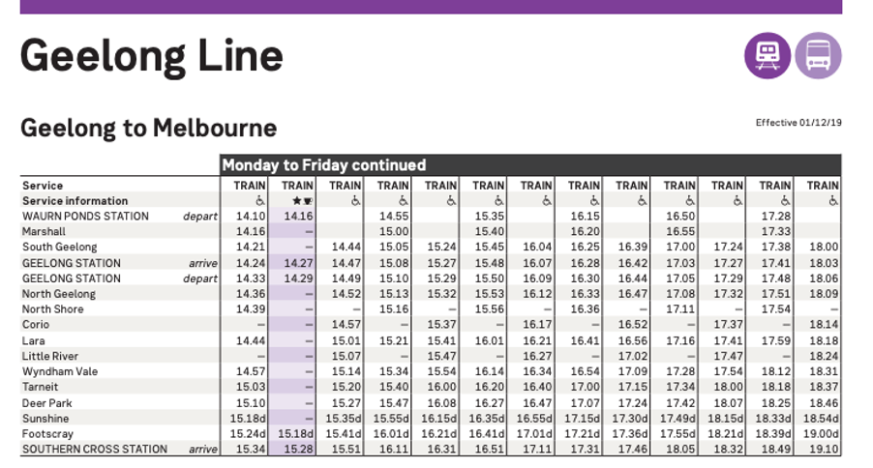

If you get on the 2.10 pm from Waurn Ponds, what time do you get to Southern Cross?

How much quicker is the 2.16 pm ‘express’ train from Waurn Ponds to Southern Cross?

How many trains are there so you can depart at Corio?

Which train will get you to Southern Cross as close to 6 p.m. as possible?

If you have an appointment on Southbank near the Crown Casino at 5 pm what train and time would you select to ensure you were there on time? Explain.

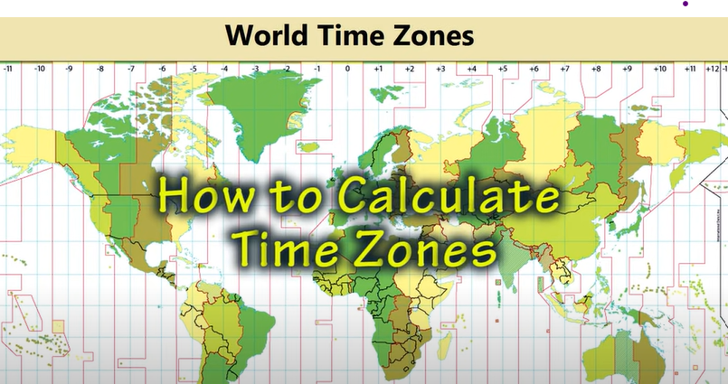
Task 10- What’s the time? 10.3 Time zones
Video link: https://youtu.be/X1DkiuaFCuA?si=Pl6DMiUrN3yUIO6e
Part 1: Watch the 4 minute youtube video on time zones and answer the following questions in the table below. See video link here Understanding Time Zones.
1.Why was there a need for standardised time?

2.Why was the city of Greenwich selected as in 1884?

3.What does GMT stand for?

4.How many time zones are there?

5.Why is each time zone counted every 15 degrees longitude?

6.What is the International date line?
7.How many time zones does Australia have?

Part 2:Time Zone problems- Using the time zone calculator linked figure out the following time zone problems below. Remember to add the city-date and time and then add Melbourne as the next city.
Time Zone Converter
Problem 1: Emily runs a company and needs to attend a Zoom meeting with Tom who lives in Chicago. The meeting starts at 7 pm on Thursday Chicago time, what day/time (in Melbourne) will Emily be meeting with Tom via Zoom?
Problem 2: Luci lives in Melbourne and has a business seminar via the Internet she needs to watch. The business seminar is taking place in London at 6 pm, what day/time would this be for Luci in Melbourne?
Problem 3: You have a work conference call with the Tokyo office at 4 pm (Tokyo time). What time will you call in from your home in Victoria?
Problem 4: You have a direct flight to London from Perth, Australia. The flight leaves Perth on July 15 at 10pm and takes 18 hours to get there. What date and time will your flight arrive in London?
Problem 5: Paulo flies from Santiago, Chile to Sydney. He leaves on February 10 at 2:30pm and his flight takes 14.5 hours. What date and time will he get to Sydney?

Task 10- What’s the time? 10.4 Gym session bookings
Part 1: Read over the booking information in the image and respond to the following questions below.

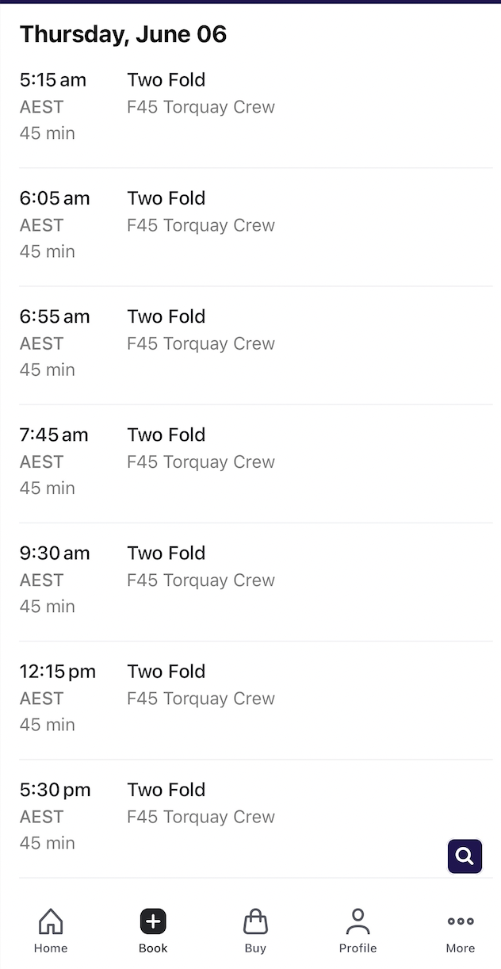

1.What time is the first F45 Session of the day?
2.What time is the last session of the day?

3.Which sessions(times) could you book if you have to be at work at 9 am and don’t finish work until 6 pm?

4. If you completed the 5.15 am session before work and the 5.30 pm session after work, how much recovery time do you have in between?

Task 10 - Feedback and Assessment
Peer Feedback
Activity 10.1 | 12 hour to 24 hour time conversion | Choose an item.
Activity 10.2 | Time and time tables | Choose an item.
Activity 10.3 | Time zones | Choose an item.
Activity 10.4 | Gym session bookings | Choose an item.
Peer Comment:
Name of Peer:

AoS 2 KS 4 Read and interpret units of analogue and digital time including 24-hour time and time zones.
Student Reflection - How well did you go with this step? (Please check the box below)
☐Not Submitted | ☐Beginning | ☐Consolidating | ☐Achieving | ☐Excelling
Student Comment (Optional):
Teacher Feedback
☐Not Submitted | ☐Beginning | ☐Consolidating | ☐Achieving | ☐Excelling
Not Submitted: No work has been submitted or attempted for this outcome. | Beginning: You have attempted to answer some of the questions. To bump it up, you need to complete all parts of the activity and show that you can read and interpret units of analogue and digital time. | Consolidating: You have shown a basic ability to read and interpret units of analogue and digital time. You have shown some working out. To bump it up, check over your answers to see if they are correct and include more details of your working out. | Achieving: You have shown an ability to read and interpret units of analogue and digital time. You have shown your workings. To bump it up, recheck your answers to make sure your answers are all correct. | Excelling: You have shown a high ability to read and interpret units of analogue and digital time. You have shown all your workings out and all your answers are correct. Great work!
Teacher Comment:

AoS 2 KS 6 Perform calculations using multiple units of time, including time zones, and calculate time durations, including the use of calendar months, weeks, days, as well as hours, minutes, and seconds.
Student Reflection - How well did you go with this step? (Please check the box below)
☐Not Submitted | ☐Beginning | ☐Consolidating | ☐Achieving | ☐Excelling
Student Comment (Optional):
Teacher Feedback
☐Not Submitted | ☐Beginning | ☐Consolidating | ☐Achieving | ☐Excelling
Not Submitted: No work has been submitted or attempted for this outcome. | Beginning: You have attempted to answer some of the questions. To bump it up, you need to complete all parts of the activity and show that you can perform calculations using multiple units of time, and calculate time durations. | Consolidating: You have shown a basic ability to perform calculations using multiple units of time and calculate time durations.  You have shown some working out. To bump it up, check over your answers and see if you can include more information in each of your answers. | Achieving: You have shown an ability to perform calculations using multiple units of time and calculate time durations. To bump it up, recheck your answers to make sure your answers are all correct. | Excelling: You have shown a high ability to perform calculations using multiple units of time and calculate time durations. You have shown all your workings out and all your answers are correct. Great work!
Teacher Comment:

Numeracy Task 11 Human resources (HR) wages

Numeracy Context: Vocational (e)
Area of Study (AoS): 4 Relationships

Key knowledge and key skills
AoS 4 KS 1 Use and apply rates to solve problems such as $/m3, L/hr, wages/hr
AoS 4 KS 2 Use and apply formulas to solve real-life problems
AoS 4 KS 3 Describe relationships between variables and explain their significance in relationship to the applied context
AoS 4 KS 4 Develop and represent relationships with mathematical expressions, or graphical or tabular representations
AoS 4 KS 5 Use and apply relevant ratios and proportions to solve problems such as scales on maps and plans, in the mixing of chemicals or ingredients, or calculating magnification factors.

Task Checklist
☐ Task 11- Activity 11.1 Collecting data and performing calculations
☐ Task 11- Activity 11.2 Covering costs

In this task, you will calculate how much adding an employee to a business may cost. You will need to find out the hourly pay rate of an employee at your structured workplace learning (SWL). You will then perform a number of different calculations to find out how much these employees will cost over a week, month and year. You will then calculate how many more members you will need to cover the cost of these new employees.

Task 11- HR wages 11.1 Collecting data and performing calculations
Part 1: When you are at your structured workplace learning placement you will need to speak to your manager/boss to find out the hourly pay rate. Enter your data in the space below.
Structured Workplace Learning business name-
Employee Hourly Rate- $

Part 2: Performing Calculations- Using the information you have just collected you will need to work out how much money will be required to pay three new staff members to the business. Please read the case studies below and find the key information in the descriptions.
Employee Number 1- Scott
Scott is a very enthusiastic worker and extremely knowledgeable in the industry, he has just completed his Diploma. He has gained full-time employment at the business. Scott has negotiated a full-time position with weekends off and four weeks of paid holidays each year (full pay). He is happy to work the standard 38 hour working week.
Scott- key information
Hourly rate (see part 1)
Hours worked per day
Days worked per week
Weeks worked per year

Answer the questions using Scott key information and show your working out in the tables below.
1.How much money does Scott earn in a week?

2.How much money does Scott earn in a month?

3.How much money does Scott earn in a year?

Employee Number 2- Olivia
Olivia is an experienced professional who has recently returned from travelling overseas. Olivia cannot commit to full-time work as she also runs a successful dog-sitting business specialising in large breeds. Olivia can’t work weekends or Mondays and Fridays as they are the busiest days for her dog-sitting business. Olivia is working a 7.6 hour day and is happy with two weeks of unpaid holidays per year.
Olivia- key information
Hourly rate (see part 1)
Hours worked per day
Days worked per week
Weeks worked per year

Answer the questions using Olivias key information and show your working out in the tables below.
1.How much money does Olivia earn in a week?

2.How much money does Olivia earn in a month?

3.How much money does Olivia earn in a year?

Employee Number 3- Thomas
Thomas is in Year 12 and is interested in working in the industry. He can not work during the week as he is currently completing his VCE Vocational Major studies at his local secondary school. Thomas has committed to working weekends for the year, but needs two weekends off unpaid, to attend schoolies in late November. Thomas is happy to work eight-hour days and has negotiated an extra 10% per hour in penalty rates compared to the other employees.

Thomas- key information
Hourly rate (see part 1)
Hours worked per day
Days worked per week
Weeks worked per year

Answer the questions using Thomas’s key information and show your working out in the tables below.
1.How much money does Thomas earn in a week?

2.How much money does Thomas earn in a month?

3.How much money does Thomas earn in a year?

Part 3: Yearly Wages- Fill out the table below showing the yearly wages for each of the new employees.
Employee name | Yearly wage ($)
Scott | $
Olivia | $
Thomas | $

Part 4: How much do all three employees cost the business in wages for the year?
Working out:

Part 5: What is the total cost of hiring 3 new employees for the year?

Task 11- HR wages 11.2 Covering costs

Now we know how much the employees cost the business in wages for the year, we need to cover this cost to ensure the business is successful.
There are many ways in which a business can make money. Businesses can…
- Provide a Service
Example: A cleaning company offers home cleaning services for a fee.
- Sell a Product
Example: An online store sells handmade jewellery to customers.
- Charge a membership
Example: A streaming platform charges users a monthly fee for access to its content.

Part 1: Explain how your SWL business makes money, give one example and the cost of the service/product/membership in the space beklow.
Worked example
My business makes money by servicing cars.

A car service would cost $300

My business makes money by …

How many extra services/products/memberships will your business have to provide/sell to cover the cost of the new employees? Show your working out below.

My Business will need to provide/sell (add amount here) to cover the cost of the new employees.

Part 2: Knowing how to calculate wages per hour, week, month, and year is an important skill to learn for both the employer and the employee. List what benefits this skill has for the employer and employee in the space below.

Employer-

Employee-

Task 11 - Feedback and Assessment
Peer Feedback
Activity 11.1 | Collecting data and performing calculations | Choose an item.
Activity 11.2 | Covering costs | Choose an item.
Peer Comment:
Name of Peer:

AoS 4 KS 1 Use and apply rates to solve problems such as $/m3, L/hr, wages/hr.
Student Reflection - How well did you go with this step? (Please check the box below)
☐Not Submitted | ☐Beginning | ☐Consolidating | ☐Achieving | ☐Excelling
Student Comment (Optional):
Teacher Feedback
☐Not Submitted | ☐Beginning | ☐Consolidating | ☐Achieving | ☐Excelling
Not Submitted: No work has been submitted or attempted for this outcome. | Beginning: You have attempted to answer some of the questions. To bump it up, you need to complete all parts of the activity and show that you can use and apply rates to solve problems. | Consolidating: You have shown a basic understanding of using and applying rates to solve problems. You have shown some working out. To bump it up, check over your answers to see if they are correct and include more details of your working out. | Achieving: You have shown an understanding of using and applying rates to solve problems. You have shown your workings. To bump it up, recheck your answers to make sure your answers are all correct. | Excelling: You have shown a high level of understanding of using and applying rates to solve problems. You have shown all your workings out and all your answers are correct. Great work!
Teacher Comment:

AoS 4 KS 2 Use and apply formulas to solve real-life problems.
Student Reflection - How well did you go with this step? (Please check the box below)
☐Not Submitted | ☐Beginning | ☐Consolidating | ☐Achieving | ☐Excelling
Student Comment (Optional):
Teacher Feedback
☐Not Submitted | ☐Beginning | ☐Consolidating | ☐Achieving | ☐Excelling
Not Submitted: No work has been submitted or attempted for this outcome. | Beginning: You have attempted to answer some of the questions. To bump it up, you need to complete all parts of the activity and show that you can use and apply formulas to solve real-life problems. | Consolidating: You have shown a basic understanding of using and applying formulas to solve real-life problems. You have shown some working out. To bump it up, check over your answers to see if they are correct and include more details of your working out. | Achieving: You have shown an understanding of using and applying formulas to solve real-life problems. You have shown your workings. To bump it up, recheck your answers to make sure your answers are all correct. | Excelling: You have shown a high level of understanding of using and applying formulas to solve a range of problems. You have shown all your workings out and all your answers are correct. Great work!
Teacher Comment:

AoS 4 KS 3 Describe relationships between variables and explain their significance in relationship to the applied context.
Student Reflection - How well did you go with this step? (Please check the box below)
☐Not Submitted | ☐Beginning | ☐Consolidating | ☐Achieving | ☐Excelling
Student Comment (Optional):
Teacher Feedback
☐Not Submitted | ☐Beginning | ☐Consolidating | ☐Achieving | ☐Excelling
Not Submitted: No work has been submitted or attempted for this outcome. | Beginning: You have attempted to answer some of the questions. To bump it up, you need to complete all parts of the activity and show that you can describe relationships between variables. | Consolidating: You have shown a basic ability to describe relationships between variables and explain their significance in an applied context. You have shown some working out. To bump it up, check over your answers to see if they are correct and include more details of your working out. | Achieving: You have shown an ability to describe relationships between variables and explain their significance in an applied context. You have shown your workings. To bump it up, recheck your answers to make sure your answers are all correct. | Excelling: You have shown a high level ability to describe relationships between variables and explain their significance in an applied context. You have shown all your workings out and all your answers are correct. Great work!
Teacher Comment:

AoS 4 KS 4 Develop and represent relationships with mathematical expressions, or graphical or tabular representation.
Student Reflection - How well did you go with this step? (Please check the box below)
☐Not Submitted | ☐Beginning | ☐Consolidating | ☐Achieving | ☐Excelling
Student Comment (Optional):
Teacher Feedback
☐Not Submitted | ☐Beginning | ☐Consolidating | ☐Achieving | ☐Excelling
Not Submitted: No work has been submitted or attempted for this outcome. | Beginning: You have attempted to answer some of the questions. To bump it up, you need to complete all parts of the activity and show that you can develop and represent relationships. | Consolidating: You have shown a basic ability to develop and represent relationships. You have shown some working out. To bump it up, check over your answers to see if they are correct and include more details of your working out. | Achieving: You have shown an ability to develop and represent relationships. You have shown your workings. To bump it up, recheck your answers to make sure your answers are all correct. | Excelling: You have shown a high level ability to develop and represent relationships. You have shown all your workings out and all your answers are correct. Great work!
Teacher Comment:

AoS 4 KS 5 Use and apply relevant ratios and proportions to solve problems such as scales on maps and plans, in the mixing of chemicals or ingredients, or calculating magnification factors.
Student Reflection - How well did you go with this step? (Please check the box below)
☐Not Submitted | ☐Beginning | ☐Consolidating | ☐Achieving | ☐Excelling
Student Comment (Optional):
Teacher Feedback
☐Not Submitted | ☐Beginning | ☐Consolidating | ☐Achieving | ☐Excelling
Not Submitted: No work has been submitted or attempted for this outcome. | Beginning: You have attempted to answer some of the questions. To bump it up, you need to complete all parts of the activity and show that you can use and apply relevant ratios and proportions to solve problems. | Consolidating: You have shown a basic ability to use and apply relevant ratios and proportions to solve problems. You have shown some working out. To bump it up, check over your answers to see if they are correct and include more details of your working out. | Achieving: You have shown an ability to use and apply relevant ratios and proportions to solve problems. You have shown your workings. To bump it up, recheck your answers to make sure your answers are all correct. | Excelling: You have shown a high level ability to use and apply relevant ratios and proportions to solve problems. You have shown all your workings out and all your answers are correct. Great work!
Teacher Comment:

