VCE Vocational Major

Unit 1 Striving Individuals
Work Related Skills Curriculum
Support Materials

Authorised and published by the Victorian Curriculum and Assessment Authority
Level 7, 2 Lonsdale Street
Melbourne VIC 3000
ISBN: 978-1-xxxxxx-xx-x [email vcaa.media.publications@edumail.vic.gov.au for ISBN requests]
© Victorian Curriculum and Assessment Authority [year]

No part of this publication may be reproduced except as specified under the Copyright Act 1968 or by permission from the VCAA. Excepting third-party elements, schools may use this resource in accordance with the VCAA educational allowance. For more information go to https://www.vcaa.vic.edu.au/Footer/Pages/Copyright.aspx.
The VCAA provides the only official, up-to-date versions of VCAA publications. Details of updates can be found on the VCAA website at www.vcaa.vic.edu.au.
This publication may contain copyright material belonging to a third party. Every effort has been made to contact all copyright owners. If you believe that material in this publication is an infringement of your copyright, please email the Copyright Officer vcaa.copyright@edumail.vic.gov.au
Copyright in materials appearing at any sites linked to this document rests with the copyright owner/s of those materials, subject to the Copyright Act. The VCAA recommends you refer to copyright statements at linked sites before using such materials.
The VCAA logo is a registered trademark of the Victorian Curriculum and Assessment Authority.

Contact us if you need this information in an accessible format - for example, large print or audio.
Telephone (03) 9032 1635 or email vcaa.media.publications@edumail.vic.gov.au

Contents
Table of Contents
Work Related Skills (WRS) activities 4
Task 1 - Employment Research 4
Task 1- Employment research Activity 1.1 Classification table & written explanation 6
Task 1- Employment research Activity 1.2 Personal capabilities examples 8
Task 1– Employment research Activity 1.3 Labour Market Information Research by location 9
Task 1- Employment research Activity 1.4 Labour Market Information Occupation Research 12
Task 1- Employment research Activity 1.5 Peer share back and skills list 14
Task 2- Industry investigation 16
Task 2- Industry investigation Activity 2.1 Local Industry brainstorm and discussions 17
Task 2- Industry investigation Activity 2.2 Personal capabilities examples 18
Task 2-Activity 2.3 Industry Site Visit 1 19
Task 2-Activity 2.4 Industry Growth advantages and disadvantages 23
Before you move onto WRS Task 3 – Self Promotion 25
Task 3- Self-promotion 26
Task 3- Self-promotion Activity 3.1 Video questions 27
Task 3- Self-promotion Activity 3.2 Trusted Adult check-in questions 28
Task 3- Self Promotion Activity 3.3 Self-promotion video 29
Task 4- Career Action Plan 31
Task 4- Career Action Plan Activity 4.1 Career Action Plan 32
Task 4- Career Action Plan Activity 4.2 Career action plan summary 33
Task 4- Career Action Plan Activity 4.3 Occupation Research Notes 34
Before you move onto WRS Task 5 – Careers Meeting 35
Task 5 Careers Meeting 36
Task 5- Careers Meeting Activity 5.1 Career Meeting Questions 37
Task 5- Careers Meeting Activity 5.2 Careers Meeting 38
Task 5- Careers Meeting Activity 5.3 Career Meeting Reflection 39
Before you move onto WRS Task 6 – Career Findings Presentation 40
Task 6 – Career Findings Presentation 41
Task 6- Careers presentation Activity 6.1 Alternative and Traditional Educational Pathways 42
Task 6- Careers presentation Activity 6.2 Careers Digital presentation 44
Task 6- Careers Presentation Activity 6.3 Career Meeting Reflection 45
Before you move onto another task 46

Work Related Skills (WRS) activities

Task 1 - Employment Research



Task Checklist
Students will complete the following for Work Related Studies Task 1 – Employment Research.
☐ WRS Task 1 Activity 1.1 Classification table of credible sources
☐ WRS Task 1 Activity 1.1 Credible source and information written explanation
☐ WRS Task 1 Activity 1.2 LMI Video and personal written explanation
☐ WRS Task 1-Activity 1.3 Labour Market Information Industry research task tables X 3 and summary findings
☐ WRS Task 1 Activity 1.4 Occupations of interest LMI research and digital presentation
☐ WRS Task 1-Activity 1.5 Peer sharing photograph
☐ WRS Task 1 Activity 1.5 ‘Skills’ list

Key vocabulary (you need to know)
Reliable: that may be relied on or trusted; dependable in achievement, accuracy, honesty, etc.
Credible: capable of being believed; believable
Labour Market Information: is a set of data and insights that helps describe how jobs are changing, now and into the future.
Occupations: a person's usual or principal work or business, especially as a means of earning a living; vocation.
Skills shortage: A skill shortage exists when employers can't fill vacancies in an occupation or in a specialisation of that occupation.
Geographic location: A location is the place where something happens or is situated.
Industry growth: an industry that is increasing in size and developing quickly.
Emerging industry: refers to companies that are formed around a new product or idea that is in the early stages of development.
Green industry: means economies striving for a more sustainable pathway of growth, by undertaking green public investments and implementing public policy initiatives that encourage environmentally responsible private investments.
Trend: general development in a situation or in the way that people behave.

Task 1- Employment research Activity 1.1 Classification table & written explanation

 Part 1: In the classification table below identify sources of reliable and credible employment information in the categories that you would use to find out about future employment of study/training opportunities. You should have at least 3 examples for each category.

Double click on the on the classification table below and complete your answers in the ‘DRAW’ setting. Click ‘Save and close’ when you are finished.

Reliable and credible employment information

Industry publications
Government websites
Career Specialists
Tertiary institutions
Employment agencies
Part 2: In the text box below explain why and how the sources you have chosen are reliable and credible. What features in the resources confirm your opinion/thoughts this information is credible?

Task 1 Activity 1.1 Classification table & written explanation
Student Reflection - How well did you go with this step? (Please check the box below)
☐Not Submitted | ☐Beginning | ☐Consolidating | ☐Achieving | ☐Excelling
Student Comment (Optional):
Teacher Feedback
☐Not Submitted | ☐Beginning | ☐Consolidating | ☐Achieving | ☐Excelling
Not Submitted: No work has been submitted or attempted for this activity. | Beginning: You have attempted some aspects of the tasks. To bump it up- you need at least 3 sources of information from each category and to provide a basic explanation as to why you think the sources/information you have identified is reliable and credible. | Consolidating: You have provided 3 examples for each category in the classification table. You have included a brief and basic explanation on why you think the chosen resources are credible and reliable sources of employment information. | Achieving: You have provided a range of examples for each category in the classification table. You have included a detailed explanation of why you think the chosen resources are credible and reliable sources of employment information. | Excelling: You have provided a range of examples for each category in the classification table. You have hyperlinked in your examples directly to your classification table. You have included a highly detailed explanation on why you think the chosen resources are credible and reliable sources of employment information. Excellent work!
Teacher Comment:

Task 1- Employment research Activity 1.2 Personal capabilities examples
Part 1: Watch the short video below that explains what Labour Market Information (LMI) is and why it is important for you to know about.
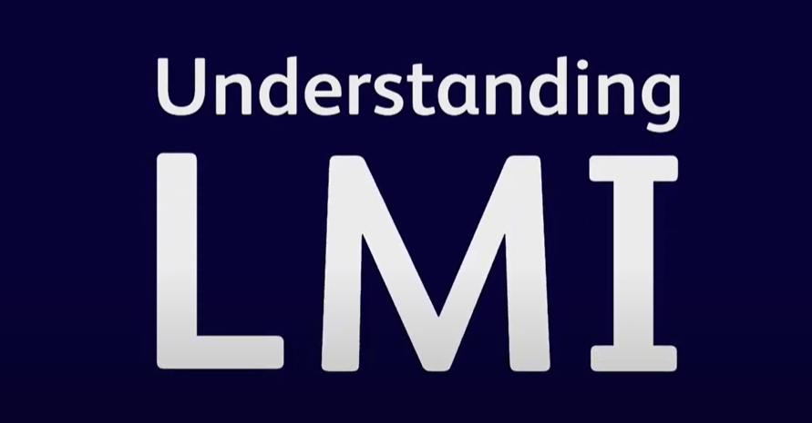

Link access: https://youtu.be/5z3v5TktjYM?si=cd-pumTQ8UZfZ50u

Part 2: In your own words below explain why it is important to know about LMI and describe how you can use LMI information to support you to make informed decisions about your pathway goals and aspirations?

Type your response here 3-5 sentences.

Task 1 Activity 1.2 Personal capabilities examples
Student Reflection - How well did you go with this step? (Please check the box below)
☐Not Submitted | ☐Beginning | ☐Consolidating | ☐Achieving | ☐Excelling
Student Comment (Optional):
Teacher Feedback
☐Not Submitted | ☐Beginning | ☐Consolidating | ☐Achieving | ☐Excelling
Not Submitted: No work has been submitted or attempted for this activity. | Beginning: You have attempted some aspects of the task. To bump it up, you should re-watch the LMI video and describe in more detail how you can personally use LMI to help you make informed decisions about your pathways and career aspirations. | Consolidating: You have provided a brief and general response to what LMI is and how it can be used. To bump it up, you need to include more specific details about how you could personally utilise this information. | Achieving: You have provided a detailed response to what LMI is and how it can be used. To bump it up, you need to include more specific details about how you could personally utilise this information in your own pathways planning. | Excelling: You have provided a highly detailed response to what LMI is and how it can be used. You have included personal and specific details about how you can utilise LMI to support you to make informed decisions about your future pathways planning goals. Great work!
Teacher Comment:

Task 1– Employment research Activity 1.3 Labour Market Information Research by location

Part 1: It is highly recommended that the teacher runs through a specific example here for students of how to use the website and locate information explicitly with students. You could include a discussion here about the types of skills you need for this research task.

Part 2: Using the Jobs and Skills Atlas by the Australian Government complete the LMI data table below based on the geographic locations. You will need to use the industry data sets for this task.

For ‘National and state’ data use the top left tab, for data about the local area that you live click the middle ‘SA4 Regions’ tab and to compare different areas click on the ‘Compare’ tab. See here for FAQ

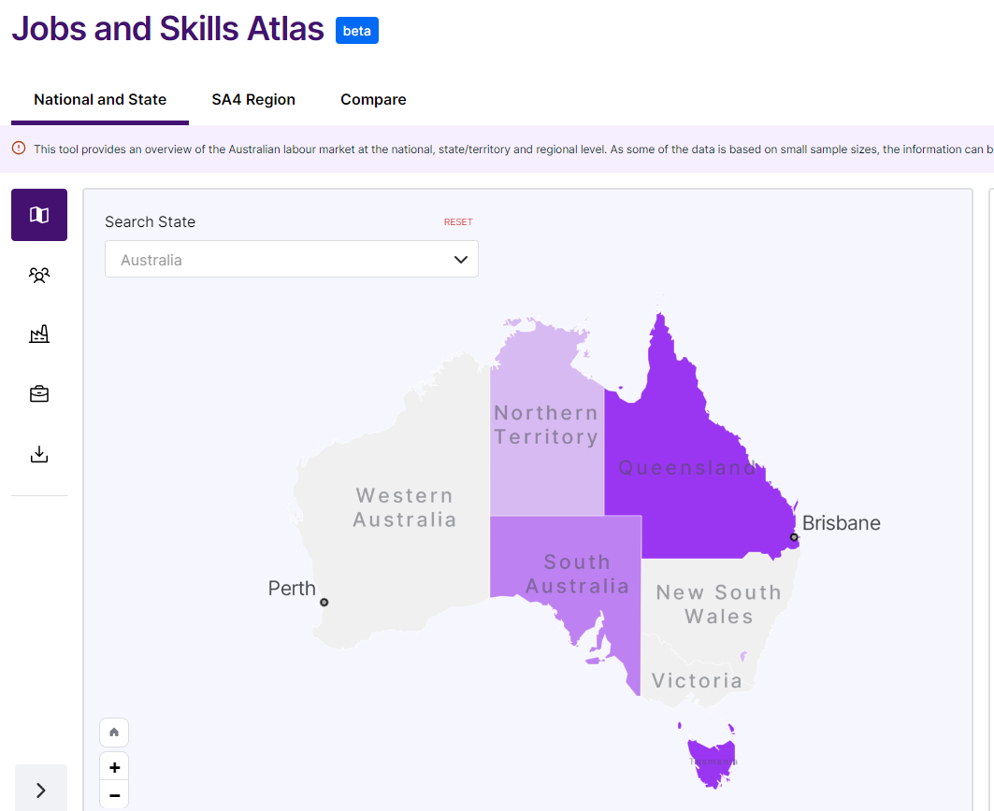
Link: https://www.jobsandskills.gov.au/jobs-and-skills-atlas-dashboard?nav=state&tab=state-map&region=aus

Part 3: Complete the following tables.
Add where you live here.
Factors | Industries impacted by the factors
Skills shortage areas
Industry Growth areas
Emerging industries
Green industries
Victoria
Factors | Industries impacted by the factors
Skills shortage areas
Industry Growth areas
Emerging industries
Green industries
Australia
Factors | Industries impacted by the factors
Skills shortage areas
Industry Growth areas
Emerging industries
Green industries
Part 4: From the tables above review the industry information from your Local, State and National research and respond to the questions below.
What are the similarities in information?

What are the differences in the information?

What opinions or thoughts do you have about this research? Is this different to what you thought previously? What evidence/research supported you to come to these thoughts/opinions/conclusions?

Task 1 Activity 1.3 Labour Market Information Research by location
Student Reflection - How well did you go with this step? (Please check the box below)
☐Not Submitted | ☐Beginning | ☐Consolidating | ☐Achieving | ☐Excelling
Student Comment (Optional):
Teacher Feedback
☐Not Submitted | ☐Beginning | ☐Consolidating | ☐Achieving | ☐Excelling
Not Submitted: No work has been submitted or attempted for this activity. | Beginning: You have attempted some aspects of the task. To bump it up, you need to include industries impacted by the factors for where you live currently, Victoria and Australia in all sections of the 3 tables. | Consolidating: You have provided at least one industry for each section required in the 3 tables for where you live, Victoria and Australia. To bump it up, you need to provide a basic response on the information you research on industries by different locations. | Achieving: You have provided several industries for each section required in the 3 tables for where you live, Victoria and Australia. You have included a basic response to the summary questions. To bump it up, you need to provide more detailed information for your summary questions. | Excelling: You have provided several industries for each section required in the 3 tables for where you live, Victoria and Australia. You have included a detailed response to the summary questions. You have outlined what information led you to develop and justify your findings from your industry research. Excellent work!
Teacher Comment:

Task 1- Employment research Activity 1.4 Labour Market Information Occupation Research

Part 1: As a class or large group brainstorm, list as many ‘occupations’ as you can in the jam board below. Contribute as many as you can possibly think off.
 Create your own class jam board and check that share settings on Jam Board are set to ‘Anyone with the link’ and ‘can edit’. Then hyperlink to the text above ‘Occupation List Class Jam Board’. Use (Ctrl and K) then paste (Ctrl and V) copied jam board link. Alternatively, you could do a class brainstorm on the whiteboard or using butcher’s paper.

Part 2: Utilising the class Jam Board brainstorm or finding others identify 3-5 occupations that are of some interest to you and present your findings using an infographic or digital presentation. They do not have to be jobs that you want to do but ones that you would like to know more about.

You will need to use the Jobs and Skills Atlas by the Australian Government and then find information from another 3-5 credible and reliable sources or websites. You will need to reference these resources in the bibliography space below.

For each occupation you need to find the following information:
☐ Occupation Name
☐ Industry the occupation belongs to (For example- Nurse is in the Healthcare industry)
☐ LMI- Shortage and Future demand of occupation?
☐ Any LMI impacts on the occupation from the following factors: geographic locations, industry growth, emerging industries, green industries or any local, national or global trends?
☐ Level of education or training needed to become qualified.
☐ Where can you get those qualifications or training?
☐ What is the average wage for the occupation?
☐ Are there different pay levels/scales for career progression?
☐ Based on your research would you pursue this occupation? Why or why not?

You can collate the information below for the 3-5 occupations you select below:
Occupation Notes research:

Bibliography:

1. Jobs and Skills Atlas by the Australian Government
2.
3.
4.
5.
Part 3: Present your findings using an infographic, digital presentation or digital format of your choice below.
Insert or hyperlink your digital presentation of your occupation research here.

Task 1 Activity 1.4 Labour Market Information Occupation Research
Student Reflection - How well did you go with this step? (Please check the box below)
☐Not Submitted | ☐Beginning | ☐Consolidating | ☐Achieving | ☐Excelling
Student Comment (Optional):
Teacher Feedback
☐Not Submitted | ☐Beginning | ☐Consolidating | ☐Achieving | ☐Excelling
Not Submitted: No work has been submitted or attempted for this activity. | Beginning: You have attempted some aspects of the task. To bump it up, you must complete the required research for at least 3 occupations. Your findings should be presented in a digital format of your choice. | Consolidating: You have provided the basic information for 3 chosen occupations. You have presented your findings in a digital format. To bump it up you should add more details to your chosen occupations and add further colour, pictures or interesting features to your digital presentation. | Achieving: You have provided the basic information for 5 chosen occupations. You have presented your findings in a digital format. To bump it up you should add more details to your chosen occupations and add further colour, pictures or interesting features to your digital presentation. | Excelling: You have provided detailed information for 5 chosen occupations. You have presented your findings in a digital format that is aesthetically appealing to your audience and information. Excellent work!
Teacher Comment:

Task 1- Employment research Activity 1.5 Peer share back and skills list

Part 1: In a pair or small group take turns to share the main points of your occupation's presentation that is a summary of your research and findings.
Insert a picture of your group sharing.

Part 2: In your pair or small group create a list of as many ‘skills’ that you and your group can think of that you need to be able to research, identify, interpret, understand and summarise the LMI information for both industries and occupations. You will come back to this list in WRS Task 3- so make sure it is as detailed as possible.

List of skills needed:
Example- Numeracy skills for analysing LMI data- how to read and understand tables.
1.
2.
3.
4.
5.
6.
7.
8.
9.
10.

Task 1 Activity 1.5 - Peer share back and skills list
Student Reflection - How well did you go with this step? (Please check the box below)
☐Not Submitted | ☐Beginning | ☐Consolidating | ☐Achieving | ☐Excelling
Student Comment (Optional):
Teacher Feedback
☐Not Submitted | ☐Beginning | ☐Consolidating | ☐Achieving | ☐Excelling
Not Submitted: No work has been submitted or attempted for this activity. | Beginning: You have attempted some aspects of the task. To bump it up, you need to include more skills in your list. | Consolidating: You have included a picture of your presentation sharing and provided a basic list of 5 ‘skills’ you needed to be able to complete this task. To bump it up, you need to add additional skills to your list. | Achieving: You have included a picture of your presentation sharing and provided a basic list of 5-10 ‘skills’ you needed to be able to complete this task. To bump it up, you need to add additional details of your skills to your list. | Excelling: You have included a picture of your presentation sharing and provided a detailed list of 5-10 ‘skills’ you needed to be able to complete this task. Great work!
Teacher Comment:

Before you move onto WRS Task 2 – Industry Investigation activities have you completed the following activities?
Task Checklist
Students will complete the following for Work Related Studies Task 1 – Employment Research.
☐ WRS Task 1-Activity 1.1 Classification table of credible sources.
☐ WRS Task 1-Activity 1.1 Credible source and information written explanation.
☐ WRS Task 1-Activity 1.2 LMI Video and personal written explanation.
☐ WRS Task 1-Activity 1.3 Labour Market Information Industry research task tables X 3 and summary findings.
☐ WRS Task 1-Activity 1.4 Occupations of interest LMI research and digital presentation.
☐ WRS Task 1-Activity 1.5 Peer sharing photograph.
☐ WRS Task 1-Activity 1.5 ‘Skills’ list.

Task 2- Industry investigation


Task Checklist
Students will complete the following for Work Related Studies Task 2 – Industry Investigation.
☐ WRS Task 2- Activity 2.1 Local Industry brainstorm
☐ WRS Task 2- Activity 2.2 Notes-information to find out prior to Industry visits
☐ WRS Task 2- Activity 2.3 LMI- dot points for research prior to Industry visits
☐ WRS Task 2- Activity 2.3 Industry visits table x 3
☐ WRS Task 2- Activity 2.4 Industry Growth advantages and disadvantages
☐ WRS Task 2- Activity 2.4 SWOT analysis
☐ WRS Task 2- Activity 2.4 Skills and capabilities reflection

Key vocabulary (you need to know)
Industry- the people and activities involved in one type of business that produces goods or offers services.
Local- pertaining to, characteristic of, or restricted to a particular place or particular places
Labour Market Information- is a set of data and insights that helps describe how jobs are changing, now and into the future.
Research- a detailed study of a subject, especially in order to discover (new) information or reach a (new) understanding:
Skill- the ability to do something well.
Capability- The power or ability to do something.

Task 2- Industry investigation Activity 2.1 Local Industry brainstorm and discussions
Part 1: In consultation with your teacher as a class/group identify a range of local industries within your area. As a class, select 3 industries/businesses to visit and plan when these visits will take place. How are these industries similar or different to your LMI research in task 1?
Type your response here or insert a photo of class brainstorm.

Part 2: In a small group discuss and take notes below of what information you want to find out before and during your site visits.
Type your group members names and responses here.

Task 2 Activity 2.1 - Local Industry brainstorm and discussions
Student Reflection - How well did you go with this step? (Please check the box below)
☐Not Submitted | ☐Beginning | ☐Consolidating | ☐Achieving | ☐Excelling
Student Comment (Optional):
Teacher Feedback
☐Not Submitted | ☐Beginning | ☐Consolidating | ☐Achieving | ☐Excelling
Not Submitted: No work has been submitted or attempted for this activity. | Beginning: You have attempted some aspects of the tasks. To bump it up- you need to be actively involved in identifying some local industries/businesses to visit and contribute to the discussion on what information you want to know from the visit. | Consolidating: You have shown some level of involvement in identifying local business and industries to visit. You have been present for discussions about what information to find prior to industry visits. To bump it up- try to add more ideas to discussions. | Achieving: You have been involved in identifying local businesses and industries to visit. You have been engaged in discussions about what information to find prior to industry visits. To bump it up- try to extend yourself in your contributions to the discussions. | Excelling: You have been highly involved in identifying local businesses and industries to visit. You have been proactively engaged in discussions about what information to find prior to industry visits. Well done on your contributions.
Teacher Comment:

Task 2- Industry investigation Activity 2.2 Personal capabilities examples

Part 1: Now that you have identified which businesses/industries you are going to visit, identify what LMI research and information you need or want to know before each industry visits. List what you need to research below using dot points:

Helpful website: Jobs and Skills Atlas by the Australian Government
Is this a low-growth, medium growth or high-growth industry?

Add your own ideas here. If you are not sure check back over Task 1-Employment Research for support.

Task 2- Activity 2.2 - Personal capabilities examples
Student Reflection - How well did you go with this step? (Please check the box below)
☐Not Submitted | ☐Beginning | ☐Consolidating | ☐Achieving | ☐Excelling
Student Comment (Optional):
Teacher Feedback
☐Not Submitted | ☐Beginning | ☐Consolidating | ☐Achieving | ☐Excelling
Not Submitted: No work has been submitted or attempted for this activity. | Beginning: You have attempted some aspects of the task. To bump it up- you should look over Task 1-Employment research so you can add more ideas to your list. | Consolidating: You have identified several (3-4) pieces of LMI to research prior to your industry visits. To bump it up- add more dot points of information to your list. | Achieving: You have identified a range (5-7) of LMI to research prior to your industry visits. To bump it up- add more dot points of information to your list and include an explanation about what you will gain from researching this information. | Excelling: You have identified a comprehensive range (8+) of LMI to research prior to your industry visits. You have included an explanation about what you will gain from researching this information. Excellent work!
Teacher Comment:

Task 2-Activity 2.3 Industry Site Visit 1

Part 1: Industry Site Visit 1 Add Industry/Business name here.

Before Industry Visit
LMI Research:
insert specific information related to the industry/business you are visiting.
- Is this a low-growth, medium growth or high-growth industry according to the LMI research?
- What are the advantages of working in this industry?
- What are the disadvantages of working in this industry?

From your LMI research what questions would you like to ask during the Industry site visit? Create 3-5 questions. These should be checked off by your teacher before the industry visit.
1.
2.
3.
4.
5.

During Industry Visit
Date:

Site Visit participation:
Insert a picture of you at the location.

What questions did you ask on site?

What skills or capabilities are required to work in this industry?
Any other notes or important information shared:

Post Industry Site Visit
Did the LMI research and data match up with the information shared by the owners and employees at the site visit or was it different? Explain.
What personal skills and capabilities were required to work in that industry?
What did you learn from the site visit that you did not know previously?

Part 2: Industry Site Visit 2 Add Industry/Business name here.

Before Industry Visit
LMI Research:
insert specific information related to the industry/business you are visiting.
- Is this a low-growth, medium growth or high-growth industry according to the LMI research?
- What are the advantages of working in this industry?
- What are the disadvantages of working in this industry?

From your LMI research what questions would you like to ask during the Industry site visit? Create 3-5 questions. These should be checked off by your teacher before the industry visit.
1.
2.
3.
4.
5.

During Industry Visit
Date:

Site Visit participation:
Insert a picture of you at the location.

What questions did you ask on site?

What skills or capabilities are required to work in this industry?
Any other notes or important information shared:

Post Industry Site Visit
Did the LMI research and data match up with the information shared by the owners and employees at the site visit or was it different? Explain.
What personal skills and capabilities were required to work in that industry?
What did you learn from the site visit that you did not know previously?

Part 3: Industry Site Visit 3 Add Industry/Business name here.

Before Industry Visit
LMI Research:
insert specific information related to the industry/business you are visiting.
- Is this a low-growth, medium growth or high-growth industry according to the LMI research?
- What are the advantages of working in this industry?
- What are the disadvantages of working in this industry?

From your LMI research what questions would you like to ask during the Industry site visit? Create 3-5 questions. These should be checked off by your teacher before the industry visit.
1.
2.
3.
4.
5.

During Industry Visit
Date:

Site Visit participation:
Insert a picture of you at the location.

What questions did you ask on site?

What skills or capabilities are required to work in this industry?
Any other notes or important information shared:

Post Industry Site Visit
Did the LMI research and data match up with the information shared by the owners and employees at the site visit or was it different? Explain.
What personal skills and capabilities were required to work in that industry?
What did you learn from the site visit that you did not know previously?

Task 2 Activity 2.3 - Industry Site Visits
Student Reflection - How well did you go with this step? (Please check the box below)
☐Not Submitted | ☐Beginning | ☐Consolidating | ☐Achieving | ☐Excelling
Student Comment (Optional):
Teacher Feedback
☐Not Submitted | ☐Beginning | ☐Consolidating | ☐Achieving | ☐Excelling
Not Submitted: No work has been submitted or attempted for this activity. | Beginning: You have attempted some aspects of the task. To bump it up- you need to complete all the requirements for 3 industry site visits. | Consolidating: You have provided basic responses for all the required information in the tables for 3 industry site visits. You were present for the industry visits. To bump it up- add further details to your responses. | Achieving: You have provided detailed responses for all the required information in the tables for 3 industry site visits. You were engaged and involved in the industry site visits. To bump it up- extend your responses to include further thoughts, opinions or wonderings that you have developed from the information you have discovered. | Excelling: You have provided highly detailed responses for all the required information in the tables for 3 industry site visits. You were highly engaged and involved in the industry site visits. Your responses include further thoughts, opinions or wonderings that you have developed from the information you have discovered. Great work!
Teacher Comment:

Task 2-Activity 2.4 Industry Growth advantages and disadvantages
Part 1: From your LMI research in Task 1 and Industry site visits, what do you think the advantages and disadvantages are for pursuing employment in low-growth, medium-growth or high-growth industries? Complete the advantages and disadvantages charts below for each.

Low-growth industries
Advantages | Disadvantages
1.  2. | 1.  2.

Medium-growth industries
Advantages | Disadvantages
1.  2. | 1.  2.

High-growth industries
Advantages | Disadvantages
1.  2. | 1.  2.

Part 2: Pick one industry from your site visits that interests you the most. Complete the SWOT chart below based on the LMI and industry visit findings. A SWOT analysis is a great tool to use when you are exploring different options or making decisions.
Strengths | Weaknesses
1.  2.  3. | 1.  2.  3.
Opportunities | Threats
1.  2.  3. | 1.  2.  3.

Part 3: Respond to the following questions.
1. In the future what type of industry do you think you would be suited to or like to work in? Explain why.

2. From your LMI research and industry visits did you find out about any industry/occupations/work that you don’t want to do?

What do you need to do/learn/practice between now and being able to get where you want to go?

Part 4: What types of skills and capabilities across the industry visits did you learn about and identify as being important for employment? List as many as you can think of below in dot points (you will apply this information in the next task).
Skills | Capabilities

Task 2 Activity 2.4 - Industry Growth advantages and disadvantages
Student Reflection - How well did you go with this step? (Please check the box below)
☐Not Submitted | ☐Beginning | ☐Consolidating | ☐Achieving | ☐Excelling
Student Comment (Optional):
Teacher Feedback
☐Not Submitted | ☐Beginning | ☐Consolidating | ☐Achieving | ☐Excelling
Not Submitted: No work has been submitted or attempted for this activity. | Beginning: You have attempted some aspects of the task. To bump it up- you need to make sure you complete the required advantages and disadvantages table, SWOT analysis and include a basic response about what type of industry you think you would be suited to in the future. | Consolidating: You have provided the basic information for the 3 advantages and disadvantages tables for industry growth and SWOT analysis. You have provided a brief response on what type of industry you would like to work in. You listed one skill and capability you identified as being important. To bump it up- add more details to your response about what industry you think you would be suited to working in. | Achieving: You have provided the basic information for the 3 advantages and disadvantages tables for industry growth and SWOT analysis. You have provided a detailed response on what type of industry you would like to work in. You have listed several skills and capabilities that you identified as being important. To bump it up- add more details to your response about the advantages and disadvantages table. | Excelling: You have provided detailed information for the 3 advantages and disadvantages tables for industry growth and SWOT analysis. You have listed a range of skills and capabilities that you identified as being important. You have provided a detailed response on what type of industry you would like to work in. Great work!
Teacher Comment:

Before you move onto WRS Task 3 – Self Promotion
Have you completed the following activities?
Task Checklist
Students will complete the following for Work Related Studies Task 2 – Industry Investigation.
☐ WRS Task 2- Activity 2.1 Local Industry brainstorm
☐ WRS Task 2- Activity 2.2 Notes-information to find out prior to Industry visits
☐ WRS Task 2- Activity 2.3 LMI- dot points for research prior to Industry visits
☐ WRS Task 2- Activity 2.3 Industry visits table x 3
☐ WRS Task 2- Activity 2.4 Industry Growth advantages and disadvantages
☐ WRS Task 2- Activity 2.4 SWOT analysis
☐ WRS Task 2- Activity 2.4 Skills and capabilities reflection

Task 3- Self-promotion

Task Checklist
Students will complete the following for Work Related Studies Task 3 – Self-promotion.
☐ WRS Task 3- Activity 3.1 Video questions
☐ WRS Task 3- Activity 3.2 Trusted Adult Questions
☐ WRS Task 3- Activity 3.3 Video script
☐ WRS Task 3-Activity 3.3 Self-promotion video

Key vocabulary (you need to know)
Pathways Planning: a series of actions that can be taken in order to achieve something.
Strategy: is a plan or method put in place to achieve a goal or result.
Self-promotion: the act or practice of promoting one's own interests, profile, etc

Task 3- Self-promotion Activity 3.1 Video questions

Part 1: Watch the video below.

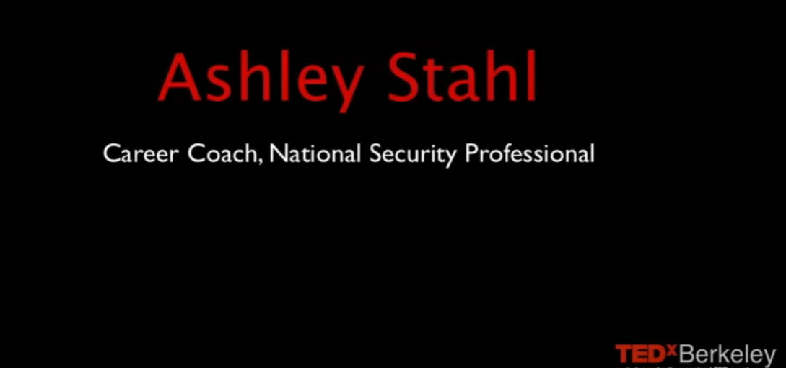

Link: https://youtu.be/vMiSf7LpFQE?si=QAlMr4kYkYrCAPI8

Part 2: Answer the following questions.
1. What am I good at?
2. What do people tell me I am good at?
3. What’s holding me back?

Task 3 Activity 3.1 Video questions
Student Reflection - How well did you go with this step? (Please check the box below)
☐Not Submitted | ☐Beginning | ☐Consolidating | ☐Achieving | ☐Excelling
Student Comment (Optional):
Teacher Feedback
☐Not Submitted | ☐Beginning | ☐Consolidating | ☐Achieving | ☐Excelling
Not Submitted: No work has been submitted or attempted for this activity. | Beginning: You have attempted some aspects of the tasks. To bump it up- you need to rewatch the video and respond to all questions in the task. | Consolidating: You have provided basic responses to each of the questions. To bump it up- you need to add additional details to your responses. | Achieving: You have provided detailed responses to each of your questions. To bump it up- include details or steps of how you can proactively overcome what is holding you back. | Excelling: You have provided detailed responses to each of your questions. You have included details or steps of how you can proactively overcome what is holding you back.
Teacher Comment:

Task 3- Self-promotion Activity 3.2 Trusted Adult check-in questions

Pathways and career planning will change over your lifetime and will depend on what stage of life you are in. According to the Foundation for Young Australians (FYA, 2017) report, "It's more likely that a 15-year-old today will experience a portfolio career, potentially having 17 different jobs over five careers in their lifetime". Link: Our Reports: The New Work Order Series - FYA

As you get older you need to make more decisions. Making decisions can be hard so using decision-making strategies such as a SWOT analysis in task 2 or talking to a trusted person can support you in the process of making decisions, identifying strengths or areas for growth.

Part 1: For this activity you are going to consult with a trusted adult of your choice such as a career advisor, mentor, coach, employer or teacher (someone who knows you well). Ask them the questions below and make a record of their responses.

Name:
How you know them:

What am I good at?

What are some of my character strengths?

What employability skills have you seen me demonstrate? (Communication, planning and organising, teamwork, problem solving, self-management, initiative and enterprise, Technology, commitment to on-going learning)

What is an area that I would benefit from developing?

Task 3 Activity 3.2 Trusted Adult check-in questions
Student Reflection - How well did you go with this step? (Please check the box below)
☐Not Submitted | ☐Beginning | ☐Consolidating | ☐Achieving | ☐Excelling
Student Comment (Optional):
Teacher Feedback
☐Not Submitted | ☐Beginning | ☐Consolidating | ☐Achieving | ☐Excelling
Not Submitted: No work has been submitted or attempted for this activity. | Beginning: You have attempted some aspects of the task. To bump it up- you need to collect a response for all the questions. | Consolidating: You have provided basic responses to the questions in this task. To bump it up- add in additional information that was said or ask additional questions to get more information. | Achieving: You have provided detailed responses to the questions in this task. To bump it up- make further comments on the responses about what actions you could take from the responses of your trusted adult. | Excelling: You have provided highly detailed responses to the questions in this task. You have also made further comments on the responses about what actions you could take moving forward from the responses of your trusted adult. Great work!
Teacher Comment:

Task 3- Self Promotion Activity 3.3 Self-promotion video

An important part of gaining experience and employment is self-promotion skills. As a part of job applications, more companies are asking for digital applications like videos and snapchats even before the interview stage.

One of the hardest things is to sell yourself. But the more you can practice the easier it becomes and the less nervous you will be for job interviews. You should also have some great things to share from WRS Task 3- Self-promotion Activity 3.2 Trusted Adult Check-in questions.
Part 1: Create a 30 second video about yourself to send to a potential employer. If you aren’t sure what to pick you can use the KMART example below.
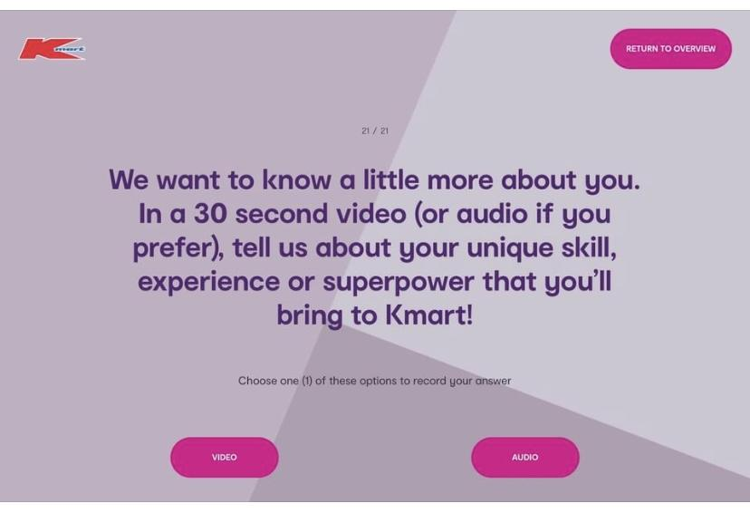

Link: https://jobs.kmart.com.au/KMART/
Part 2: Write your script in the space below.

Part 3: Have your script checked by your teacher.

Part 4: In consultation with your teacher make your audition video.
Things to remember to make a great impression:
- Eye contact
- Speak clearly and not too fast.
- Speak politely/formally (no slang or swearing!)
- Have a tidy appearance.
- Smile
Part 5: Insert video or video link below in the box below.
Add video or video link here.
Task 3 Activity 3.3 Self-promotion video
Student Reflection - How well did you go with this step? (Please check the box below)
☐Not Submitted | ☐Beginning | ☐Consolidating | ☐Achieving | ☐Excelling
Student Comment (Optional):
Teacher Feedback
☐Not Submitted | ☐Beginning | ☐Consolidating | ☐Achieving | ☐Excelling
Not Submitted: No work has been submitted or attempted for this activity. | Beginning: You have attempted some aspects of the task. To bump it up- you need to make sure that you complete all requirements of this task. | Consolidating: You have provided a basic script and video response to this task. To bump it up- try to add more details to your script so you are supported to talk about more of your skills and capabilities in your video. | Achieving: You have provided a detailed script and video response to this task. To bump it up- incorporate specific skills or examples of how/why you are the best person for the job. | Excelling: You have provided a highly detailed script and video response to this task. You have incorporated specific skills or examples of how/why you are the best person for the job. Excellent work!
Teacher Comment:

Before you move onto WRS Task 4 – Presentation of career and education goals have you completed the following activities?
Task Checklist
Students will complete the following for Work Related Studies Task 3 – Self-promotion.
☐ WRS Task 3- Activity 3.1 Video questions
☐ WRS Task 3- Activity 3.2 Trusted Adult Questions
☐ WRS Task 3- Activity 3.3 Video script
☐ WRS Task 3-Activity 3.3 Self-promotion video

Task 4- Career Action Plan

Task Checklist
Students will complete the following for Work Related Studies Task 4 – Career Action Plan.
☐ WRS Task 4- Activity 4.1 Career Action Plan
☐ WRS Task 4- 4.2 Personal aspirations/skills/capabilities table
☐ WRS Task 4- 4.3 Occupations research notes

Key vocabulary (you need to know)
Career Action Plan: is a dynamic planning document owned and managed by young people intended to reflect their increased career development learning.
Skill: the ability to do something well.
Capability: The power or ability to do something.
Aspiration: is the driving feeling you get when thinking about what you want to achieve in life.

Task 4- Career Action Plan Activity 4.1 Career Action Plan

Part 1: Create a career action plan through the My career portfolio platform.
Log into the my career portfolio platform to create an action plan via the link here: My Career Portfolio student login on the home page select the ‘My Career Action Plan’ square and click ‘GO’. Add as much detail to your responses as you can.
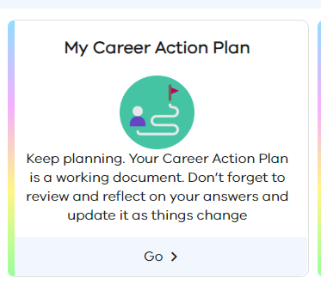
You will need to have an EDUPASS LOGIN to access this. If you are not sure, check with your teacher.

Part 2: Once you have completed your action plan save a copy or take screenshots and insert them in the space below.

Insert/add your career action plan here.

Task 4 Activity 4.1 Career Action Plan
Student Reflection - How well did you go with this step? (Please check the box below)
☐Not Submitted | ☐Beginning | ☐Consolidating | ☐Achieving | ☐Excelling
Student Comment (Optional):
Teacher Feedback
☐Not Submitted | ☐Beginning | ☐Consolidating | ☐Achieving | ☐Excelling
Not Submitted: No work has been submitted or attempted for this activity. | Beginning: You have attempted some aspects of your career action plan. To bump it up, you need to complete all required sections of your career action plan. | Consolidating: You have provided basic responses for most sections of your career action plan. To bump it up, complete all responses in your action plan and add additional details. | Achieving: You have provided basic responses for all sections of your career action plan. To bump it up, complete all responses in your action plan and add additional details. | Excelling: You have provided detailed responses for all sections of your career action plan. Great work!
Teacher Comment:

Task 4- Career Action Plan Activity 4.2 Career action plan summary
Part 1: Read over your career action plan linked above. Remember a career action plan is an ongoing and working document that is meant to be updated and changed over time.

From your career action plan summarise the information required below and list in dot form where you are at or your strengths in the following areas. You need a minimum of 3 for each category.

Personal aspirations  (What energises you?) | Skills  (Things you already do well) | Capabilities  (Things you can do well)

Task 4 Activity 4.2 Career action plan summary
Student Reflection - How well did you go with this step? (Please check the box below)
☐Not Submitted | ☐Beginning | ☐Consolidating | ☐Achieving | ☐Excelling
Student Comment (Optional):
Teacher Feedback
☐Not Submitted | ☐Beginning | ☐Consolidating | ☐Achieving | ☐Excelling
Not Submitted: No work has been submitted or attempted for this activity. | Beginning: You have attempted so many aspects of this task. To bump it up, you need to complete a minimum of 3 dot points for each category. | Consolidating: You have provided a basic response for nearly all aspects of this task. To bump it up, you need to complete a minimum of 3 dot points for each category. | Achieving: You have provided a basic response of 3 dot points for each category. To bump it up, you need to add additional details to your dot points. | Excelling: You have provided a detailed response of 3 dot points for each category. Great work!
Teacher Comment:

Task 4- Career Action Plan Activity 4.3 Occupation Research Notes

Part 1: Read all instructions first before beginning this task. Log into your My Career Portfolio platform where you developed an action plan via the link here: My Career Portfolio student login. You will need to have an EDUPASS LOGIN to access this. If you are not sure, check with your teacher.

On the home page select the ‘My Future’ square and click ‘GO’.

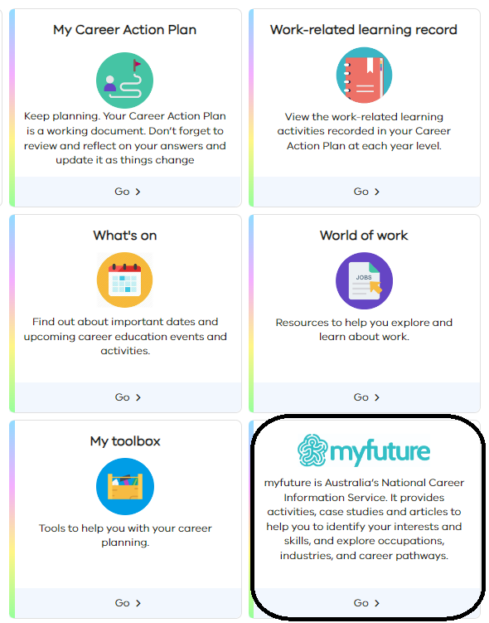
In the My Future section click into the ‘Occupations’ square below. Hot tip- watch the shorts video in the occupations section that looks like ‘? View a short video about this section.’

Part 2: From the information you identified in WRS Task 4- Career Action plan Activity 4.2, you are going to research some occupations based on your personal aspirations, skills and capabilities. You need to research 3 occupations of your choice that you have some interest in knowing more about and find out the following information for each.
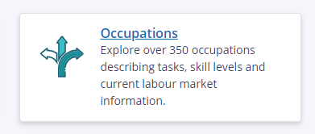

Make sure your notes are as detailed as possible as you will be using this information in future activities.
Occupation research
☐ What Industry does this occupation belong to?
☐ What interests you about this occupation and industry?
☐ From the occupation you have chosen, what are the potential employment possibilities?
☐ What are the educational pathway options necessary to develop skills and knowledge for the chosen occupation or industry?
☐ What are the entry-level pathways into this occupation?
☐ How does this occupation fit with your personal aspirations, skills and capabilities?
☐ What skills and capabilities would you need to develop to be able to do this job?

Insert your notes for your 3 occupations here.

Task 4 Activity 4.3 Occupation Research Notes
Student Reflection - How well did you go with this step? (Please check the box below)
☐Not Submitted | ☐Beginning | ☐Consolidating | ☐Achieving | ☐Excelling
Student Comment (Optional):
Teacher Feedback
☐Not Submitted | ☐Beginning | ☐Consolidating | ☐Achieving | ☐Excelling
Not Submitted: No work has been submitted or attempted for this activity. | Beginning: You have attempted some aspects of the task. To bump it up- you need to make sure that you complete all requirements of this task with basic responses for each occupation. | Consolidating: You have provided basic information for what is required. To bump it up- you need to add additional details to your notes for each occupation so that you have as much information as possible to support you in future tasks. | Achieving: You have provided highly detailed information for what is required. To bump it up- you need to add additional notes about what other questions you have or what else you would like to know from your research. | Excelling: You have provided highly detailed information for what is required. You have included additional notes about what other questions you have or what else you would like to know from your research.  Excellent work!
Teacher Comment:

Before you move onto WRS Task 5 – Careers Meeting
Have you completed the following activities?
Task Checklist
Students will complete the following for Work Related Studies Task 4 – Career Action Plan.
☐ WRS Task 4-Activity 4.1 Career Action Plan
☐ WRS Task 4- Activity 4.2 Personal aspirations/skills/capabilities table
☐ WRS Task 4- Activity 4.3 Occupations research notes

Task 5 Careers Meeting


Task Checklist
Students will complete the following for Work Related Studies Task 5 – Career Meeting.
☐ WRS Task 5 Activity 5.1 Career Meeting questions
☐ WRS Task 5 Activity 5.2 Career Meeting
☐ WRS Task 5 Activity 5.3 Post Careers Meeting reflections

Key vocabulary (you need to know)
Career Action Plan: is a dynamic planning document owned and managed by young people intended to reflect their increased career development learning.
Aspiration: is the driving feeling you get when thinking about what you want to achieve in life.
Entry level: of, relating to, or filling a low-level job in which an employee may gain experience or skills:
Educational pathway options: The different education and training options/choices to select from when working towards gaining employment in a specific industry or job.

Task 5- Careers Meeting Activity 5.1 Career Meeting Questions
Part 1: From your career action plan and occupation research in Task 4 develop 5 or more questions to ask a Careers Teacher or Advisor at your school.

These questions should be specific to you and your aspirations. These questions need to be checked off by your teacher.

Example questions:
- What are the different ways I can study/train to become a nurse?

- What is a starting job in the building industry? What is the minimum qualification I need?

- If I want to be an electrician for the next few years, but later I want to become a project manager, what do I need to do?

- I want to be a makeup artist and run my own business. What do I need to do to be able to do both well?

- I am interested in a range of different jobs. How can I keep my options open?

Add your questions in the space provided below.
1.
2.
3.
4.
5.

Part 2: Get your questions checked off by your teacher.

Task 5 Activity 5.1 Career Meeting questions
Student Reflection - How well did you go with this step? (Please check the box below)
☐Not Submitted | ☐Beginning | ☐Consolidating | ☐Achieving | ☐Excelling
Student Comment (Optional):
Teacher Feedback
☐Not Submitted | ☐Beginning | ☐Consolidating | ☐Achieving | ☐Excelling
Not Submitted: No work has been submitted or attempted for this activity. | Beginning: You have attempted aspects of this task. To bump it up- you need to develop a minimum of 5 questions to ask a careers advisor/teacher. You need to get your teacher to check over your questions. | Consolidating: You have created 5 general questions to ask a careers advisor/teacher. You have had your questions checked off by your teacher. To bump it up- you need to further develop your questions to include specific details for you to be able to research and follow up on. | Achieving: You have created 5 detailed and specific questions to ask a careers advisor/teacher. You have had your questions checked off by your teacher. To bump it up- create more open-ended questions that will require further follow-up or research. | Excelling: You have created 5 or more highly detailed and specific questions to ask a careers advisor/teacher. Your questions include some open-ended questions for you to be able to research and follow up on. You have had your questions checked off by your teacher. Great work!
Teacher Comment:

Task 5- Careers Meeting Activity 5.2 Careers Meeting

Part 1: Book a session and attend a careers meeting with the career's advisor or careers teacher at your school. Make sure you have your pre-planned questions ready to ask the Careers advisor/teacher at your appointment.

You need to keep a record of your meeting. You can choose how you would like to do this some options could be:
- Written notes and pictures with careers advisor/teacher.
- Video record the session with the career's advisor/teacher.
- Take a picture with the career's advisor/teacher.

At the start of the session, you should ask permission from the careers advisor to check that it is ok with them how you want to record the session.

Add record of your careers meeting here.

Task 5 Activity 5.2 Careers Meeting
Student Reflection - How well did you go with this step? (Please check the box below)
☐Not Submitted | ☐Beginning | ☐Consolidating | ☐Achieving | ☐Excelling
Student Comment (Optional):
Teacher Feedback
☐Not Submitted | ☐Beginning | ☐Consolidating | ☐Achieving | ☐Excelling
Not Submitted: No work has been submitted or attempted for this activity. | Beginning: You have attempted some aspects of this task. To bump it up- you need to make sure you have provided evidence of your participation in a careers meeting with a careers advisor/teacher. | Consolidating: You have included some evidence of your careers meeting. To bump it up- you need to make sure you have provided another type of evidence of your participation in a careers meeting with a careers advisor/teacher. | Achieving: You have included different types of evidence to record your career meeting. To bump it up- you need to make sure you include responses/follow up actions from your questions. | Excelling: You have provided different types of evidence to record your career meeting. You have included responses/follow up actions from your questions. Excellent work!
Teacher Comment:

Task 5- Careers Meeting Activity 5.3 Career Meeting Reflection
Part 1: Review your career meeting evidence/ record and complete the following thinking prompts. Double click on the image below and add your own response. When you are finished click save and close.
Before the meeting I didn’t know…
(type something new you found out)
I wonder…
(type something you want to know more about)
I am going to find out about…
(type something you need to follow up from your discussion)

Task 5 Activity 5.3 Career Meeting Reflection
Student Reflection - How well did you go with this step? (Please check the box below)
☐Not Submitted | ☐Beginning | ☐Consolidating | ☐Achieving | ☐Excelling
Student Comment (Optional):
Teacher Feedback
☐Not Submitted | ☐Beginning | ☐Consolidating | ☐Achieving | ☐Excelling
Not Submitted: No work has been submitted or attempted for this activity. | Beginning: You have attempted some aspects of the task. To bump it up, you must respond to all reflection prompts. | Consolidating: You have provided a basic response for the 3 reflection prompts. To bump it up, you need to add additional details to your responses. | Achieving: You have provided a detailed response for the 3 reflection prompts. To bump it up, you need to add additional details to your response including what specific information you are going to follow up on or actions you will take. | Excelling: You have provided a detailed response for the 3 reflection prompts. You have extended your response to include specific information about what you are going to follow up on or actions you will take from your careers meeting conversation.
Teacher Comment:

Before you move onto WRS Task 6 – Career Findings Presentation
Have you completed the following activities?
Task Checklist
Students will complete the following for Work Related Studies Task 5 – Careers Meeting.
☐ WRS Task 5- Activity 5.1 Career Action Plan
☐ WRS Task 5- Activity 5.2 Personal aspirations/skills/capabilities table
☐ WRS Task 5- Activity 5.3 Occupations research notes

Task 6 – Career Findings Presentation

Task Checklist
Students will complete the following for Work Related Studies Task 6 – Career Findings Presentation.
☐ WRS Task 6- Activity 6.1 3 x Occupation or industries of your choice
☐ WRS Task 6- Activity 6.1 Read over ‘School to work’ pathways resources examples
☐ WRS Task 6- Activity 6.1 3 x Occupation or industry tables
☐ WRS Task 6- Activity 6.2 Careers digital presentation
☐ WRS Task 6- Activity 6.3 Careers presentation group photo
☐ WRS Task 6-Activity 6.3 Careers presentation reflection questions

Key vocabulary (you need to know)
Aspiration: is the driving feeling you get when thinking about what you want to achieve in life.
Educational pathway options: The different education and training options/choices to select from when working towards gaining employment in a specific industry or job.
Traditional: customs, beliefs, or methods are ones that have existed for a long time without changing.
Alternative: one of the things, propositions, or courses of action that can be chosen.
Route: a course, way, or road for passage or travel.

Task 6- Careers presentation Activity 6.1 Alternative and Traditional Educational Pathways

Part 1: Choose 3 occupations or industries of your interest. One must be an occupation or industry that is a ‘growth’ area. List them below.

1.
2.
3.

Part 2: Review the My Future ‘School to work’ Pathways resources for a range of examples of traditional and alternative routes into different occupations and industries. Click on the image below and click on the hyperlink.

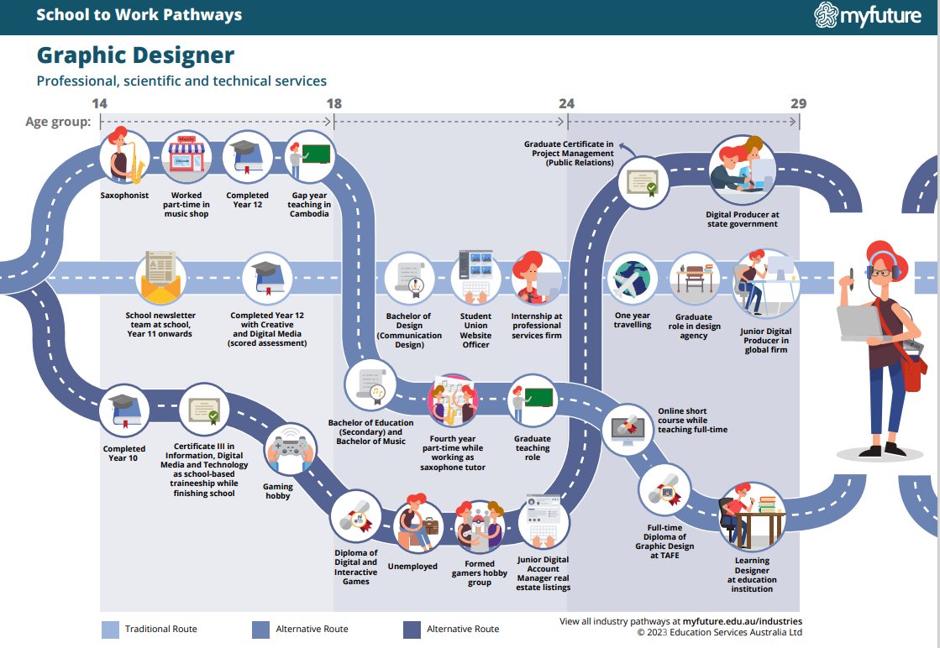
Link: https://myfuture.edu.au/docs/default-source/school-to-work-pathways-infographics/booklet-school-to-work-pathways-infographics-complete.pdf?sfvrsn=53ea41db_1

Part 3: For each of your three occupations or industries map out one traditional route and one alternative route. This should contain the different educational or training options you could take from now until gaining employment.
Evaluate each option and list the pros and cons of each occupation or industry in the templates below.
Occupation or Industry 1 name:
Traditional Route |  | Alternative Route
Add at least three dot points here. |  | Add at least three dot points here.
Positives | Negatives | Positives | Negatives
List 3 positives here. | List 3 negatives here. | List 3 positives here. | List 3 negatives here.

Occupation or Industry 2 name:
Traditional Route |  | Alternative route
Add at least three dot points here. |  | Add at least three dot points here.
Positives | Negatives | Positives | Negatives
List 3 positives here. | List 3 negatives here. | List 3 positives here. | List 3 negatives here.

Occupation or Industry 3 name:
Traditional Route |  | Alternative route
Add at least three dot points here. |  | Add at least three dot points here.
Positives | Negatives | Positives | Negatives
List 3 positives here. | List 3 negatives here. | List 3 positives here. | List 3 negatives here.

Task 6 Activity 6.1 Alternative and Traditional Educational Pathways
Student Reflection - How well did you go with this step? (Please check the box below)
☐Not Submitted | ☐Beginning | ☐Consolidating | ☐Achieving | ☐Excelling
Student Comment (Optional):
Teacher Feedback
☐Not Submitted | ☐Beginning | ☐Consolidating | ☐Achieving | ☐Excelling
Not Submitted: No work has been submitted or attempted for this activity. | Beginning: You have attempted aspects of this task. To bump it up you need to complete the tables for all three occupations or industries of your choice. | Consolidating: You have provided basic responses for most of this task. To bump it up- you need to ensure that you complete all the sections of each table for all three occupations or industries of your choice. | Achieving: You have provided basic responses for all aspects of this task. To bump it up- add additional details to your responses as well as include if there are more than 1 alternative route into your occupation or industry of interest. | Excelling: You have provided detailed responses for all aspects of this task. You have also included relevant information if there is more than 1 alternative route into your occupation or industry of interest. Great work!
Teacher Comment:

Task 6- Careers presentation Activity 6.2 Careers Digital presentation
Part 1: Create a digital presentation in a format of your choice. This information is a summary of what you have researched in Task 4 and 5. You will be sharing your presentation in small groups.

Your presentation needs to include the following information:
☐ Outline the 3 occupations that you chose in Part 1 and visually show the alternative and traditional routes into each occupation. See the example here:
☐ My Future pathways template
☐ Discuss the pros and cons of each pathway option.
☐ Share one goal on how you plan to develop your skills and knowledge required in your occupation/industry of choice moving forward. Include details on how this goal will support you to get to where you are aiming for.
☐ Ask your teacher check off your presentation when you think you are done. Make any changes from their feedback.
Add/Insert a copy of your digital presentation here.

Task 6 Activity 6.2 Careers Digital presentation
Student Reflection - How well did you go with this step? (Please check the box below)
☐Not Submitted | ☐Beginning | ☐Consolidating | ☐Achieving | ☐Excelling
Student Comment (Optional):
Teacher Feedback
☐Not Submitted | ☐Beginning | ☐Consolidating | ☐Achieving | ☐Excelling
Not Submitted: No work has been submitted or attempted for this activity. | Beginning: You have attempted some aspects of this task. To bump it up- you need to make sure you have included all the information from the checklist above in your digital presentation. | Consolidating: You have attempted most aspects of this task. To bump it up- you need to re-read the presentation checklist above and include any missed information. Look over your presentation and see that it is visually appealing to look at and easy to understand for others. | Achieving: You have completed all aspects of this task and included all the relevant information. To bump it up-Look over your presentation and see that it is visually appealing to look at and easy to understand for others. | Excelling: You have completed all aspects of this task in detail and have included all the relevant information. Your digital presentation is visually appealing to look at and easy to understand for others. Great work!
Teacher Comment:

Task 6- Careers Presentation Activity 6.3 Career Meeting Reflection

Part 1: Careers Presentation In a small group take turns to share your presentation and talk about each of the required checklist points from WRS Task 6 Activity 1.2 Careers Digital Presentation. Ensure when you are not presenting you are demonstrating respectful and active listening skills to your peers.

Insert a picture of your group.

Part 2: Careers Presentation reflection- After your presentation and group sharing complete the three questions below:

1. List one thing you learnt from creating this presentation?

2. What did you learn from others in your group who shared?

3. Give yourself a rating from 0-5 about how confident you feel finding and accessing information to support you to make informed career and pathway decisions? Explain why.
(0= not confident 5=very confident)

Task 6 Activity 6.3 Career Meeting Reflection
Student Reflection - How well did you go with this step? (Please check the box below)
☐Not Submitted | ☐Beginning | ☐Consolidating | ☐Achieving | ☐Excelling
Student Comment (Optional):
Teacher Feedback
☐Not Submitted | ☐Beginning | ☐Consolidating | ☐Achieving | ☐Excelling
Not Submitted: No work has been submitted or attempted for this activity. | Beginning: You have attempted some aspects of the task. To bump it up- you need to participate in your presentation and complete the reflection questions. | Consolidating: You have attempted most aspects of this task. To bump it up- you need to complete the reflection questions. | Achieving: You have attempted all aspects of this task. To bump it up- you need to add additional details and extend your responses to the reflection questions. | Excelling: You have attempted all aspects of this task. Your reflection question responses are highly detailed. Great work!
Teacher Comment:

Before you move onto another task
Have you completed the following activities?
Task Checklist
Students will complete the following for Work Related Studies Task 6 – Career Findings Presentation.
☐ WRS Task 6- Activity 6.1 3 x Occupation or industries of your choice
☐ WRS Task 6- Activity 6.1 Read over ‘School to work’ pathways resources examples
☐ WRS Task 6- Activity 6.1 3 x Occupation or industry tables
☐ WRS Task 6- Activity 6.2 Careers digital presentation
☐ WRS Task 6- Activity 6.3 Careers presentation group photo
☐ WRS Task 6-Activity 6.3 Careers presentation reflection questions

