VCE Vocational Major

Unit 1 Striving Individuals
Personal Development Skills Curriculum
Support Materials

Authorised and published by the Victorian Curriculum and Assessment Authority
Level 7, 2 Lonsdale Street
Melbourne VIC 3000
ISBN: 978-1-xxxxxx-xx-x [email vcaa.media.publications@edumail.vic.gov.au for ISBN requests]
© Victorian Curriculum and Assessment Authority [year]

No part of this publication may be reproduced except as specified under the Copyright Act 1968 or by permission from the VCAA. Excepting third-party elements, schools may use this resource in accordance with the VCAA educational allowance. For more information go to https://www.vcaa.vic.edu.au/Footer/Pages/Copyright.aspx.
The VCAA provides the only official, up-to-date versions of VCAA publications. Details of updates can be found on the VCAA website at www.vcaa.vic.edu.au.
This publication may contain copyright material belonging to a third party. Every effort has been made to contact all copyright owners. If you believe that material in this publication is an infringement of your copyright, please email the Copyright Officer vcaa.copyright@edumail.vic.gov.au
Copyright in materials appearing at any sites linked to this document rests with the copyright owner/s of those materials, subject to the Copyright Act. The VCAA recommends you refer to copyright statements at linked sites before using such materials.
The VCAA logo is a registered trademark of the Victorian Curriculum and Assessment Authority.

Contact us if you need this information in an accessible format - for example, large print or audio.
Telephone (03) 9032 1635 or email vcaa.media.publications@edumail.vic.gov.au

Contents
Table of Contents
VCE VM Personal Development Skills (PDS) activities 4
Task 1 Gratitude Journal 4
Task 2 -Who am I? 8
Task 2- Activity 2.1 Personal Identity and Emotional Intelligence – What is a personal identity? 8
Task 2-Activity 2.2 Koorie Youth Council -The Aboriginal Social and Wellbeing wheel 10
Task 2- Activity 2.3 Personal Identity Brainstorm 12
Task 2- Activity 2.4 Who am I? Infographic 13
Task 2- Activity 2.5 Emotional Intelligence Quiz and PMI 14
Task 2- Activity 2.6 Action plan 16
Task 2- Activity 2.7 Example and Explanation 17
Before you move onto another task 17

VCE VM Personal Development Skills (PDS) activities

Task 1 Gratitude Journal

 Part 1: Watch the video below on the benefits and power of gratitude.

Source link: https://youtu.be/4tq7V0spFmU

Part 2: For this part activity will be introduced in class to our SCSC gratitude journal designed by previous SCSC students. You will complete your gratitude journal each Monday and Friday. This is an ongoing assessment; you will be given your own gratitude journal in hard copy format. You will be marked on this when you have completed a minimum of 20 journal entries.

You can use the template images below or find another gratitude journal template. It is highly recommended that the gratitude journal template you provide to students is in a hard copy format and filled in handwritten.

Once you have completed the gratitude journal entries reflect on your experience below:

What went Well? | Even better if | Where to next?


Gratitude Journal Entries

Part 3: Complete the gratitude journal entry below.
Learning About Myself
Date
What is one behavior you want to change about yourself?
(E.g., being reactive, yelling, swearing, getting angry at people you love)

What positive statements will help remind you when you feel like you are about to show the behaviour you want to change, do not overthink them, keep it simple.
(E.g., I am calm, I think before I speak, I breathe before I act)
1.
2.
3.

What is one way you will show or practice your new behaviour throughout your day? (something you do)
(E.g. I take a break before I get angry, I run around the block when I'm agitated, I practice my grounding - 5 things I can see, 4 things you can touch, three things you can hear, two things you can smell, 1 thing I can taste)

Daily Intention
Date

My positive statement of the day
(E.g.- I will be more grateful for the small things in life)

Today I will focus on improving a trait within myself that I want to improve on
(E.g. taking things for granted, remembering myself worth, focusing on the positives instead of the negatives)

I am grateful for list three things…
(E.g. family friends, my pet food, a home)

3 traits my ideal self will have…
(E.g. calm, focused, motivated)

I can show better behaviour today when I choose to respond by…...
(E.g. being kind, not yelling, thinking before I act)

When I think about my future improved self, I feel ………
(E.g. Brave, Proud, Content)

Draw/Create below

Link: How to Get the Most Out of Future Self Journaling - The Holistic Psychologist

Part 4: Once you have completed the gratitude journal entries reflect on your experience below.
What went well? | Even better if? | Where to next?

Task 1 Gratitude Journal
Student Reflection - How well did you go with this step? (Please check the box below)
☐Not Submitted | ☐Beginning | ☐Consolidating | ☐Achieving | ☐Excelling
Student Comment (Optional):
Teacher Feedback
☐Not Submitted | ☐Beginning | ☐Consolidating | ☐Achieving | ☐Excelling
Not Submitted: No work has been submitted or attempted for this outcome. | Beginning: You completed some journal entries with basic responses. You need to complete at least 20 and respond using full sentences. | Consolidating: You completed the required 20 journal entries using basic sentences. Try to complete more responses and add in greater detail. | Achieving: You completed the required 20 or more journal entries with detailed responses. Try to add in more specific examples to bump up your responses. | Excelling: You completed the required 20 or more journal entries with highly detailed responses including specific examples. Excellent work!
Teacher Comment:

Task 2 -Who am I?

Task Checklist
Students will complete the following for PDS Task 2 – Who am I?
☐ PDS Task 2- Activity 2.1 Personal identity rotation brainstorm and small group discussion
☐ PDS Task 2- Activity 2.2 The Aboriginal Social and Wellbeing Wheel table reflection
☐ PDS Task 2- Activity 2.3 Personal Identity Brainstorm
☐ PDS Task 2- Activity 2.4 Who am I? Infographic
☐ PDS Task 2- Activity 2.5 Emotional intelligence quiz & PMI chart
☐ PDS Task 2- Activity 2.6 Action plan template
☐ PDS Task 2- Activity 2.7 Example and explanation on how you have applied the strategies individually and within a group context.

Task 2- Activity 2.1 Personal Identity and Emotional Intelligence – What is a personal identity?
Part 1: Watch the short video on the Japanese concept of ‘3 faces’
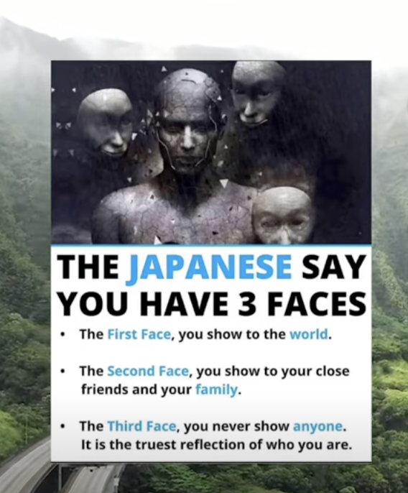
Link: https://youtu.be/-6t3sLkccM8
Do you agree or disagree with this concept? Circle/Highlight below.

Agree | Disagree

Part 2: Using an online dictionary look up the definition of personal identity. In your own words summarise and provide an explanation of the definition of ‘Personal identity’ below. You should include any factors that contribute to the concept of ‘Personal identity’.

Type your response here.

Task 2 Activity 2.1 What is Personal Identity
Student Reflection - How well did you go with this step? (Please check the box below)
☐Not Submitted | ☐Beginning | ☐Consolidating | ☐Achieving | ☐Excelling
Student Comment (Optional):
Teacher Feedback
☐Not Submitted | ☐Beginning | ☐Consolidating | ☐Achieving | ☐Excelling
Not Submitted: No work has been submitted or attempted for this outcome. | Beginning: You have attempted to list some aspects of what personal identity is. To bump it up make sure you are completing your responses in full basic sentences. | Consolidating: You were able to give a basic summary about what personal identity is. To bump it up try to add more details to your response. | Achieving: You were able to describe what personal identity is. To bump it up try to add to a range of factors that contribute to the concept of personal identity. | Excelling: You described what personal identity is and included a range of factors that contribute to it.
Teacher Comment:

Task 2-Activity 2.2 Koorie Youth Council -The Aboriginal Social and Wellbeing wheel

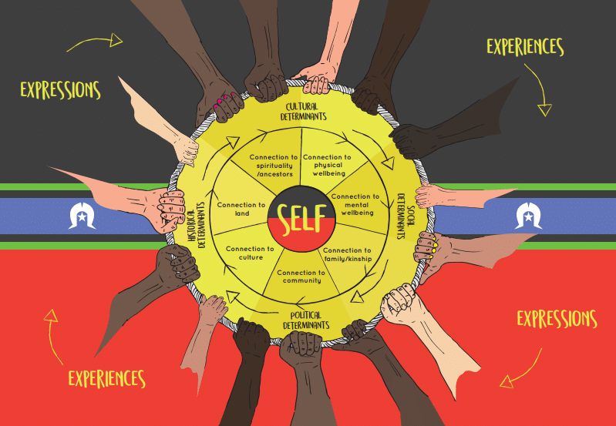

Link: https://koorieyouthcouncil.org.au/news/the-aboriginal-social-and-wellbeing-wheel-world-mental-health-day/

“The Aboriginal social and emotional wellbeing wheel considers the center (self) as inseparable from culture, family and community. The wheel outlines that a healthy connection to mental wellbeing is vital to our overall strong sense of self. If one spoke in that wheel isn’t working, then the wheel doesn’t function properly. We must remember that we have to practice self-care. It’s important to look after yourself first, so that you can place yourself in a position to better help others.” Douglas Briggs, KYC Policy & Advocacy Officer.

Part 1: Reflecting on the first nations social and wellbeing wheel list and explain 3 different concepts from the wheel that you connect with in the table below.

List your chosen concept from the wheel. | Explain why that concept is important  for your sense of self?
Example- Connection to physical wellbeing. | I prioritise moving my body each day as it makes my body and mind feel more energised and focused.
1.

2.

3.

Task 2 Activity 2.2 Koorie Youth Council -The Aboriginal Social and Wellbeing wheel
Student Reflection - How well did you go with this step? (Please check the box below)
☐Not Submitted | ☐Beginning | ☐Consolidating | ☐Achieving | ☐Excelling
Student Comment (Optional):
Teacher Feedback
☐Not Submitted | ☐Beginning | ☐Consolidating | ☐Achieving | ☐Excelling
Not Submitted: No work has been submitted or attempted for this outcome. | Beginning: You have attempted to list and explain some concepts from The Aboriginal Social and Wellbeing wheel. To bump it up, try to complete all sections of the task. | Consolidating: You have listed 3 concepts from the wheel and provided a basic explanation of why these concepts are important to you. To bump it up try to add more details and specific details on how these are reflected in your everyday life. | Achieving: You have listed 3 concepts from the wheel and provided a detailed explanation of why these concepts are important to you. To bump it up try to make connections about other areas of the wheel that you think could support you in further developing your sense of self. | Excelling: You have listed 3 concepts from the wheel and provided a highly detailed explanation of why these concepts are important to you. You have made connections to the other sections of the wheel and made comments about how these areas could help you to further develop your sense of self.
Teacher Comment:

Task 2- Activity 2.3 Personal Identity Brainstorm
Part 1: In a small group (4) use a mind map to brainstorm ‘What is personal identity?’. You should have ‘Personal Identity’ at the center of your brainstorm.
Insert mind/map and brainstorm here.

Part 2: Once you have exhausted all your own team ideas, research personal identity and add more details to your brainstorm.

Insert further researched mind/map and brainstorm here.

Task 2 Activity 2.3 Personal Identity Brainstorm
Student Reflection - How well did you go with this step? (Please check the box below)
☐Not Submitted | ☐Beginning | ☐Consolidating | ☐Achieving | ☐Excelling
Student Comment (Optional):
Teacher Feedback
☐Not Submitted | ☐Beginning | ☐Consolidating | ☐Achieving | ☐Excelling
Not Submitted: No work has been submitted or attempted for this outcome. | Beginning: You need to add more ideas to your brainstorm and research. To bump it up, add in more details to both your brainstorming and research. | Consolidating: You were able to brainstorm and research basic ideas. To bump it up, add in more details to both your brainstorming and research. | Achieving: You were able to describe what personal identity is. To bump it up, add more details to your researched brainstorm. | Excelling: Your team research and brainstorm was very detailed. Great work!
Teacher Comment:

Task 2- Activity 2.4 Who am I? Infographic

Part 1: Who am I? For this task create a collage including a range of categories from the concept of ‘personal identity’ to provide us with a snapshot of who you are now.

You can choose your own app or program for how you want to do this. If you are unsure, you could use canva and select a template from collage style on the right-hand side. If images are not your thing you could also make a word cloud. See some examples below:
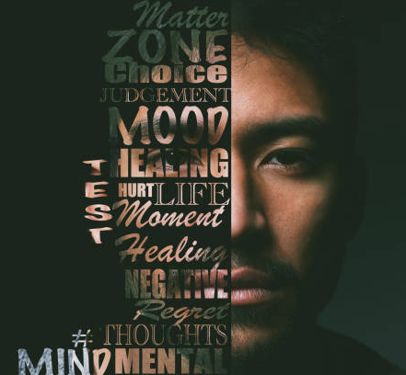 |  |  | 

Add/Insert your collage or word cloud below.

Task 2 Activity 2.4 Who am I? Infographic
Student Reflection - How well did you go with this step? (Please check the box below)
☐Not Submitted | ☐Beginning | ☐Consolidating | ☐Achieving | ☐Excelling
Student Comment (Optional):
Teacher Feedback
☐Not Submitted | ☐Beginning | ☐Consolidating | ☐Achieving | ☐Excelling
Not Submitted: No work has been submitted or attempted for this outcome. | Beginning: You have created a basic ‘Who am I?’ image. To bump it up, you need to include more categories and images of self-identity concepts. | Consolidating: You have created a basic ‘Who am I?’ image. You have included a range of self-identity concepts. To bump it up, add some more details to your infographic. | Achieving: You have created a detailed ‘Who am I?’ image. You have included a range of self-identity concepts. To bump it up add additional images. | Excelling: You have created a highly detailed ‘Who am I?’ image. You have included a broad range of self-identity concepts that represent you.
Teacher Comment:

Task 2- Activity 2.5 Emotional Intelligence Quiz and PMI

Part 1: What is emotional intelligence? ‘Emotional intelligence, aka emotional quotient (EQ), is the ability to understand, interpret, and manage your emotions, as well as those of other people. If you have high EQ, you’re able to communicate with others, show empathy when needed, and overcome emotionally charged situations.’
The concept of emotional intelligence was first introduced by psychologist and author Daniel Goleman in the 1990s. He referenced 5 components of emotional intelligence:
- Self-regulation
- Self-awareness
- Empathy
- Motivation
- Social skills
Link: Emotional Intelligence (EQ): Components and Tips | Psych Central
 Part 2: Complete the short Emotional Intelligence quiz via the following link: https://www.ihhp.com/free-eq-quiz/. At the end of the Quiz click ‘print results’ and take a screenshot of your results. Insert the screenshot of your results below.

Insert screenshot of your results here.

Example to delete.

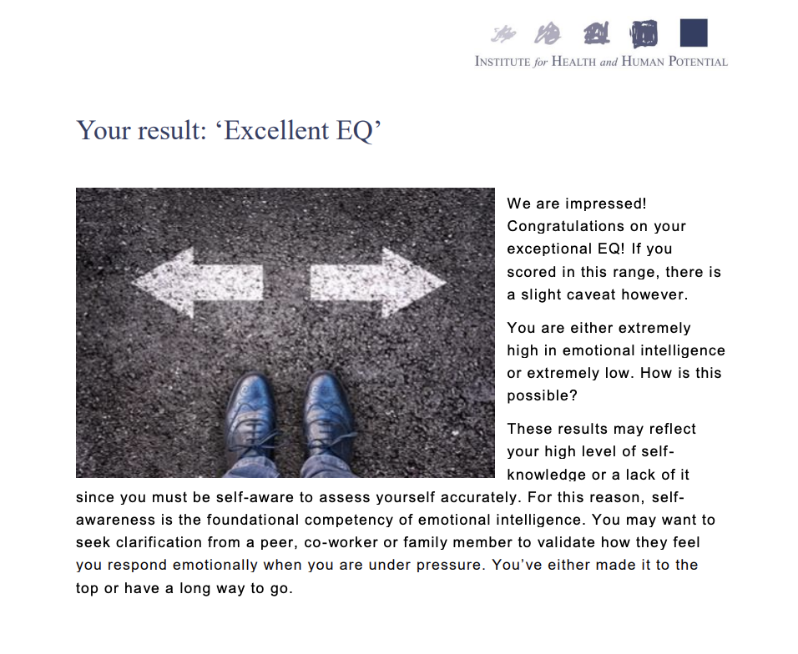

Part 3: Reflecting on your results complete the following positives, minuses and interesting (PMI Chart below).
Positives  (What were some of  the strengths?) | Minuses  (Anything you did not  agree with?) | Interesting  (Did anything surprise you?)

Task 2 Activity 2.5 Emotional Intelligence Quiz and PMI
Student Reflection - How well did you go with this step? (Please check the box below)
☐Not Submitted | ☐Beginning | ☐Consolidating | ☐Achieving | ☐Excelling
Student Comment (Optional):
Teacher Feedback
☐Not Submitted | ☐Beginning | ☐Consolidating | ☐Achieving | ☐Excelling
Not Submitted: No work has been submitted or attempted for this outcome. | Beginning: You have completed some aspects of this task. To bump it up you need to add more details to your PMI Chart. | Consolidating: You have completed your EI quiz and reflected on your results. In the PMI chart you have listed one piece of basic information for each category. To bump it up, more details for each category. | Achieving: You have completed your EI quiz and reflected on your results. In the PMI chart you have listed several ideas for each category. To bump it up add more detail using the 5 areas above in the EI explanation. | Excelling: You have completed your EI quiz and reflected on your results in detail. In the PMI chart you have listed a range of ideas in detail for each category. Well done!
Teacher Comment:

Task 2- Activity 2.6 Action plan

Part 1: We are always developing our emotional intelligence. To grow your emotional intelligence, pick three from the five areas of emotional intelligence (EI) to work on below individually and throughout your project work.

These five EI skills include- self-regulation, self-awareness, empathy, motivation and social skills.

Action plan template

Emotional Intelligence Categories | What am I going to do to improve this skill? (Be specific and action focused) | How will I know if I have improved these skills?  (How can I measure or see it?) | What will this look like for me as an individual? | What will this look like in a group setting?
Add one of the 5 EI skills here.
Add one of the 5 EI skills here.
Add one of the 5 EI skills here.

Task 2 Activity 2.6 Action plan
Student Reflection - How well did you go with this step? (Please check the box below)
☐Not Submitted | ☐Beginning | ☐Consolidating | ☐Achieving | ☐Excelling
Student Comment (Optional):
Teacher Feedback
☐Not Submitted | ☐Beginning | ☐Consolidating | ☐Achieving | ☐Excelling
Not Submitted: No work has been submitted or attempted for this outcome. | Beginning: You have attempted some sections of your action plan. To bump it up, you need to complete all sections of the action plan. | Consolidating: You have completed all parts of your action plan including what and how you are going to achieve your goals. You have stated what this looks like individually and in a group. To bump it up, you need to add more specific details to your responses. | Achieving: You have completed all parts of your action plan in detail including what and how you are going to achieve your goals. You have stated what this looks like individually and in a group. To bump it up, add more specific actions that connect to the goal you want to achieve. | Excelling: You have completed all parts of your action plan in detail, including what and how you are going to achieve your goals. You have stated what this looks like individually and in a group.
Teacher Comment:

Task 2- Activity 2.7 Example and Explanation

Part 1: Provide an example and explanation on how you have applied the strategies individually and within a group context throughout your project work or participation in fitness or community activities.
Individual Example
Explanation
Group Example
Explanation

Task 2 Activity 2.7 Example and explanation on how you have applied the strategies
Student Reflection - How well did you go with this step? (Please check the box below)
☐Not Submitted | ☐Beginning | ☐Consolidating | ☐Achieving | ☐Excelling
Student Comment (Optional):
Teacher Feedback
☐Not Submitted | ☐Beginning | ☐Consolidating | ☐Achieving | ☐Excelling
Not Submitted: No work has been submitted or attempted for this outcome. | Beginning: You have attempted to provide an individual and group example and explanation. To bump it up you need to provide more specific information. | Consolidating: You have provided a basic individual and group example and explanation. To bump it up, expand upon your responses with additional information. | Achieving: You have provided a detailed individual and group example and explanation. To bump it up add in a reflection of your growth. | Excelling: You have provided a highly detailed individual and group example and explanation. You have demonstrated the ability to reflect on your emotional intelligence growth. Well done!
Teacher Comment:

Before you move onto another task
Have you completed the following activities?
Task Checklist
Students will complete the following for PDS Task 2 – Who am I?
☐ Task 2- Activity 2.1 Personal identity rotation brainstorm and small group discussion
☐ Task 2- Activity 2.2 The Aboriginal Social and Wellbeing Wheel table reflection
☐ Task 2- Activity 2.3 Personal Identity Brainstorm
☐ Task 2- Activity 2.4 Who am I? Infographic
☐ Task 2- Activity 2.5 Emotional intelligence quiz & PMI chart
☐ Task 2- Activity 2.6 Action plan template
☐ Task 2- Activity 2.7 Example and explanation on how you have applied the strategies individually and within a group context.

