VCE Vocational Major

Unit 1 Striving Individuals
Literacy Curriculum
Support Materials

Authorised and published by the Victorian Curriculum and Assessment Authority
Level 7, 2 Lonsdale Street
Melbourne VIC 3000
ISBN: 978-1-xxxxxx-xx-x [email vcaa.media.publications@edumail.vic.gov.au for ISBN requests]
© Victorian Curriculum and Assessment Authority [year]

No part of this publication may be reproduced except as specified under the Copyright Act 1968 or by permission from the VCAA. Excepting third-party elements, schools may use this resource in accordance with the VCAA educational allowance. For more information go to https://www.vcaa.vic.edu.au/Footer/Pages/Copyright.aspx.
The VCAA provides the only official, up-to-date versions of VCAA publications. Details of updates can be found on the VCAA website at www.vcaa.vic.edu.au.
This publication may contain copyright material belonging to a third party. Every effort has been made to contact all copyright owners. If you believe that material in this publication is an infringement of your copyright, please email the Copyright Officer vcaa.copyright@edumail.vic.gov.au
Copyright in materials appearing at any sites linked to this document rests with the copyright owner/s of those materials, subject to the Copyright Act. The VCAA recommends you refer to copyright statements at linked sites before using such materials.
The VCAA logo is a registered trademark of the Victorian Curriculum and Assessment Authority.

Contact us if you need this information in an accessible format - for example, large print or audio.
Telephone (03) 9032 1635 or email vcaa.media.publications@edumail.vic.gov.au

Contents
Table of Contents
Literacy activities 4
Literacy Cultural Capital Folio (CCF) 4
CCF Task 1 - Letter to my teachers 4
CCF Task 2 - You Can’t Ask That! 6
CCF Task 3 – Podcasts 8
CCF Task 4 - On the Sauce 10
CCF Task 5 - Fyre Festival 12
CCF Task 6 - Oasis Project 15
CCF Task 7 - Jordan Rides the Bus 22
CCF Task 8 – 2040 24
CCF Task 9 -Work Related Writing Tasks 26
CCF Task 10 - The Final Quarter – Adam Goodes and Australia Day 28

Literacy activities

Literacy Cultural Capital Folio (CCF)

CCF Task 1 - Letter to my teachers
Task Checklist
Students will complete the following for Cultural Capital Folio – Letter to my teachers.
☐ CCF Task 1- Handwritten draft
☐ CCF Task 1- Edited letter
☐ CCF Task 1- Final copy

 Teacher advice- Write your own letter to your students using the correct letter format structure as an example.
 Link or add your own letter example here.

 Part 1: Write a draft letter to your teachers about you. This letter needs to be HANDWRITTEN as a draft. Word requirement 300 - 400 words.
Here are some ideas that you can include in your letter:
- General information, name, age etc.
- Something interesting about yourself.
- Things that you like to do for fun or as a hobby.
- Your past work experiences.
- Industry you would like to work in the future.
- What are some ideas you would like to explore in the VCE VM program?
- What is something you find challenging or distracting that can affect your work output?
- What gets you motivated?
- What do you hope to gain from the VCE VM program and how will this support your long-term goals?
Add/Insert copy of handwritten draft here.

Part 2: Edit your own letter use the following checklist.
Have I corrected any spelling errors? | ☐
Have I used formal language? | ☐
Have I used several paragraphs? | ☐
Is my letter clear and easy to read? | ☐
Part 3: Complete a typed final copy of your letter.
Add/Insert final typed copy of your letter here.

CCF Task 1-Letter to your teachers
Student Reflection - How well did you go with this step? (Please check the box below)
☐Not Submitted | ☐Beginning | ☐Consolidating | ☐Achieving | ☐Excelling
Student Comment (Optional):
Teacher Feedback
☐Not Submitted | ☐Beginning | ☐Consolidating | ☐Achieving | ☐Excelling
Not Submitted: No work has been submitted or attempted for this outcome. | Beginning: You have attempted some aspects of this task. To bump it up-You need to re-read the instructions and check that you have included a draft and final copy typed letter. Make sure you go through the editing process to fix up any spelling or punctuation errors | Consolidating: You have included a basic draft and typed letter. You have provided minimal information about yourself and goals for the year. There are some minor spelling and punctuation errors in your final draft. To bump it up- you need to expand your responses and include more information. Look over the prompts and sample letters for more ideas that you could customise to talk about yourself. Ensure you recheck your work and correct any spelling or punctuation errors. | Achieving: You have included a detailed draft and typed letter. You have provided several pieces of information about yourself and goals for the year. You have checked over your work and there are no spelling or punctuation errors in your final draft. To bump it up- you need to expand your responses and include a range of details about yourself that you are comfortable to share. Look over the prompts and sample letters for more ideas that you could customise to talk about yourself in greater detail. | Excelling: You have included a highly detailed draft and typed letter. You have provided a range of comprehensive information about yourself and goals for the year. You have checked over your work and there are no spelling or punctuation errors in your final draft. From your letter we get a sense of who you are and what you are working towards within the program. We are excited to be working with you. Excellent job!
Teacher Comment:

CCF Task 2 - You Can’t Ask That!

Task Checklist
Students will complete the following for Cultural Capital Folio – Letter to my teachers.
☐ CCF Task 2- Choose a You Can’t Ask That! Episode
☐ CCF Task 2- Before watching brainstorm
☐ CCF Task 2- After watching 3 main points
☐ CCF Task 2- Questions table

Part 1: Select an episode from the following website: ABC - You Can’t Ask That
Part 2: What is the episode you have selected about?
Part 3: BEFORE Watching- What do you already know about this issue? (If you don’t know anything, you could research four things).

Topic

Part 4: AFTER WATCHING- Explain three pieces of information that you found interesting or that you didn’t know prior to this episode.

1.
2.
3.
Part 5: Complete the following questions about the episode that you have just watched.

Question | Your Response
What was the main point of the episode?
Who’s story stood out to you most in the episode? Why?
How were people in the episode made to feel by society?
Has this issue personally affected you?
Do you feel differently about this topic after watching the episode?
What is something you would like to know more about from the episode?

CCF Task 2-You Can’t Ask that!
Student Reflection - How well did you go with this step? (Please check the box below)
☐Not Submitted | ☐Beginning | ☐Consolidating | ☐Achieving | ☐Excelling
Student Comment (Optional):
Teacher Feedback
☐Not Submitted | ☐Beginning | ☐Consolidating | ☐Achieving | ☐Excelling
Not Submitted: No work has been submitted or attempted for this outcome. | Beginning: You have shown some understanding of the topic before watching the video. You have attempted some responses throughout the task. To bump it up, you need to complete all aspects of the task with basic responses. | Consolidating: You have completed a basic brainstorm on the topic before viewing the You Can’t Ask That episode. You have provided brief and basic responses to the follow-up tasks. To bump it up, you need to add additional details to your brainstorm and responses. | Achieving: You have completed a detailed brainstorm on the topic before viewing the You Can’t Ask That episode. When answering ‘after watching’ questions, your responses included specific information from the episode. You have shown an understanding of the table by answering each question. You have checked your work and have shown the correct use of spelling and punctuation throughout all elements of the task. To bump it up- try to draw more connections from the episode to how this may impact you, the community you live in or people you know of. | Excelling: You have completed a highly detailed brainstorm on the topic before viewing the You Can’t Ask That episode. When answering ‘after watching’ questions, your responses included specific information from the episode. You have shown an understanding of the table by answering each question. You have expanded your responses and made broader connections to yourself, your community and other people you know of. You have checked your work and have shown the correct use of spelling and punctuation throughout all elements of the task.
Teacher Comment:

CCF Task 3 – Podcasts

Task Checklist
Students will complete the following for Cultural Capital Folio Task 3 – Podcasts
☐ Task 3- Summary of the Podcast
☐ Task 3- Review the Podcast
☐ Task 3- Discussion with a peer
Part 1: Choose a podcast to listen to.
Link in podcast platforms here that would be suitable for your students to access.

Part 2: What is the name of the podcast that you listened to?

Part 3: Summarise the podcast that you listened to in the table below.
WHO?
WHAT?
WHEN?
WHERE?
WHY?

Part 4: Who is the intended audience of your podcast?

Part 5: On a scale of 1 - 5, what would you rate this podcast?
1 – Boring  ☐ | 2  ☐ | 3  ☐ | 4  ☐ | 5 - Loved it!  ☐

Part 6: In four to five sentences, give a review on the podcast that you listened to.

Part 7: Share with one other person what your podcast is about and your review. Record one other person’s information about their selected podcast below.
Name of partner:
Name of their podcast:
What was their podcast about?
How did they rate it?
One piece of information from their review:

Task 3- Podcasts
Student Reflection - How well did you go with this step? (Please check the box below)
☐Not Submitted | ☐Beginning | ☐Consolidating | ☐Achieving | ☐Excelling
Student Comment (Optional):
Teacher Feedback
☐Not Submitted | ☐Beginning | ☐Consolidating | ☐Achieving | ☐Excelling
Not Submitted: No work has been submitted or attempted for this outcome. | Beginning: You have attempted some aspects of the tasks.  To bump it up, you need to include more detail in each of your responses. Make sure you check over your work once you think you are done for any spelling and punctuation that might need fixing before submitting. | Consolidating: You have provided a basic response to all aspects of this task. To bump it up, you need to expand your responses and add more specific information.  Make sure you check over your work once you think you are done for any spelling and punctuation that might need fixing before submitting. | Achieving: You have provided a detailed response to all aspects of this task. You have checked over your work to ensure there are no spelling or grammar errors. To bump it up, you need to expand your responses by making connections as to how the podcast connects to broader issues, ideas and cultural norms. | Excelling: You have provided a detailed response to all aspects of this task. You have made connections and links as to the purpose of the podcast, the intended audience and how it adds to the conversation of broader topics, issues and ideas. Excellent work!
Teacher Comment:

CCF Task 4 - On the Sauce

Task Checklist
Students will complete the following for Cultural Capital Folio Task 4 – On the Sauce
☐ Task 4- Discussion of student's own perspective of alcohol
☐ Task 4- Positive and Negative table
☐ Task 4- Rank the risk
☐ Task 4- Peer pressure brainstorm

Part 1: Watch the ‘On the Sauce’ Documentary. Shaun Micallef is searching for answers about why Australians drink.

Part 2: Discuss whether you think that drinking alcohol for teenagers is a ‘rite of passage’ (something people should experience as part of life)? Make dot point notes of the main discussion points.

Part 3: What do you identify as positives and negatives of teenage drinking? Shaun identified some positives to B&S Balls, 18th Birthday Parties in terms of alcohol. For example, social connections, friendships and community connections. What are your thoughts?
Positives | Negatives

Part 4: Rank the Risks - Reorder the following from your most risky scenario to the least.
- Having a drink with your parents.
- Drinking alone.
- Having a sculling competition with friends.
- Getting drunk at a pub.
- Drinking while on medication.
- Getting into a car with a driver who has been drinking.
Most risky scenario
Scenario | Your explanation
1.
2.
3.
4.
5.
6.
Least risky scenario

Part 5: Peer Pressure is often associated with teenage drinking habits. Brainstorm ways of how you think this could be addressed.
STOP PEER PRESSURE

Task 4-On the Sauce
Student Reflection - How well did you go with this step? (Please check the box below)
☐Not Submitted | ☐Beginning | ☐Consolidating | ☐Achieving | ☐Excelling
Student Comment (Optional):
Teacher Feedback
☐Not Submitted | ☐Beginning | ☐Consolidating | ☐Achieving | ☐Excelling
Not Submitted: No work has been submitted or attempted for this outcome. | Beginning: You have attempted some aspects of this task. To bump it up, recheck over the task and make sure you have provided a basic response to all sections, using complete and full sentence. | Consolidating: You have been able to provide a basic response to all aspects of the task. To bump it up, add more details to your responses and. Check over your work to ensure there are no spelling or punctuation errors. | Achieving: You have been able to provide a detailed response to all aspects of the task. You have checked over your work to ensure there are no spelling or grammar errors To bump it up, add more details to your explanation in ranking the risks and provide specific examples or evidence that supports your explanation. | Excelling: You have been able to provide a detailed response to all aspects of the task. You have included specific examples and evidence to support your explanation in the ranking of the risks table. You have checked over your work to ensure there are no spelling or grammar errors. Excellent work!
Teacher Comment:

CCF Task 5 - Fyre Festival

Task Checklist
Students will complete the following for Cultural Capital Folio Task 5 – Fyre Festival
☐ Task 5- One option chosen from the writing prompts.
☐ Task 5- Brainstorm of ideas
☐ Task 5- Written response
☐ Task 5- Review and final copy edit completed

Part 1: Watch the ‘Fyre Festival’ Documentary.

Part 2: Choose one of the following prompts to discuss in detail. You may need to complete additional research to develop an informed opinion. Circle or highlight which option you pick.

Option 1  How is social media used to both deceive and expose? Discuss with reference to the film and other contexts.  ☐ | Option 2  What is more important, intent or outcome? Discuss with reference to the film and other contexts.  ☐ | Option 3  ‘Defence Lawyer’  Summarise an opening statement of defence on behalf of Billy.  ☐
Option 4  News Article - Write an ‘Opinion Piece’ on this Fyre Fiasco  ☐ | Option 5  ‘Prosecutor’ - Summarise an opening statement on behalf of all customers against Billy.  ☐ | Option 6  Proper preparation prevents poor performance. Identify and outline what should’ve been done to make this Fyre Festival a success.  ☐

Part 3: Things to consider:
☐ Use the processes of planning, drafting and editing to produce written texts.
☐ Use language and tone appropriate to the text’s purpose and audience.
☐ Sequence and structure ideas and arguments to suit the purpose.
☐ Relate several ideas or pieces of information within a text rather than treating them as separate units.
☐ Provide evidence and argue persuasively from a point of view.
☐ Spell, punctuate and use grammar with reasonable accuracy.

Part 4: Brainstorm your ideas below.
TOPIC

Part 5: Write your response in the text box below.

Part 6: Read over your response and review the final copy checklist below.
☐ Use language appropriate to the text type
☐ Present your opinion and provide evidence to justify it
☐ Present your ideas in a logical sequence (using paragraphs).
☐ Edit your work for correct spelling, punctuation and grammar

CCF Task 5- Fyre Festival
Student Reflection - How well did you go with this step? (Please check the box below)
☐Not Submitted | ☐Beginning | ☐Consolidating | ☐Achieving | ☐Excelling
Student Comment (Optional):
Teacher Feedback
☐Not Submitted | ☐Beginning | ☐Consolidating | ☐Achieving | ☐Excelling
Not Submitted: No work has been submitted or attempted for this outcome. | Beginning: You have attempted to respond to the prompt but not completed all required aspects of this task. To bump it, make sure you complete all sections of the task and check over your spelling and punctuation. | Consolidating: You have been able to provide a basic response to your chosen prompt. You have shown the ability to include relevant information. To bump it up, you need to add more specific details and examples to your response. Make sure you check over your spelling and punctuation. | Achieving: You have been able to provide a detailed response to your chosen prompt. You have shown the ability to include relevant information and provided a sequential argument with supported evidence. You have checked over your response and there are no spelling or punctuation errors. To bump it up, you need to include an opposing viewpoint and then undermine this perspective/opinion to persuade your audience to agree with your perspective/position on the topic. | Excelling: You have been able to provide a highly detailed response to your chosen prompt. You have shown the ability to include relevant information and provided a sequential argument with supporting evidence. You have checked over your response and there are no spelling or punctuation errors. You have included an opposing viewpoint and then undermined this perspective/opinion to persuade your audience which strengthened your perspective/position on the topic. Fantastic work!
Teacher Comment:

CCF Task 6 - Oasis Project

Task Checklist
Students will complete the following for Cultural Capital Folio Task 6 – Oasis Project:
☐ Task 6- Oasis Project main take away.
☐ Task 6- Infographic analysis tables
☐ Task 6- Planning your infographic
☐ Task 6- Create your own infographic on an issue.

Part 1: Watch the ‘Oasis Project’.

Part 2: What was one piece of information that you learnt when watching ‘The Oasis Project’?

Part 3: Analyse the following infographics in the tables below.

Worked example
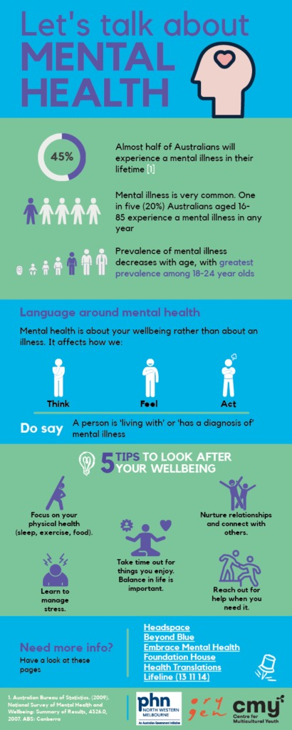  Link: Mental health infographic in English - Centre For Multicultural Youth (cmy.net.au) | Purpose:  What is the aim of this text? | This infographic aims to educate people about key factors that impact mental health.
 | Audience:  Who is the target audience for this infographic? | The target audience is aimed at teenagers. The resource was created by The Centre for Multicultural Youth.
 | Positives | Image used to repeat text points.  Short and simple tips (not a lot of writing).  Well formatted.  Appeals to target audience by using images and graphs which summarises complex information which is appealing to teenagers.
 | Negatives | Bottom section is cluttered.  Links to other sources but it is unclear which source is connected to which section in the infographic.
 | Interesting  (Could be elements that you would like to include in your infographic.) | I would like to include icons in my infographic for each bit of text.  I would like to keep the information short and simple.

Infographic 1:
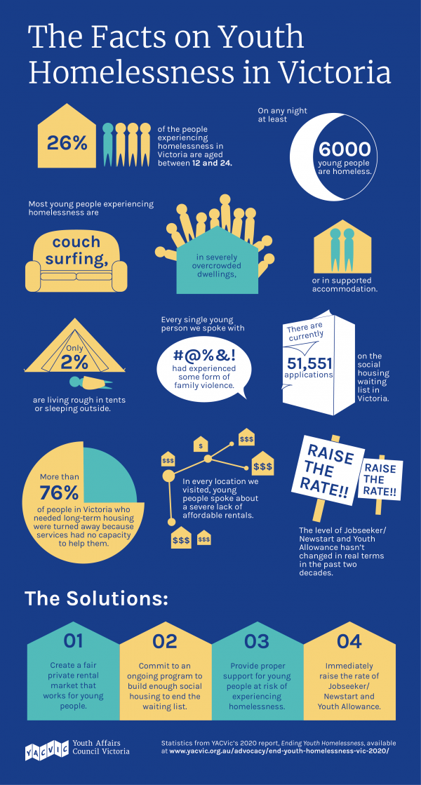  Link: Youth Affairs Council Victoria | Young people call on Government to commit to ending youth homelessness (yacvic.org.au) | Purpose:  What is the aim of this text?
Audience:
Who is the target audience for this infographic?

 | Positives
 | Negatives
Interesting

(Could be elements that you would like to include in your infographic.)

Infographic 1:
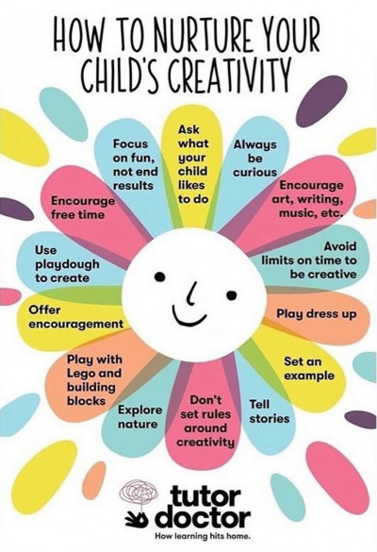  Link: Tuning Into Teens | Wyndham City | Purpose:  What is the aim of this text?
Audience:
Who is the target audience for this infographic?

 | Positives
 | Negatives
Interesting

(Could be elements that you would like to include in your infographic.)

Infographic 3:
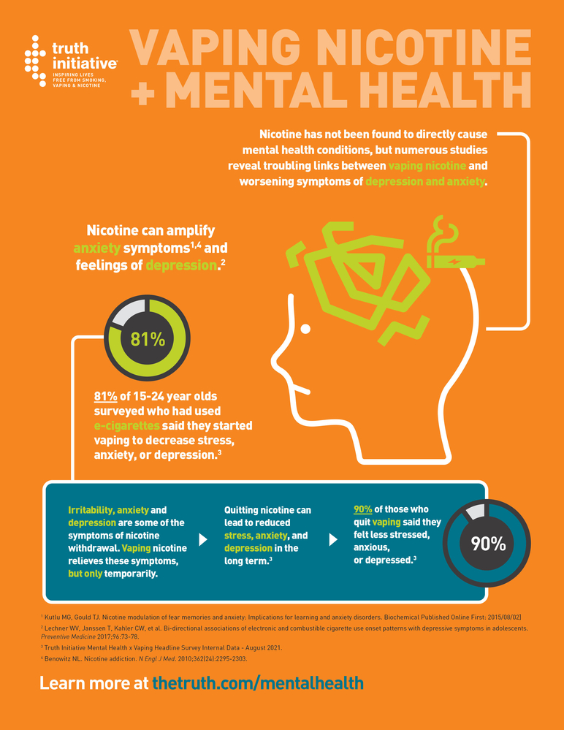  Link: Vaping Nicotine and Mental Health Infographic (truthinitiative.org) | Purpose:  What is the aim of this text?
Audience:
Who is the target audience for this infographic?

 | Positives
 | Negatives
Interesting

(Could be elements that you would like to include in your infographic.)

Part 4: Plan to create your own infographic. Select from the issues provided or choose your own. Then complete the questions below.
☐Alcohol
☐ Drugs
☐ Bullying
☐ Homelessness
☐ Poverty
☐ Individual differences
☐ Racism
☐OTHER - think of your own.

1. The issue I have chosen is...

2. My target audience for my poster is...

3. The purpose for my infographic is...

Part 5: Create your own infographic. You could use Canva or another infographic program of your choice.
Checklist to include:
☐ Clear title
☐ Multiple images related to your topic
☐ Statistics
☐ Information about the issue is clear and concise
☐ Subheadings

Add or insert the infographic in the space provided below.

CCF Task 6- Oasis Project
Student Reflection - How well did you go with this step? (Please check the box below)
☐Not Submitted | ☐Beginning | ☐Consolidating | ☐Achieving | ☐Excelling
Student Comment (Optional):
Teacher Feedback
☐Not Submitted | ☐Beginning | ☐Consolidating | ☐Achieving | ☐Excelling
Not Submitted: No work has been submitted or attempted for this outcome. | Beginning: You have been able to analyse some elements of the infographics. You have attempted to create an infographic. To bump it up, refer to the checklist to ensure all elements are included. | Consolidating: You have been able to analyse some elements of the infographic and provide a basic response to each element. To bump it up, you need to expand upon your responses to each element of the table. Refer to the checklist to ensure all elements are included. | Achieving: You have provided a detailed analysis of each of the infographics. You have been able to use your learnings from this analysis to help create your own basic infographic. To bump it up, try to add more relevant details or connections to your infographic. | Excelling: You have completed a highly detailed analysis of each of the infographics. You have been able to use your learnings from this analysis to help create your own detailed, informative and well-structured infographic. Great work!
Teacher Comment:

CCF Task 7 - Jordan Rides the Bus

Task Checklist
Students will complete the following for Cultural Capital Folio Task 7 – Jordan rides the bus.
☐ Task 7- Complete all questions.

Part 1: Watch the ‘Jordan rides the Bus’. See-SBS On Demand Link

Michael Jordan the greatest basketballer of all time decided on a career change after winning 3 NBA Championships in a row to baseball.

Jordan could articulate and explain why he wanted to do this as well as outline what steps he needed to achieve to make this happen. It is important to note the sheer determination and work ethic of his practice that Jordan displayed throughout his career.

Part 2: Respond to questions below focused on what your pathway is and can you
explain it?
1. What is your professional work goal now?

2. What VET certificate are you currently enrolled in?

3. Will this VET support your goal from Q1? Explain why or why not?

4. What work experience, structured workplace learning, or industry contacts are you currently connected with to support this goal from Q1? Explain.

5. What do you think will be some key employability skills required to achieve this goal? Explain why you selected each employability skill. Select a minimum of three.

6. Explain how choosing the VCE VM senior secondary certificate will assist you to achieve this goal.

Checklist:
☐ All my responses are in detail.
☐ I have included full sentences in each of my responses.
☐ I have made sure that my spelling is correct.
☐ I have used correct punctuation.

CCF Task 7- Jordan Rides the Bus
Student Reflection - How well did you go with this step? (Please check the box below)
☐Not Submitted | ☐Beginning | ☐Consolidating | ☐Achieving | ☐Excelling
Student Comment (Optional):
Teacher Feedback
☐Not Submitted | ☐Beginning | ☐Consolidating | ☐Achieving | ☐Excelling
Not Submitted: No work has been submitted or attempted for this outcome. | Beginning: You have attempted each question. To bump it up, you need to respond to all questions with basic complete sentences. | Consolidating: You have provided a basic response for each question. To bump it up, you need to add additional details to your responses and check your spelling and punctuation before submitting. | Achieving: You have provided a detailed response for each question. You have checked over your work to ensure there are no spelling or grammar errors. To bump it up, you need to add further information about what advice you could take away and apply to your own journey. | Excelling: You have provided a highly detailed response for each question. You have checked over your work to ensure there are no spelling or grammar errors. You have reflected on the documentary and made connections to how you can apply Michael Jordan’s advice to your own journey. Excellent work!
Teacher Comment:

CCF Task 8 – 2040

Task Checklist
Students will complete the following for Cultural Capital Folio Task 8 –2024- Fact Based Dreaming
☐ Task 8-Watch ’2040 - Join the Regeneration
☐ Task 8-Brainstorm
☐ Task 8-Climate Change Activity

Part 1: Watch ‘2040- Join the Regeneration’.

Part 2: Brainstorm what you would like to see in the future.

WHAT WOULD I LIKE TO SEE IN THE FUTURE ?

Part 3: The following text types below all relate to the issue of climate change. Analyse each of the texts below in the tables provided.

Who do you think the target audience is for this text?

Explain why you think this.

What is the purpose of this text?

What are three main points within this text?

How do they get their point of view across?

Think about the elements that you like about this text.

Task 8- 2040
Student Reflection - How well did you go with this step? (Please check the box below)
☐Not Submitted | ☐Beginning | ☐Consolidating | ☐Achieving | ☐Excelling
Student Comment (Optional):
Teacher Feedback
☐Not Submitted | ☐Beginning | ☐Consolidating | ☐Achieving | ☐Excelling
Not Submitted: No work has been submitted or attempted for this outcome. | Beginning: You have attempted some aspects of this task. To bump it up, You need to complete all sections of this task with basic responses. | Consolidating: You have been able to provide basic responses to all sections of this task. To bump it up, recheck your answers to see if they are correct. Check your spelling and grammar. Try to add additional details with specific information to your responses. | Achieving: You have been able to provide detailed responses to all sections of this task. You have provided the correct information in your responses. To bump it up, try to add additional details with specific information to your responses. | Excelling: You have been able to provide highly detailed responses to all sections of this task. You have provided the correct information in your responses. You have checked your responses to ensure there are no spelling or grammar errors. Excellent work!
Teacher Comment:

CCF Task 9 -Work Related Writing Tasks

Task Checklist
Students will complete the following for Cultural Capital Folio Task 9 – Work related writing tasks
☐ Task 9- Written response to at least one scenario.

Part 1: Select one of the following scenarios and complete the required task.

Option 1

For the last three weeks, you think that you have not been paid overtime correctly. Your base salary rate is $20 an hour and overtime is time and a half, making it $30 an hour. You worked the same amount of overtime the last three weeks, 4 hours each week. Your pay each week has been different. Your base salary minus tax should be $532. For the last three weeks you have been paid $540, then $560, then $532. The accounts person who looks after pay works in the central office in Melbourne, so you need to write him an email.

Write a draft of that email.

Option 2

Requesting leave
You started a new job 4 weeks ago. At your new company they have a no leave policy over the peak Christmas and new year period. HR have just sent an email out to all staff reminding them that there is no leave to be taken during this period. However, you have tickets for a 5-day festival and accommodation booked and paid for during this time. It is non-refundable. You told your new boss prior to taking the position that you have already planned to go away during their ‘no leave’ period. Your new boss said that this should be ok and to remind her closer to the date. You are about to book flights and just want to get formal approval before doing so.

Option 3

Choose one of the scenarios below. Read over it then response to the questions. You must label things correctly using a heading, the date and numbers the questions. Answer in full sentences.

Responsibility: Scenario 1
You asked your co-worker, Michael, to drop off a package at the post office after work on Tuesday. It is not too far out of the way home for him to do so, and you live farther away. It is important that the package be at its destination, National Manufacturing Incorporated, by noon on Wednesday. It includes a proposal that is going to be discussed at a meeting with international business partners who are in town only for that day. You find out on Wednesday afternoon that the package never arrived. You are responsible.

Points of view to consider:
• You, the employee
• Michael, the co-worker
• Management at National Manufacturing Incorporated
• The international business partners

QUESTIONS TO ANSWER
• How could you have handled your communication better?
• What steps should you have taken to clearly communicate with Lindsay?
• Where did the communication channels break down in this instance?
• How can you work to better serve customers in the future?
• What written communication and verbal communication could have helped in this instance?

Option 4

Scenario:
The business that you work for is a branch of a larger company that is based in Melbourne. They have five locations for their business in Victoria: Geelong, Melbourne, Shepperton, Albury and Warrnambool.
Business at the Geelong branch where you work has slowed down. Your boss has told you that you are required to work from the Albury branch for a month until work picks up again in Geelong. They will cover your travel costs to get there and accommodation. They will not cover your travel costs if you wish to return home each weekend.

Task One:
Brainstorm at least three things that you would do to check to see if your employer is allowed to send you to work in another location as part of your employment conditions.
Task Two:
List at least five ways that going up to Albury for a month may impact on your life in a negative way.
Are there any positives to this situation?
Task Three:
Draft a letter to your employer explaining why you do not wish to be sent to Albury for a month. Include details about why you should not have to do this (legally) and also how it will negatively impact you.

Part 2: Complete the following written responses.

- I have selected option…
- Complete your written response in the space below.
Add/type your response here.

Task 9- Work Related Writing Tasks
Student Reflection - How well did you go with this step? (Please check the box below)
☐Not Submitted | ☐Beginning | ☐Consolidating | ☐Achieving | ☐Excelling
Student Comment (Optional):
Teacher Feedback
☐Not Submitted | ☐Beginning | ☐Consolidating | ☐Achieving | ☐Excelling
Not Submitted: No work has been submitted or attempted for this outcome. | Beginning: You have attempted to write a response for this task. To bump it up, re-read the instructions and make sure you include all the information needed. | Consolidating: You were able to provide a basic written response. To bump it up, you need to include more information and details in your written response and check your spelling and grammar is correct. | Achieving: You were able to provide a detailed written response. To bump it up, try to add more details and check your spelling and grammar is correct. | Excelling: You have included two or more highly detailed written responses. You have checked that your responses contain correct spelling and grammar. Well done!
Teacher Comment:

CCF Task 10 - The Final Quarter – Adam Goodes and Australia Day

Task Checklist
You will complete the following for Cultural Capital Folio Task 10 - The Final Quarter – Adam Goodes and Australia Day
☐ Task 10-Written Responses
☐ Task 10- Watch the Final Quarter
☐ Task 10- Written feedback on the Final Quarter
☐ Task 10- Written response on Australia Day perspectives
☐ Task 10-View video ‘Debunking Andrew Bolt’.
☐ Task 10- Written responses to ‘Deep Listening’.

Part 1: Respond to the questions below before watching the documentary ‘The final quarter’.

1. Research and explain the difference between equality and equity?

2. What was your knowledge of this story before viewing the ‘Final Quarter’ Documentary?

Part 2: Watch the documentary ‘The final quarter’.

Part 3: Respond to the questions below after watching the documentary ‘The final quarter’.

1. What are your thoughts after viewing the Final Quarter?

2. Australia Day has become a divisive and controversial day, what is your understanding of both views?

CCF-Task 10 -The Final quarter
Student Reflection - How well did you go with this step? (Please check the box below)
☐Not Submitted | ☐Beginning | ☐Consolidating | ☐Achieving | ☐Excelling
Student Comment (Optional):
Teacher Feedback
☐Not Submitted | ☐Beginning | ☐Consolidating | ☐Achieving | ☐Excelling
Not Submitted: No work has been submitted or attempted for this outcome. | Beginning: You have completed/attempted some aspects of this reflection. Some parts are incomplete or require more information. To bump it up, complete all required sections of this task. | Consolidating: You have responded to all 4 questions with basic responses. To bump it up, add further details to your responses about your opinions, including how and why you have come to this viewpoint. | Achieving: You have responded to all 4 questions with detailed responses. To bump it up, expand on your responses further by commenting on if you think your opinions are similar or different to the broader community. Provide an explanation on why you think this might be. | Excelling: You have responded to all 4 questions with highly detailed responses. You have expanded upon your responses further by exploring if you think your opinions are similar or different to the broader community. You have provided a comprehensive explanation as to why you think this might be. Excellent work!
Teacher Comment:

Part 4: Watch the short clip below and respond to the following questions.

Media Watch Debunking Andrew Bolt (https://vimeo.com/352635106/608471eda9)

- How would deep listening have contributed to a greater understanding of what Adam Goodes was saying here?

- What is the connection between listening and judgement?

- How does failure to listen contribute to controversy?

Task 10 Part 4 – ‘Deep Listening’
Student Reflection - How well did you go with this step? (Please check the box below)
☐Not Submitted | ☐Beginning | ☐Consolidating | ☐Achieving | ☐Excelling
Student Comment (Optional):
Teacher Feedback
☐Not Submitted | ☐Beginning | ☐Consolidating | ☐Achieving | ☐Excelling
Not Submitted: No work has been submitted or attempted for this outcome. | Beginning: You have completed/attempted some aspects of this reflection. Some parts are incomplete or require more information. To bump it up, complete all required sections of this task. | Consolidating: You have responded to all 3 questions with basic responses. To bump it up, add further details to your responses. Watch/listen back to the clips to see what specific information you could use as examples. | Achieving: You have responded to all 3 questions with detailed responses. To bump it up, add further details to your responses of how you have come to the opinions you have developed. Watch/listen back to the clips to see what specific information you could use as supporting evidence or examples for further discussion. | Excelling: You have responded to all 3 questions with highly detailed responses. You have included further details to your responses about how you have come to the opinions you have developed. You have used specific information/examples from the clips to expand your responses. Excellent work!
Teacher Comment:

