VCE Vocational Major

Unit 1 Striving Individuals
Integrated Curriculum
Support Materials

Authorised and published by the Victorian Curriculum and Assessment Authority
Level 7, 2 Lonsdale Street
Melbourne VIC 3000
ISBN: 978-1-xxxxxx-xx-x [email vcaa.media.publications@edumail.vic.gov.au for ISBN requests]
© Victorian Curriculum and Assessment Authority [year]

No part of this publication may be reproduced except as specified under the Copyright Act 1968 or by permission from the VCAA. Excepting third-party elements, schools may use this resource in accordance with the VCAA educational allowance. For more information go to https://www.vcaa.vic.edu.au/Footer/Pages/Copyright.aspx.
The VCAA provides the only official, up-to-date versions of VCAA publications. Details of updates can be found on the VCAA website at www.vcaa.vic.edu.au.
This publication may contain copyright material belonging to a third party. Every effort has been made to contact all copyright owners. If you believe that material in this publication is an infringement of your copyright, please email the Copyright Officer vcaa.copyright@edumail.vic.gov.au
Copyright in materials appearing at any sites linked to this document rests with the copyright owner/s of those materials, subject to the Copyright Act. The VCAA recommends you refer to copyright statements at linked sites before using such materials.
The VCAA logo is a registered trademark of the Victorian Curriculum and Assessment Authority.

Contact us if you need this information in an accessible format - for example, large print or audio.
Telephone (03) 9032 1635 or email vcaa.media.publications@edumail.vic.gov.au

Contents
Table of Contents
5 Step project 5
Step 1- Ideas 5
Step 1- Activity 1.1 Brainstorm 6
Step 1- Activity 1.2 Health Promotion Research Analysis 7
Step 1- Activity 1.3 Comparison Tables 10
Step 1- Activity 1.4 Contribution to Padlet 11
Step 1- Activity 1.5 PMI Chart 12
Before you move onto Step 2 - Plan 13
Step 2 - Plan 14
Step 2- Activity 2.1 Guest Speakers (Before) 15
Step 2- Activity 2.2 Guest Speakers (During) 17
Step 2- Activity 2.3 Guest Speakers (After) 19
Step 2- Activity 2.4 Design Phase- Project Brainstorm and PMI 20
Step 2- Activity 2.5 Design Phase- Project statement and SMART goal 22
Step 2- Activity 2.6 Design Phase- Resource list and descriptions 23
Step 2- Activity 2.7 Design Phase- Identifying the mathematics table 24
Step 2- Activity 2.8 Design Phase- Problems and Solutions table 27
Step 2- Activity 2.9 Design Phase- Project measurement tools and evaluation of technology 28
Step 2- Activity 2.10 Email- handwritten draft and scaffold template 29
Step 2- Activity 2.11 Email- Final copy screenshot 31
Before you move onto Step 3 - Act 32
Step 3 – Act 33
Step 3 - Activity 3.1 Pre-program Survey 33
Step 3 - Activity 3.2 Program Log Record 35
Step 3 - Activity 3.3 post-program survey- Act on and use the mathematics. 42
Before you move onto Step 4 - Adapt 43
Step 4 – Adapt 44
Step 4 - Activity 4.1 Comparison of pre and post data sets 45
Step 4 - Activity 4.2 Wellbeing Explanation 45
Step 4 - Activity 4.3 Mathematical Toolkit 47
Step 4 - Activity 4.4 Numeracy Reflection Table 49
Step 4 - Activity 4.5 Three Recommendations for project improvement 51
Before you move onto Step 5 - Reflect 51
Step 5 - Reflect 52
Step 5 - Activity 5.1 Cluster Map 53
Step 5 - Activity 5.2 SWOT Analysis of Technology 54
Step 5 - Activity 5.3 Self Reflection 55
Step 5 - Activity 5.4 Peer Sharing Table and Pair Photo 56
Step 5 - Activity 5.5 Mathematics Problem Solving Cycle and Interview 57
Before you move onto another task 59

5 Step project

Step 1- Ideas
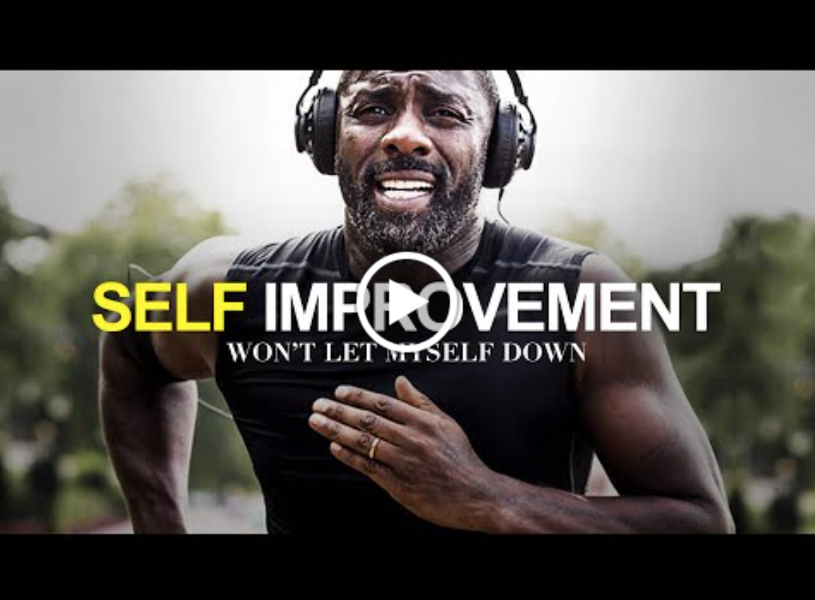

Video Link: https://youtu.be/RO4abBz6W7M?si=Y9fiwTrwzbQWzHp0
Task Checklist
Students will complete the following for Step 1- Ideas.
☐Step.1 Activity 1.1 Brainstorm
☐Step 1. Activity 1.2 Health promotion research analysis
☐Step. 1 Activity 1.3 Comparison table
☐Step.1 Activity 1.4 Screenshot of students’ contribution to class Padlet
☐Step.1 Activity 1.5 PMI chart

Key vocabulary (you need to know)
Health: the general condition of the body or mind with reference to soundness and vigour.
Well-being: a good or satisfactory condition of existence; a state characterised by health, happiness, and prosperity; welfare
Health promotion: is the process of enabling people to increase control over, and to improve, their health.
Emotional: subject to or easily affected by emotion.
Social: relating to, devoted to, or characterised by friendly companionship or relations.
Physical: of or relating to the body.
Cultural: of or relating to culture or cultivation.
Economic: pertaining to the production, distribution, and use of income, wealth, and commodities.
Environmental: of or relating to the totality of things, conditions, influences, cultural forces, that surround and shape the life of a person or a population.
Geographical: of or relating to the natural features, population, industries, of a region or regions.

Step 1- Activity 1.1 Brainstorm
 Part 1: In a pair or small group, brainstorm what you currently know about health and wellbeing. Include factors that positively or negatively impact health and wellbeing.

Think about factors such as emotional, social, physical, cultural, economic, environmental or geographical.

Present your brainstorm below using one of the following tools or pick your own:
- Pen and paper
- Canva
- MindMup
- Mindmeister

Add brainstorm here.

Activity 1.1- Brainstorm
Student Reflection - How well did you go with this step? (Please check the box below)
☐Not Submitted | ☐Beginning | ☐Consolidating | ☐Achieving | ☐Excelling
Student Comment (Optional):
Teacher Feedback
☐Not Submitted | ☐Beginning | ☐Consolidating | ☐Achieving | ☐Excelling
Not Submitted: No work has been submitted or attempted for this activity. | Beginning: You were able to show, in a brainstorm, some knowledge about health and wellbeing however, you did not demonstrate an understanding of factors that impact health and wellbeing. To bump it up try to add more details so that you have more ideas about different factors that impact health and wellbeing. | Consolidating: You were able to create a brainstorm about what you currently know about health and wellbeing. You have shown evidence of several different factors that can impact health and wellbeing. To bump it up try to add more details so you can show a range of factors that impact on health and wellbeing. | Achieving: You were able to create a detailed brainstorm about what you currently know about health and wellbeing. You have shown evidence of a range of factors that can impact health and wellbeing. To bump it up try to add more details and connections. | Excelling: You were able to create a highly detailed brainstorm about what you currently know about health and wellbeing. You have shown evidence of a range of factors, in detail, that can both positively and negatively impact on health and wellbeing. Well done!
Teacher Comment:

Step 1- Activity 1.2 Health Promotion Research Analysis

 Part 1: Complete the table analysis below for two articles.

Choose your own Health Promotion Service or select from the following:

Surf Coast Walk
Park Run
Vic Health Programs 7 Projects
Active April
This Girl Can
Think - Mental Health

Worked example
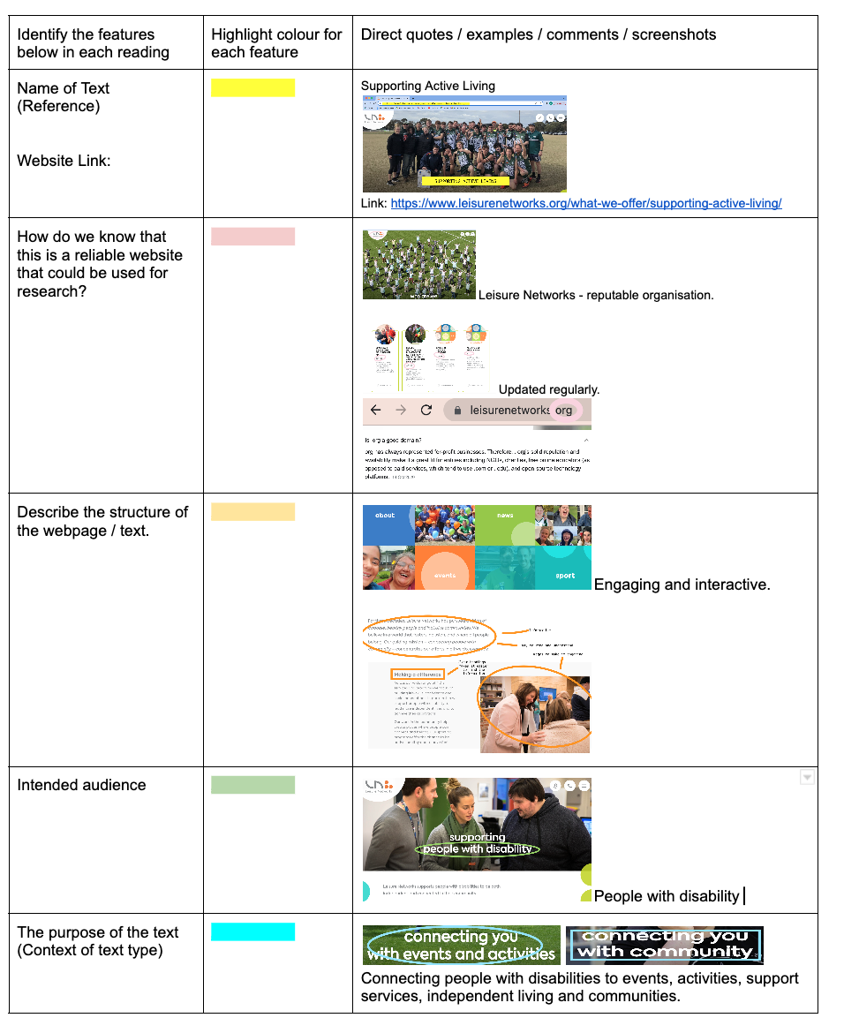

Health Promotion Service Article or Website One:
Identify the features below in each reading. | Highlight colour for  each feature. | Direct quotes, examples or comments/screenshots
Name of Text:
(Reference)

Author:

Website Link:

Outline how you know this is a reliable website that could be used for research.
Intended audience.
The purpose of the text.

(Context of text type)

Identify three key points of the program.
Provide a summary of the article.

(Who, what, when, why, where and how)

Health Promotion Service Article or Website Two:
Identify the features below in each reading. | Highlight colour for  each feature. | Direct quotes, examples or comments/screenshots
Name of Text:
(Reference)

Author:

Website Link:

Outline how you know this is a reliable website that could be used for research.
Intended audience.
The purpose of the text.
(Context of text type)

Identify three key points of the program.
Provide a summary of the article.

(Who, what, when, why, where and how)

Activity 1.2- Health Promotion Research Analysis
Student Reflection - How well did you go with this step? (Please check the box below)
☐Not Submitted | ☐Beginning | ☐Consolidating | ☐Achieving | ☐Excelling
Student Comment (Optional):
Teacher Feedback
☐Not Submitted | ☐Beginning | ☐Consolidating | ☐Achieving | ☐Excelling
Not Submitted: No work has been submitted or attempted for this activity. | Beginning: You have not completed all elements of the table or have not included the correct information. To bump it up you need to provide a basic response to all elements of the table with the correct information. | Consolidating: You have been able to complete all elements of the table with the correct information. To bump it up you can expand your responses in greater detail. | Achieving: You have been able to complete all elements of the table in detail with the correct information. To bump it up you can expand your responses in greater detail. | Excelling: You have been able to complete all aspects of the analysis table in significant detail. Excellent work well done!
Teacher Comment:

Step 1- Activity 1.3 Comparison Tables
Part 1: Complete the following comparison tables for your articles to outline the similarities and differences.
Similarities | Differences

Activity 1.3- Comparison Table
Student Reflection - How well did you go with this step? (Please check the box below)
☐Not Submitted | ☐Beginning | ☐Consolidating | ☐Achieving | ☐Excelling
Student Comment (Optional):
Teacher Feedback
☐Not Submitted | ☐Beginning | ☐Consolidating | ☐Achieving | ☐Excelling
Not Submitted: No work has been submitted or attempted for this activity. | Beginning: You have shown some understanding of either similarities or differences within your program but have missed some elements of the comparison table. To bump it up you need to provide further details and complete all sections of the comparison table. | Consolidating: You have been able to show some similarities and differences between the health promotion programs you have explored. To bump it up you need to add further details to your responses. | Achieving: You have demonstrated a detailed understanding of the similarities and differences between the health promotion programs you have explored. To bump it up you need to extend your responses further and draw additional connections between the similarities and differences between the health promotion programs you have explored. | Excelling: You have demonstrated a thorough understanding of the similarities and differences between the health promotion programs you have explored. Excellent work well done!
Teacher Comment:

Step 1- Activity 1.4 Contribution to Padlet
Part 1: In a group, discuss the effects of technology on individuals and society. Think about communication, lifestyle, employment, citizenship, democracy, culture, safety and security, social connectedness, transportation, environment, medicine and science.

After the discussion, describe one of your ideas on the class padlet.

Teacher Advice: See example image below. You will need to create your own Padlet and link it to the section above. Delete the image and this information when you give this activity to your students.

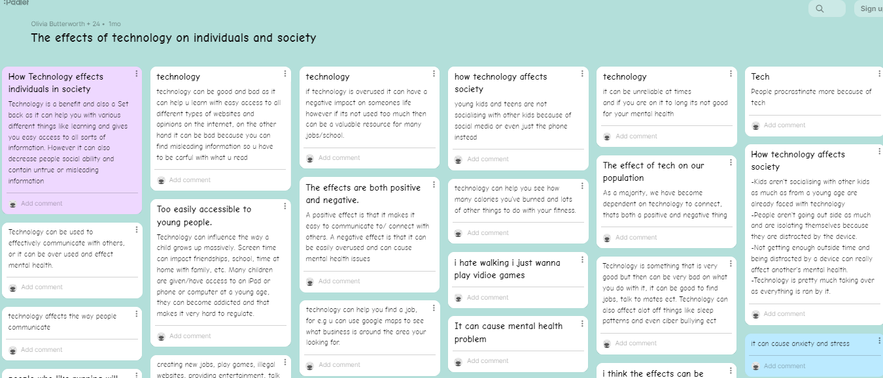

Activity 1.4- Padlet contribution screenshot
Student Reflection - How well did you go with this step? (Please check the box below)
☐Not Submitted | ☐Beginning | ☐Consolidating | ☐Achieving | ☐Excelling
Student Comment (Optional):
Teacher Feedback
☐Not Submitted | ☐Beginning | ☐Consolidating | ☐Achieving | ☐Excelling
Not Submitted: No work has been submitted or attempted for this activity. | Beginning: You have inserted a photo of the class discussion board. However, you haven’t demonstrated your contribution. To bump it up you need to add at least one comment to the Padlet. | Consolidating: You have demonstrated your contribution towards the class discussion board with at least one comment and inserted a screenshot. To bump it up you need to add additional detailed comments to the Padlet. | Achieving: You have demonstrated your contribution towards the class discussion board by contributing two comments and inserted a screenshot. To bump it up you need to add additional detailed comments to the Padlet. | Excelling: You have demonstrated your contribution towards the class discussion board by contributing several comments and inserting a screenshot. Great work!
Teacher Comment:

Step 1- Activity 1.5 PMI Chart
Part 1: Select one of the health promotion programs from Activity 1.2 that use technology to reach their audience.

Name of Program: Type name here.

Using a PMI chart, explain how the program uses technology to reach their target audience.

Positives | Minuses | Interesting  (Think about what they may be able to do better, describe and explain).
1.  2. | 1.  2. | 1.  2.

Activity 1.5- PMI Chart
Student Reflection - How well did you go with this step? (Please check the box below)
☐Not Submitted | ☐Beginning | ☐Consolidating | ☐Achieving | ☐Excelling
Student Comment (Optional):
Teacher Feedback
☐Not Submitted | ☐Beginning | ☐Consolidating | ☐Achieving | ☐Excelling
Not Submitted: No work has been submitted or attempted for this activity. | Beginning: You have been able to attempt some elements of the PMI chart, but some elements are incomplete or require more detail. To bump it up your response needs to complete all elements of the PMI chart with basic responses. | Consolidating: You have been able to explain how the program uses technology by completing all elements of the PMI chart with basic information. To bump it up your responses need to include more details. | Achieving: You have been able to explain how the program uses technology by completing all elements of the PMI chart with enough detail. To bump it up your responses need to include higher levels of detail. | Excelling: You have been able to explain how the program uses technology by completing all elements of the PMI chart with high levels of detail.
Teacher Comment:

Before you move onto Step 2 - Plan
Have you completed the following activities?
Task Checklist
☐Activity 1.1-Brainstorm
☐Activity 1.2-Health promotion research analysis
☐Activity 1.3-Comparision table
☐Activity 1.4-Screenshot of students’ contribution to class Padlet
☐Activity 1.5-PMI chart

Step 2 - Plan


Task Checklist
Students will complete the following for Step 2- Plan.
​☐ Step.2 Activity 2.1 Guest speakers: Research (Before)
☐ Step.2 Activity 2.2 Guest speakers: Note taking (During)
☐ Step.2 Activity 2.3 Guest speakers: SWOT (After)
☐ Step.2 Activity 2.4 Design phase: Project brainstorm and PMI
☐ Step.2 Activity 2.5 Design phase: Project statement and SMART goal
☐ Step.2 Activity 2.6 Design phase: Resource list and descriptions
☐ Step.2 Activity 2.7 Design phase: Identifying the mathematics table.
☐ Step.2 Activity 2.8 Design phase: Problems and solutions table
☐ Step.2 Activity 2.9 Design phase: Project measurement tools and evaluation of technology
☐ Step.2 Activity 2.10 Email: Handwritten draft and template
☐ Step.2 Activity 2.11 Email: Final copy

Key vocabulary (you need to know)
Health: the general condition of the body or mind with reference to soundness and vigour.
Well-being: a good or satisfactory condition of existence; a state characterised by health, happiness, and prosperity; welfare
Health promotion: It enables people to increase control over, and improve, their health.

Step 2- Activity 2.1 Guest Speakers (Before)
Part 1: A panel of guest speakers has been formed to share their experiences in the health and wellbeing space. You will be required to complete the following tasks below.

Part 2: The Guest Speaker I have chosen is…

Guest Speakers List
Chloe - F45

Olsen - Body Sculpt

Matt – Boneyards

Michelle – Wellbeing

Regan Neoh - Youth Services

Part 3: Search for the website of your selected organisation or presenter. Add the link to the website in the space below.

Part 4: List two things below that you learnt from your research. This needs to include the requirements for undertaking various individual or group activities or voluntary work in the community. For example- fees, skills, levels of fitness, equipment, space, and qualifications.

Example: Anytime Fitness: The equipment at Anytime Fitness includes: Treadmills, Ellipticals, Exercise Cycles, Stair Climbers, Rowing Machines, Free Weights, Racks, Synergy 360 Systems, Cable Crossovers, Kettlebells, Lateral X Trainers, Amt Cross-trainers.
1
2

Part 5: In your group, come up with two questions that you would like to know about the organisation that you could not find from your research.

Example: To work at Anytime Fitness, are all staff members required to have a personal training qualification?
1
2

Activity 2.1- Guest speaker research (Before)
Student Reflection - How well did you go with this step? (Please check the box below)
☐Not Submitted | ☐Beginning | ☐Consolidating | ☐Achieving | ☐Excelling
Student Comment (Optional):
Teacher Feedback
☐Not Submitted | ☐Beginning | ☐Consolidating | ☐Achieving | ☐Excelling
Not Submitted: No work has been submitted or attempted for this activity. | Beginning: You attempted some aspects of the tasks. To bump it up, complete all sections with basic responses. | Consolidating: You completed all aspects of the tasks. You have provided basic responses. To bump it up you need to add more details to your responses. | Achieving: You completed all aspects of the tasks. You have provided detailed responses. To bump it up add in links to how your research could fit in with your project idea. | Excelling: You completed all aspects of the tasks. You have provided highly detailed and comprehensive responses. You have made clear links to how your research could fit in with your own project ideas. Great work!
Teacher Comment:

Step 2- Activity 2.2 Guest Speakers (During)
Part 1: Fill in the note taking scaffold provided below or use a blank piece of paper to take notes from the guest speakers and insert a photo or the link to your document below. Consider how the guest speakers design, implement and evaluate their programs.
Note taking template
Guest Speaker | Notes
Name
How did they get into what they are doing now?

What did they do before?

What do they love about what they do?

What are some of the challenges in this industry? (general or business)

The most recent ‘Youth Survey’ in our shire states the issues of greatest personal concern to young people 15–25-year-old.  What are the speaker's thoughts on this? | 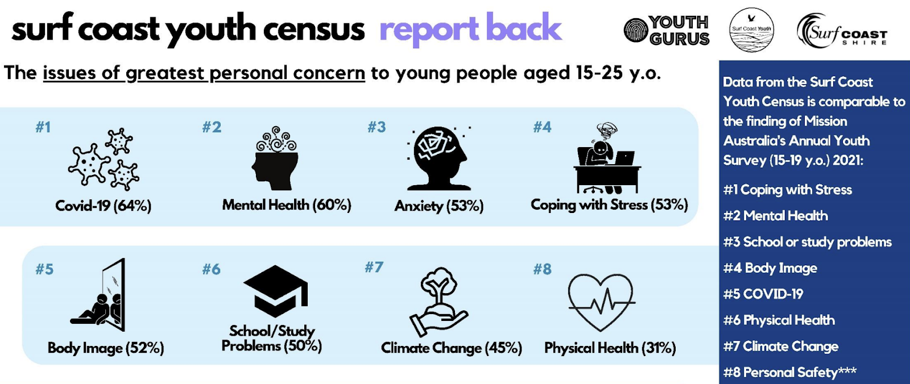  Reference: Surf-Coast-Youth-Census-Final-Report-Presentation.pdf
Is numeracy something they use in their work life and is there something that stands out to them?

How do they use numeracy?

Do they like or dislike this?
If your question has not been answered throughout this session, please ask it and record the answer.

Alternatively, you can take your own notes and insert them in the space below.

Activity 2.2- Note taking (During)
Student Reflection - How well did you go with this step? (Please check the box below)
☐Not Submitted | ☐Beginning | ☐Consolidating | ☐Achieving | ☐Excelling
Student Comment (Optional):
Teacher Feedback
☐Not Submitted | ☐Beginning | ☐Consolidating | ☐Achieving | ☐Excelling
Not Submitted: No work has been submitted or attempted for this outcome. | Beginning: You made an effort to actively listen and attempted to take some notes from the guest speaker. To bump it up you need to add more details to your notes. | Consolidating: You demonstrated the ability to actively listen and take some basic notes from the guest speaker. To bump it up you need to include basic notes of how the guest speaker designs, implements and evaluates their programs. | Achieving: You demonstrated the ability to actively listen and collate some basic notes from the guest speaker about how they design, implement and evaluate their programs. To bump it up you need to add more specific details for how the guest speaker designs, implements and evaluates their programs. | Excelling: You demonstrated the ability to actively listen and collate highly detailed notes from the guest speaker about how they design, implement and evaluate their programs. Excellent work! Well done.
Teacher Comment:

Step 2- Activity 2.3 Guest Speakers (After)
Part 1: Complete the following SWOT analysis chart for your chosen guest speaker or organisation.
STRENGTHS | WEAKNESSES
Example: The speaker gave examples from their companies, and this was engaging.  1. | Example: The speaker spoke for a long time, and I lost interest in what they were saying.  1.
OPPORTUNITIES | THREATS
Example: The speaker could make their chat more engaging by including a presentation, photos or videos.  1. | Example: Time was a threat because, due to a limited amount of time that they had to speak, they may not have shared everything they wanted to.  1.

Activity 2.3- SWOT
Student Reflection - How well did you go with this step? (Please check the box below)
☐Not Submitted | ☐Beginning | ☐Consolidating | ☐Achieving | ☐Excelling
Student Comment (Optional):
Teacher Feedback
☐Not Submitted | ☐Beginning | ☐Consolidating | ☐Achieving | ☐Excelling
Not Submitted: No work has been submitted or attempted for this activity. | Beginning: You have attempted some parts of the SWOT analysis chart. To bump it up, complete all sections of your SWOT analysis. | Consolidating: You have completed all parts of the SWOT analysis chart and provided basic responses. To bump it up you need to add more details to your responses. | Achieving: You have completed all parts of the SWOT analysis chart and provided detailed responses. To bump it up you need to add additional details. | Excelling: You have completed all parts of the SWOT analysis chart and provided detailed and highly comprehensive responses. Excellent work!
Teacher Comment:

Step 2- Activity 2.4 Design Phase- Project Brainstorm and PMI
Part 1: In a group, brainstorm project ideas that you would like to be involved in.
Insert picture of your brainstorm here.

Part 2: From the brainstorm, select two project ideas and complete the below PMI chart for each:
Project Idea One:
Plus | Minus | Interesting
Example: I get to work on improving my fitness. | Example: This project is time consuming. | Example: Learning how to use new gym equipment.
Project Idea Two:
Plus | Minus | Interesting
Example: I get to work on improving my fitness. | Example: This project is time consuming. | Example: Learning how to use new gym equipment.

Activity 2.4- Project statement and PMI
Student Reflection - How well did you go with this step? (Please check the box below)
☐Not Submitted | ☐Beginning | ☐Consolidating | ☐Achieving | ☐Excelling
Student Comment (Optional):
Teacher Feedback
☐Not Submitted | ☐Beginning | ☐Consolidating | ☐Achieving | ☐Excelling
Not Submitted: No work has been submitted or attempted for this outcome. | Beginning: You have attempted some aspects of the brainstorm section. You have attempted to complete some sections of the PMI charts for your top two project ideas. To bump it up you need to complete all aspects of the task with basic responses. | Consolidating: You have completed a basic brainstorm of ideas on how to improve your health and wellbeing. You have completed all required sections of the PMI charts for your top two project ideas. You have provided basic responses. To bump it up you need to add more details to your responses. | Achieving: You have completed a detailed brainstorm of ideas on how to improve your health and wellbeing and made links to community connections. You have attempted some sections of the PMI charts for your top two project ideas. To bump it up you need to make clearer links to community connections. | Excelling: You have completed a highly detailed brainstorm of ideas on how to improve your health and wellbeing with clear links to community connections. You have completed all required sections of the PMI charts for your top two project ideas. You have provided highly detailed and comprehensive responses. Great work!
Teacher Comment:

Step 2- Activity 2.5 Design Phase- Project statement and SMART goal

Part 1: State what your project is below:
My project is...
Part 2: In what context, activity or program will your project occur?
Add your response here.

Part 3: Use the following SMART goal scaffold to help you create a goal for your project. If you need more information on how to make a SMART goal watch the video here.

Element of SMART goal: | Things to think about: | How is this element included in your project?
Specific | What do you want to accomplish?
Measurable | How will you know when you have accomplished your goal?
Attainable | How can the goal be accomplished? Is this realistic?
Relevant | How is it relevant for you?
Timely | When will the goal be accomplished?

Activity 2.5- Design Phase – project statement and SMART goal
Student Reflection - How well did you go with this step? (Please check the box below)
☐Not Submitted | ☐Beginning | ☐Consolidating | ☐Achieving | ☐Excelling
Student Comment (Optional):
Teacher Feedback
☐Not Submitted | ☐Beginning | ☐Consolidating | ☐Achieving | ☐Excelling
Not Submitted: No work has been submitted or attempted for this outcome. | Beginning: You have attempted to state what your project idea is and have begun to develop a SMART goal. To bump it up you need to state what your project is and develop a basic SMART goal to work towards for your project. | Consolidating: You have stated what your project idea is and developed a basic SMART goal. To bump it up you need to add more details to your SMART goal to work towards for your project. | Achieving: You have stated what your project idea is and developed a detailed SMART goal. To bump it up you need to add more information to both your project statement and SMART goal. | Excelling: You have explained in detail what your project idea is and developed a comprehensive SMART goal. Well done! Excellent work.
Teacher Comment:

Step 2- Activity 2.6 Design Phase- Resource list and descriptions
Part 1: For your project to be successful what resources will you need and how are you going to use them?
Complete the table below (Add additional rows if you need).
Think - Equipment, Venue, Materials, Experts.

List the Resources below: | Describe how you are going to use the resource:
Example: Yoga Mat | Example: I will need a yoga mat because my project is learning a yoga routine. I want to be able to feel comfortable whilst practicing yoga. Using a yoga mat is beneficial in reducing my risk of injury from slips or falls.

Activity 2.6- Design Phase – Resource list and descriptions
Student Reflection - How well did you go with this step? (Please check the box below)
☐Not Submitted | ☐Beginning | ☐Consolidating | ☐Achieving | ☐Excelling
Student Comment (Optional):
Teacher Feedback
☐Not Submitted | ☐Beginning | ☐Consolidating | ☐Achieving | ☐Excelling
Not Submitted: No work has been submitted or attempted for this outcome. | Beginning: You have attempted some sections of this task. To bump it up you need to provide a basic response for all sections. | Consolidating: You have listed the resources and provided a basic description of how the resources will be used in your project. To bump it up you need to include more information about how the resource will be used in your project. | Achieving: You have listed the resources and provided a detailed description of how the resources will be used in your project. To bump it up you need to expand your list of resources and include more information about how the resources will be used in your project. | Excelling: You have listed a comprehensive list of the resources and provided a highly detailed description of how the resources will be used in your project. Excellent work!
Teacher Comment:

Step 2- Activity 2.7 Design Phase- Identifying the mathematics table
Part 1: In the left-hand column tick the box of the different mathematical skills you will require for this project. In the right-hand column describe how you will use this skill in your project.
Worked example
Click on the checkbox to select a  mathematical skill | Describe how you are going to use the mathematical skill in your project
Number:  ☐ Reading numbers - place value and decimal place value  ☒ Practical calculations with whole numbers and decimals  ☐ Using common fractions and decimals  ☐ Calculate increase and decrease of percentages  ☐ Using Proportions or ratios | - Understanding the weights to use for my workouts and how much I should increase these weights.  - As a measurement tool. Measuring how fast I can run 400 metres and then see if that improves throughout the program.
Shape:  ☒ Reflection rotation and symmetry.  ☐ Name 2D and 3D shapes  ☐ Identifying patterns of shapes | - Being able to utilise the space effectively within a gym environment. Understand the equipment's shapes and how it will effectively fit in the space.
Quantity and Measures:  ☐ Estimate and measure familiar objects and distances  ☐ Determine measurement of distance, perimeter, area and volume  ☐ Measurement conversion  ☐ Read and interpret time and temperature  ☒ Calculations using time months, weeks, days and hours.  ☐ Use simple mathematical expressions | - Using my diary and scheduling in each of my sessions over term.  - Planning my workout to go for the session duration.
Relationships:  ☐ Substitution with simple formulas to find solutions to everyday problems  ☐ Apply rates such as km/hr.  ☒ Formulas to find solutions for area amounts or costing | - Calculate how many km you are doing on each piece of equipment.  - Use google maps to work out how long it will take me to walk to the gym.

Click on the checkbox to select a  mathematical skill | Describe how you are going to use the mathematical skill in your project
Number:
☐ Reading numbers - place value and decimal place value.
☐ Practical calculations with whole numbers and decimals.
☐ Using common fractions and decimals.
☐ Calculate increase and decrease of percentages.
☐ Using Proportions or ratios.
Shape:
☐ Reflection rotation and symmetry.
☐ Name 2D and 3D shapes.
☐ Identifying patterns of shapes.
Quantity and Measures:
☐ Estimate and measure familiar objects and distances.
☐ Determine measurement of distance, perimeter, area and volume.
☐ Measurement conversion.
☐ Read and interpret time and temperature.
☐ Calculations using time months, weeks, days and hours.
☐ Use simple mathematical expressions.
Relationships:
☐ Substitution with simple formulas to find solutions to everyday problems.
☐ Apply rates such as km/hr.
☐ Formulas to find solutions for area amounts or costing.

Activity 2.7- Identifying the mathematics table
Student Reflection - How well did you go with this step? (Please check the box below)
☐Not Submitted | ☐Beginning | ☐Consolidating | ☐Achieving | ☐Excelling
Student Comment (Optional):
Teacher Feedback
☐Not Submitted | ☐Beginning | ☐Consolidating | ☐Achieving | ☐Excelling
Not Submitted: No work has been submitted or attempted for this outcome. | Beginning: You have attempted to select some of the mathematical skills. You have tried to link how this mathematical skill will be used in your project. To bump it up you need to select a mathematical skill from each category and provide a basic explanation for how you will use this in your project. | Consolidating: You have selected a mathematical skill from each of the numeracies. You have given a basic description of how these are going to be used in your project. To bump it up you need to include more details about how you are going to show these mathematical skills in your project. | Achieving: You have selected a mathematical skill from each of the numeracies. You have given a detailed description of how these are going to be used in your project. To bump it up you need to add specific details about when and how these mathematical skills will be demonstrated in your project. | Excelling: You have selected a mathematical skill from each of the numeracies. You have given a highly detailed description of when and how these mathematical skills will be used in your project. Well done! Excellent work.
Teacher Comment:

Step 2- Activity 2.8 Design Phase- Problems and Solutions table
Part 1: Think about the possible issues, problems or hazards for your program and how these could be managed.
Potential problem/issue/hazard | How could this problem be  prevented or resolved?
Example: During my project, there is a potential for injury. | Example: Ensure that you do a warmup activity and stretches before beginning the program.

Activity 2.8- Problems and solutions table
Student Reflection - How well did you go with this step? (Please check the box below)
☐Not Submitted | ☐Beginning | ☐Consolidating | ☐Achieving | ☐Excelling
Student Comment (Optional):
Teacher Feedback
☐Not Submitted | ☐Beginning | ☐Consolidating | ☐Achieving | ☐Excelling
Not Submitted: No work has been submitted or attempted for this outcome. | Beginning: You have attempted to identify some potential problems, issues or hazards within your project idea. To bump it up you need to include responses to how you can resolve or prevent the problem, issue or hazard occurring within your project. | Consolidating: You have identified some potential problems, issues or hazards within your project idea. You have given a basic response on how this problem, issue or hazard could be resolved or prevented. To bump it up you need to add further details on how you will resolve or prevent the problem, issue or hazard occurring within your project. | Achieving: You have identified several potential problems, issues or hazards within your project idea. You have given a detailed response on how this problem, issue or hazard could be resolved or prevented. To bump it up you need to include more potential problems, Issues or hazards and detailed responses on how to prevent or resolve them. | Excelling: You have identified and described a range of potential problems, issues or hazards within your project idea. You have given a detailed response on how this problem, issue or hazard could be resolved or prevented. Well done!
Teacher Comment:

Step 2- Activity 2.9 Design Phase- Project measurement tools and evaluation of technology

Part 1: Brainstorm or list how you are going to know your program is successful or not (This could include reflections, data sets, surveys, mood scales, images and video).

Add brainstorm or list here.

Part 2: List below 3 examples of how you will use technology throughout your project. Evaluate the positives and negatives of each technology type for your specific project. Examples of technology types could include Google docs, Google sheets, Google forms, heart rate monitor devices, Fit bits, calculator and walking trackers. walking trackers.

Technology type (name) | Positives | Negatives

Activity 2.9- Project measurement tools and evaluation of technology
Student Reflection - How well did you go with this step? (Please check the box below)
☐Not Submitted | ☐Beginning | ☐ Consolidating | ☐Achieving | ☐Excelling
Student Comment (Optional):
Teacher Feedback
☐Not Submitted | ☐Beginning | ☐ Consolidating | ☐Achieving | ☐Excelling
Not Submitted: No work has been submitted or attempted for this outcome. | Beginning: You have attempted some parts of the brainstorm and technology evaluation activities. To bump it up, provide basic responses to all activities. | Consolidating: You have provided basic responses to the brainstorm and technology evaluation activities. To bump it up add more details to your responses. | Achieving: You have provided detailed responses to the brainstorm and technology evaluation activities. To bump it up add more detailed information and specific examples from your project idea. | Excelling: You have provided highly detailed responses to your brainstorming and technology evaluation activities. Excellent work!
Teacher Comment:

Step 2- Activity 2.10 Email- handwritten draft and scaffold template
Plan, edit and complete a final copy of a formal email outlining your project idea.

Part 1: Handwrite a draft of your email outlining your project. This should take no more than 10-20 minutes. Structure this just how you think this email should look. Insert the photo of your handwritten draft below.
Insert a picture of your handwritten draft below.

Example email

Dear VCE-VM Teachers 2023,
I’m writing to inform you about my project involving students’ well-being and fitness. I am here to learn about how fitness can affect a teen’s mental well-being/health. This project’s goal is to assess my own health and well-being and see how it might improve or decline with a certain amount of fitness per week. To track my progress during this time I will keep track of it in a data format. My primary goal is to make the mind healthier and happier by incorporating fitness into my current lifestyle.

To complete this project, I will need to be provided with a gym and gym materials that are appropriate for my fitness needs.

Throughout the project, I will also need a way to track my progress, which I will do on my phone and laptop. I will make a Google sheet to create a timetable of what reps and activities I will perform to finish my project. This brings me to the topic of how I intend to use technology to complete my project. As previously stated, I intend to track my progress using my phone and laptop. I’ll be able to upload pictures of myself doing the activity using my phone to track my progress overtime. This will allow me to assess my form and how I perform my activity and see where I can improve to use the correct muscles.

The goal of this project is to learn how doing fitness can improve your well-being and make you a happier person in general. Not only will it make you feel better but participating in weekly/daily fitness activities will improve your overall quality of life.

Thank you for taking the time to read this email.
Yours sincerely,
Student name

Part 2: Complete the following scaffold.
Title:
You can use the following sentence starter if needed.

How to ___________________________________________.

Goal/ Purpose:

Materials:

Steps: (make sure your steps are in order)

Activity 2.10- Email- Handwritten draft and scaffold template
Student Reflection - How well did you go with this step? (Please check the box below)
☐Not Submitted | ☐Beginning | ☐ Consolidating | ☐Achieving | ☐Excelling
Student Comment (Optional):
Teacher Feedback
☐Not Submitted | ☐Beginning | ☐ Consolidating | ☐Achieving | ☐Excelling
Not Submitted: No work has been submitted or attempted for this outcome. | Beginning: You have attempted some aspects of the draft and scaffold writing task. To bump it up you need to provide basic responses for all sections of these activities. | Consolidating: You have provided a photo of your handwritten draft response and completed basic information in the scaffold template about your project or program plan. To bump it up you need to add more details to your responses. | Achieving: You have provided a photo of your handwritten draft response and completed detailed information in the scaffold template about your project or program plan. To bump it up you need to include more specific examples of how you intend to carry out and complete your project or program idea. | Excelling: You have provided a photo of your handwritten draft response. Both your handwritten draft and scaffold template are highly detailed with specific information on how you intend to complete your project or program idea.
Teacher Comment:

Step 2- Activity 2.11 Email- Final copy screenshot
Part 1: Type a final copy of your email and insert a screenshot of the final version below.

Things to consider
Target Audience: who will your email be addressed to?
Ideas: Parents, Caregivers, Teachers or Organisations (e.g. the gym that you are going to attend)
Checklist of information that must be included in your email:
☐ | Greeting at the beginning.
☐ | Outline what your project is.
☐ | Outline the goals for your project.
☐ | List the materials you will need for the successful completion of your project.
☐ | Discuss how you are going to use technology within your project.
☐ | Discuss what the purpose of undertaking this project is.
☐ | Sign off with your full name.
Before submitting your final copy of your email, make sure you have considered the following:
☐ |  | You have structured your email well including use of paragraphs.
☐ |  | You have checked your spelling and punctuation.
☐ |  | You have got a peer or a teacher to read over your email and implement their feedback.
Add/Insert screenshot of your email below:
Insert a picture of your sent email.

Activity 2.11- Email- Final copy screenshot
Student Reflection - How well did you go with this step? (Please check the box below)
☐Not Submitted | ☐Beginning | ☐ Consolidating | ☐Achieving | ☐Excelling
Student Comment (Optional):
Teacher Feedback
☐Not Submitted | ☐Beginning | ☐Consolidating | ☐Achieving | ☐Excelling
Not Submitted: No work has been submitted or attempted for this outcome. | Beginning: You have attempted to write a formal email to your chosen audience. You completed some of the checklist information. To bump it up you need to include all the required checklist information. | Consolidating: You have written a basic formal email to your chosen audience. You completed all the checklist information. To bump it up you need to include more information, details and specific examples in your response. | Achieving: You have written a detailed formal email to your chosen audience. You responded to all the checklist information with attention to detail. To bump it up you need to read over and see if you can add any further details and check over for any minor spelling or grammar errors. | Excelling: You have written a highly detailed formal email to your chosen audience. You responded to the checklist information with attention to detail. There are no errors or corrections needed. Great work!
Teacher Comment:

Before you move onto Step 3 - Act
Have you completed the following activities?
Task Checklist
Students will complete the following for Step 2- Plan.
​☐ Step.2 Activity 2.1 Guest speakers: Research (Before)
☐ Step.2 Activity 2.2 Guest speakers: Note taking (During)
☐ Step.2 Activity 2.3 Guest speakers: SWOT (After)
☐ Step.2 Activity 2.4 Design phase: Project brainstorm and PMI
☐ Step.2 Activity 2.5 Design phase: Project statement and SMART goal
☐ Step.2 Activity 2.6 Design phase: Resource list and descriptions
☐ Step.2 Activity 2.7 Design phase: Identifying the mathematics table
☐ Step.2 Activity 2.8 Design phase: Problems and solutions table
☐ Step.2 Activity 2.9 Design phase: Project measurement tools and evaluation of technology
☐ Step.2 Activity 2.10 Email: Handwritten draft and template
☐ Step.2 Activity 2.11 Email: Final copy

Step 3 – Act

Task Checklist
​ Students will complete the following for Step 3 - Act.
☐ Step.3 Activity 3.1 Pre-program numeracy survey
☐ Step. 3 Activity 3.2 6 x Fitness reflection logs completed on the Google Slide
☐ Step.3 Activity 3.3 Post-program numeracy survey

Key vocabulary (you need to know)
Health: the general condition of the body or mind with reference to soundness and vigour.
Well-being: a good or satisfactory condition of existence; a state characterised by health, happiness, and prosperity; welfare
Health promotion: is the process of enabling people to increase control over, and to improve, their health.

Step 3 - Activity 3.1 Pre-program Survey

Part 1: Complete pre-program survey questions below. Built into your weekly sessions you will also complete a range of numeracy tasks. The project will be relevant, realistic and related to your weekly focus sessions and associated organisation.

PRE - Project survey - 'Identify the mathematics'

Numeracy Problem Solving Cycle
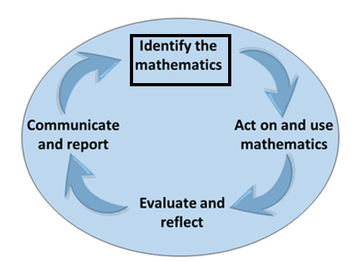
1. What is your Project Goal, Aim and Purpose?

2. Where will you apply this in your project?

3. Pre-Program - how are you feeling about your project?

4. Pre-Program - how do you feel about the Numeracy required for this project that you identified in Step 2?

5. Program - what do you hope to get out of this project?

6. Pre-Program - What mathematical tools are you likely to use? (e.g. digital spreadsheets & tables, handheld such as ruler or tape measure)

7. Pre-Program - what do you need to clarify, find out, learn, ask or seek assistance with?

Activity 3.1- Pre-program Survey
Student Reflection - How well did you go with this step? (Please check the box below)
☐Not Submitted | ☐Beginning | ☐Consolidating | ☐Achieving | ☐Excelling
Student Comment (Optional):
Teacher Feedback
☐Not Submitted | ☐Beginning | ☐Consolidating | ☐Achieving | ☐Excelling
Not Submitted: No work has been submitted or attempted for this outcome. | Beginning: You have completed or attempted some aspects of the pre-survey. Some parts are incomplete or require more information. To bump it up, complete all required sections of this task. | Consolidating: You have completed all required parts of the pre-survey. Your responses are basic full sentences. To bump it up add further details to your responses that include specific details. | Achieving: You have completed all required parts of the pre-survey. Your responses are detailed. To bump it up include specific details or examples and actions that will support you to develop and action the numeracy skills required for your project. | Excelling: You have completed all required parts of the pre-survey. Your responses are highly detailed. You have included specific details or examples and actions that will support you to develop and act on the numeracy skills required for your project. Great work!
Teacher Comment:

Step 3 - Activity 3.2 Program Log Record

Part 1: You will keep an ongoing log and reflection of 6 sessions that you actively participate in using the templates below.
Session 1 Record
Add your responses in the table below.
Session 1: Add location date and time here.
You must participate in your selected activity. It is important to remember you will need photo evidence of your participation, so don't forget to take photos at every session. After each session, you must insert your photo evidence and complete a reflection about it.

Requirements for this logbook:
Photo Evidence
Reflection
Pre and Post Session Data collection  Highlight the box that best reflects how you feel pre and post session.  Pre-program rating: Prior to the session I am feeling…  Post-program rating: After the session I am feeling... | Reflection must include:  1. Did you use technology to complete your activity?  2. What went well?  3. What were some challenges while participating in your program?  4. What could you do differently next time that would make your experience even better?
  1  Poor | 2 | 3 | 4 | 5  Excellent
  1  Poor | 2 | 3 | 4 | 5  Excellent
Session 1 Participation Evidence
Add your participation evidence here.

Activity 3.2 - Program Log Record - Session 1
Student Reflection - How well did you go with this step? (Please check the box below)
☐Not Submitted | ☐Beginning | ☐Consolidating | ☐Achieving | ☐Excelling
Student Comment (Optional):
Teacher Feedback
☐Not Submitted | ☐Beginning | ☐Consolidating | ☐Achieving | ☐Excelling
Not Submitted: No work has been submitted or attempted for this outcome. | Beginning: You have completed or attempted some aspects of this reflection. Some parts are incomplete or require more information. To bump it up, complete all required sections of this task. | Consolidating: You have completed all required parts of this task. Your reflection responses are basic full sentences. To bump it up add further details to your reflections. | Achieving: You have completed all required parts of this task. Your reflection responses are detailed full sentences. To bump it up, add specific information on how to improve or resolve issues throughout the program or note changes you want to make. | Excelling: You have completed all required parts of this task. Your reflection responses are detailed full sentences. Your reflections also include comprehensive plans to continue to improve and overcome challenges. Excellent work!
Teacher Comment:

Session 2 Record
Add your responses in the table below.
Session 2: Add location date and time here.
You must participate in your selected activity. It is important to remember you will need photo evidence of your participation, so don't forget to take photos at every session. After each session, you must insert your photo evidence and complete a reflection about it.
Requirements for this logbook:
Photo Evidence
Reflection
Pre and Post Session Data collection  Highlight the box that best reflects how you feel pre and post session.  Pre-program rating: Prior to the session I am feeling…  Post-program rating: After the session I am feeling... | Reflection must include:  1. Did you use technology to complete your activity?  2. What went well?  3. What were some challenges while participating in your program?  4. What could you do differently next time that would make your experience even better?
  1  Poor | 2 | 3 | 4 | 5  Excellent
  1  Poor | 2 | 3 | 4 | 5  Excellent
Session 2 Participation Evidence
Add your participation evidence here.

Activity 3.2 - Program Log Record - Session 2
Student Reflection - How well did you go with this step? (Please check the box below)
☐Not Submitted | ☐Beginning | ☐Consolidating | ☐Achieving | ☐Excelling
Student Comment (Optional):
Teacher Feedback
☐Not Submitted | ☐Beginning | ☐Consolidating | ☐Achieving | ☐Excelling
Not Submitted: No work has been submitted or attempted for this outcome. | Beginning: You have completed or attempted some aspects of this reflection. Some parts are incomplete or require more information. To bump it up, complete all required sections of this task. | Consolidating: You have completed all required parts of this task. Your reflection responses are basic full sentences. To bump it up add further details to your reflections. | Achieving: You have completed all required parts of this task. Your reflection responses are detailed full sentences. To bump it up, add specific information on how to improve or resolve issues throughout the program or note changes you want to make. | Excelling: You have completed all required parts of this task. Your reflection responses are detailed full sentences. Your reflections also include comprehensive plans to continue to improve and overcome challenges. Excellent work!
Teacher Comment:

Session 3 Record
Add your responses in the table below.
Session 3: Add location date and time here.
You must participate in your selected activity. It is important to remember you will need photo evidence of your participation, so don't forget to take photos at every session. After each session, you must insert your photo evidence and complete a reflection about it.
Requirements for this logbook:
Photo Evidence
Reflection
Pre and Post Session Data collection  Highlight the box that best reflects how you feel pre and post session.  Pre-program rating: Prior to the session I am feeling…  Post-program rating: After the session I am feeling... | Reflection must include:  1. Did you use technology to complete your activity?  2. What went well?  3. What were some challenges while participating in your program?  4. What could you do differently next time that would make your experience even better?
  1  Poor | 2 | 3 | 4 | 5  Excellent
  1  Poor | 2 | 3 | 4 | 5  Excellent
Session 3 Participation Evidence
Add your participation evidence here.

Activity 3.2 - Program Log Record - Session 3
Student Reflection - How well did you go with this step? (Please check the box below)
☐Not Submitted | ☐Beginning | ☐Consolidating | ☐Achieving | ☐Excelling
Student Comment (Optional):
Teacher Feedback
☐Not Submitted | ☐Beginning | ☐Consolidating | ☐Achieving | ☐Excelling
Not Submitted: No work has been submitted or attempted for this outcome. | Beginning: You have completed or attempted some aspects of this reflection. Some parts are incomplete or require more information. To bump it up, complete all required sections of this task. | Consolidating: You have completed all required parts of this task. Your reflection responses are basic full sentences. To bump it up add further details to your reflections. | Achieving: You have completed all required parts of this task. Your reflection responses are full sentences. To bump it up, add specific information on how to improve or resolve issues throughout the program or note changes you want to make. | Excelling: You have completed all required parts of this task. Your reflection responses are detailed. Your reflections also include comprehensive plans to continue to improve and overcome challenges. Excellent work!
Teacher Comment:

Session 4 Record
Add your responses in the table below.
Session 4: Add location date and time here.
You must participate in your selected activity. It is important to remember you will need photo evidence of your participation, so don't forget to take photos at every session. After each session, you must insert your photo evidence and complete a reflection about it.
Requirements for this logbook:
Photo Evidence
Reflection
Pre and Post Session Data collection  Highlight the box that best reflects how you feel pre and post session.  Pre-program rating: Prior to the session I am feeling…  Post-program rating: After the session I am feeling... | Reflection must include:  1. Did you use technology to complete your activity?  2. What went well?  3. What were some challenges while participating in your program?  4. What could you do differently next time that would make your experience even better?
  1  Poor | 2 | 3 | 4 | 5  Excellent
  1  Poor | 2 | 3 | 4 | 5  Excellent
Session 4 Participation Evidence
Add your participation evidence here.

Activity 3.2 - Program Log Record - Session 4
Student Reflection - How well did you go with this step? (Please check the box below)
☐Not Submitted | ☐Beginning | ☐Consolidating | ☐Achieving | ☐Excelling
Student Comment (Optional):
Teacher Feedback
☐Not Submitted | ☐Beginning | ☐Consolidating | ☐Achieving | ☐Excelling
Not Submitted: No work has been submitted or attempted for this outcome. | Beginning: You have completed or attempted some aspects of this reflection. Some parts are incomplete or require more information. To bump it up, complete all required sections of this task. | Consolidating: You have completed all required parts of this task. Your reflection responses are basic full sentences. To bump it up add further details to your reflections. | Achieving: You have completed all required parts of this task. Your reflection responses are detailed full sentences. To bump it up, add specific information on how to improve or resolve issues throughout the program or note changes you want to make. | Excelling: You have completed all required parts of this task. Your reflection responses are detailed full sentences. Your reflections also include comprehensive plans to continue to improve and overcome challenges. Excellent work!
Teacher Comment:

Session 5 Record
Add your responses in the table below.
Session 5: Add location date and time here.
You must participate in your selected activity. It is important to remember you will need photo evidence of your participation, so don't forget to take photos at every session. After each session, you must insert your photo evidence and complete a reflection about it.
Requirements for this logbook:
Photo Evidence
Reflection
Pre and Post Session Data collection  Highlight the box that best reflects how you feel pre and post session.  Pre-program rating: Prior to the session I am feeling…  Post-program rating: After the session I am feeling... | Reflection must include:  1. Did you use technology to complete your activity?  2. What went well?  3. What were some challenges while participating in your program?  4. What could you do differently next time that would make your experience even better?
  1  Poor | 2 | 3 | 4 | 5  Excellent
  1  Poor | 2 | 3 | 4 | 5  Excellent
Session 5 Participation Evidence
Add your participation evidence here.

Activity 3.2 - Program Log Record - Session 5
Student Reflection - How well did you go with this step? (Please check the box below)
☐Not Submitted | ☐Beginning | ☐Consolidating | ☐Achieving | ☐Excelling
Student Comment (Optional):
Teacher Feedback
☐Not Submitted | ☐Beginning | ☐Consolidating | ☐Achieving | ☐Excelling
Not Submitted: No work has been submitted or attempted for this outcome. | Beginning: You have completed or attempted some aspects of this reflection. Some parts are incomplete or require more information. To bump it up, complete all required sections of this task. | Consolidating: You have completed all required parts of this task. Your reflection responses are basic full sentences. To bump it up add further details to your reflections. | Achieving: You have completed all required parts of this task. Your reflection responses are full sentences. To bump it up, add specific information on how to improve or resolve issues throughout the program or note changes you want to make. | Excelling: You have completed all required parts of this task. Your reflection responses are detailed sentences. Your reflections also include comprehensive plans to continue to improve and overcome challenges. Excellent work!
Teacher Comment:

Session 6 Record
Add your responses in the table below.
Session 6: Add location date and time here.
You must participate in your selected activity. It is important to remember you will need photo evidence of your participation, so don't forget to take photos at every session. After each session, you must insert your photo evidence and complete a reflection about it.
Requirements for this logbook:
Photo Evidence
Reflection
Pre and Post Session Data collection  Highlight the box that best reflects how you feel pre and post session.  Pre-program rating: Prior to the session I am feeling…  Post-program rating: After the session I am feeling... | Reflection must include:  1. Did you use technology to complete your activity?  2. What went well?  3. What were some challenges while participating in your program?  4. What could you do differently next time that would make your experience even better?
  1  Poor | 2 | 3 | 4 | 5  Excellent
  1  Poor | 2 | 3 | 4 | 5  Excellent
Session 6 Participation Evidence
Add your participation evidence here.

Activity 3.2 - Program Log Record - Session 6
Student Reflection - How well did you go with this step? (Please check the box below)
☐Not Submitted | ☐Beginning | ☐Consolidating | ☐Achieving | ☐Excelling
Student Comment (Optional):
Teacher Feedback
☐Not Submitted | ☐Beginning | ☐Consolidating | ☐Achieving | ☐Excelling
Not Submitted: No work has been submitted or attempted for this outcome. | Beginning: You have completed or attempted some aspects of this reflection. Some parts are incomplete or require more information. To bump it up, complete all required sections of this task. | Consolidating: You have completed all required parts of this task. Your reflection responses are basic full sentences. To bump it up add further details to your reflections. | Achieving: You have completed all required parts of this task. Your reflection responses are detailed full sentences. To bump it up, add specific information on how to improve or resolve issues throughout the program or note changes you want to make. | Excelling: You have completed all required parts of this task. Your reflection responses are detailed full sentences. Your reflections also include comprehensive plans to continue to improve and overcome challenges. Excellent work!
Teacher Comment:

Step 3 - Activity 3.3 post-program survey- Act on and use the mathematics.
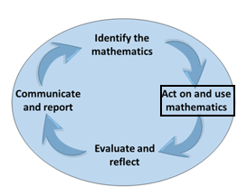

Part 1: Complete post-program questions below.

1.From the data you have collected how do you plan to measure the effectiveness of this project? (SMART = Specific/Measurable).

2. Measurable goal 1 – Quantitative (expressed as numbers.)
Add measurable goal here- Quantitative (expressed as numbers).

3. Measurable goal 2 - Quantitative (expressed as numbers.)
Add measurable goal here- Quantitative (expressed as numbers).

4. Measurable goal 3 – Qualitative (personal accounts, feelings, ratings).
Add measurable goal here- Qualitative (personal accounts, feelings, ratings).

Activity 3.3- Post-program Survey
Student Reflection - How well did you go with this step? (Please check the box below)
☐Not Submitted | ☐Beginning | ☐Consolidating | ☐Achieving | ☐Excelling
Student Comment (Optional):
Teacher Feedback
☐Not Submitted | ☐Beginning | ☐Consolidating | ☐Achieving | ☐Excelling
Not Submitted: No work has been submitted or attempted for this outcome. | Beginning: You have completed or attempted some aspects of the post-survey. Some parts are incomplete or require more information. To bump it up, complete all required sections of this task. | Consolidating: You have completed all required parts of the post-survey. Your responses are basic full sentences. To bump it up add further details to your responses that include specific details. | Achieving: You have completed all required parts of the post-survey. Your responses are detailed. To bump it up include specific details or examples and actions that will support you to develop and action the numeracy skills required for your project. | Excelling: You have completed all required parts of the post-survey. Your responses are highly detailed. You have included specific details or examples and actions that will support you to develop and act on the numeracy skills required for your project. Great work!
Teacher Comment:

Before you move onto Step 4 - Adapt
Have you completed the following activities?
Task Checklist
☐ Step.3 Activity 3.1 Pre-program survey
☐ Step.3 Activity 3.2 6 Fitness reflection logs
☐ Step.3 Activity 3.3 Post-program survey

Step 4 – Adapt
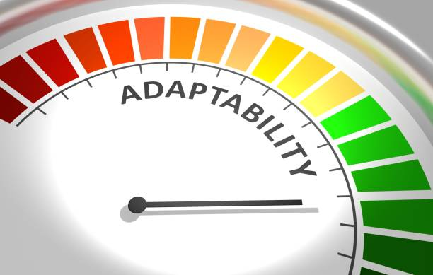

Task Checklist
Students will complete the following for Step 4 - Adapt.
☐ Step. 4 Activity 4.1 Comparison of pre and post data numeracy sets (from Step 3)
☐ Step.4 Activity 4.2 Wellbeing explanation
☐ Step.4 Activity 4.3 Mathematical toolkit
☐ Step. 4 Activity 4.4 Numeracy reflection table
☐ Step.4 Activity 4.5 Three recommendations for project improvement

Key vocabulary (you need to know)
Health: the general condition of the body or mind with reference to soundness and vigour.
Well-being: a good or satisfactory condition of existence; a state characterised by health, happiness, and prosperity; welfare
Health promotion: is the process of enabling people to increase control over, and to improve, their health.
Mathematical Toolkit: a place for students to develop a range of resources and strategies to use where necessary as students undertake their numeracy practices, activities and tasks.

Step 4 - Activity 4.1 Comparison of pre and post data sets

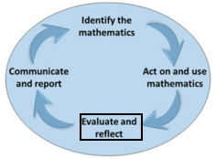

Part 1: In the table below, compare the two data sets. Go back to your Step 3 activities and refer to ‘Step 3. Activity 1.1 Pre-program survey’ and ‘Step.3 Activity 1.3 Post Program survey’ for the pre and post program survey results.

Similarities between pre and  post program data sets | Differences between pre and  post program data sets
1.  2.  3. | 1.  2.  3.

Activity 4.1- Comparison of pre and post data sets
Student Reflection - How well did you go with this step? (Please check the box below)
☐Not Submitted | ☐Beginning | ☐Consolidating | ☐Achieving | ☐Excelling
Student Comment (Optional):
Teacher Feedback
☐Not Submitted | ☐Beginning | ☐Consolidating | ☐Achieving | ☐Excelling
Not Submitted: No work has been submitted or attempted for this outcome. | Beginning: You have attempted to complete some parts of this task. To bump it up add responses to both the similarities and differences categories. | Consolidating: You have provided basic responses for both the similarities and differences in your pre and post data sets. To bump it up add further details to your responses. | Achieving: You have provided detailed responses for both the similarities and differences in your pre and post data sets. To bump it up add further explanations to your responses. | Excelling: You have provided highly detailed explanations for both the similarities and differences in your pre and post data sets. Excellent work!
Teacher Comment:

Step 4 - Activity 4.2 Wellbeing Explanation

Part 1: How successful do you think your program was in improving your overall wellbeing?
(Use the survey results and reflection notes from Step 3. Act Activity 1.2 Record log and any other evidence you may have.
☐ | ☐ | ☐ | ☐ | ☐
The program I participated in caused a significant decline in my overall wellbeing. | The program I participated in caused a slight decline in my overall wellbeing. | The program I participated in caused no change in my overall wellbeing. | The program I participated in slightly improved my overall wellbeing. | The program I participated in enhanced my overall wellbeing.

Part 2: Explain in detail below why you rated the program the way you did above. Include specific examples of your experience throughout the program.
Type your response here

Activity 4.2- Wellbeing Explanation
Student Reflection - How well did you go with this step? (Please check the box below)
☐Not Submitted | ☐Beginning | ☐Consolidating | ☐Achieving | ☐Excelling
Student Comment (Optional):
Teacher Feedback
☐Not Submitted | ☐Beginning | ☐Consolidating | ☐Achieving | ☐Excelling
Not Submitted: No work has been submitted or attempted for this outcome. | Beginning: You have attempted to reflect on your program experience and have tried to explain your selected rating. To bump it up, you need to complete all aspects of this task. | Consolidating: You have given a rating on your experience and provided a brief explanation about your selected rating. To bump it up, you need to add additional details to your explanation. | Achieving: You have given a rating on your experience and provided a detailed explanation about your selected rating. To bump it up, you need to add additional details to your explanation. | Excelling: You have given a rating on your experience and provided a highly detailed explanation about your selected rating. Excellent work!
Teacher Comment:

Step 4 - Activity 4.3 Mathematical Toolkit

Mathematical Toolkit example only. You may need to modify this example to suit your own context.

Part 1: Fill in the mathematical toolkit template below and outline what numeracy knowledge and skills you are applying and demonstrating throughout your project. You will use this template each time you add to your numeracy toolkit.

Individual Project Mathematical Toolkit

Resource: Add the name of the resource here.

Numeracy Toolkit Examples
Representational | Physical | Digital
- Models  - Manipulatives  - Scaffolds  - Worked examples | - Word walls  - Placemats  - Graphical organisers  - Measuring equipment  - Calculator | - Spreadsheet  - Specific programs  - Specific apps  - Websites

Purpose:
When to use:
Accuracy:
Notes:

Insert photo or link to resource here (Digital):

Insert photo of you are using the resource here (Physical/Representational):

Activity 4.3- Mathematical Toolkit
Student Reflection - How well did you go with this step? (Please check the box below)
☐Not Submitted | ☐Beginning | ☐Consolidating | ☐Achieving | ☐Excelling
Student Comment (Optional):
Teacher Feedback
☐Not Submitted | ☐Beginning | ☐Consolidating | ☐Achieving | ☐Excelling
Not Submitted: No work has been submitted or attempted for this outcome. | Beginning: You have attempted some aspects of developing a mathematical toolkit. To bump it up, add responses to all sections of the template for each numeracy skill you have used in your project. | Consolidating: You have developed a basic mathematical toolkit which provides basic information for each of the numeracy skills you have utilised in your project. To bump it up, you need to include more examples and details about the numeracy skills you have demonstrated throughout your project. | Achieving: You have developed a detailed mathematical toolkit which provides detailed information for a range of the numeracy skills you have utilised in your project. To bump it up, you need to include more examples and details about the numeracy skills you have demonstrated throughout your project | Excelling: You have developed a highly detailed mathematical toolkit which provides comprehensive and details information about a wide range of the numeracy skills you have utilised in your project. Excellent work!
Teacher Comment:

Step 4 - Activity 4.4 Numeracy Reflection Table

Part 1: Find and review your completed Step.2 Activity 2.7 Design Phase- Identify the mathematics task. Check off the same numeracies you identified in that activity. Then complete the table below.

Check the same numeracy mathematical skills you identified from Step 2.Plan outcome template. | Outline how this skill helped you in your project. Did you stick to your original plan or did this need to change? Include what modifications you needed to make. | Explain how you could use this skill in the workplace or outside of school
Number:
☐ Reading numbers - place value and decimal place value.
☐ Practical calculations with whole numbers and decimals.
☐ Using common fractions and decimals.
☐ Calculate increase and decrease of percentages.
☐ Using proportions or ratios.
Shape:
☐ Reflection rotation and symmetry.
☐ Name 2D and 3D shapes.
☐ Identifying patterns of shapes.
Quantity and Measures:
☐ Estimate and measure familiar objects and distances.
☐ Determine measurement of distance, perimeter, area and volume.
☐ Measurement conversion.
☐ Read and interpret time and temperature.
☐ Calculations using time months, weeks, days and hours.
☐ Use simple mathematical expressions.
Relationships:
☐ Substitution with simple formulas to find solutions to everyday problems.
☐ Apply rates such as km/hr.
☐ Formulas to find solutions for area amounts or costing.
☐ Use simple mathematical expressions.

Activity 4.4- Numeracy Reflection Table
Student Reflection - How well did you go with this step? (Please check the box below)
☐Not Submitted | ☐Beginning | ☐Consolidating | ☐Achieving | ☐Excelling
Student Comment (Optional):
Teacher Feedback
☐Not Submitted | ☐Beginning | ☐Consolidating | ☐Achieving | ☐Excelling
Not Submitted: No work has been submitted or attempted for this outcome. | Beginning: You have attempted some parts of this task. To bump it up, you need to go back and check that you have provided a basic response for each row and column. | Consolidating: You have provided a basic response for each numeracy you selected in Step 2, outlined how this skill supported or required changes throughout your project and made links to how this numeracy skill is relevant in real world contexts. To bump it up, you need to include more specific details in your responses. | Achieving: You have provided a detailed response for each numeracy you selected in Step 2, outlined how this skill supported or required changes throughout your project and made links to how this numeracy skill is relevant in real world contexts. To bump it up, you need to include more specific details and examples in your responses. | Excelling: You have provided a highly detailed response for each numeracy you selected in Step 2, outlined in detail specific examples how this skill supported or required changes throughout your project and made links to how this numeracy skill is relevant in real world contexts. Excellent work!
Teacher Comment:

Step 4 - Activity 4.5 Three Recommendations for project improvement

Part 1: If you were to complete this project again, list three recommendations that you could implement to help improve your project. These recommendations can be related to anything to do with your project.

Recommendation 1
Recommendation 2
Recommendation 3

Activity 4.5- Three Recommendations for Project Improvement
Student Reflection - How well did you go with this step? (Please check the box below)
☐Not Submitted | ☐Beginning | ☐Consolidating | ☐Achieving | ☐Excelling
Student Comment (Optional):
Teacher Feedback
☐Not Submitted | ☐Beginning | ☐Consolidating | ☐Achieving | ☐Excelling
Not Submitted: No work has been submitted or attempted for this outcome. | Beginning: You have attempted to provide some recommendations for your project. To bump it up you need to provide a basic recommendation using complete sentences. | Consolidating: You have listed three basic recommendations on how to improve your project for next time. To bump it up you need to add more details about what actions are needed next time to support the recommendation. | Achieving: You have provided three detailed recommendations on how to improve your project for next time. To bump it up add further specific details about what actions are needed to support the implementation of the recommendations. | Excelling: You have provided three highly detailed recommendations on how to improve your project for next time. You have given specific details on the required actions needed to implement the recommendation next time. Well done!
Teacher Comment:

Before you move onto Step 5 - Reflect
Have you completed the following activities?
Task Checklist
Students will complete the following for Step 4 - Adapt.
☐ Step. 4 Activity 4.1 Comparison of pre and post data numeracy sets (from Step 3)
☐ Step.4 Activity 4.2 Wellbeing explanation
☐ Step.4 Activity 4.3 Mathematical toolkit
☐ Step. 4 Activity 4.4 Numeracy reflection table
☐ Step.4 Activity 4.5 Three recommendations for project improvement

Step 5 - Reflect



Task Checklist
Students will complete the following for Step 5 - Reflect.
☐ Step.5 Activity 5.1 Cluster map
☐ Step.5 Activity 5.2 SWOT analysis on use of technology
☐ Step.5 Activity 5.3 Self reflection
☐ Step.5 Activity 5.4 Peer sharing table and pair photo
☐ Step. 5 Activity 5.5 Numeracy problem solving cycle report and interview

Key vocabulary (you need to know)
Health: the general condition of the body or mind with reference to soundness and vigour.
Well-being: a good or satisfactory condition of existence; a state characterised by health, happiness, and prosperity; welfare
Health promotion: is the process of enabling people to increase control over, and to improve, their health.

Step 5 - Activity 5.1 Cluster Map

Part 1: Complete cluster map below including what went well in your project and even better if. Double click on the cluster map below. In the draw setting add your information then click ‘Save and close.’

PROGRAM
EVEN BETTER IF?
WHAT WENT WELL?

Activity 5.1- Cluster Map
Student Reflection - How well did you go with this step? (Please check the box below)
☐Not Submitted | ☐Beginning | ☐Consolidating | ☐Achieving | ☐Excelling
Student Comment (Optional):
Teacher Feedback
☐Not Submitted | ☐Beginning | ☐Consolidating | ☐Achieving | ☐Excelling
Not Submitted: No work has been submitted or attempted for this outcome. | Beginning: You have attempted to complete some parts of this task. To bump it up, you need to complete all sections of the cluster map. | Consolidating: You have provided a basic response for all sections in the cluster map. To bump it up, add more details to your responses. | Achieving: You have provided a detailed response for all sections in the cluster map. To bump it up, outline the reasoning behind why you think things went well and discuss how you could ensure the Even Better If happens within your project. | Excelling: You have provided a highly detailed response for all sections in the cluster map. You have included information about the reasons why things went well and described how you could ensure that the Even Better If could occur next time. Excellent work! Well done!
Teacher Comment:

Step 5 - Activity 5.2 SWOT Analysis of Technology
Part 1: Complete a SWOT analysis below on how you implemented technology within your project.
STRENGTHS | WEAKNESSES
Example: I used my Apple Watch to gain data from each workout. | Example: My workout relies on the internet, when the internet is not working, this is a weakness.
OPPORTUNITIES | THREATS
Example: I can Google new and improved ideas for my sessions and this gives me opportunities to try new things. | Example: When I have technology and I am completing my sessions, I can get distracted by the technology which can have a negative impact on my session.

Activity 5.2 SWOT Analysis of Technology
Student Reflection - How well did you go with this step? (Please check the box below)
☐Not Submitted | ☐Beginning | ☐Consolidating | ☐Achieving | ☐Excelling
Student Comment (Optional):
Teacher Feedback
☐Not Submitted | ☐Beginning | ☐Consolidating | ☐Achieving | ☐Excelling
Not Submitted: No work has been submitted or attempted for this outcome. | Beginning: You have attempted some aspects of the SWOT chart. To bump it up, add responses to all sections of the chart. | Consolidating: You have outlined basic dot points in all sections of the SWOT chart. To bump it up, include more details of your responses. | Achieving: You have provided detailed responses in all sections of the SWOT chart. To bump it up, include further details about what can be done to overcome these challenges. | Excelling: You have provided highly detailed responses in all sections of the SWOT chart. Excellent work!
Teacher Comment:

Step 5 - Activity 5.3 Self Reflection
Part 1: Working on a project over time can be challenging. What is the biggest ‘take away’ or ‘lesson’ you learnt from completing this project? Provide a detailed response below.

Activity 5.3 Self Reflection
Student Reflection - How well did you go with this step? (Please check the box below)
☐Not Submitted | ☐Beginning | ☐Consolidating | ☐Achieving | ☐Excelling
Student Comment (Optional):
Teacher Feedback
☐Not Submitted | ☐Beginning | ☐Consolidating | ☐Achieving | ☐Excelling
Not Submitted: No work has been submitted or attempted for this outcome. | Beginning: You have attempted to give a response. To bump it up you need to use complete sentences and reflect on what you learnt and what you would do differently next time. | Consolidating: You have provided a basic response to the biggest ‘take away’ or ‘learning’ from your project. To bump it up you need to include more details and reflect on what you learnt and what you would do differently next time. | Achieving: You have provided a detailed response to the biggest ‘take away’ or ‘learning’ from your project. To bump it up you need to include specific information about the challenges you faced throughout and things you will do differently next time. | Excelling: You have provided a detailed response to the biggest ‘take away’ or ‘learning’ from your project. You have included specific information about the challenges you faced throughout and things you will do differently next time. Excellent work!
Teacher Comment:

Step 5 - Activity 5.4 Peer Sharing Table and Pair Photo

Part 1: In a pair, share details of your project goal and whether you were successful or not. Discuss any changes that you might make if you needed to do this project again.
Complete the table and insert a picture of your pair discussion below.
Partner's name:
Date:
Project goal:
Goal reached?
Changes you would make next time:

Insert picture of pair discussion:

Activity 5.4 Peer Sharing Table and Pair Photo
Student Reflection - How well did you go with this step? (Please check the box below)
☐Not Submitted | ☐Beginning | ☐Consolidating | ☐Achieving | ☐Excelling
Student Comment (Optional):
Teacher Feedback
☐Not Submitted | ☐Beginning | ☐Consolidating | ☐Achieving | ☐Excelling
Not Submitted: No work has been submitted or attempted for this outcome. | Beginning: You have completed some aspects of this task. To bump it up, complete all required sections. | Consolidating: You have provided basic responses for all aspects of this task. To bump it up, you need to include more details about your peers' project and include a photo of the discussion. | Achieving: You have provided detailed responses for all aspects of this task. To bump it up, you need to include a photo of the discussion. | Excelling: You have provided highly detailed responses for all aspects of this task. You have included a photo of the discussion. Excellent work!
Teacher Comment:

Step 5 - Activity 5.5 Mathematics Problem Solving Cycle and Interview
Part 1: Complete the template below.

Unit 1: Striving Individuals Communicate and Report

Identify the mathematics | List what numeracy skills you demonstrated throughout this project. Explain why you needed to use these numeracy skills specific to your project.  You can use and summarise information from the following activities you have already completed:  Step.2 Activity 2.7 Design Phase- Identify the mathematics.  Step.3 Activity 3.1 Pre-program survey  Step.3 Activity 3.3 Post-program survey  Add your information here.
Act on and use the mathematics | Summarise the numeracy skills you used throughout your project. Include information about things that worked and didn’t work.  Provide information about the different data sets and numeracy skills you needed.  You can use and summarise information from the following activities you have already completed:  Step.3 Activity 3.2 6 Fitness reflection logs  Step.4 Activity 4.3 Mathematical toolkit  Add your information here.
Evaluate and reflect | Outline the positives and negatives of the numeracy skills you used throughout your project.  How did your results compare with your project goal? Explain how you measured this.  You can use and summarise information from the following activities you have already completed:  Step.4 Activity 4.4 Numeracy reflection table  Step.4 Activity 4.1 Comparison of pre and post data sets  Step.3 Activity 3.3 Post-program survey  Add your information here.
Communicate and report | What worked and didn’t work when using your numeracy skills within your project?  What did you find challenging?  If you were to complete this project again, would you collect any more data to help prove the effectiveness of it?  Add your information here.

Part 2: Using the information you have collated in Part.1 to create a digital presentation of your choice. You can use the categories in the left-hand column for the title headings for each section of your presentation.
Add your presentation or link to your presentation here.

Part 3: Book in a Teacher interview time to communicate and report on your numeracy Problem-Solving Cycle throughout your project work.
Teacher Name:
Date:
Sign off:
Teacher Feedback about presentation:

Activity 5.5 Mathematics Problem Solving Cycle and Interview
Student Reflection - How well did you go with this step? (Please check the box below)
☐Not Submitted | ☐Beginning | ☐Consolidating | ☐Achieving | ☐Excelling
Student Comment (Optional):
Teacher Feedback
☐Not Submitted | ☐Beginning | ☐Consolidating | ☐Achieving | ☐Excelling
Not Submitted: No work has been submitted or attempted for this outcome. | Beginning: You have completed parts of this task. To bump it up, you need to complete all sections of this task with basic information. | Consolidating: You have provided a basic presentation and communicated your use of mathematics and the problem-solving cycle in your teacher interview. To bump it up, you need to include more detailed specific examples from your project. | Achieving: You have provided a detailed presentation and successfully communicated your use of mathematics and the problem-solving cycle in your teacher interview. To bump it up, you need to include more detailed specific examples from your project. | Excelling: You have provided a comprehensive presentation. You have clearly communicated your use of mathematics and the problem-solving cycle supported by a range of examples in your teacher interview. Excellent work!
Teacher Comment:

Before you move onto another task
Have you completed the following activities?
Task Checklist
Students will complete the following for Step 5 - Reflect.
☐ Step.5 Activity 5.1 Cluster map
☐ Step.5 Activity 5.2 SWOT analysis on use of technology
☐ Step.5 Activity 5.3 Self reflection
☐ Step.5 Activity 5.4 Peer sharing table and pair photo
☐ Step. 5 Activity 5.5 Numeracy problem solving cycle report and interview.

