Victorian Pathways Certificate

Unit 1
Striving Individuals
Work Related Skills Curriculum
Support Materials

Authorised and published by the Victorian Curriculum and Assessment Authority
Level 7, 2 Lonsdale Street
Melbourne VIC 3000
ISBN: 978-1-xxxxxx-xx-x [email vcaa.media.publications@edumail.vic.gov.au for ISBN requests]
© Victorian Curriculum and Assessment Authority [year]

No part of this publication may be reproduced except as specified under the Copyright Act 1968 or by permission from the VCAA. Excepting third-party elements, schools may use this resource in accordance with the VCAA educational allowance. For more information go to https://www.vcaa.vic.edu.au/Footer/Pages/Copyright.aspx.
The VCAA provides the only official, up-to-date versions of VCAA publications. Details of updates can be found on the VCAA website at www.vcaa.vic.edu.au.
This publication may contain copyright material belonging to a third party. Every effort has been made to contact all copyright owners. If you believe that material in this publication is an infringement of your copyright, please email the Copyright Officer vcaa.copyright@edumail.vic.gov.au
Copyright in materials appearing at any sites linked to this document rests with the copyright owner/s of those materials, subject to the Copyright Act. The VCAA recommends you refer to copyright statements at linked sites before using such materials.
The VCAA logo is a registered trademark of the Victorian Curriculum and Assessment Authority.

Contact us if you need this information in an accessible format - for example, large print or audio.
Telephone (03) 9032 1635 or email vcaa.media.publications@edumail.vic.gov.au

Contents
Contents
Work Related Skills (WRS) Activities 4
Task 1 – Career action plan 4
Task 1 - Activity 1.1 Career Action Plan 4
Task 1- Activity 1.2 Career action plan summary 6
Task 1- Activity 1.3 Occupation Research Notes 7
Task 2- Employment opportunities and conditions 10
Task 2 Activity 2.1 Employment Opportunities 10
Task 2 Activity 2.2 How do I upskill? 15
Task 3 Resume and Cover Letters 17
Task 3- Resume and cover letters Activity 3.1 Finding Information about Resumes and Cover Letters 17
Task 3- Resume and cover letters Activity 3.2 Creating a Resume and Cover Letter 20

Work Related Skills (WRS) Activities

Task 1 – Career action plan



Task Checklist
Students will complete the following for Work Related Studies Task 1 – Employment Research.
☐ WRS Task 1- Activity 1.1 Career Action Plan
☐ WRS Task 1- Activity 1.2 Interests/skills/capabilities table
☐ WRS Task 1-Activity 1.3 Occupation - table notes

Key vocabulary (you need to know)
Career Action Plan: is a dynamic planning document owned and managed by young people intended to reflect their increased career development learning.
Skill: the ability to do something well.
Capability: The power or ability to do something.
Aspiration: is the driving feeling you get when thinking about what you want to achieve in life.

Task 1 - Activity 1.1 Career Action Plan

 Part 1: Create a career action plan through the My career portfolio platform.
Log into the my career portfolio platform to create an action plan via the link here: My Career Portfolio student login on the home page select the ‘My Career Action Plan’ square and click ‘GO’. Add as much detail to your responses as you can.
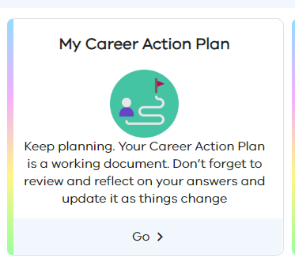
You will need to have an EDUPASS LOGIN to access this. If you are not sure, check with your teacher.

Part 2: Once you have completed your action plan save a copy or take screenshots and insert them in the space below.

Insert/add your career action plan here.

Task 1- Activity 1.1 Career Action Plan
Student Reflection - How well did you go with this step? (Please check the box below)
☐Not Submitted | ☐Beginning | ☐Consolidating | ☐Achieving | ☐Excelling
Student Comment (Optional):
Teacher Feedback
☐Not Submitted | ☐Beginning | ☐Consolidating | ☐Achieving | ☐Excelling
Not Submitted: No work has been submitted or attempted for this activity. | Beginning: I can attempt some aspects of my career action plan.  To bump it up, you need to complete all required sections of my career action plan. | Consolidating: I can provide basic responses for most sections of my career action plan.  To bump it up, you need to complete all responses in your action plan and add additional details. | Achieving: I can provide basic responses for all sections of my career action plan.  To bump it up, you need to complete all responses in your action plan and add additional details. | Excelling: I can provide detailed responses for all sections of your career action plan.
Teacher Comment:

Task 1- Activity 1.2 Career action plan summary


Part 1: Read over your career action plan linked above. Remember a career action plan is an ongoing and working document that is meant to be updated and changed over time.

From your career action plan summarise the information required below and list in dot form where you are at or your strengths in the following areas. You need a minimum of 2 for each category.

Personal aspirations  (What energises you?) | Skills  (Things you already do well) | Capabilities  (Things you can do well)

Task 1 Activity 1.2 Career action plan summary
Student Reflection - How well did you go with this step? (Please check the box below)
☐Not Submitted | ☐Beginning | ☐Consolidating | ☐Achieving | ☐Excelling
Student Comment (Optional):
Teacher Feedback
☐Not Submitted | ☐Beginning | ☐Consolidating | ☐Achieving | ☐Excelling
Not Submitted: No work has been submitted or attempted for this activity. | Beginning: I can attempt some aspects of this task.  To bump it up, you need to complete a minimum of 2 dot points for each category. | Consolidating: I can provide a basic response.  To bump it up, you can add more details | Achieving: I can provide a detailed response of 2 dot points for each category.  To bump it up, you could add more dot points in your categories. | Excelling: I can provide a detailed response of several dot points for each category.
Teacher Comment:

Task 1- Activity 1.3 Occupation Research Notes

Part 1: Read all instructions first before beginning this task. Log into your My Career Portfolio platform where you developed an action plan via the link here: My Career Portfolio student login. You will need to have an EDUPASS LOGIN to access this. If you are not sure, check with your teacher.

On the home page select the ‘My Future’ square and click ‘GO’.
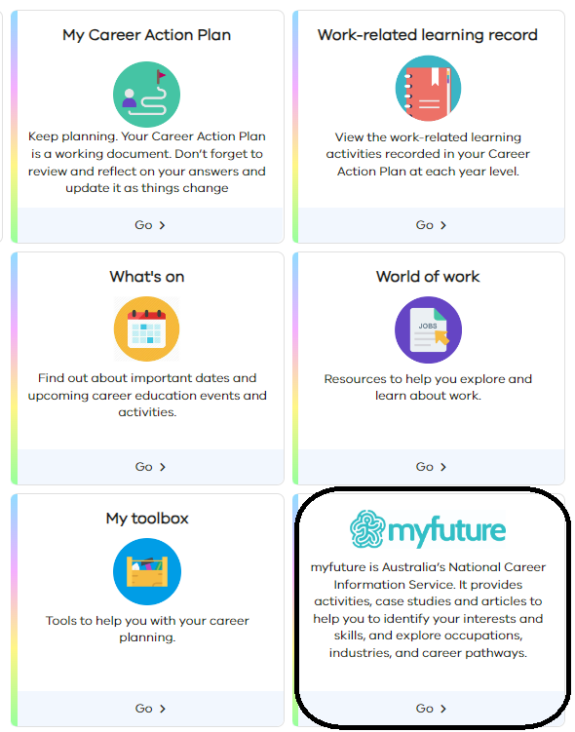

In the My Future section click into the ‘Occupations’ square below. Hot tip- watch the shorts video in the occupations section that looks like ‘? View a short video about this section.’

Part 2: From the information you identified in WRS Task 1- Career Action plan Activity 1.1, you are going to research some occupations based on your personal aspirations, skills and capabilities. You need to research 2 occupations of your choice that you have some interest in knowing more about and find out the following information for each.
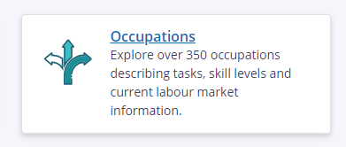

Part 3: Using the information, you identified for Part 2 and your research of two occupations complete the two tables below.
Occupation/job/industry 1 (Type your response here)
Question | Response
From the occupation/industry/job you have chosen, what are the potential employment possibilities?
Hint- You can look on an employment site such as Seek to see what is currently available and list them to the right.
What are the educational pathway options necessary to develop skills and knowledge for the chosen occupation or industry?
Hint- Is there a TAFE course? Short course? Any educational courses that will help you within the industry?

What employability skills, knowledge, capabilities are important for this occupation?
Hint- Are any of the following important? Communication, teamwork, problem-solving, initiative, planning, organising, self-management, learning, and technology.

How does this occupation fit with your personal aspirations, skills and capabilities?
Hint- Refer to the table in ‘part 2’. Refer to these and how they will help within this industry.

What skills and capabilities would you need to develop to be able to do this job? | A skill that is required in my industry is (insert skill/capability). I have limited experience with (insert skill/capability). To develop this skill, I could… (insert a strategy to help develop this skill).

Occupation/job/industry 2: (Type your response here)
Question | Response
From the occupation/industry/job you have chosen, what are the potential employment possibilities?
Hint- You can look on an employment site such as Seek to see what is currently available and list them to the right.
What are the educational pathway options necessary to develop skills and knowledge for the chosen occupation or industry?
Hint- Is there a TAFE course? Short course? Any educational courses that will help you within the industry?

What employability skills, knowledge, capabilities are important for this occupation?
Hint- Are any of the following important? Communication, teamwork, problem-solving, initiative, planning, organising, self-management, learning, and technology.

How does this occupation fit with your personal aspirations, skills and capabilities?
Hint- Refer to the table in ‘part 2’. Refer to these and how they will help within this industry.

What skills and capabilities would you need to develop to be able to do this job? | A skill that is required in my industry is (insert skill/capability). I have limited experience with (insert skill/capability). To develop this skill, I could… (insert a strategy to help develop this skill).

Task 1- Activity 1.3 Occupation Research Notes
Student Reflection - How well did you go with this step? (Please check the box below)
☐Not Submitted | ☐Beginning | ☐Consolidating | ☐Achieving | ☐Excelling
Student Comment (Optional):
Teacher Feedback
☐Not Submitted | ☐Beginning | ☐Consolidating | ☐Achieving | ☐Excelling
Not Submitted: No work has been submitted or attempted for this activity. | Beginning: I can attempt some aspects of the task.  To bump it up, you need to make sure that you complete all requirements. | Consolidating: I can complete basic responses to most of the requirements.  To bump it up, you need to respond to all parts of this task and add more details. | Achieving: I can provide detailed responses to each element of the tables for 2 occupations.  To bump it up, I could explain how I am going to use this information moving forward. | Excelling: I can provide highly detailed responses to each of the sections in the table for two occupations.
Teacher Comment:

Before you submit, please check you have completed the following
Task Checklist
Students will complete the following for Work Related Studies Task 1 – Career Action Plan.
☐ WRS Task 1- Activity 1.1 Career Action Plan
☐ WRS Task 1- Activity 1.2 Personal skills/capabilities table
☐ WRS Task 1- Activity 1.3 Occupations research notes

Task 2- Employment opportunities and conditions



Task Checklist
Students will complete the following for Work Related Studies Task 2 – Employment opportunities and conditions
☐ WRS Task 2- Activity 2.1 Employment Opportunities
☐ WRS Task 2- Activity 2.2 How do I upskill?

Task 2 Activity 2.1 Employment Opportunities

  Part 1: Research and identify three employment opportunities (Job advertisements) in your chosen industry or workplace of interest. List them and included details in the table below.

You can use the following websites or select your own.
Seek
Indeed

Job Title  You can just add a screenshot of this  directly from the site. | Role Description  You can just add a screenshot of this  directly from the site.
Example  Night Fill Manager - Woolworths Waurn Ponds.  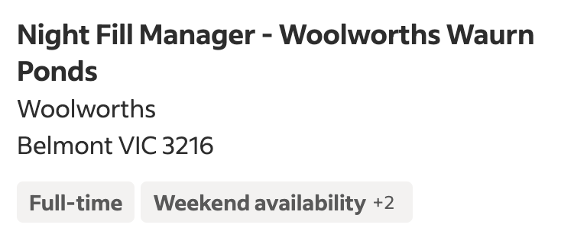 | 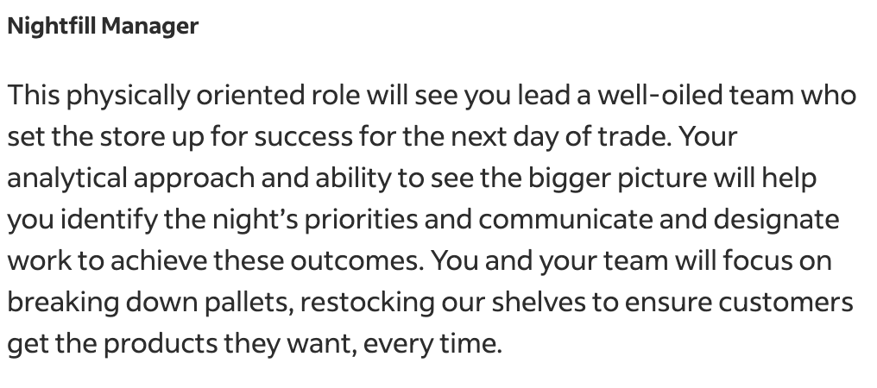

Part 2: Research and describe the workplace conditions and wage entitlements for different classifications/arrangements of employment in your chosen industry or workplace. Fill in the table below.
You can use the following to assist you.
Fair Work Ombudsman

Worker Type / Classification | Conditions and Entitlements
Apprentice | Wage:  Conditions:  Tick the boxes if the following apply to being an apprentice.  ☐Work under direct supervision  ☐Provided with specific training  ☐Paid leave  ☐Unsupervised work  ☐Unpaid leave  ☐Sick pay  ☐Work in a safe environment  ☐Overtime compensation for exceeding standard work hours.  ☐Access to required protective equipment and safety measures  ☐Training on workplace safety  ☐Leading and directing other workers  ☐Supervising other workers  ☐Supervising apprentices  ☐Set and consistent hours per week  ☐Protection against discrimination based on race, gender, age, religion, disability, etc.  ☐Equal opportunities for career advancement.  ☐Rest breaks and meal breaks during work hours.
Part-Time Worker | Wage:  Conditions:  Tick the boxes if the following apply to being a part time worker.  ☐Work under direct supervision  ☐Provided with specific training  ☐Paid leave  ☐Unsupervised work  ☐Unpaid leave  ☐Sick pay  ☐Work in a safe environment  ☐Overtime compensation for exceeding standard work hours.  ☐Access to required protective equipment and safety measures  ☐Training on workplace safety  ☐Leading and directing other workers  ☐Supervising other workers  ☐Supervising apprentices  ☐Set and consistent hours per week  ☐Protection against discrimination based on race, gender, age, religion, disability, etc.  ☐Equal opportunities for career advancement.  ☐Rest breaks and meal breaks during work hours.
Casual Worker | Wage:  Conditions:  Tick the boxes if the following apply to being a casual worker.  ☐Work under direct supervision  ☐Provided with specific training  ☐Paid leave  ☐Unsupervised work  ☐Unpaid leave  ☐Sick pay  ☐Work in a safe environment  ☐Overtime compensation for exceeding standard work hours.  ☐Access to required protective equipment and safety measures  ☐Training on workplace safety  ☐Leading and directing other workers  ☐Supervising other workers  ☐Supervising apprentices  ☐Set and consistent hours per week.  ☐Protection against discrimination based on race, gender, age, religion, disability, etc.  ☐Equal opportunities for career advancement.  ☐Rest breaks and meal breaks during work hours.
Full-time Worker | Wage:  Conditions:  Tick the boxes if the following apply to being a full time, worker.  ☐Work under direct supervision  ☐Provided with specific training  ☐Paid leave  ☐Unsupervised work  ☐Unpaid leave  ☐Sick pay  ☐Work in a safe environment  ☐Overtime compensation for exceeding standard work hours.  ☐Access to required protective equipment and safety measures.  ☐Training on workplace safety  ☐Leading and directing other workers  ☐Supervising other workers  ☐Supervising apprentices  ☐Set and consistent hours per week  ☐Protection against discrimination based on race, gender, age, religion, disability, etc.  ☐Equal opportunities for career advancement.  ☐Rest breaks and meal breaks during work hours.
Manager | Wage:  Conditions:  Tick the boxes if the following apply to being a manager.  ☐Work under direct supervision  ☐Provided with specific training  ☐Paid leave  ☐Unsupervised work  ☐Unpaid leave  ☐Sick pay  ☐Work in a safe environment  ☐Overtime compensation for exceeding standard work hours.  ☐Access to required protective equipment and safety measures.  ☐Training on workplace safety.  ☐Leading and directing other workers.  ☐Supervising other workers.  ☐Supervising apprentices.  ☐Set and consistent hours per week.  ☐Protection against discrimination based on race, gender, age, religion, disability, etc.  ☐Equal opportunities for career advancement.  ☐Rest breaks and meal breaks during work hours.
10 + Years experience worker | Wage:  Conditions:  Tick the boxes if the following apply to being a 10 + years experienced worker.  ☐Work under direct supervision  ☐Provided with specific training  ☐Paid leave  ☐Unsupervised work  ☐Unpaid leave  ☐Sick pay  ☐Work in a safe environment  ☐Overtime compensation for exceeding standard work hours.  ☐Access to required protective equipment and safety measures.  ☐Training on workplace safety  ☐Leading and directing other workers.  ☐Supervising other workers  ☐Supervising apprentices  ☐Set and consistent hours per week.  ☐Protection against discrimination based on race, gender, age, religion, disability, etc.  ☐Equal opportunities for career advancement.  ☐Rest breaks and meal breaks during work hours.

Task 2- Employment Opportunities
Student Reflection - How well did you go with this step? (Please check the box below)
☐Not Submitted | ☐Beginning | ☐Consolidating | ☐Achieving | ☐Excelling
Student Comment (Optional):
Teacher Feedback
☐Not Submitted | ☐Beginning | ☐Consolidating | ☐Achieving | ☐Excelling
Not Submitted: No work has been submitted or attempted for this activity. | Beginning: I can attempt some aspects of tasks.  To bump it up, you need to make sure you complete all sections of the task. | Consolidating: I can provide a basic response for most sections.  To bump it up, you need to complete all responses with more detail. | Achieving: I can provide responses for all sections.  To bump it up you could add more detail. | Excelling: I can provide detailed responses for all sections.
Teacher Comment:

Task 2 Activity 2.2 How do I upskill?

Part 1: Where do you see yourself in 5-10 years?
Within the next 5-10 years, within my career, I hope to be…

Part 2: Research experiences, qualifications, learning opportunities and study that are available for your industry of interest. Outline three potential opportunities you could use to upskill yourself and how these would help you in your industry.

Upskilling Strategy:  Experiences, qualifications, learning opportunities and study | How will this help with my career progression?
Upskilling Strategy 1:

Upskilling Strategy 2:

Upskilling Strategy 3:

Task 2- Activity 2.2 How can I upskill?
Student Reflection - How well did you go with this step? (Please check the box below)
☐Not Submitted | ☐Beginning | ☐Consolidating | ☐Achieving | ☐Excelling
Student Comment (Optional):
Teacher Feedback
☐Not Submitted | ☐Beginning | ☐Consolidating | ☐Achieving | ☐Excelling
Not Submitted: No work has been submitted or attempted for this activity. | Beginning: I can attempt some aspects of this task.  To bump it up, you need to make sure that you respond to all the sections. | Consolidating: I can include basic responses for most of the sections.  To bump it up, you need to include more detail and respond to all sections. | Achieving: I can provide a basic response for all the sections.  To bump it up, you need to include more detail. | Excelling: I can provide detailed responses to all the sections.
Teacher Comment:

Before you submit, please check you have completed the following
Task Checklist
Students will complete the following for Work Related Studies – Employment opportunities and conditions
☐ WRS Task 2- Activity 2.1 Employment Opportunities
☐ WRS Task 2- Activity 2.2 How do I upskill?

Task 3 Resume and Cover Letters



Task Checklist
Students will complete the following for Work Related Studies Task 3 –Resume and Cover Letters
☐ WRS Task 3- Activity 3.1 Finding information about resumes and cover letters
☐ WRS Task 3- Activity 3.2 Create a resume and cover letter

Task 3- Resume and cover letters Activity 3.1 Finding Information about Resumes and Cover Letters

Part 1: What makes a good resume? List a minimum of three pieces of information you found important to include in a resume.

Use the below websites or choose your own.
How to format your resumé
How to make a resume
How to write a resume

1.
2.
3.

Part 2: What makes a cover Letter? List a minimum of three pieces of information you found important to include in a cover letter.
Use the below websites or choose your own.
How to Write a Cover Letter
How to write a cover letter in Australia: Your guide to standing out.

1.
2.
3.

Part 3: Select an employment opportunity from a recruitment site and take a screenshot of the job that interests you. Complete the questions below.
1.Go to Seek or choose your own job search website.
2.Search for a job in your industry or a part-time job that interests you, in a location where you would like to work.

Add/Insert screen shot of chosen job here.

3.Copy the selection criteria of the job in the space provided below.
Hint- this may not state ‘selection criteria’ but find the key skills, knowledge and experience that is required to be considered for the job.
Add job advertisement position details here.

Task 3- Activity 3.1 Finding information about cover letters and resumes
Student Reflection - How well did you go with this step? (Please check the box below)
☐Not Submitted | ☐Beginning | ☐Consolidating | ☐Achieving | ☐Excelling
Student Comment (Optional):
Teacher Feedback
☐Not Submitted | ☐Beginning | ☐Consolidating | ☐Achieving | ☐Excelling
Not Submitted: No work has been submitted or attempted for this activity. | Beginning: I can attempt some aspects of tasks.  To bump it up, you need to provide a basic response for all parts of the task. | Consolidating: I can provide basic responses for most of the parts.  To bump it up, you need to complete all responses with more detail. | Achieving: I can respond to all parts of the task with basic responses.  To bump it up, you need to include more detail. | Excelling: I can provide detailed responses for all parts of this activity.
Teacher Comment:

Task 3- Resume and cover letters Activity 3.2 Creating a Resume and Cover Letter

Part 1: Create a resume for your selected employment opportunity.
Use can use template below or create your own.

(Student Name) | (Student Name)  (Address)  (Phone Number)  (email)@
Skills | Problem solving  Shows initiative  Working with different people and in a team  Excellent communication skills  Hard working
Experience | Name of workplace – Dates worked  Overview of work you have done and/or skills displayed.  Name of workplace – Dates worked  Overview of work you have done and/or skills displayed.
Education  Referees | (Add school name)  (start year) - present  (Add Tafe name)  Certificate (III/II) (Name of VET)  School events– (start Year) to present  (Add overview of school events/programs/activities You have been involved in  (Person’s Name): (Job Role  (Business name)  (Phone number): (Mobile/Work)  Person’s Name): (Job Role)  (Business name)  (Phone number): (Mobile/Work)  Person’s Name): (Job Role)  (Business name)  (Phone number): (Mobile/Work)

Part 2: Create a cover letter for your selected employment opportunity. Use the following template or create your own. Remember to refer to the selection criteria you identified in the Task 3 Activity 3.1.

Your name
Contact number
Address
Email address
To whom it may concern, (try to find out the person’s name who you need to address the cover letter to- often the job contact on the advertisement).
I wish to express my interest in the position (job title) currently advertised (where you saw the job advertisement listed).
My name is (your name). I’m (age) years old and I am currently completing Year (enter year level) undertaking the Victorian Pathways Certificate at (Enter school name). In addition to my senior studies, I am currently completing a (Certificate II/III in Cert name) at (Institute name).
I am excited by the opportunity to join the team at (business name). I am a considerate person who is honest and reliable (list your employability skills related to you). I have a strong work ethic, work well in a team and take initiative to find jobs that need to be done (include some personal capability examples). HINT - Refer to the selection criteria for the job you have selected and refer to these and provide examples of how you have demonstrated them).
I’d like to thank you for taking the time to review my cover letter and resume attached for the role of (job title).
I look forward to speaking with you shortly to discuss my suitability for the role of (job title)
Yours sincerely,
(Your name)

Part 3: Get feedback on your resume and cover letter. Complete the peer and teacher feedback checklists below.

Peer Feedback- Choose one peer you feel comfortable with to complete the checklist below.

☐Correct spelling
☐Clear format
☐Job specific information
☐Easy to read
☐Resume 1 page only
☐Cover Letter 1 page only
What did they do well? | One area for improvement. | Your Name:  Date:

Teacher Feedback- Choose a VPC Staff team member to complete the checklist below.
☐Correct spelling
☐Clear format
☐Job specific information
☐Easy to read
☐Resume 1 page only
☐Cover Letter 1 page only
What you did well? | One area for improvement. | Your Name:  Date:

Part 4: Complete the questions below.

- After receiving feedback from both a peer and a teacher, implement this feedback into your resume and cover letter.

☐ Tick this box when you have implemented your feedback from both your peer and teacher.

- List the changes that you have made below (at least two).

1.
2.

Task 3- Activity 3.2 Creating Resumes and Cover Letters
Student Reflection - How well did you go with this step? (Please check the box below)
☐Not Submitted | ☐Beginning | ☐Consolidating | ☐Achieving | ☐Excelling
Student Comment (Optional):
Teacher Feedback
☐Not Submitted | ☐Beginning | ☐Consolidating | ☐Achieving | ☐Excelling
Not Submitted: No work has been submitted or attempted for this activity. | Beginning: I can attempt most parts of this task.  To bump it up, you need to make sure complete all parts. | Consolidating: I can provide a basic response for most parts of this task.  To bump it up, you need complete all parts of this task and add more details. | Achieving: I can provide a basic response for all parts of this task.  To bump it up, you need to add more details. | Excelling: I can provide detailed responses for all parts of this task.
Teacher Comment:

Before you submit, please check you have completed the following

Task Checklist
Students will complete the following for Work Related Studies Task 3 –Resume and Cover Letters
☐ WRS Task 3- Activity 3.1 Finding information about resumes and cover letters
☐ WRS Task 3- Activity 3.2 Create a resume and cover letter

