Victorian Pathways Certificate

Unit 1
Striving Individuals
Personal Development Skills Curriculum
Support Materials

Authorised and published by the Victorian Curriculum and Assessment Authority
Level 7, 2 Lonsdale Street
Melbourne VIC 3000
ISBN: 978-1-xxxxxx-xx-x [email vcaa.media.publications@edumail.vic.gov.au for ISBN requests]
© Victorian Curriculum and Assessment Authority [year]

No part of this publication may be reproduced except as specified under the Copyright Act 1968 or by permission from the VCAA. Excepting third-party elements, schools may use this resource in accordance with the VCAA educational allowance. For more information go to https://www.vcaa.vic.edu.au/Footer/Pages/Copyright.aspx.
The VCAA provides the only official, up-to-date versions of VCAA publications. Details of updates can be found on the VCAA website at www.vcaa.vic.edu.au.
This publication may contain copyright material belonging to a third party. Every effort has been made to contact all copyright owners. If you believe that material in this publication is an infringement of your copyright, please email the Copyright Officer vcaa.copyright@edumail.vic.gov.au
Copyright in materials appearing at any sites linked to this document rests with the copyright owner/s of those materials, subject to the Copyright Act. The VCAA recommends you refer to copyright statements at linked sites before using such materials.
The VCAA logo is a registered trademark of the Victorian Curriculum and Assessment Authority.

Contact us if you need this information in an accessible format - for example, large print or audio.
Telephone (03) 9032 1635 or email vcaa.media.publications@edumail.vic.gov.au

Contents
Contents
Personal Development Skills (PDS) Activities 4
Task 1 Gratitude Journal 4
Task 2 -Who am I? 8
Task 2 – Activity 2.1 What is personal identity? 8
Task 2- Activity 2.2 Who am I? 10
Task 2- Activity 2.3 Values and strength quizzes 12
Task 3-Respectful Relationships 17
Task 3- Activity 3.1 What is respect? 17
Task 3- Activity 3.2 Relationships 21
Task 3- Activity 3.3 Sexual Coercion and Consent 23

Personal Development Skills (PDS) Activities

Task 1 Gratitude Journal

  Part 1: Watch the video below on the benefits and power of gratitude.
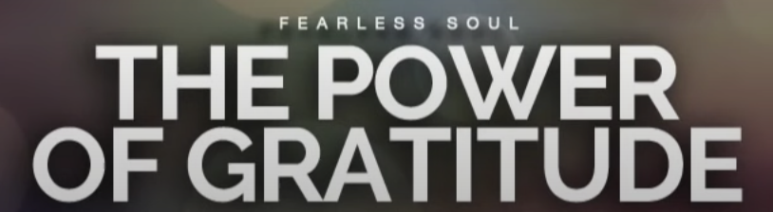
Source link: https://youtu.be/4tq7V0spFmU
Part 2: For this part activity will be introduced in class to our SCSC gratitude journal designed by previous SCSC students. You will complete your gratitude journal each Monday and Friday. This is an ongoing assessment- you will be given your own gratitude journal in hard copy format. You will be marked on this when you have completed a minimum of 20 journal entries.

 You can use the template images below or find another gratitude journal template. It is highly recommended that the gratitude journal template you provide to students is in a hard copy format and filled in handwritten.

Gratitude Journal Entries

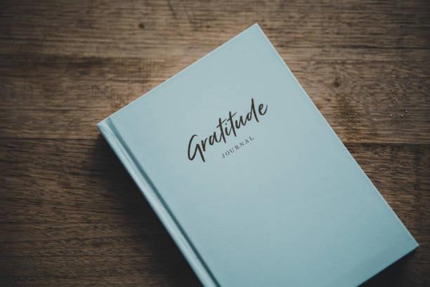

Learning About Myself
Date -
What is one behavior you want to change about yourself?
(E.g., being reactive, yelling, swearing, getting angry at people you love)

What positive statements will help remind you when you feel like you are about to show the behaviour you want to change, do not overthink them, keep it simple.
(E.g., I am calm, I think before I speak, I breathe before I act)
1.
2.
3.

What is one way you will show or practice your new behaviour throughout your day? (something you do)
(E.g. I take a break before I get angry, I run around the block when I'm agitated, I practice my grounding - 5 things I can see, 4 things you can touch, three things you can hear, two things you can smell, 1 thing I can taste)

Daily Intention
Date -

My positive statement of the day
(E.g.- I will be more grateful for the small things in life)

Today I will focus on improving a trait within myself that I want to improve on
(E.g. taking things for granted, remembering myself worth, focusing on the positives instead of the negatives)

I am grateful for list three things…  (E.g. family friends, my pet food, a home) | 1.  2.  3.
3 traits my ideal self will have  (E.g. calm, focused, motivated) | 1.  2.  3.
I can show better behaviour today when I choose to respond by…...
(E.g. being kind, not yelling, thinking before I act)

When I think about my future improved self, I feel ………
(E.g. Brave, Proud, Content)

Draw/Create below
Source Link: How to Get the Most Out of Future Self Journaling - The Holistic Psychologist
 Part 3: Once you have completed the gratitude journal entries reflect on your experience below.
What went well? | Even better if? | Where to next?

Task 1-Gratitude Journal
Student Reflection - How well did you go with this step? (Please check the box below)
☐Not Submitted | ☐Beginning | ☐Consolidating | ☐Achieving | ☐Excelling
Student Comment (Optional):
Teacher Feedback
☐Not Submitted | ☐Beginning | ☐Consolidating | ☐Achieving | ☐Excelling
Not Submitted: No work has been submitted or attempted for this activity. | Beginning: I can complete some journal entries with basic responses.  To bump it up, you need to complete a minimum of 20 and make sure you respond using full sentences. | Consolidating: I can complete the required 20 journal entries using basic sentences.  To bump it up, try to complete more responses and add in more detail. | Achieving: I can complete the required 20 or more journal entries with detailed responses.  To bump it up, try to add in more specific information to your responses. | Excelling: I can complete the required 20 or more journal entries with highly detailed responses including specific examples.
Teacher Comment:

Task 2 -Who am I?

Task Checklist
Students will complete the following for PDS Task 2 – Who am I?
☐ PDS Task 2- Activity 2.1 Watch the ‘Identity’ and ‘values’ video and complete the questions.
☐ PDS Task 2- Activity 2.2 Who am I? Brainstorm and Infographic.
☐ PDS Task 2- Activity 2.3 Values and strengths quiz and reflection

Task 2 – Activity 2.1 What is personal identity?

Part 1: Watch the short video on Identity and Values.

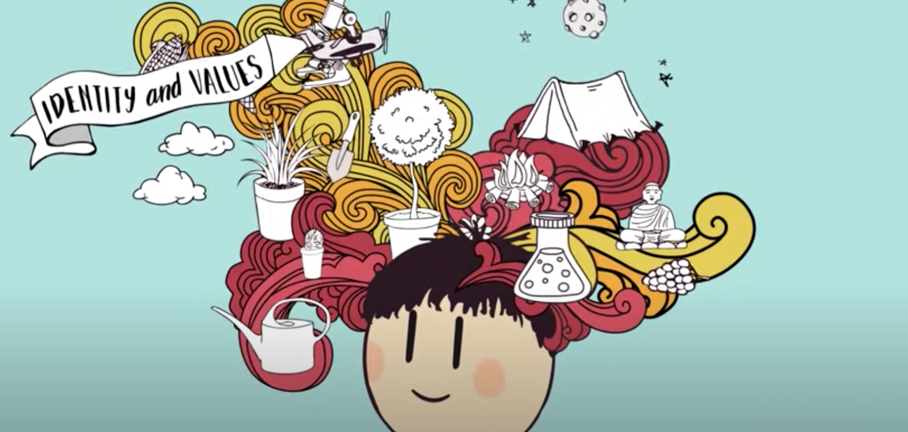
Video source: https://youtu.be/om3INBWfoxY?si=eakeSepv2EAO-Nb-

Part 1: Answer the following questions.
- What are some factors that make up an individual's identity?
(eg - personal hobbies)
Hint- watch up until 1:23, then answer this question.
- What are values? Provide some examples.
Hint- watch between 1:23 - 2:13, then answer this question.

- The video provides some tips to help you find out your values. The video provides three tips to help you recognise what you value and to feel good about your own identity. List these tips in the space below.
Hint- watch between 2:13 - end of video, then answer this question.

Task 2 Activity 2.1 Video Response Questions
Student Reflection - How well did you go with this step? (Please check the box below)
☐Not Submitted | ☐Beginning | ☐Consolidating | ☐Achieving | ☐Excelling
Student Comment (Optional):
Teacher Feedback
☐Not Submitted | ☐Beginning | ☐Consolidating | ☐Achieving | ☐Excelling
Not Submitted: No work has been submitted or attempted for this activity. | Beginning: I can attempt to answer some questions.  To bump it up, you need to answer all the questions. | Consolidating: I can answer most the questions with basic responses.  To bump it up, you could add some more detail into your responses. | Achieving: I can answer all the questions with detailed responses.  To bump it up, recheck your answers to make sure the information you have provided is correct. | Excelling: I can answer each question in detail and all responses are correct.
Teacher Comment:

Task 2- Activity 2.2 Who am I?

Part 1: In the template below, brainstorm what makes you who you are.
Think about the following- your passions, interests, family, experiences, values, goals, culture, community, personality, traits.

Name

Part 2: For this task create a collage including a range of categories from the concept of ‘personal identity’ to provide us with a snapshot of who you are now.

You can choose your own app or program for how you want to do this. If you are unsure, we recommend you use Canva program and select a template from collage style on the right-hand side. If images are not your thing you could also make a word cloud. See some examples below.

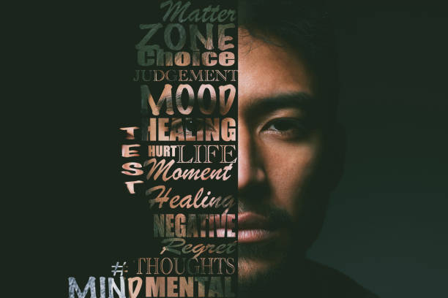 |  |  | 

Part 3: Insert/add your collage or word cloud below.

Task 2- Activity 2.2 Who am I?
Student Reflection - How well did you go with this step? (Please check the box below)
☐Not Submitted | ☐Beginning | ☐Consolidating | ☐Achieving | ☐Excelling
Student Comment (Optional):
Teacher Feedback
☐Not Submitted | ☐Beginning | ☐Consolidating | ☐Achieving | ☐Excelling
Not Submitted: No work has been submitted or attempted for this outcome. | Beginning: I can create a basic ‘Who am I?’ image.  To bump it up you need to include more detail and make sure that the brainstorming and image have both been completed. | Consolidating: I can create a basic ‘Who am I?’ image. I have included a range of self-identity/values.  To bump it up, you could add in some more details to your infographic. | Achieving: I have created a detailed ‘Who am I?’ image and detailed brainstorming. I have included a range of self-identity/concepts.  To bump it up, you could add additional images. | Excelling: I have created a highly detailed ‘Who am I?’ image and brainstorm. I have included a broad range of self-identity/concepts that represent me.
Teacher Comment:

Task 2- Activity 2.3 Values and strength quizzes

Part 1: In this activity you will utilise online quizzes to further help you identify your values and strengths. Complete the following Personal Values Quiz and insert a screenshot of your results below.
Values assessment | Personal Values

Teacher advice- Example to delete.

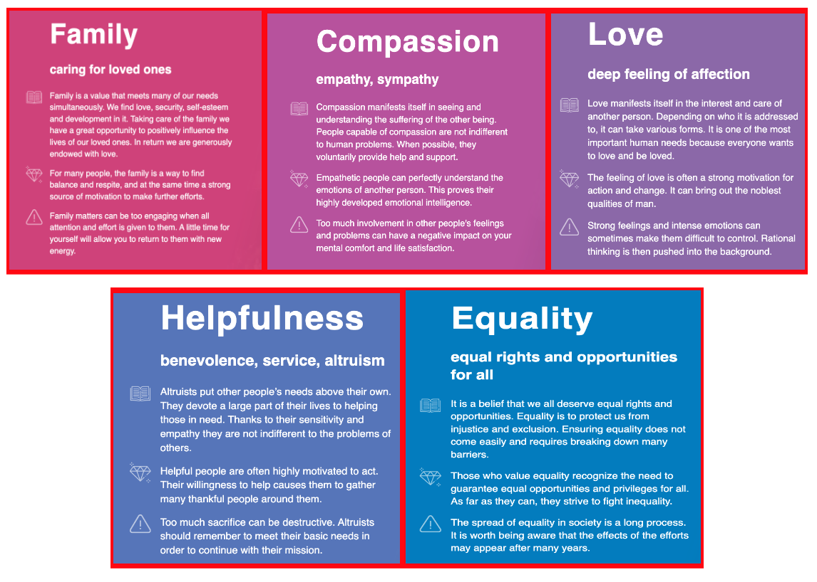

Part 2: Answer the following questions based on your results above.

- What were your top five values?
1.
2.
3.
4.
5.

- Are your results surprising or are they what you would have expected?

Helpful sentences you can use-
- I was surprised that (insert value) was in my top five values. I was surprised because….
- I expected to see (insert value) in my top five values. I expected this because (insert your own examples, or why the value is important to you).

Part 3: Complete the following VIA Character Strength Survey and insert/add a screenshot of your results below.

Login | VIA Institute (viacharacter.org)

Teacher advice- Example to delete.
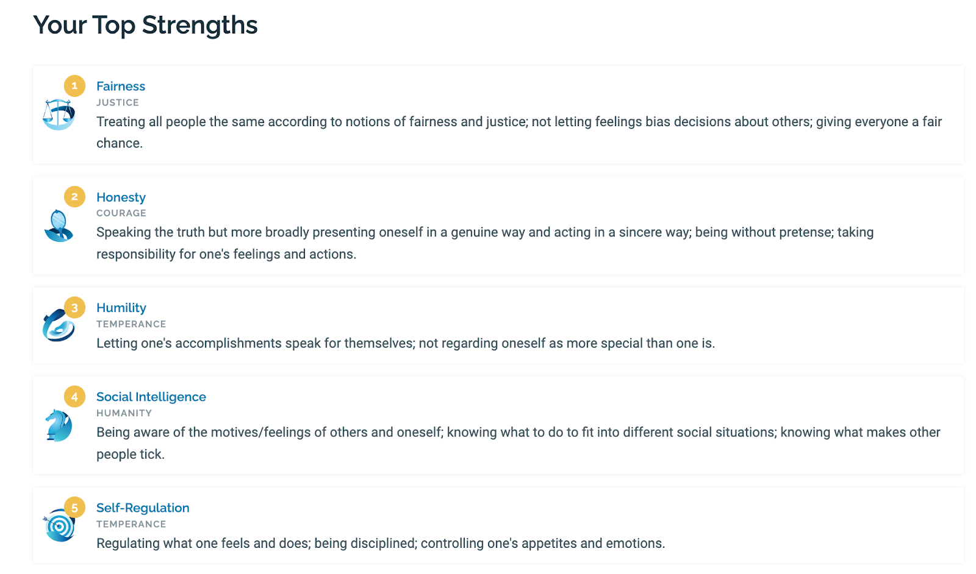
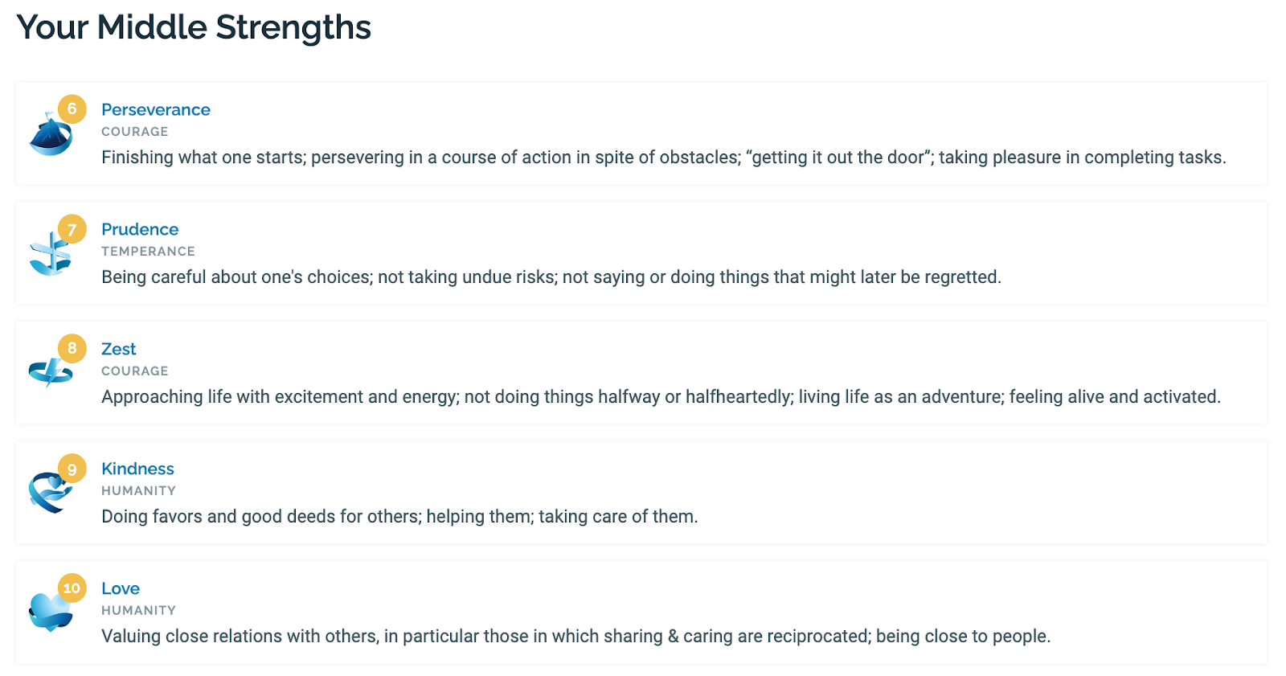
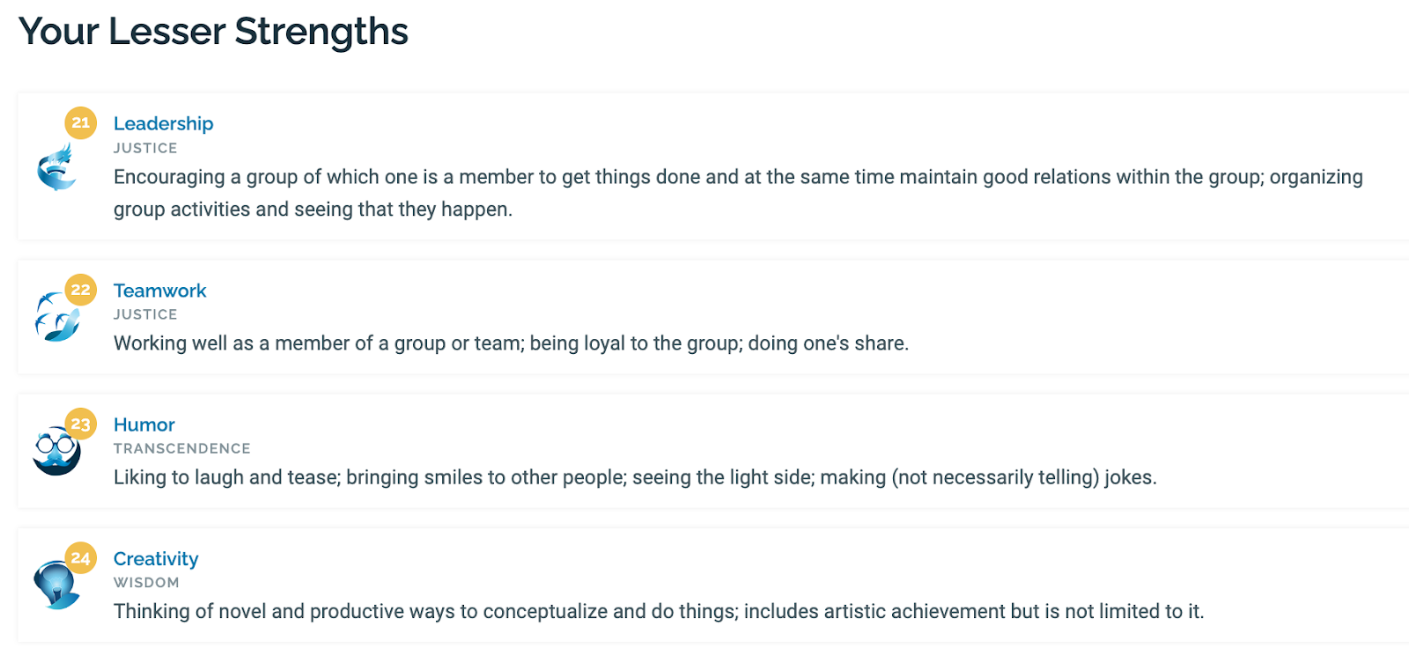

Hint- To get all your results, scroll down and find ‘DOWNLOAD YOUR FREE RESULTS’. This will display all your results.
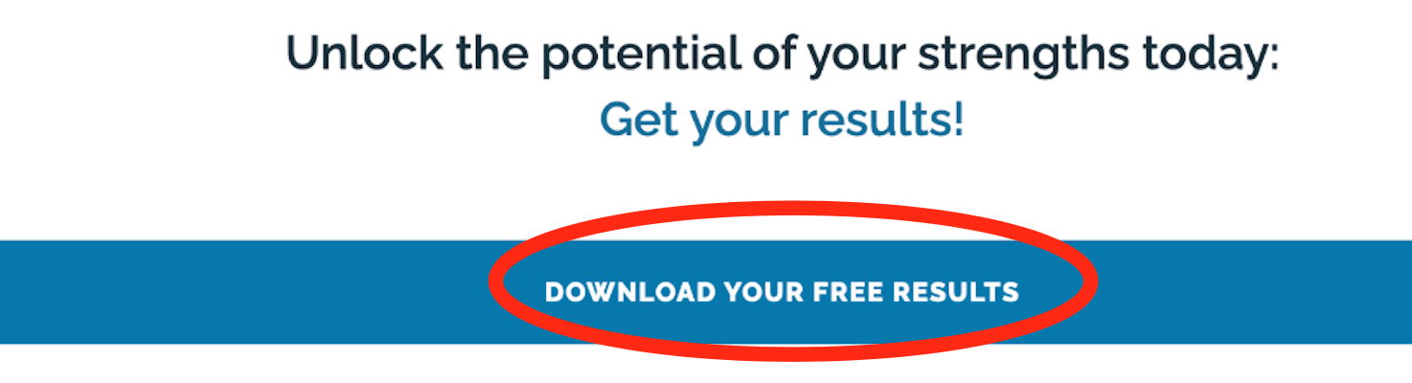
Images source: Login | VIA Institute (viacharacter.org)

Part 4: Answer the following questions based on your VIA character strength results above.

- What were your top five strengths?
1.
2.
3.
4.
5.

- Select one of your top five strengths. In the space below, outline an example where you applied this strength to make a positive impact or to achieve a goal.

Worked Example
Selected Strength: Social Intelligence.
An example of when I have shown a high level of social intelligence is when I saw someone in my netball team not have a partner when completing an activity. I invited them to join my group so that they felt included.

Selected Strength: _____________________

Sentence starter: An example of when I have shown a high level of (insert strength) is when…

- What were your four ‘lesser strengths’?
1.
2.
3.
4.

- Select one of your ‘lesser strengths and outline how you could improve this.

Worked Example
Selected ‘Lesser Strength’: Teamwork
I can improve teamwork by being more aware of my team's strengths and supporting my team to contribute their individual strengths to the overall team goals.

Selected Strength: __________________

Sentence starter: I can improve my (insert ‘lesser strength’) by…

Task 2- Activity 2.3 Values and Strength quiz and reflection
Student Reflection - How well did you go with this step? (Please check the box below)
☐Not Submitted | ☐Beginning | ☐Consolidating | ☐Achieving | ☐Excelling
Student Comment (Optional):
Teacher Feedback
☐Not Submitted | ☐Beginning | ☐Consolidating | ☐Achieving | ☐Excelling
Not Submitted: No work has been submitted or attempted for this activity. | Beginning: I can complete some aspects of this task.  To bump it up, you need to ensure both quizzes have been completed and you have answered all of the reflection questions. | Consolidating: I can complete both quizzes. I can answer most of the questions with detailed responses.  To bump it up, you need to add some more detail into your responses. | Achieving: I can complete both quizzes. I can answer all the reflection questions with detail and have reflected on my results.  To bump it up, you could include more specific examples in your responses. | Excelling: I can complete both quizzes. I can answer each of the questions with some great reflections and examples.
Teacher Comment:

Before you submit have you completed the following:

Task Checklist
Students will complete the following for PDS Task 2 – Who am I?
☐ PDS Task 2- Activity 2.1 Watch the ‘Identity’ and ‘values’ video and complete the questions.
☐ PDS Task 2- Activity 2.2 Who am I? Brainstorm and Infographic.
☐ PDS Task 2- Activity 2.3 Values and strengths quiz and reflection

Task 3-Respectful Relationships
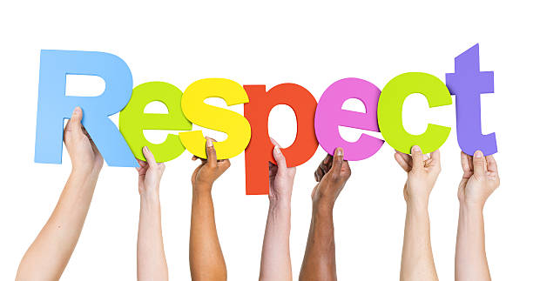

Task Checklist
Students will complete the following Respectful Relationships.
☐ PDS Task 3- Activity 3.1 What is respect?
☐ PDS Task 3- Activity 3.2 Relationships
☐ PDS Task 3- Activity 3.3 Consent

Key Vocabulary (you need to know)
Sexual Coercion - Sexual coercion is unwanted sexual activity that happens when you are pressured, tricked, threatened, or forced in a nonphysical way. Coercion can make you think you owe sex to someone. It might be from someone who has power over you, like a teacher, landlord, or boss.

Task 3- Activity 3.1 What is respect?

Part 1: In your own words define what the word ‘respect’ means.
You can use your own experience and understanding to create a definition. You may also research information to help you with this.

Part 2: Read the following passage from the ‘Kids Helpline’ Website.
All About Respect | Why Is Respect Important? | Kids Helpline

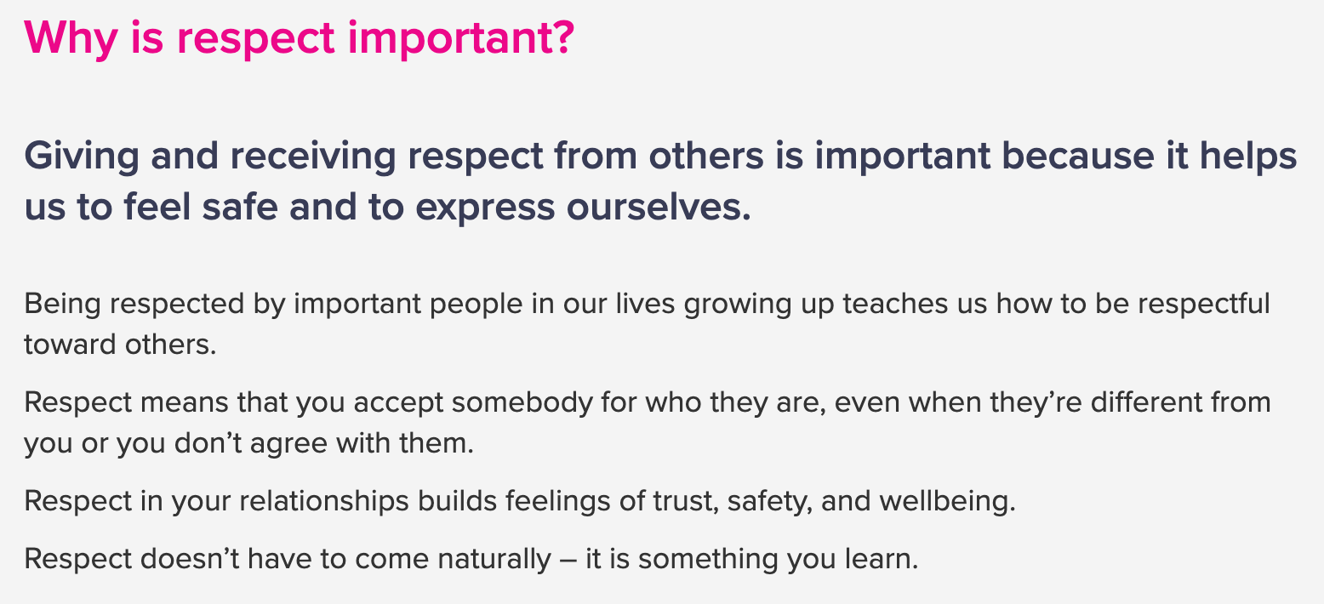
Image source: All About Respect | Why Is Respect Important? | Kids Helpline

Part 3: List below what you think are the key words in this written paragraph.

Part 4: Using the passage above and the words you have listed, explain why respect is important.

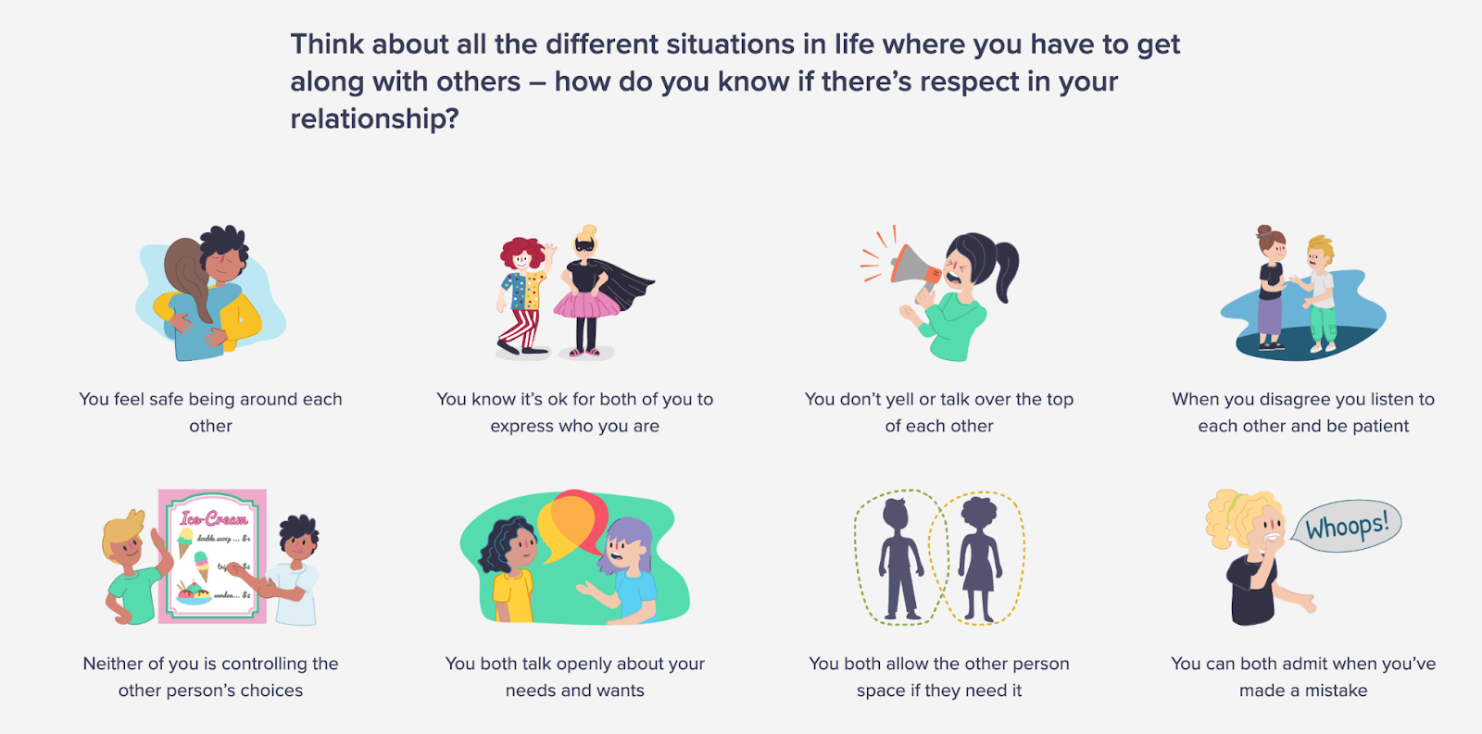
Image source: All About Respect | Why Is Respect Important? | Kids Helpline

Part 5: Using the image above and your own research, create a list of five characteristics that you think are most important in a respectful relationship.

1.
2.
3.
4.
5.

Part 6: Respect is important in all contexts. Complete the table below with examples of how you show respect in the following settings.

Setting | Example of respect
Example: School | Example: I show respect at school by listening when someone else is talking. If I have a question in the classroom, I raise my hand.
School:

Workplace:

Home:

Task 3- Activity 3.1 - What is respect?
Student Reflection - How well did you go with this step? (Please check the box below)
☐Not Submitted | ☐Beginning | ☐Consolidating | ☐Achieving | ☐Excelling
Student Comment (Optional):
Teacher Feedback
☐Not Submitted | ☐Beginning | ☐Consolidating | ☐Achieving | ☐Excelling
Not Submitted: No work has been submitted or attempted for this activity. | Beginning: I can answer some questions.  To bump it up, you need to answer all the questions. | Consolidating: I can answer most the questions.  To bump it up, you could add some more detail into your responses. | Achieving: I can answer all the questions in detail.  To bump it up, you need to check over your information to see if it is correct. | Excelling: I can answer each question in detail and all my responses are correct.
Teacher Comment:

Task 3- Activity 3.2 Relationships

Relationships refer to connections between individuals, groups or entities. These can include Parents, siblings (brothers and sisters), extended family, friends, teammates, classmates, teachers, neighbours, coaches, members of the public, people providing you with a service (bus driver, check out assistant at Woolworths, waitress, etc.), colleagues, girlfriends/boyfriends/wives/husbands, yourself.
Part 1: Think about the relationships in your life. Using the table below, identify what a respectful and positive relationship ‘looks like’, ‘sounds like’ and ‘feels like’.
Respectful and Positive Relationships
Looks like | Sounds like | Feels like
Part 2: Not all relationships are positive or healthy and it is important to be able to recognise this. Read through the ‘Relationships exist on a spectrum’ information below or via the website love is respect.
Relationship spectrum - love is respect
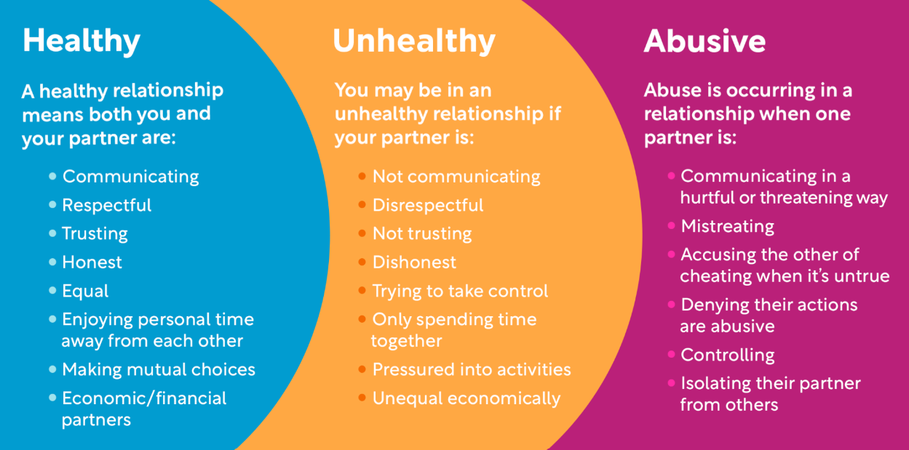
Image source: Relationship spectrum - love is respect

Part 3: Read through the following scenarios and use the relationship spectrum categories to indicate if the scenario demonstrates characteristics of a ‘healthy’, ‘unhealthy’, or ‘abusive’ relationship. Provide a reason for your answer.

Scenario | Relationship spectrum characteristic | Explanation
Morgan receives a call from a long-lost friend who wants to meet up for coffee. Excited about reconnecting, Morgan informs Sam about the plans. Sam reacts with anger, accuses Morgan of disloyalty, and threatens harm if Morgan goes out. Fearing the consequences, Morgan cancels the meeting.
Alex receives exciting news about a job promotion. Taylor expresses genuine happiness and offers support for the new responsibilities. They discuss how this might impact their schedules but work together to find a balance that suits both of them.
Casey receives an invitation to a friend's party and is excited to attend. When informing Jordan about the event, Jordan becomes angry and insists that Casey skips the party to spend time together. Feeling guilty, Casey decides to skip the party to avoid conflict.

Task 3- Activity 3.2 - Relationships
Student Reflection - How well did you go with this step? (Please check the box below)
☐Not Submitted | ☐Beginning | ☐Consolidating | ☐Achieving | ☐Excelling
Student Comment (Optional):
Teacher Feedback
☐Not Submitted | ☐Beginning | ☐Consolidating | ☐Achieving | ☐Excelling
Not Submitted: No work has been submitted or attempted for this activity. | Beginning: I can answer some questions.  To bump it up, you need to answer all the questions. | Consolidating: I can answer a most of the questions.  To bump it up, you could add some more detail to your responses. | Achieving: I can answer all the questions in detail.  To bump it up, you need to check that the information in your responses is correct. | Excelling: I can answer each question in detail and all responses have accurate information.
Teacher Comment:

Task 3- Activity 3.3 Sexual Coercion and Consent
  Part 1: Watch the following video below.
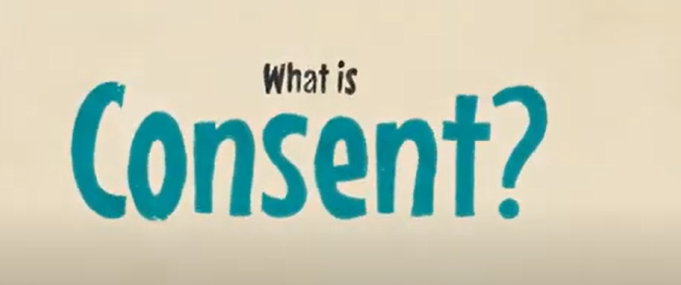
Video source: ‘What is Consent?’

Part 2: After watching the video, outline your understanding of consent. You can research information if you need to help you explain your response.
Consent is…

Part 3: How can you ensure that you have consent?

Part 4: Answer true or false to the following statements.
Statement | True or False
In a committed relationship, consent is always assumed.
Consent can be taken away at any time.
Consent can be given under the influence of drugs or alcohol.
Consent cannot be given if an individual is asleep.
Consent is always required.
Consent is only necessary the first time you engage in sexual activity with someone.
If someone is silent, it is implied consent.
Consent is valid if someone feels pressured or coerced into giving it.

Task 3- Activity 3.3 Consent
Student Reflection - How well did you go with this step? (Please check the box below)
☐Not Submitted | ☐Beginning | ☐Consolidating | ☐Achieving | ☐Excelling
Student Comment (Optional):
Teacher Feedback
☐Not Submitted | ☐Beginning | ☐Consolidating | ☐Achieving | ☐Excelling
Not Submitted: No work has been submitted or attempted for this activity. | Beginning: I can answer some questions.  To bump it up, you need to answer all the questions. | Consolidating: I can answer most of the questions.  To bump it up, you could add some more detail to my responses and complete all the questions. | Achieving: I can answer all the questions in detail.  To bump it up, recheck your responses to make sure you have provided the correct information. | Excelling: I can answer each question in detail and all my responses are correct.

Before you move onto another task have you completed the following activities?
Task Checklist
Students will complete the following Respectful Relationships.
☐ PDS Task 3- Activity 3.1 What is respect?
☐ PDS Task 3- Activity 3.2 Relationships
☐ PDS Task 3- Activity 3.3 Consent

