Victorian Pathways Certificate

Unit 1
Striving Individuals
Integrated Curriculum
Support Materials

Authorised and published by the Victorian Curriculum and Assessment Authority
Level 7, 2 Lonsdale Street
Melbourne VIC 3000
ISBN: 978-1-xxxxxx-xx-x [email vcaa.media.publications@edumail.vic.gov.au for ISBN requests]
© Victorian Curriculum and Assessment Authority [year]

No part of this publication may be reproduced except as specified under the Copyright Act 1968 or by permission from the VCAA. Excepting third-party elements, schools may use this resource in accordance with the VCAA educational allowance. For more information go to https://www.vcaa.vic.edu.au/Footer/Pages/Copyright.aspx.
The VCAA provides the only official, up-to-date versions of VCAA publications. Details of updates can be found on the VCAA website at www.vcaa.vic.edu.au.
This publication may contain copyright material belonging to a third party. Every effort has been made to contact all copyright owners. If you believe that material in this publication is an infringement of your copyright, please email the Copyright Officer vcaa.copyright@edumail.vic.gov.au
Copyright in materials appearing at any sites linked to this document rests with the copyright owner/s of those materials, subject to the Copyright Act. The VCAA recommends you refer to copyright statements at linked sites before using such materials.
The VCAA logo is a registered trademark of the Victorian Curriculum and Assessment Authority.

Contact us if you need this information in an accessible format - for example, large print or audio.
Telephone (03) 9032 1635 or email vcaa.media.publications@edumail.vic.gov.au

Contents
Contents
Step 1- Ideas 4
Step 1- Activity 1.1 Brainstorm understanding health and wellbeing 4
Step 1- Activity 1.2 Healthy Habits 6
Step 1- Activity 1.3 Health Promotion Research Analysis 8
Step 1- Activity 1.4 Online safety and strategies 10
Before you move onto Step 2 - Plan 11
Step 2 12
Step 2- Activity 2.1 Guest Speakers (Before) 12
Step 2- Activity 2.2 Project statement and SMART goal 14
Step 2- Activity 2.3 Design Phase - Resource List 15
Step 2- Activity 2.4 Identifying the Mathematics Table 16
Step 2- Activity 2.5 Problems and solutions table 20
Step 2- Activity 2.6 Project Measurement Tools 21
Step 2- Activity 2.7 Email - Handwritten Draft and Scaffold Template 22
Step 2- Activity 2.8 Email - Final Copy 23
Before you move onto Step 3 - Act 25
Step 3 Act 26
Step 3- Activity 3.1 Pre-program Survey 26
Step 3- Activity 3.2 Program Log Record 28
Step 3- Activity 3.3 post-program survey 36
Before you move onto Step 4 - Adapt 37
Step 4 – Adapt 38
Step 4- Activity 4.1 Wellbeing Explanation 38
Step 4-Activity 4.2 Mathematical toolkit 40
Step 4-Activity 4.3 Numeracy reflection 42
Before you move onto Step 5 - Reflect 43
Step 5- Reflect 45
Step 5 - Activity 5.1 Cluster Map 45
Step 5- Activity 5.2 Skills reflection 47
Step 5- Activity 5.3 Numeracy Problem-Solving Cycle and Interview 48
Before you move onto another task 50

Step 1- Ideas
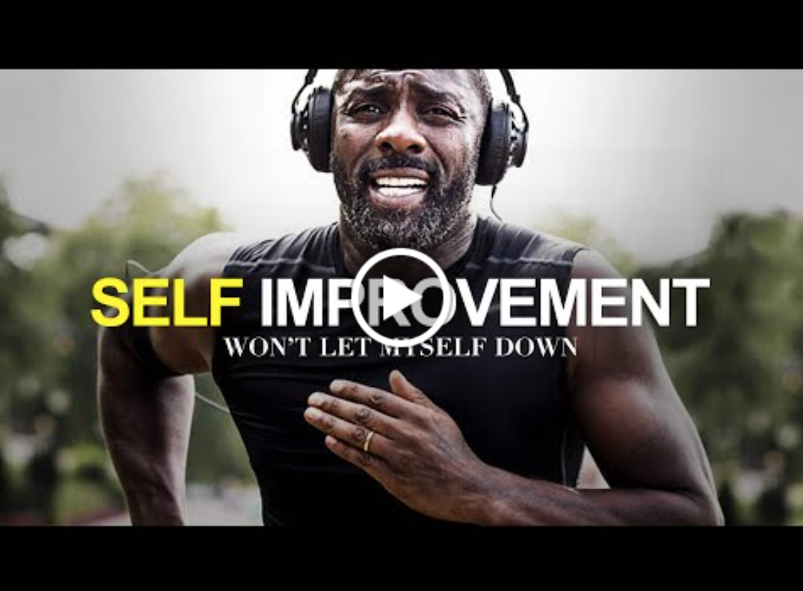

Video Link: https://youtu.be/RO4abBz6W7M?si=Y9fiwTrwzbQWzHp0
Task Checklist
Students will complete the following for Step 1- Ideas.
☐ Step.1 Activity 1.1 Brainstorm
☐ Step.1 Activity 1.2 Health and wellbeing video questions
☐ Step 1 Activity 1.3 Health promotion research analysis
☐ Step 1 Activity 1.4 Online safety and strategies.

Key vocabulary (you need to know)
Health: the general condition of the body or mind with reference to soundness and vigour.
Well-being: a good or satisfactory condition of existence; a state characterised by health, happiness, and prosperity; welfare
Health promotion: is the process of enabling people to increase control over, and to improve their health.
Emotional: subject to or easily affected by emotion.
Social: relating to, devoted to, or characterised by friendly companionship or relations.
Physical: of or relating to the body.
Cultural: of or relating to culture or cultivation.
Digital Footprint: information about a particular person that exists on the internet as a result of their online activity.

Step 1- Activity 1.1 Brainstorm understanding health and wellbeing
  Part 1: In a pair or small group, brainstorm what you currently know about health and wellbeing. Include factors that positively or negatively impact health and wellbeing.

Think about factors such as emotional, social, physical, cultural, economic, environmental or geographical.

Present your brainstorm below using one of the following tools or pick your own:

- Pen and paper
- Canva
- MindMup
- Mindmeister

Add your brainstorm here.

Activity 1.1- Brainstorm
Student Reflection - How well did you go with this step? (Please check the box below)
☐Not Submitted | ☐Beginning | ☐Consolidating | ☐Achieving | ☐Excelling
Student Comment (Optional):
Teacher Feedback
☐Not Submitted | ☐Beginning | ☐Consolidating | ☐Achieving | ☐Excelling
Not Submitted: No work has been submitted or attempted for this activity. | Beginning: I can brainstorm some things that come to mind when I think of health and well-being.  To bump it up, you need to add some more examples of factors to your brainstorm. | Consolidating: I can brainstorm what I currently know about health and well-being.  To bump it up, you need to add some more examples of factors to your brainstorm. | Achieving: I can brainstorm what I currently know about health and well-being. I have added other people’s knowledge too my brainstorm too.  To bump it, try to think together of what other factors are important to include. | Excelling: I can brainstorm with extensive detail about what I currently know about health and wellbeing. I have shared ideas and considered other people’s thoughts which are also included in my brainstorm.
Teacher Comment:

Step 1- Activity 1.2 Healthy Habits
  Part 1: Watch the video linked below.

Video link: https://youtu.be/dhpCdqOtuj0?si=tHZWMV5xdAG3kkeO

Part 2: After watching the video, why is health and well-being important?

I think health and well-being are important because…

 Part 3: Different factors can impact health (both positively and negatively). Select one of the factors listed below and explain what impact (positive or negative) this factor can have on an individual's health and well-being.
Tick the box
☐ Shelter
☐ Food
☐ Safety
☐ Exercise
☐ Sleep
☐ Income
☐ Access to healthcare
(Insert factor you ticked above) can have a (select either positive or negative) impact on health because…

Activity 1.2 Understanding Health and Wellbeing video
Student Reflection - How well did you go with this step? (Please check the box below)
☐Not Submitted | ☐Beginning | ☐Consolidating | ☐Achieving | ☐Excelling
Student Comment (Optional):
Teacher Feedback
☐Not Submitted | ☐Beginning | ☐Consolidating | ☐Achieving | ☐Excelling
Not Submitted: No work has been submitted or attempted for this activity. | Beginning: I can watch a video and answer some of the questions.  To bump it up you, you need to answer all the questions. | Consolidating: I can watch a video and answer most of the questions with basic responses.  To bump it up, you need to add more details to your responses. | Achieving: I can watch a video and answer all the questions with detailed responses.  To bump it up, recheck your answers to make sure they are accurate. You could also research more information to add to your responses. | Excelling: I can watch the video and answer all the questions with detailed responses. My responses include information gained from the video and additional researched information.
Teacher Comment:

Step 1- Activity 1.3 Health Promotion Research Analysis
Part 1: Select from the following or use the ‘How to be SunSmart’ image and website linked below.

Surf Coast Walk
Park Run
Vic Health Programs 7 Projects
Active April
This Girl Can
Think - Mental Health

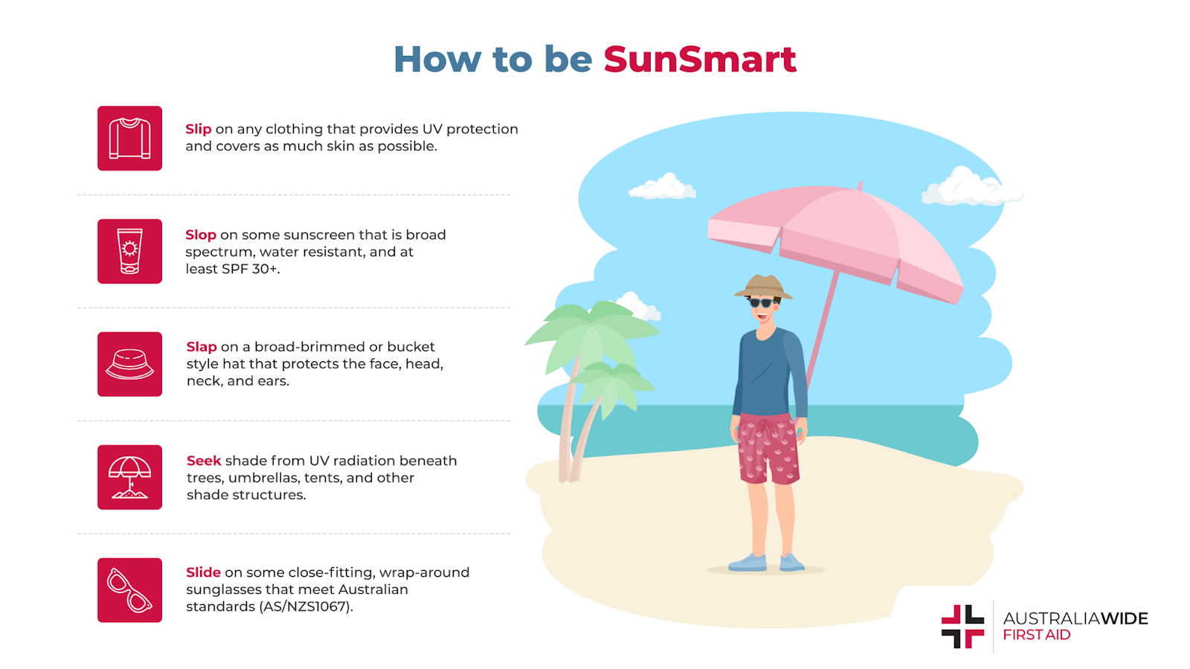
Image source: What is Slip Slop Slap Seek and Slide? (australiawidefirstaid.com.au)
What is Slip Slop Slap Seek and Slide? (australiawidefirstaid.com.au)

Part 2: Complete the following table for the SunSmart image and website above. Or the health promotion service you selected.

Identify the features below in each reading | Direct quotes/examples/comments
Name of Text
(Reference)

Author:

Link:

How do we know that this is a reliable website? | - Is the author or website from a trusted source? For example-Government or professional organisations.  ☐Yes  ☐No  - Is this website up to date and/or is a date provided?  ☐Yes  ☐No  - Is the site clear, organised and set out well?  ☐ Yes  ☐ No  - Does the site look professional?  ☐Yes  ☐No  - Is there are hyperlinks on the website? Click on a few of the hyperlinks, do these links lead to trusted sites?  ☐Yes  ☐No
Based on the above information, do you think this website is reliable? Explain.

I think this website (is or is not) reliable because… (use the points that you answered ‘yes’ or ‘no’ to above).
Target audience: The group of people at which a product/message /service is aimed towards.  Can include:  - Age  - Gender  - Location  - Interests  - Values  - Education level | The target audience for ‘How to be SunSmart: Slip Slop Slap Seek and Slide’ is …
What is the purpose of the program? | The purpose of the ‘How to be SunSmart: Slip Slop Slap Seek and Slide’ article is …

Activity 1.3 Health Promotion Research Analysis
Student Reflection - How well did you go with this step? (Please check the box below)
☐Not Submitted | ☐Beginning | ☐Consolidating | ☐Achieving | ☐Excelling
Student Comment (Optional):
Teacher Feedback
☐Not Submitted | ☐Beginning | ☐Consolidating | ☐Achieving | ☐Excelling
Not Submitted: No work has been submitted or attempted for this activity. | Beginning: I have attempted some elements of the table.  To bump it up, you need to provide a basic response to all elements of the table. | Consolidating: I can complete all elements of the table with basic information.  To bump it up, you need to add more details to your responses. | Achieving: I can complete all elements of the table with detailed information.  To bump it up, recheck your responses to make sure all the information is correct. | Excelling: I can complete all aspects of the analysis table with detailed responses and correct information.
Teacher Comment:

Step 1- Activity 1.4 Online safety and strategies

Part 1: Answer the questions below.

- Google yourself and see what comes up if an employer were to look you up. Do you have a good online profile? Why /why not?

- What do you need to change?

3. List 3 ways to have a positive digital footprint (how you are represented online).
Example- Ensure that your privacy settings are switched on.
1.

2.

3.

Part 2: Technology can be a positive way of expressing yourself. Technology also can come with some negative effects. Complete the table below including the positives and negatives of technology on individuals.

Positives | Negatives
1.
2.

Activity 1.4 - Online safety and strategies
Student Reflection - How well did you go with this step? (Please check the box below)
☐Not Submitted | ☐Beginning | ☐Consolidating | ☐Achieving | ☐Excelling
Student Comment (Optional):
Teacher Feedback
☐Not Submitted | ☐Beginning | ☐Consolidating | ☐Achieving | ☐Excelling
Not Submitted: No work has been submitted or attempted for this activity. | Beginning: I can answer some of the questions provided.  To bump it up, you need to answer all the questions. | Consolidating: I can answer most of the questions about my own digital footprint. I have identified basic information about the negatives and positives of technology.  To bump it up, you need to add more details to your responses. | Achieving: I can reflect and respond to all questions about my digital footprint. I have identified the negatives and positives impacts of technology and explained my responses in detail.  To bump it up, you could include more information about changes you may need to make to your digital footprint. | Excelling: I can reflect and respond in detail to all questions about my digital footprint. I have identified the negatives and positives impacts of technology and explained my responses. I have included changes that I may need to make to my own digital footprint.
Teacher Comment:

Before you move onto Step 2 - Plan
Have you completed the following activities?
Task Checklist
Students will complete the following for Step 1- Ideas.
☐Activity 1.1 Brainstorm
☐Activity 1.2 Health and wellbeing video questions
☐ Activity 1.3 Health promotion research analysis
☐Activity 1.4 Online safety and strategies.

Step 2


Task Checklist
Students will complete the following for Step 2: Plan:
☐ Step.2 Activity 2.1 Guest Speakers
☐ Step.2 Activity 2.2 Design phase: Project statement and SMART goal
☐ Step.2 Activity 2.3 Design phase: Resource list
☐ Step.2 Activity 2.4 Design phase: Identifying the mathematics table
☐ Step.2 Activity 2.5 Design phase: Problems and solutions table
☐ Step.2 Activity 2.6 Design phase: Project measurement tool
☐ Step.2 Activity 2.7 Design phase: Email: Handwritten draft and scaffold template
☐ Step.2 Activity 2.8 Email: Final copy

Key Vocabulary (you need to know)
Health: the general condition of the body or mind with reference to soundness and vigour.
Well-being: a good or satisfactory condition of existence; a state characterised by health, happiness, and prosperity; welfare
Health promotion: the process of enabling people to increase control over, and to improve their health.

Step 2- Activity 2.1 Guest Speakers (Before)

 Part 1: A panel of guest speakers has been formed to share their experiences in the health and wellbeing space. You will be required to complete the following tasks below.

Part 2: The Guest Speaker I have chosen is…

Guest Speakers List
Chloe - F45

Olsen - Body Sculpt

Matt – Boneyards

Michelle – Wellbeing

Regan Neoh - Youth Services

Part 3: Guest Speakers Notetaking (During)-Use a blank piece of paper to take notes from the guest speakers and insert a photo or the link to your document below.

What do you need to include in your notes?
Who? Name of guest speaker
What? Identify the main ideas and key information that was discussed by your selected guest speaker (Minimum of three dot points).
Who?

What?

Activity 2.1 Guest Speakers - Notetaking
Student Reflection - How well did you go with this step? (Please check the box below)
☐Not Submitted | ☐Beginning | ☐Consolidating | ☐Achieving | ☐Excelling
Student Comment (Optional):
Teacher Feedback
☐Not Submitted | ☐Beginning | ☐Consolidating | ☐Achieving | ☐Excelling
Not Submitted: No work has been submitted or attempted for this activity. | Beginning: I can make an effort to actively listen and I have attempted to take some notes from the guest speaker.  To bump it up, you need to add more details to your notes. | Consolidating: I can actively listen and take some basic notes from the guest speaker.  To bump it up, you need to include more detail into my notes. | Achieving: I can actively listen and collate notes from the guest speaker with detail.  To bump it up, you could include more information or create follow up questions you might like to ask. | Excelling: I can actively listen and collate highly detailed notes from the guest speaker including a broad range of areas that were discussed including follow up questions.
Teacher Comment:

Step 2- Activity 2.2 Project statement and SMART goal

Part 1: Design Phase- self-care is important to make sure an individual is healthy and well. Part of your Tuesday afternoon activities will be engaging in some kind of self-care activity. These will include F45, Body Sculpt, Mindfulness / Meditation, school-based activities, team sports and Bone Yards.

Teacher advice- Delete out non relevant options and add in your own.

From the list provided, select one of the following that you would like to base your health and wellbeing project around.

☐ F45
☐ Body Sculpt
☐ Mindfulness / Meditation
☐ School-based activities
☐ Team sports
☐ Bone Yards
☐ Other: ________________

Part 2: State what your project is below.

My project is…

 Part 3: Use the following SMART goal template to help you create a goal for your project. If you need more information on how to make a SMART goal watch the video here.

Element of SMART goal: | Worked example | Response -  How is this element included in your project?
Specific  What do you want to accomplish? | After completing one term at:  Body Sculpt  I will have achieved a 50 kg bench press for 3 reps. | After completing one term at:  ☐ F45  ☐ Body Sculpt  ☐ Mindfulness / Meditation  ☐ School-based activities  ☐ Team sports  ☐ Bone Yards  ☐ Other: ________________  I will have achieved…
Measurable  How will you know when you have accomplished your goal? | I will track my progress by [using a weights tracker app], aiming to reach [50 kg bench press for 3 reps] within one term of attending Body Sculpt. | I will track my progress by  [using specific criteria],  aiming to reach [a specific number or amount] within one term of attending [your chosen program].
Attainable  How can the goal be accomplished? Is this realistic? | I will make sure my goal is doable by ensuring that I attend Body Sculpt every Tuesday afternoon. | I will make sure my goal is doable by…
Relevant  How is it relevant for you? | This goal is important to me because I play football and an area, I am hoping to improve on is my strength. | This goal is important to me because…
Timely  When will the goal be accomplished? | I will participate in Body Sculpt every Tuesday afternoon for one term. I hope to achieve this goal at the end of the term. | I hope to have my goal achieved by…

Activity 2.2 Design Phase - Project statement and SMART goal
Student Reflection - How well did you go with this step? (Please check the box below)
☐Not Submitted | ☐Beginning | ☐Consolidating | ☐Achieving | ☐Excelling
Student Comment (Optional):
Teacher Feedback
☐Not Submitted | ☐Beginning | ☐Consolidating | ☐Achieving | ☐Excelling
Not Submitted: No work has been submitted or attempted for this activity. | Beginning: I can create some elements of the SMART goal.  To bump it up, you need to develop a basic SMART goal to work towards for your project. | Consolidating: I can develop a basic SMART goal.  To bump it up, you need to add more details to your SMART goal to work towards for your project. | Achieving: I can develop a detailed SMART goal.  To bump it up, you need to add more specific information to how your SMART goal links directly to your project. | Excelling: I can create a comprehensive SMART goal.
Teacher Comment:

Step 2- Activity 2.3 Design Phase - Resource List

Part 1: For your project to be successful what resources will you need? Complete the table below (Add additional rows if you need to list more resources). Think - Equipment, venue, materials and experts.
List the Resources below
Example: Yoga Mat

Activity 2.3 Design Phase - Resource List
Student Reflection - How well did you go with this step? (Please check the box below)
☐Not Submitted | ☐Beginning | ☐Consolidating | ☐Achieving | ☐Excelling
Student Comment (Optional):
Teacher Feedback
☐Not Submitted | ☐Beginning | ☐Consolidating | ☐Achieving | ☐Excelling
Not Submitted: No work has been submitted or attempted for this activity. | Beginning: I can provide a minimal list of resources.  To bump it up, you need to include more of what you need to your list for your project to be successful. | Consolidating: I can list the resources I need for my project to be successful.  To bump it up, you could add some more information to your list (including experts, venue, materials and equipment). | Achieving: I can make a detailed list of the resources I require. My list includes project specific resources such as equipment, venue, materials and experts.  To bump it up, you could include resource that you may need to access if problems occur throughout your project. | Excelling: I can create a comprehensive list of the resources that are essential and may be needed for my project. I have described how the resources will be used in my project accurately.
Teacher Comment:

Step 2- Activity 2.4 Identifying the Mathematics Table
Part 1: In the left-hand column tick the box of the different mathematical skills you will require for this project. In the right-hand column describe how you will use this skill in your project.

Click on the checkbox to select a mathematical skill | Describe how you are going to use the mathematical skill in your project
Location  ☐ 1.1Find location and direction in relation to everyday, familiar places within the vicinity.  Examples/things to think about:  - How do you organise your gym program in relation to familiar exercises or activities within the gym?  - Think about your favourite workout areas in the gym. How do you incorporate exercises in relation to those places? For instance, do you perform strength training near the free weights section or cardiovascular exercises near the cardio equipment?  ☐ 1.2 Find location and direction with every day, simple and familiar maps and technologies.  Examples/things to think about:  Google Maps  Directions  Are you walking to a gym and how will you know where to go?  ☐ 1.3 Use every day oral directions using informal language such as left/right, up/down, front/back, under/beside/over.  Examples/things to think about:  - Can you describe your gym program using everyday oral directions and informal language?  - If you were giving directions to someone to follow your workout routine, how would you describe it using informal language? For instance, "Start with 10 minutes on the treadmill, then head to the weights area for some squats. After that, move to the mat for core exercises. | I will use ‘location’ throughout my project by…
Systematics  ☐ 1.1 Find common and familiar information and data inputs  Examples/things to think about:  - Sets and reps in your workouts  - Duration of workout  - Weights lifted  ☐ 1.2 Read data outputs  Examples/things to think about:  - Check heart rate data  - Calories burned  - Data on exercise machines  - Recording reps, sets and weights achieved in the workout  - Intensity of workouts  ☐ 1.3 Summarise information  Examples/things to think about:  - Summarising your workout performance for a week, highlighting achievements and areas for improvement.  - Summarising data - can you compare data from each session? Were there improvements in your results? For example, were you able to lift a heavier weight?  - Are there key trends or patterns?  - Summarise your overall progress towards your SMART goals. | I will use ‘systematics’ throughout my project by…
Numbers  ☐ 1.1 Place value and numbers up to 1000  Examples/things to think about:  - Sets and reps of your workout/program  - Time of your workout/program  - Heart rate  ☐ 1.2 Whole numbers and monetary amounts up to $1000  Examples/things to think about:  - Is there a cost of your program? Usually, there will be some cost (check with your teacher).  - Do you have a membership to a gym, program, sporting club, etc? How much does this cost?  - Does anything need to be purchased for you to complete your program? How much would this cost?  ☐ 1.3 Addition and subtraction (with no borrowing or decomposition) of whole numbers and familiar monetary amounts into the 100s  Examples/things to think about:  - Working out how many sessions you complete per week. How many hours per week/month/year on your program?  - Total sets and reps in the workout.  - Increase or decrease in weights lifted. For example - I started by being able to bench press 30kg from the beginning, increasing to 40 kg at the end of the program. This is an increase of 10kg.  ☐ 1.4 common, simple unit fractions such as 1/2, 1/4 and 1/10  Examples / things to think about:  - How do you wish to split your program? If a person spends half an hour on cardio and half an hour on strength training during a one-hour workout, each activity gets 1/2 of the total time.  ☐ 1.5 common decimals and percentages such as 0.5, 0.25, 50%, 25%.  Examples/things to think about:  - Increasing the weights I lift on a bench press by 10% each week.  - Increasing the distance of my run by 5% each week. | I will use ‘numbers’ throughout my project by…
Change  ☐ 1.1 Pattern prediction with shapes  Examples/things to think about:  - Tracking changes - I will be able to improve my reps and increase the reps I complete by 1 rep each week.  ☐ 1.2 Repeating patterns with one element such as with shapes, or $2, $4, $6, $8.  Examples/things to think about:  - Repeating pattern in workout sets. If a person does a workout routine of 2 sets of push-ups, 4 sets of squats, 6 sets of lunges, and so on, the pattern repeats with the increment of 2 sets each time.  ☐ 1.3 changes and number matching with simple numbers. For example, prices increasing or decreasing, matching corresponding numbers.  Examples/things to think about:  - Will you increase or decrease your strength, endurance, and mental health throughout your program? | I will use ‘change’ throughout my project by…

Activity 2.4 - Identifying the Mathematics Table
Student Reflection - How well did you go with this step? (Please check the box below)
☐Not Submitted | ☐Beginning | ☐Consolidating | ☐Achieving | ☐Excelling
Student Comment (Optional):
Teacher Feedback
☐Not Submitted | ☐Beginning | ☐Consolidating | ☐Achieving | ☐Excelling
Not Submitted: No work has been submitted or attempted for this activity. | Beginning: I can select some mathematical skills. I have tried to link how this mathematical skill will be used in my project.  To bump it up, you need to select a mathematical skill from each category and provide a basic explanation for how you will use this in your project. | Consolidating: I can select mathematical skills from the table a provide a basic explanation of how I will use this skill in my project.  To bump it up, you need to add more details to your explanations. | Achieving: I can select a mathematical skill from each of the numeracies. I can give a detailed description of how these are going to be used in my project.  To bump it up, you need to add specific details about when and how these mathematical skills will be demonstrated in your project. | Excelling: I can select a mathematical skill from each of the numeracies. I have given a highly detailed description of when and how these mathematical skills will be used in my project for me to reach my project goal/aim.
Teacher Comment:

Step 2- Activity 2.5 Problems and solutions table

Part 1: Consider any possible issues, problems or hazards for your program and how these could be managed.

Potential Problem/Issue/Hazard | How could this problem be prevented or resolved?
Example: During my project, there is a potential for injury. | Example: Ensure that a warm-up and stretches are done before beginning the program.
Lack of motivation / can’t be bothered.

Soreness of muscle after a session.

Add your own here.

Add your own here.

Activity 2.5 Problems and solutions table
Student Reflection - How well did you go with this step? (Please check the box below)
☐Not Submitted | ☐Beginning | ☐Consolidating | ☐Achieving | ☐Excelling
Student Comment (Optional):
Teacher Feedback
☐Not Submitted | ☐Beginning | ☐Consolidating | ☐Achieving | ☐Excelling
Not Submitted: No work has been submitted or attempted for this activity. | Beginning: I can attempt to provide solutions or preventative measures for issues that may arise.  To bump it up, you need to ensure all the tables are complete. | Consolidating: I can provide basic solutions or preventative measures for issues that may arise.  To bump it up, you need to add more details to your responses. | Achieving: I can provide solutions or preventative measures for issues that may arise.  To bump it up, you could include more information about what you would do if the issue still occurred after you put preventative measures in place. | Excelling: I can provide solutions or preventative measures for issues that may arise. I have explained how and why the strategies will help. I have considered what actions I could take if the issues or hazards still occurred.
Teacher Comment:

Step 2- Activity 2.6 Project Measurement Tools
Part 1: Brainstorm in the space below how you are going to know whether your program is successful or not. What and how will you measure if you have been successful? Measurement tools could include reflections, data sets, surveys, mood scales, images and videos.

Activity 2.6 Project Measurement Tools
Student Reflection - How well did you go with this step? (Please check the box below)
☐Not Submitted | ☐Beginning | ☐Consolidating | ☐Achieving | ☐Excelling
Student Comment (Optional):
Teacher Feedback
☐Not Submitted | ☐Beginning | ☐Consolidating | ☐Achieving | ☐Excelling
Not Submitted: No work has been submitted or attempted for this activity. | Beginning: I have attempted to brainstorm some project measurement tools.  To bump it up, you need to identify specific project measurement tools, so you will be able to tell if you have been successful in your project. | Consolidating: I have listed a couple of project measurement tools.  To bump it up, you need to include more information about how you are going to use these project measurement tools, so you will be able to tell if you have been successful in your project. | Achieving: I have listed several project measurement tools. I have included details about how I will use them in my project.  To bump it up, include more information about why you have chosen the project measurement tools you have selected. | Excelling: I have selected several project measurement tools and included highly detailed information about how I intend to use them in my project and why I chose them.
Teacher Comment:

Step 2- Activity 2.7 Email - Handwritten Draft and Scaffold Template

Part 1: Handwrite a draft email outlining your project. This should take no more than 10-20 minutes. Structure this just how you think this email should look. Add a photo of your handwritten draft in the space below.

Add image here.

Activity 2.7 Email - Handwritten Draft
Student Reflection - How well did you go with this step? (Please check the box below)
☐Not Submitted | ☐Beginning | ☐Consolidating | ☐Achieving | ☐Excelling
Student Comment (Optional):
Teacher Feedback
☐Not Submitted | ☐Beginning | ☐Consolidating | ☐Achieving | ☐Excelling
Not Submitted: No work has been submitted or attempted for this activity. | Beginning: I have attempted to write a draft email.  To bump it up, you need to ensure that you have submitted a photo of my draft. | Consolidating: I can write a basic email. I have provided a photo of my handwritten draft.  To bump it up, you need to include more details about your project. | Achieving: I can write an email that contains some detailed information in sections. I have provided a photo of my handwritten draft  To bump it up, you need to add more details to your email overall. | Excelling: I can write an email that contains highly detailed information relevant to my specific project. I have provided a photo of my handwritten draft.
Teacher Comment:

Step 2- Activity 2.8 Email - Final Copy

Part 1: From your draft email in Step.2 Activity 2.7 review your draft email. Compare your draft email to the table below. From the information outlined in the table, create a final copy of your email. You will add a copy of your final email in the space provided below.

Things to consider
Target Audience: who will your email be addressed to?
You email could be to:
- Parents
- Teachers
- Organisations (the gym that you are going to attend)

Checklist of information that must be included in your email:
☐ Greeting at the beginning
☐ Outline what your project is.
☐ Outline the goals for your project.
☐ List the materials that you will need for the successful completion of your project.
☐ Discuss what the purpose of undertaking this project is.
☐ Sign off with your full name
Before submitting your final copy of your email, make sure you have considered the following:
☐ You have structured your email well including the use of paragraphs.
☐ You have checked your spelling and punctuation.
☐ You have got a peer or a teacher to read over your email and implement their feedback.
Use the following scaffold to assist in writing your email:
Hi (insert name of who the email is to),

As part of my ‘Striving Individuals Project’ I am focusing on improving my health, well-being and self-care strategies.

To improve these areas my project focus will be attending (insert your selected program) on a Tuesday afternoon in sessions five and six.

My goal is to (insert what you hope to achieve throughout the term - refer to ‘Step 2 – Activity 2.2’).

For this project, I need to make sure I am organised and have the appropriate materials. The materials I need to have for each session include (insert materials needed - refer to ‘Step 2 – Activity 2.3’).

Every Tuesday, after lunch I will (insert method - give step-by-step instructions of what you do - meet in the classroom, how long does it take to walk there? What do you do in the sessions? What time do you leave to get back to school on time? Are you going to track your progress in your sessions?)

Engaging in this activity will help to improve my overall health, well-being and self-care by…

Thanks,

(Insert your name)

Worked Example
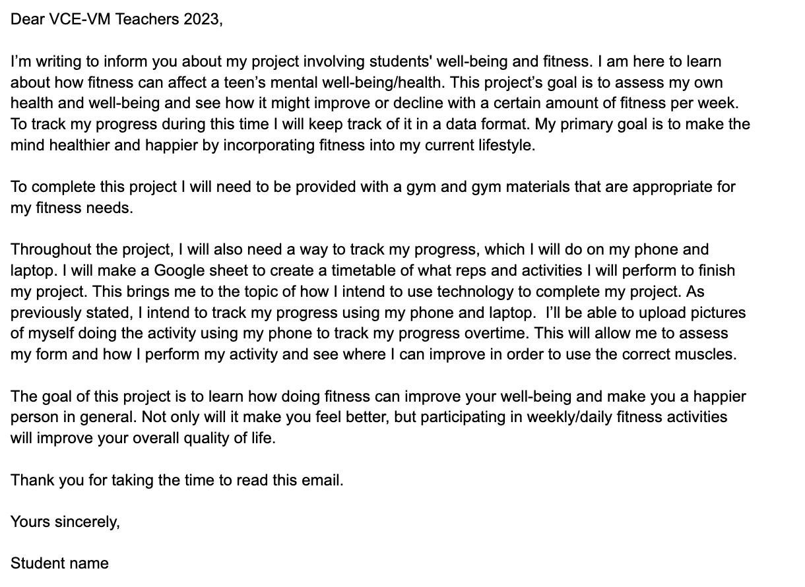

Add your final email copy here.

Activity 2.8 Email - Final Copy
Student Reflection - How well did you go with this step? (Please check the box below)
☐Not Submitted | ☐Beginning | ☐Consolidating | ☐Achieving | ☐Excelling
Student Comment (Optional):
Teacher Feedback
☐Not Submitted | ☐Beginning | ☐Consolidating | ☐Achieving | ☐Excelling
Not Submitted: No work has been submitted or attempted for this activity. | Beginning: I can attempt to write a formal email to my chosen audience. I attempted some of the checklist information.  To bump it up, you need to include all the required checklist information. | Consolidating: I can write a basic formal email to your chosen audience. I can include most of the checklist information.  To bump it up, you need to include more information, details, and specific examples in your response. | Achieving: I can write a detailed formal email to my chosen audience. I responded to all the checklist information  To bump it up, you need to read over your email and see if you can add any further details and check over for any minor spelling or grammar errors. | Excelling: I can write a highly detailed formal email to my chosen audience. I can respond to all the checklist information with attention to detail. My spelling and grammar have been checked and my final copy contains no errors.
Teacher Comment:

Before you move onto Step 3 - Act
Have you completed the following activities?
Task Checklist
Students will complete the following for Step 2: Plan:
☐ Step.2 Activity 2.1 Guest Speakers
☐ Step.2 Activity 2.2 Design phase: Project statement and SMART goal
☐ Step.2 Activity 2.3 Design phase: Resource list
☐ Step.2 Activity 2.4 Design phase: Identifying the mathematics table
☐ Step.2 Activity 2.5 Design phase: Problems and solutions table
☐ Step.2 Activity 2.6 Design phase: Project measurement tool
☐ Step.2 Activity 2.7 Design phase: Email: Handwritten draft and scaffold template
☐ Step.2 Activity 2.8 Email: Final copy

Step 3 Act



Task Checklist
Students will complete the following for Step.3 Act:
☐ Step.3-Activity 3.1 Pre-program numeracy survey
☐ Step.3- Activity 3.2 5 Fitness reflection record
☐ Step.3 Activity 3.3 Post-program numeracy survey

Key Vocabulary (you need to know)
Health: the general condition of the body or mind with reference to soundness and vigour.
Well-being: a good or satisfactory condition of existence; a state characterised by health, happiness, and prosperity; welfare
Health promotion: the process of enabling people to increase control over, and to improve, their health.

Step 3- Activity 3.1 Pre-program Survey

Part 1: Complete pre-program survey questions below. Built into your weekly sessions you will also complete a range of numeracy tasks. The project will be relevant, realistic and related to your weekly focus sessions and associated organisation.

PRE - Project survey- 'Identify the mathematics'
Numeracy Problem Solving Cycle
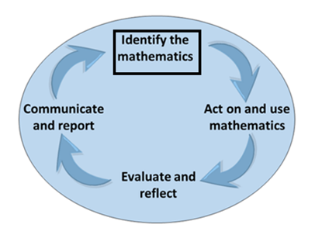
1. What is your Project goal, aim and/or purpose?

2. Where will you apply this in your project?

3. Pre-Program - how are you feeling about your project?

4. Pre-Program - how do you feel about the Numeracy required for this project that you identified in Step 2?

5. Program - what do you hope to get out of this project?

6.What mathematical tools are you likely to use? Select from the following or come up with your own.
☐ Digital spreadsheets
☐ Tables
☐ Rulers
☐ Tape measures
☐ GPS technology
☐ Survey data collection
☐ Data collection apps
☐ Time calculators
☐ Apps to track data
☐ Pedometers
☐ Reps and sets
☐Other:
☐ ________________________
☐________________________
☐________________________

7. Pre-Program - what do you need to clarify, find out, learn, ask or seek assistance with?

Activity 3.1 Pre-survey
Student Reflection - How well did you go with this step? (Please check the box below)
☐Not Submitted | ☐Beginning | ☐Consolidating | ☐Achieving | ☐Excelling
Student Comment (Optional):
Teacher Feedback
☐Not Submitted | ☐Beginning | ☐Consolidating | ☐Achieving | ☐Excelling
Not Submitted: No work has been submitted or attempted for this activity. | Beginning: I have attempted some aspects of the pre-survey. Some parts are incomplete or require more information.  To bump it up, you need to complete all required sections of this task. | Consolidating: I can complete most required parts of the pre-survey. My responses are basic full sentences.  To bump it up, you need to add further details to your responses that include specific details. | Achieving: I can complete all required parts of the pre-survey. My responses are detailed.  To bump it up, you could include specific details or examples and actions that will support you to develop and action the numeracy skills required for your project. | Excelling: I can complete all required parts of the pre-survey. My responses are highly detailed. I have included specific details or examples and actions that will support me to develop and action the numeracy skills required for my project.
Teacher Comment:

Step 3- Activity 3.2 Program Log Record

Part 1: You will keep an ongoing log and reflection of 5 sessions that you actively participate in using the templates below.

Session 1 Record
Add your responses in the table below.
Session 1: Add location date and time here.
You must participate in your selected activity. It is important to remember you will need photo evidence of your participation, so don't forget to take photos at every session. After each session, you must insert your photo evidence and complete a reflection about it.

Requirements for this logbook:
Photo Evidence
Reflection
Pre and Post Session Data collection  Highlight the box that best reflects how you feel pre and post session.  Pre-program rating: Prior to the session I am feeling…  Post-program rating: After the session I am feeling... | Reflection must include:  1. Did you use technology to complete your activity?  2. What went well?  3. What were some challenges while participating in your program?  4. What could you do differently next time that would make your experience even better?
  1  Poor | 2 | 3 | 4 | 5  Excellent
  1  Poor | 2 | 3 | 4 | 5  Excellent
Session 1 Participation Evidence
Add your participation evidence here.

Activity 3.2 - Program Log Record - Session 1
Student Reflection - How well did you go with this step? (Please check the box below)
☐Not Submitted | ☐Beginning | ☐Consolidating | ☐Achieving | ☐Excelling
Student Comment (Optional):
Teacher Feedback
☐Not Submitted | ☐Beginning | ☐Consolidating | ☐Achieving | ☐Excelling
Not Submitted: No work has been submitted or attempted for this activity. | Beginning: I can complete or attempt some aspects of this reflection.  To bump it up, you need to complete all required sections of this task | Consolidating: I can complete most required parts of this task.  To bump it up, you need to add further details to your reflections. | Achieving: I can complete all parts of this task. I have shown that I can reflect on my experiences and provide responses in detailed complete sentences.  To bump it up, you could add specific information on how to improve or resolve issues that have occurred throughout the program. | Excelling: I can complete all parts of this task. My reflection responses are detailed full sentences. My reflections also include comprehensive plans to continue to improve and overcome challenges.
Teacher Comment:

Session 2 Record
Add your responses in the table below.
Session 2: Add location date and time here.
You must participate in your selected activity. It is important to remember you will need photo evidence of your participation, so don't forget to take photos at every session. After each session, you must insert your photo evidence and complete a reflection about it.

Requirements for this logbook:
Photo Evidence
Reflection
Pre and Post Session Data collection  Highlight the box that best reflects how you feel pre and post session.  Pre-program rating: Prior to the session I am feeling…  Post-program rating: After the session I am feeling... | Reflection must include:  1. Did you use technology to complete your activity?  2. What went well?  3. What were some challenges while participating in your program?  4. What could you do differently next time that would make your experience even better?
  1  Poor | 2 | 3 | 4 | 5  Excellent
  1  Poor | 2 | 3 | 4 | 5  Excellent
Session 2 Participation Evidence
Add your participation evidence here.

Activity 3.2 - Program Log Record - Session 2
Student Reflection - How well did you go with this step? (Please check the box below)
☐Not Submitted | ☐Beginning | ☐Consolidating | ☐Achieving | ☐Excelling
Student Comment (Optional):
Teacher Feedback
☐Not Submitted | ☐Beginning | ☐Consolidating | ☐Achieving | ☐Excelling
Not Submitted: No work has been submitted or attempted for this activity. | Beginning: I can complete or attempt some aspects of this reflection.  To bump it up, you need to complete all required sections of this task | Consolidating: I can complete most required parts of this task.  To bump it up, you need to add further details to your reflections. | Achieving: I can complete all parts of this task. I have shown that I can reflect on my experiences and provide responses in detailed complete sentences.  To bump it up, you could add specific information on how to improve or resolve issues that have occurred throughout the program. | Excelling: I can complete all parts of this task. My reflection responses are detailed full sentences. My reflections also include comprehensive plans to continue to improve and overcome challenges.
Teacher Comment:

Session 3 Record
Add your responses in the table below.
Session 3: Add location date and time here.
You must participate in your selected activity. It is important to remember you will need photo evidence of your participation, so don't forget to take photos at every session. After each session, you must insert your photo evidence and complete a reflection about it.

Requirements for this logbook:
Photo Evidence
Reflection
Pre and Post Session Data collection  Highlight the box that best reflects how you feel pre and post session.  Pre-program rating: Prior to the session I am feeling…  Post-program rating: After the session I am feeling... | Reflection must include:  1. Did you use technology to complete your activity?  2. What went well?  3. What were some challenges while participating in your program?  4. What could you do differently next time that would make your experience even better?
  1  Poor | 2 | 3 | 4 | 5  Excellent
  1  Poor | 2 | 3 | 4 | 5  Excellent
Session 3 Participation Evidence
Add your participation evidence here.

Activity 3.2 - Program Log Record - Session 3
Student Reflection - How well did you go with this step? (Please check the box below)
☐Not Submitted | ☐Beginning | ☐Consolidating | ☐Achieving | ☐Excelling
Student Comment (Optional):
Teacher Feedback
☐Not Submitted | ☐Beginning | ☐Consolidating | ☐Achieving | ☐Excelling
Not Submitted: No work has been submitted or attempted for this activity. | Beginning: I can complete or attempt some aspects of this reflection.  To bump it up, you need to complete all required sections of this task | Consolidating: I can complete most required parts of this task.  To bump it up, you need to add further details to your reflections. | Achieving: I can complete all parts of this task. I have shown that I can reflect on my experiences and provide responses in detailed complete sentences.  To bump it up, you could add specific information on how to improve or resolve issues that have occurred throughout the program. | Excelling: I can complete all parts of this task. My reflection responses are detailed full sentences. My reflections also include comprehensive plans to continue to improve and overcome challenges.
Teacher Comment:
Session 4 Record
Add your responses in the table below.
Session 4: Add location date and time here.
You must participate in your selected activity. It is important to remember you will need photo evidence of your participation, so don't forget to take photos at every session. After each session, you must insert your photo evidence and complete a reflection about it.

Requirements for this logbook:
Photo Evidence
Reflection
Pre and Post Session Data collection  Highlight the box that best reflects how you feel pre and post session.  Pre-program rating: Prior to the session I am feeling…  Post-program rating: After the session I am feeling... | Reflection must include:  1. Did you use technology to complete your activity?  2. What went well?  3. What were some challenges while participating in your program?  4. What could you do differently next time that would make your experience even better?
  1  Poor | 2 | 3 | 4 | 5  Excellent
  1  Poor | 2 | 3 | 4 | 5  Excellent
Session 4 Participation Evidence
Add your participation evidence here.

Activity 3.2 - Program Log Record - Session 4
Student Reflection - How well did you go with this step? (Please check the box below)
☐Not Submitted | ☐Beginning | ☐Consolidating | ☐Achieving | ☐Excelling
Student Comment (Optional):
Teacher Feedback
☐Not Submitted | ☐Beginning | ☐Consolidating | ☐Achieving | ☐Excelling
Not Submitted: No work has been submitted or attempted for this activity. | Beginning: I can complete or attempt some aspects of this reflection.  To bump it up, you need to complete all required sections of this task | Consolidating: I can complete most required parts of this task.  To bump it up, you need to add further details to your reflections. | Achieving: I can complete all parts of this task. I have shown that I can reflect on my experiences and provide responses in detailed complete sentences.  To bump it up, you could add specific information on how to improve or resolve issues that have occurred throughout the program. | Excelling: I can complete all parts of this task. My reflection responses are detailed full sentences. My reflections also include comprehensive plans to continue to improve and overcome challenges.
Teacher Comment:

Session 5 Record
Add your responses in the table below.
Session 5: Add location date and time here.
You must participate in your selected activity. It is important to remember you will need photo evidence of your participation, so don't forget to take photos at every session. After each session, you must insert your photo evidence and complete a reflection about it.

Requirements for this logbook:
Photo Evidence
Reflection
Pre and Post Session Data collection  Highlight the box that best reflects how you feel pre and post session.  Pre-program rating: Prior to the session I am feeling…  Post-program rating: After the session I am feeling... | Reflection must include:  1. Did you use technology to complete your activity?  2. What went well?  3. What were some challenges while participating in your program?  4. What could you do differently next time that would make your experience even better?
  1  Poor | 2 | 3 | 4 | 5  Excellent
  1  Poor | 2 | 3 | 4 | 5  Excellent
Session 5 Participation Evidence
Add your participation evidence here.

Activity 3.2 - Program Log Record - Session 5
Student Reflection - How well did you go with this step? (Please check the box below)
☐Not Submitted | ☐Beginning | ☐Consolidating | ☐Achieving | ☐Excelling
Student Comment (Optional):
Teacher Feedback
☐Not Submitted | ☐Beginning | ☐Consolidating | ☐Achieving | ☐Excelling
Not Submitted: No work has been submitted or attempted for this activity. | Beginning: I can complete or attempt some aspects of this reflection.  To bump it up, you need to complete all required sections of this task | Consolidating: I can complete most required parts of this task.  To bump it up, you need to add further details to your reflections. | Achieving: I can complete all parts of this task. I have shown that I can reflect on my experiences and provide responses in detailed complete sentences.  To bump it up, you could add specific information on how to improve or resolve issues that have occurred throughout the program. | Excelling: I can complete all parts of this task. My reflection responses are detailed full sentences. My reflections also include comprehensive plans to continue to improve and overcome challenges.
Teacher Comment:

Step 3- Activity 3.3 post-program survey

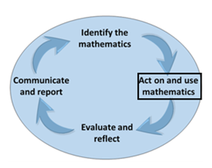

Part 1: Complete post-program questions below. Sentence starters have been provided. Where there is text in brackets, you can replace this text with your response.

1.From the data you have collected how do you plan to measure the effectiveness of this project? (SMART = Specific/Measurable).
Throughout the term, my goal is to… (insert your SMART goal from ‘Step 2-Activity 2.2).

- Measurable goal 1 – Quantitative (expressed as numbers).

I will measure the effectiveness of my program (insert your program name and details here.)

By improving my (insert what you hope to improve - e.g. physical fitness, mental well-being, happiness, strength, endurance)

Seeing an improvement in (insert how you are going to measure your improvements - e.g. the number of reps I complete each session, the number of weights I can lift).

- Measurable goal 2 – Qualitative (personal accounts, feelings, ratings).

I will measure the effectiveness of my program (insert your program)

By improving (insert what you hope to improve - physical fitness, mental wellbeing, happiness, strength, endurance)

Seeing an improvement in (Insert how you are going to measure your improvements in a non-numerical way - my journal entries and how I am feeling, photos of my progress).

Activity 3.3 post-survey
Student Reflection - How well did you go with this step? (Please check the box below)
☐Not Submitted | ☐Beginning | ☐Consolidating | ☐Achieving | ☐Excelling
Student Comment (Optional):
Teacher Feedback
☐Not Submitted | ☐Beginning | ☐Consolidating | ☐Achieving | ☐Excelling
Not Submitted: No work has been submitted or attempted for this activity. | Beginning: I can attempt some aspects of the post-survey. Some parts are incomplete or require more information.  To bump it up, you will need to complete all required sections of this task. | Consolidating: I can complete most required parts of the post-survey. My responses are basic full sentences.  To bump it up, you need to add further details to your responses that include specific details. | Achieving: I can complete all required parts of the post-survey. My responses are detailed.  To bump it up, you could include specific details or examples and actions of numeracy included in your project. | Excelling: I can complete all required parts of the post-survey. My responses are highly detailed. I have included specific details or examples and actions that I have included in my project.

Before you move onto Step 4 - Adapt
Have you completed the following activities?
Task Checklist
Students will complete the following for Step.3 Act:
☐ Step.3-Activity 3.1 Pre-program numeracy survey
☐ Step.3- Activity 3.2 5 Fitness reflection record
☐ Step.3 Activity 3.3 Post-program numeracy survey

Step 4 – Adapt

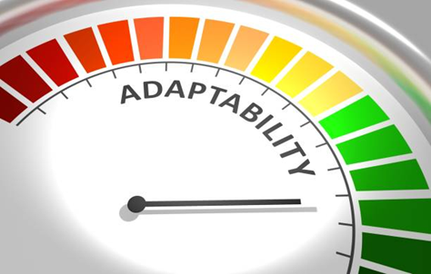

Task Checklist
Students will complete the following for Step 4 - Adapt.
☐ Step.4-Activity 4.1 Wellbeing explanation
☐ Step.4-Activity 4.2 Mathematical toolkit
☐ Step.4-Activity 4.3 Numeracy reflection

Key Vocabulary (you need to know)
Health: the general condition of the body or mind with reference to soundness and vigour.
Well-being: a good or satisfactory condition of existence; a state characterised by health, happiness, and prosperity; welfare
Health promotion: is the process of enabling people to increase control over, and to improve, their health.
Mathematical Toolkit: a place for students to develop a range of resources and strategies to use where necessary as students undertake their numeracy practices, activities and tasks.

Step 4- Activity 4.1 Wellbeing Explanation
Part 1: How successful do you think your program was in improving your overall wellbeing? (Use the survey results and reflection notes from Step 3. Act Activities and any other evidence you may have.)
☐ | ☐ | ☐ | ☐ | ☐
The program I participated in caused a significant decline in my overall wellbeing. | The program I participated in caused a slight decline in my overall wellbeing. | The program I participated in caused no change in my overall wellbeing. | The program I participated in slightly improved my overall wellbeing. | The program I participated in enhanced my overall wellbeing.

Part 2: Explain in as much detail as you can why you rated the program the way you did above. Include specific examples of your experience throughout the program.

Type your response here.

Activity 4.1 Wellbeing explanation
Student Reflection - How well did you go with this step? (Please check the box below)
☐Not Submitted | ☐Beginning | ☐Consolidating | ☐Achieving | ☐Excelling
Student Comment (Optional):
Teacher Feedback
☐Not Submitted | ☐Beginning | ☐Consolidating | ☐Achieving | ☐Excelling
Not Submitted: No work has been submitted or attempted for this activity. | Beginning: I have tried to reflect on my program experience and have attempted to explain my selected rating.  To bump it up, you need to complete all aspects of this task. | Consolidating: I can give a rating on my experience and provide a brief explanation about my selected rating.  To bump it up, you need to add additional details to your explanation. | Achieving: I can give a rating on my experience and provide a detailed explanation about my selected rating.  To bump it up, you need to add additional details to your explanation. | Excelling: I can give a rating on my experience and provide a highly detailed explanation about my selected rating.

Step 4-Activity 4.2 Mathematical toolkit

Mathematical Toolkit example only. You may need to modify this example to suit your own context.
Part 1: Fill in the mathematical toolkit template below and outline what numeracy knowledge and skills you are applying and demonstrating throughout your project. You will use this template each time you add to your numeracy toolkit.

Individual Project Mathematical Toolkit

Resource: Add the name of the resource here.

Numeracy Toolkit Examples
Representational | Physical | Digital
- Models  - Manipulatives  - Scaffolds  - Worked examples | - Word walls  - Placemats  - Graphical organisers  - Measuring equipment  - Calculator | - Spreadsheet  - Specific programs  - Specific apps  - Websites

Purpose:
When to use:
Accuracy:
Notes:

Insert photo or link to resource here (Digital):

Insert photo of you are using the resource here (Physical/Representational):

Activity 4.2- Mathematical Toolkit
Student Reflection - How well did you go with this step? (Please check the box below)
☐Not Submitted | ☐Beginning | ☐Consolidating | ☐Achieving | ☐Excelling
Student Comment (Optional):
Teacher Feedback
☐Not Submitted | ☐Beginning | ☐Consolidating | ☐Achieving | ☐Excelling
Not Submitted: No work has been submitted or attempted for this activity. | Beginning: I can attempt some aspects of developing a mathematical toolkit.  To bump it up, add responses to all sections of the template for each numeracy skill you have used in your project. | Consolidating: I can develop a basic mathematical toolkit which provides brief information for each of the numeracy skills I have used in my project.  To bump it up, you need to include more examples and details about the numeracy skills you have demonstrated throughout your project. | Achieving: I can develop a detailed mathematical toolkit which provides information for a range of the numeracy skills I have used in my project.  To bump it up, you need to include more examples and details about the numeracy skills you have demonstrated throughout your project | Excelling: I can develop a highly detailed mathematical toolkit which provides detailed information about a wide range of the numeracy skills I have used in my project.
Teacher Comment:

Step 4-Activity 4.3 Numeracy reflection

Part 1: Using the numeracy reflection table below outline what Numeracy knowledge and skills you demonstrated throughout your project.
Hint- If you need some help, please refer to ‘Step 2- Activity 2.4 Identify the mathematics’ where there are ‘examples/things to think about’ that will support you to complete the below activity.

Numeracy Outcomes | Used in your project? | Project Reflection: | Explain how you could use this skill in the workplace or outside of school.
Location
1.1 Find location and direction in relation to everyday, familiar places within the vicinity | ☐ | How did you use this within your project? Provide one example from your project.  Was the use of the ‘numeracy outcome’ effective or not?  How was this skill helpful in your project? | I could use ‘location’ in my workplace / outside of school by …
1.2 Find location and direction with every day, simple and familiar maps and technologies | ☐
1.3 Use every-day oral directions using informal language such as left/right, up/down, front/back, under/beside/over. | ☐
Systematics
1.1 Find common and familiar information and data inputs | ☐ | How did you use this within your project? Provide one example from your project.  Was the use of the ‘numeracy outcome’ effective or not?  How was this skill helpful in your project? | I could use ‘systematics’ in my workplace / outside of school by …
1.2 read data outputs | ☐
1.3 summarise information. | ☐
Numbers
1.1 place value and numbers up to 1000 | ☐ | How did you use this within your project? Provide one example from your project.  Was the use of the ‘numeracy outcome’ effective or not?  How was this skill helpful in your project? | I could use ‘numbers’ in my workplace / outside of school by …
1.2 whole numbers and monetary amounts up to $1000 | ☐
1.3 addition and subtraction (with no borrowing or decomposition) of whole numbers and familiar monetary amounts into the 100s | ☐
1.4 common, simple unit fractions such as 1/2, 1/4 and 1/10 | ☐
1.5 common decimals and percentages such as 0.5, 0.25, 50%, 25%. | ☐
Change
1.2 repeating patterns with one element such as with shapes, or $2, $4, $6, $8. | ☐ | How did you use this within your project? Provide one example from your project.  Was the use of the ‘numeracy outcome’ effective or not?  How was this skill helpful in your project? | I could use ‘change’ in my workplace / outside of school by …
1.3 changes and number matching with simple numbers. For example, prices increasing or decreasing, matching corresponding numbers. | ☐

Activity 4.3 Numeracy reflection.
Student Reflection - How well did you go with this step? (Please check the box below)
☐Not Submitted | ☐Beginning | ☐Consolidating | ☐Achieving | ☐Excelling
Student Comment (Optional):
Teacher Feedback
☐Not Submitted | ☐Beginning | ☐Consolidating | ☐Achieving | ☐Excelling
Not Submitted: No work has been submitted or attempted for this activity. | Beginning: I can attempt some aspects of the numeracy reflection table.  To bump it up, you need to add responses to all required sections. | Consolidating: I can outline the basic information in all sections relevant to my project in the numeracy reflection table.  To bump it up, you need to include more details in your responses. | Achieving: I can provide detailed responses in all sections relevant to my project in the numeracy reflection table.  To bump it up, you could add some more specific examples. | Excelling: I can provide highly detailed responses in all sections relevant to my project in the numeracy reflection table. Including relevant examples to my project.

Before you move onto Step 5 - Reflect
Have you completed the following activities?
Task Checklist
Students will complete the following for Step 4 - Adapt.
☐ Step.4-Activity 4.1 Wellbeing explanation
☐ Step.4-Activity 4.2 Mathematical toolkit
☐ Step.4-Activity 4.3 Numeracy reflection

Step 5- Reflect



Task Checklist
Students will complete the following for Step 5 - Reflect.
☐ Step.5 Activity 5.1 Cluster map
☐ Step.5 Activity 5.2 Skills reflection
☐ Step.5 Activity 5.3 Numeracy problem-solving cycle report and interview

Key Vocabulary (you need to know)
Health: the general condition of the body or mind with reference to soundness and vigour.
Well-being: a good or satisfactory condition of existence; a state characterised by health, happiness, and prosperity; welfare
Health promotion: is the process of enabling people to increase control over, and to improve, their health.

Step 5 - Activity 5.1 Cluster Map

Part 1: Complete cluster map below including what went well in your project and even better if. Double click on the cluster map below. In the draw setting add your information then click ‘Save and close.’

PROGRAM
EVEN BETTER IF ?
WHAT WENT WELL?

Activity 5.1 Cluster Map
Student Reflection - How well did you go with this step? (Please check the box below)
☐Not Submitted | ☐Beginning | ☐Consolidating | ☐Achieving | ☐Excelling
Student Comment (Optional):
Teacher Feedback
☐Not Submitted | ☐Beginning | ☐Consolidating | ☐Achieving | ☐Excelling
Not Submitted: No work has been submitted or attempted for this activity. | Beginning: I have attempted to complete some parts of this task.  To bump it up, you need to complete all sections of the cluster map. | Consolidating: I can provide a basic response for most sections in the cluster map.  To bump it up, you need to add more details to your responses. | Achieving: I can provide a detailed response for all sections in the cluster map.  To bump it up, outline the reasoning behind why you think things went well and discuss how you could ensure the ‘Even Better If’ happens within your project. | Excelling: I can provide a highly detailed response for all sections in the cluster map. I can include information about the reasons why things went well and describe how I could ensure that the ‘Even Better If’ could occur next time.

Step 5- Activity 5.2 Skills reflection

Part 1: Provide one example from your project about how you used the following skills listed in the table below.

Skill | Example
Time Management  Think about:  - How did you use your time when you were at the gym? Did you have a program planned?  - Did you create a schedule? Put it in your diary or calendar. | An example of how I used time management throughout my project was…  (Insert an example of time management in your project).
Communication  Think about:  - Did you communicate with anyone in the gym? (Teacher, gym staff members, peers).  - How did communication help your project? | An example of how I used communication throughout my project was…  (Insert an example of communication in your project).
Teamwork  Think about:  - Did you work with anyone throughout your project?  - For example - when using the bench press, I worked with a peer to spot each other. This ensured safety throughout our weight sessions. | An example of how I used teamwork throughout my project was…  (Insert an example of teamwork in your project).
Problem-Solving  Think about:  - Were there any problems you faced throughout your project?  - How did you overcome the problem? | An example of how I used problem-solving throughout my project was…  (Insert an example of problem-solving in your project).

Activity 5.2 Self Reflection
Student Reflection - How well did you go with this step? (Please check the box below)
☐Not Submitted | ☐Beginning | ☐Consolidating | ☐Achieving | ☐Excelling
Student Comment (Optional):
Teacher Feedback
☐Not Submitted | ☐Beginning | ☐Consolidating | ☐Achieving | ☐Excelling
Not Submitted: No work has been submitted or attempted for this activity. | Beginning: I have attempted to provide some examples of the skills.  To bump it up, you need to have an example for each of the skills. | Consolidating: I can provide an example of each of the skills.  To bump it up, you need to add some more details into your examples. | Achieving: I can provide examples of each of the skills with details.  To bump it up, you could explain how the use of the skills benefitted your project. | Excelling: I can provide detailed examples of each skill and explain how it benefited my project.

Step 5- Activity 5.3 Numeracy Problem-Solving Cycle and Interview

Part 1: Complete the template below.

Unit 1: Striving Individuals Communicate and Report

Identify the mathematics | List what numeracy skills you demonstrated throughout this project. Explain why you needed to use these numeracy skills specific to your project.  You can use and summarise information from the following activities you have already completed:  Step.2 Activity 2.4 Design Phase- Identify the mathematics.  Step.3 Activity 3.1 Pre-program survey  Step.3 Activity 3.3 Post-program survey  Add your information here.
Act on and use the mathematics | Summarise the numeracy skills you used throughout your project. Include information about things that worked and didn’t work.  Provide information about the different data sets and numeracy skills you needed.  You can use and summarise information from the following activities you have already completed:  Step.3 Activity 3.2 5 session records logs  Step.4 Activity 4.2 Mathematical toolkit  Add your information here.
Evaluate and reflect | Outline the positives and negatives of the numeracy skills you used throughout your project.  How did your results compare with your project goal? Explain how you measured this.  You can use and summarise information from the following activities you have already completed:  Step.2 Activity 2.2 SMART goal  Step.4 Activity 4.1 Wellbeing explanation  Step.4 Activity 4.4 Numeracy reflection table  Step.3 Activity 3.3 Post-program survey  Add your information here.
Communicate and report | What worked and didn’t work when using your numeracy skills within your project?  What did you find challenging?  If you were to complete this project again, would you collect any more data to help prove the effectiveness of it?  Add your information here.

Part 2: Using the information you have collated in Part.1 to create a digital presentation of your choice. You can use the categories in the left-hand column for the title headings for each section of your presentation.
Add your presentation or link to your presentation here.

Part 3: Book in a Teacher interview time to communicate and report on your numeracy Problem-Solving Cycle throughout your project work.
Teacher Name:
Date:
Sign off:
Teacher Feedback about presentation:

Activity 5.3 Numeracy Problem-Solving Cycle and Interview
Student Reflection - How well did you go with this step? (Please check the box below)
☐Not Submitted | ☐Beginning | ☐Consolidating | ☐Achieving | ☐Excelling
Student Comment (Optional):
Teacher Feedback
☐Not Submitted | ☐Beginning | ☐Consolidating | ☐Achieving | ☐Excelling
Not Submitted: No work has been submitted or attempted for this activity. | Beginning: I can attempt some parts of this report.  To bump it up, more information and preparation is required. | Consolidating: I can provide a basic report and communicate my use of mathematics and the problem-solving cycle in my teacher interview.  To bump it up, you need further evidence, images and specific details. | Achieving: I can provide a detailed report and successfully communicate my use of mathematics and the problem-solving cycle in my teacher interview.  To bump it up, you could use a wider range of evidence and examples to report on. | Excelling: I can provide a comprehensive report and clearly communicate my use of mathematics and the problem-solving cycle using technology in my teacher interview.

Before you move onto another task
Have you completed the following activities?
Task Checklist
Students will complete the following for Step 5 - Reflect.
☐ Step.5 Activity 5.1 Cluster map
☐ Step.5 Activity 5.2 Skills reflection
☐ Step.5 Activity 5.3 Numeracy problem-solving cycle report and interview

