2024 VCE Systems Engineering external assessment report

General comments
Approximately 1100 students undertook the VCE Systems Engineering examination in 2024. While the majority of students demonstrated an understanding of the key knowledge and key skills required across both sections of the examination, there were also several areas requiring some improvement.
- Students should read questions carefully to ensure they respond to what the questions are asking. Written responses that did not directly address the question were not awarded full marks. Responses that simply outlined knowledge of components and systems, without addressing the question, did not score highly.
- Students should provide correct units in their solutions and include appropriate working.
- Students demonstrated a sound knowledge of the principles associated with calculating work and energy. However, calculating resistance in parallel, particularly in non-conventional circuit diagrams, proved challenging for some.
- A number of responses did not interpret circuit diagrams well or demonstrate the skills required to draw schematic diagrams with the correct orientation of circuit components.

Specific information
This report provides sample answers or an indication of what answers may have included. Unless otherwise stated, these are not intended to be exemplary or complete responses.
The statistics in this report may be subject to rounding, resulting in a total more or less than 100 per cent.

Section A – Multiple-choice questions
The following table indicates the percentage of students who chose each option. The correct answer is indicated by bold text and shading.
Question | Correct answer | % A | % B | % C | % D | N/A | Comments
1 | C | 5 | 5 | 87 | 3 | 0
2 | A | 83 | 1 | 10 | 6 | 0
3 | C | 1 | 0 | 97 | 2 | 0
4 | A | 53 | 27 | 16 | 4 | 1 | $P=\frac{W}{t}$, where W = 2000 Nm and t = 5 s $∴$ $P=\frac{2000}{5}$ = 400 W
5 | C | 7 | 30 | 54 | 9 | 0 | One full rotation of the worm gear would mean only one tooth would turn on the wheel per rotation of the worm. Therefore, 60 turns of the worn gear would rotate the wheels one revolution per minute. RPM of motor = 60.
6 | B | 13 | 62 | 19 | 6 | 0 | A parallel resistor network, along with resistor tolerances, needed to be considered when determining total resistance.
7 |  |  |  |  |  |  | As a result of psychometric analysis and review, all four options were accepted as correct.
8 | A | 30 | 19 | 39 | 11 | 0 | A polarised capacitor would only reduce noise when operating in forward bias mode, and as such would not be suitable.
9 | D | 20 | 12 | 7 | 61 | 0 | 18 V – 2 V = 16 V
10 | B | 47 | 35 | 12 | 5 | 0 | The electrical energy produced, after accounting for energy used and lost, is calculated as follows: 100% – 8% – 10% = 82%. Therefore, 82% of the total energy is available, which, when multiplied by 30%, equals 24.6%, or approximately 25%. This means that when comparing the chemical energy in brown coal to the energy delivered to consumers, 24.6%, or approximately 25%, of the energy is effectively delivered.
11 | B | 2 | 51 | 28 | 18 | 0 | $C={\left(\frac{1}{200}+ \frac{1}{400}\right)}^{-1} ∴$ $C=\frac{400}{3}$ = 133 µF
12 | D | 11 | 25 | 32 | 32 | 0 | $τ=F$x $d$ $∴$ $F= \frac{480 Nm}{0.25 m}$= 1920 N
13 | C | 16 | 1 | 81 | 2 | 0
14 | B | 7 | 76 | 10 | 7 | 0
15 | D | 1 | 1 | 1 | 97 | 0
16 | C | 11 | 13 | 62 | 13 | 1
17 | D | 3 | 0 | 1 | 95 | 0 | Hazards are potential sources of harm; risks are the likelihood that harm will occur.
18 | D | 6 | 8 | 31 | 54 | 0 | Closed-loop systems use feedback loops that adjust the output.
19 | D | 6 | 20 | 11 | 62 | 0 | Curved blades capture more energy; lubrication reduces losses.
20 | A | 77 | 15 | 6 | 2 | 0 | $n$ is given by, $n=$ $\frac{P_{T}}{P_{total}}$ $×100$

Section B – Short-answer and extended-answer questions

Question 1a.
Mark | 0 | 1 | Average
% | 38 | 62 | 0.7
Any response that either determined the gradient from the graph or stated the gradient from the voltage (V) vs current (I) relationship was accepted.
The most common response was 200.

Question 1b.
Mark | 0 | 1 | 2 | Average
% | 69 | 8 | 23 | 0.6
Any method that determined the resistance of the potentiometer was accepted, given that the total resistance was 200 Ω. Alternatively, the value determined in Question 1a. was used.
$$\frac{1}{R_{T}}=\frac{1}{R_{1}}+\frac{1}{R_{2}}$$
$$\frac{1}{R_{1}}=\frac{1}{200}-\frac{1}{330}$$
$R_{1}=507.69$Ω $≈508$Ω

Question 2a.
Mark | 0 | 1 | 2 | Average
% | 48 | 3 | 49 | 1.0
The total power produced by each panel provided a basis for calculating the number of panels used, which was determined by multiplying power in watts by peak output.
360 W x 14 h = 5040 W or 5.04 kW
Given 55 kW of energy was required to be produced by the panels:
$∴$ $\frac{55 KWh}{5.04 KWh}$ $≈$ 10.91, meaning 11 panels were needed in total.

Question 2b.
Mark | 0 | 1 | 2 | Average
% | 56 | 24 | 20 | 0.7
The embodied energy for each panel was calculated by multiplying the surface area of each panel by the embodied energy per m², which was 1.7 m² x 585 kWh m⁻² = 994.5 kWh.
At peak output, each panel produces 360 W, so dividing the embodied energy per panel by the peak output yields $= \frac{994.5 KWh}{.36 KW}$, which means 2763 hours would be required.

Question 3a.
Mark | 0 | 1 | 2 | Average
% | 33 | 11 | 56 | 1.3
Work was determined by multiplying the force of the load by the distance it had been raised.
Given $F=m × a$, the mass of the load needed to be multiplied by the acceleration due to gravity outlined in the question to determine the force of the load, prior to the work being calculated.
Force = 6 kg x 10 ms⁻² = 60 N
$∴$ Work = 60 N x 3 m = 180 Nm or 180 J

Question 3b.
Mark | 0 | 1 | Average
% | 73 | 27 | 0.3
Six pulleys were used to provide a mechanical advantage of 6 to lift the load 3 m. Six times the amount of rope was needed to be pulled through the eyelet. Therefore 6 x 3 m = 18 m of rope was pulled through the eyelet.

Question 3c.
Mark | 0 | 1 | 2 | Average
% | 68 | 16 | 16 | 0.5

The speed at which the rope passed through the guiding eyelet was dependent on the solution obtained to Question 3b. Responses that demonstrated appropriate calculations using previous responses were awarded full marks.
$$P=\frac{W}{t} ∴ t=\frac{W}{P}=\frac{180 J}{90 W}=2 s$$
Subsequently, the speed at which the rope passed through the guiding eyelet was:
$$s=\frac{distance}{time}=\frac{18m}{2s}=9 ms^{-1}$$

Question 4a.
Mark | 0 | 1 | 2 | 3 | Average
% | 24 | 11 | 25 | 40 | 1.8
Students were required to make reference to the use of a stopwatch and the notch inset in the crank in order to describe a method for determining the rate of oscillation. Full marks were awarded for all three references if the procedure accurately determined the rate of oscillation.

Question 4b.
Mark | 0 | 1 | 2 | 3 | Average
% | 47 | 12 | 18 | 23 | 1.2
Marks were awarded for providing an accurate series circuit that included a non-latching switch connected in series with a lamp and power supply, along with an illustration depicting the rotation of the crank connected to the lever activating the switch. A description of the test procedure that outlined the process was intended to complement the drawing and further demonstrate how the rate of oscillation was calculated.

Question 5a.
Mark | 0 | 1 | 2 | Average
% | 13 | 26 | 61 | 1.5
Two evaluation criteria relating to the mechanical or electronic aspects of the drone included:
- its ability to operate within the 1 km radius
- its ability to effectively carry the 2 kg payload
- its range capabilities (travel at least 2 km)
- its battery life
- its mechanical durability
- its GPS capabilities and ability to operate in varying weather conditions.

Question 5b.
Mark | 0 | 1 | 2 | Average
% | 16 | 13 | 70 | 1.6
Responses that accurately outlined and described one of the testing methods used in Question 5a. were awarded full marks.

Question 6a.
Mark | 0 | 1 | 2 | 3 | Average
% | 46 | 25 | 20 | 9 | 0.9
Students needed to demonstrate an understanding of a compound gear mechanism, which required one compound gearset to exist between the input and output gears. A gear ratio of 3 along with accurately labelled input and output gears was required. The direction of motion of Gear A and Gear C also needed to be clockwise and anticlockwise, respectively.
Sample response:
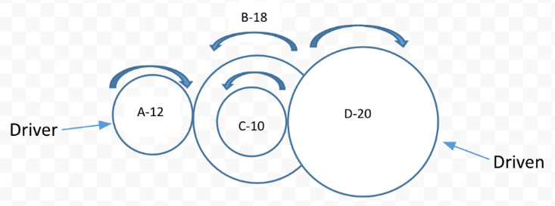

Question 6b.
Mark | 0 | 1 | Average
% | 58 | 42 | 0.4
The output rotation speed was determined using the gear ratio, which was 3:1.

$$gear ratio=\frac{input speed}{output speed} ∴ output speed= \frac{150 rpm}{3}$$

The output rotation speed was 50 rpm.

Question 7
Mark | 0 | 1 | 2 | 3 | Average
% | 45 | 3 | 3 | 49 | 1.6
The efficiency of the pulley mechanism was determined by evaluating the output energy over the input energy (i.e. work out / work in). Marks were awarded for accurate energy calculations:

${work}_{OUT}$ = 60 N x 2 m = 120 Nm ${work}_{IN}$ = 30 N x 5 m = 150 N

$$efficiency=\frac{output energy}{input energy } ×100\% or \frac{{work}_{OUT}}{{work}_{IN}} ×100\%$$

$$efficiency=\frac{120 Nm}{150 Nm} ×100\% = 80\%$$

The solution needed to be a percentage value in order to obtain full marks for the question.

Question 8a.
Mark | 0 | 1 | 2 | Average
% | 25 | 9 | 66 | 1.4
The type of lever illustrated is a first class lever as the fulcrum is located between the load and the effort.

Question 8b.
Mark | 0 | 1 | 2 | Average
% | 22 | 2 | 76 | 1.6
This question was essentially centered around equating moments clockwise and anticlockwise.
$$720 N×1 m={effort}_{force} ×6 m$$

$${effort}_{force}= \frac{720 Nm }{6 m}= 120 N$$

$∴$ The minimum effort force required was 120 N.
Alternatively, ratios could have also been used to obtain the same result (i.e. 6:1 = 720 N : 120 N).

Question 8c.
Mark | 0 | 1 | Average
% | 27 | 73 | 0.8
The mechanical advantage of the lever was determined using the formula:

$$mechanical advantage=\frac{load}{effort }= \frac{720 N}{120 N}=6$$

$∴$ The mechanical advantage is 6.

Question 9a.
Mark | 0 | 1 | 2 | 3 | 4 | Average
% | 27 | 14 | 25 | 20 | 14 | 1.8
Some similarities of hydraulic and pneumatic systems are that they both:
- have the ability to create mechanical advantage
- are controlled by valves
- use pump/fluids
- use pistons.
Differences of hydraulic and pneumatic systems include the following:
- Hydraulic systems can create higher output force due to liquid being less compressible than gas.
- Pneumatic systems are much faster in operation.
Any other response was awarded marks if both similarities and differences were included.

Question 9b.
Mark | 0 | 1 | 2 | Average
% | 42 | 22 | 36 | 1.0
A pneumatic system would be most suitable for the potato chip packaging plant. Pneumatic systems offer faster operation and are generally cleaner so there is less possibility to contaminate food.

Question 9c.
Mark | 0 | 1 | 2 | 3 | 4 | Average
% | 5 | 3 | 4 | 7 | 80 | 3.6
Responses were completed in Table 2 – Potato Chip Hazard Analysis, and were as follows:
- (A) – low risk, medium severity
- (B) – medium hazard significance
- (C) – low risk
- (D) – high severity.

Question 10a.
Mark | 0 | 1 | 2 | 3 | Average
% | 62 | 19 | 14 | 5 | 0.7
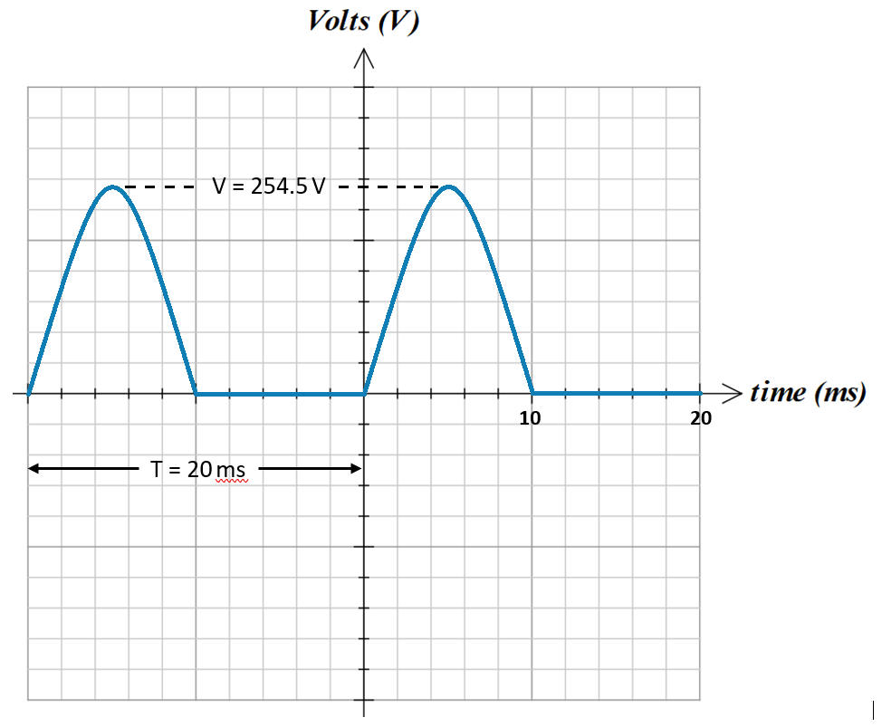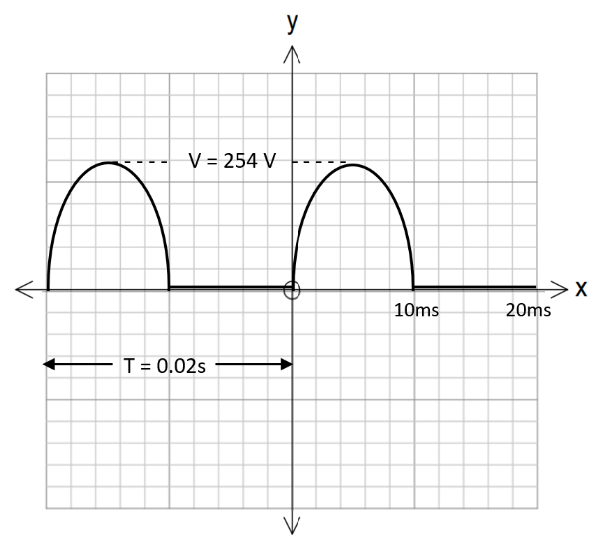

Two half-wave 50 Hz cycles

V_{PEAK} = 180 V RMS = $\sqrt{2}$ × 180V = 254.5 V RMS
Frequency = 50 Hz, T = $\frac{1}{50}$ = 0.02 seconds or 20 ms

Question 10b.
Mark | 0 | 1 | Average
% | 65 | 35 | 0.4
Suggested improvements needed to be made to the circuit outlined in Figure 6. As such, any of the following responses were accepted:
- bridge wave rectification circuit
- full wave rectifier
- capacitor in parallel with the load / smoothing capacitor.

Question 11
Mark | 0 | 1 | 2 | 3 | 4 | 5 | Average
% | 43 | 2 | 5 | 4 | 5 | 41 | 2.5
One mark was awarded for each correctly labelled component, circled in blue.
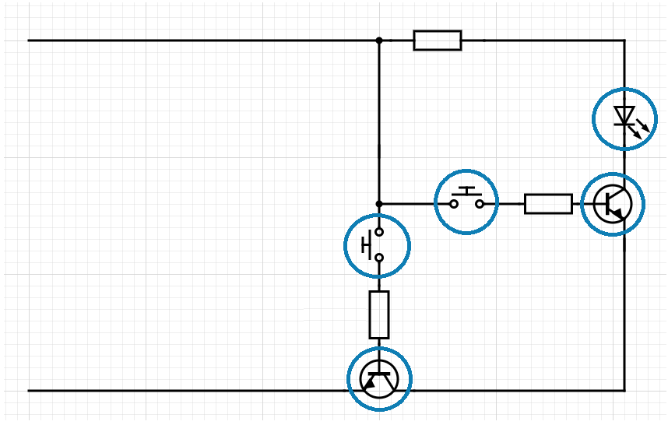

Question 12
Mark | 0 | 1 | 2 | 3 | 4 | 5 | Average
% | 20 | 4 | 11 | 21 | 23 | 21 | 2.9
Marks were awarded for application of the chosen device that included a detailed description, likely impacts (either negative or positive), and any potential issues that may have resulted from its use.
The following is a sample response created for this report:
One possible application is the use of smartwatch heart rate monitors to observe the real-time heart rate of patients. These monitors can detect unusual heart rates, particularly if the smartwatch is providing GPS readings as well. This can alert doctors about a potential medical issue and possibly save the patient’s life.
Positives of wearable technology are:
- convenient, efficient and smart
- ability to offer real-time monitoring
- a more personalised healthcare system.
Negatives of wearable technology are:
- security concerns
- cost
- battery life issues.

Question 13a.
Mark | 0 | 1 | 2 | Average
% | 59 | 19 | 22 | 0.7
A relay is an electromechanical switch that is used to both control and isolate separate circuits that usually differ in power and voltage. Advantages of using relays include:
- ability to control high voltage circuits with low voltage supply
- ability to control multiple circuits.

Question 13b.
Mark | 0 | 1 | Average
% | 58 | 42 | 0.5
The purpose of the switch is to activate/control the relay.

Question 13c.
Mark | 0 | 1 | 2 | Average
% | 65 | 17 | 18 | 0.6
The relay is used to activate the lamp circuit and to isolate the lower voltage control circuit from the higher voltage lamp circuit. When the switch is open, as in the initial condition, the relay allows current flow through the lamp. When the switch is closed, the relay opens the lamp circuit, which prevents current flow through the lamp.

Question 14a.
Mark | 0 | 1 | 2 | 3 | 4 | Average
% | 11 | 31 | 5 | 14 | 39 | 2.4
A – light-dependent resistor (LDR)
B – thermistor
C – subsystem 2 – temperature detector
D – audible warning device

Question 14b.
Mark | 0 | 1 | 2 | 3 | Average
% | 28 | 10 | 22 | 40 | 1.8
The function of the two operating systems is to determine if it is dark or light and if it is hot or cold.
Both subsystems would need to register set conditions in order to output a warning signal, meaning it would need to be both dark and cold for the signal to sound.

Question 15
Mark | 0 | 1 | 2 | 3 | 4 | 5 | Average
% | 33 | 8 | 13 | 19 | 16 | 10 | 2.1
Marks were awarded for a description of ‘cradle-to-cradle analysis’ that then discussed environmental, economic and social benefits of its application. A link to renewables was also required to obtain full marks.
The following is a sample response created for this report:
Cradle-to-Cradle offers a sustainable approach to manufacturing and production where systems are repurposed at the end of their life cycle. Benefits of such design practices include:
- reduced waste and pollution
- preservation of natural resources
- reduction in greenhouse gas emissions
- cost savings
- new business opportunities and revenue streams
- increased competitiveness
- improved health and wellbeing
- job creation
- enhanced community resilience.
Utilising renewable materials and componentry within systems that have the potential to be reused is the core principle of cradle-to-cradle design. For example, ensuring all parts used in the construction of a wind turbine can be recycled at the end of their lifetime.

Question 16a.
Mark | 0 | 1 | 2 | 3 | Average
% | 30 | 18 | 26 | 26 | 1.5
Responses needed to address three main points that included energy transformation, energy storage and energy usage.
Conversion of solar energy into electrical energy needed to mention light or photon energy (not heat), followed by the chemical energy stored by the batteries.
Light energy electrical energy chemical energy
The energy stored in the batteries is used to power the tools in her shed.

Question 16b.
Mark | 0 | 1 | 2 | Average
% | 48 | 13 | 39 | 0.9
A number of factors affect the efficiency of solar panels, some of which include:
- the angle at which the panels are installed
- heat, which has a negative impact on efficiency
- cleanliness of the panel surface
- a charge controller
- power losses in resistive wires
- the type of battery system used.

